This is the title of my D&ER paper submitted to the 2016 IAEA International Conference on Advancing the Global Implementation of Decommissioning and Environmental Remediation Programmes
LJUBENOV, Vladan,
Decommissioning and Remediation Unit, Waste and Environmental Safety Section, Address and Street, Vienna, Austria
E-mail address: V.Ljubenov@iaea.org

Abstract: The Conference will cover various areas of decommissioning and environmental remediation (D&ER) and will be organized around the following topics: national policies and strategies to enable and enhance D&ER, regulatory framework and standards for D&ER, decision-making process: societal and stakeholder involvement during the life cycle of D&ER projects, technical and technological aspects of D&ER (involving parallel sessions for decommissioning and environmental remediation), project management and supply chain considerations, optimizing waste and materials management in D&ER and international cooperation. Experts from Member States who wish to present a paper at the conference must submit an extended synopsis (in English) with 300 to 800 words (i.e. two A4 format pages of single spaced typing, or the equivalent, including any tables or diagrams and a few pertinent references) to be uploaded to the conference’s web browser-based file submission system (IAEA-INDICO) by 16 November 2015. No other submission route will be accepted. Where the number of oral requests exceeds slots available, the IAEA reserves the right to assign papers to an appropriate poster session. A Book of Synopses of accepted contributions will be made available online about one week before the opening of the Conference.

1. INTRODUCTION
The first step in submission requires creation of a user account on the INDICO conference system, using the 'Login' tab in the top right corner of the page. If you are already a registered INDICO user, please log into the system.
2. METHDOS
Figure 1 shows an example of metal decontamination by grinding in a facility being decommissioned in Sellafield. Figure 1:

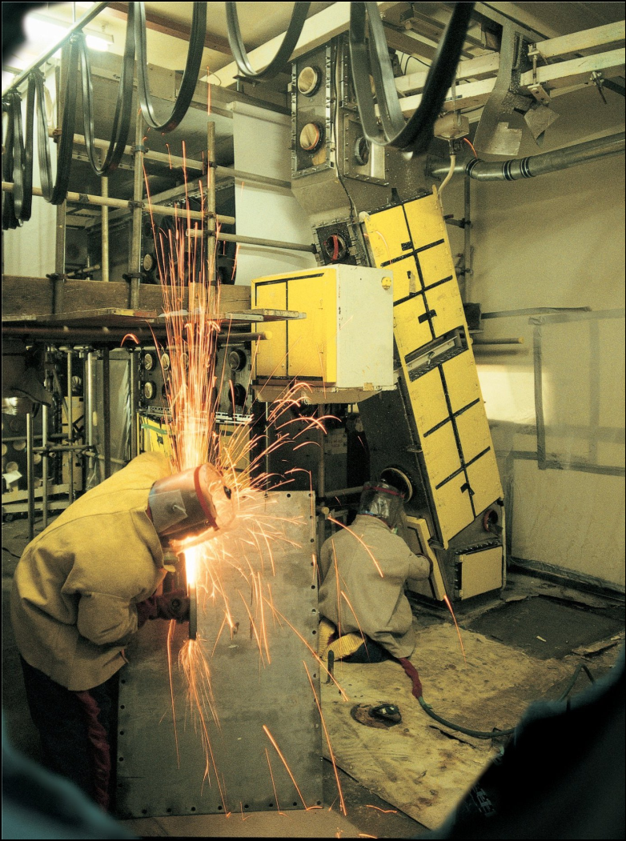
Figure 1. Metal decontamination by grinding.
3. RESULTS
The first step in submission requires creation of a user account on the INDICO conference system, using the 'Login' tab in the top right corner of the page. If you are already a registered INDICO user, please log into the system. Summary of Constraints and Strategies in Decommissioning and Environmental Remediation are tabulated in in Table 1 as shown below:
Table 1. Summary of Constraints and Strategies – Resource Issues.
Constraint | Solution
Inadequate funding and cooperation | Establish an independent D&ER fund early in the facilities lifecycle to collect funds during operation  Look for other sources of funds from international organizations
Lack of Historical Knowledge | Perform a good characterization of the facility or site  Interview current and past operational employees
Lack of Qualified Personnel | Establish a retaining programme for operations personnel  Hire D&ER specialists

4. CONCLUSIONS
All of the citations in my abstract [1] must follow the IAEA citation style [2-10], as shown below.

REFERENCES
[1] STEPHENSON, R., Introduction to Nuclear Engineering, 2nd edn, McGraw-Hill, New York
(1958) 491 pp.
[2] GEYH, M.A., Messungen der Tritium-Konzentration in Salzlaugen, Kali Steinsalz 5 (1969)
208.
[3] INTERNATIONAL COMMISSION ON RADIOLOGICAL PROTECTION, Evaluation of
Radiation Doses to Body Tissues from Internal Contamination due to Occupational Exposure,
Publication 10, Pergamon Press, Oxford and New York (1968).
[4] GUTHRIE, F.E., PERRY, J.J. (Eds), Introduction to Environmental Toxicology, Blackwell,
Oxford (1980).
[5] HOWLAND, G.P., HART, R.W., “Radiation biology of cultured plant cells”, Applied and
Fundamental Aspects of Plant Cell, Tissue, and Organ Culture, 2nd edn (REINERT, J.,
BAJAJ, Y.R.S., Eds), Springer-Verlag, Berlin (in press).
[6] BURKE, S.D., HOWELL, J.P., “Impact of prolonged wet storage of DOE reactor irradiated
nuclear materials at the Savannah River Site”, Proc. Topical Mtg on DOE Spent Nuclear Fuel
— Challenges and Initiatives, Salt Lake City, 1994, USDOE, Washington, DC (1994) 118–124.
[7] COCHRANE, M.P., DUFFS, C.M., Endosperm cell number in barley, Nature 289 (1981) 399.
[8] BLOUNT, E.I., Symmetry properties of triplet superconductors, Phys. Rev., B: Condens. Matter 32 (1985) 2935.
[9] TEPPER, L., Suboptimal control study of a nuclear power plant, IEEE Trans. Nucl. Sci. NS-22 (1975) 812.
[10] PEACOCK, K.L., Design of discrete bandpass filters for petroleum exploration, Oil Gas J. 83
42 (1985) 121.

