This is the Title of my IDOS 2019 Synopsis
Primary Author (First Initial. Last Name e.g. J. Smithª)
Co-Author 1^{b}, Co-Author 2, Co-Author…

ªInstitute of primary author, Institute address
^{b}Institute of co-author(s), Institute addresse(s)
Email address of Corresponding Author(s): myemail@domain.com
BACKGROUND
The background of the synopsis goes here.
METHODS
The methods section of the synopsis goes here. The appropriate formatting for a figure is shown in Figure 1.
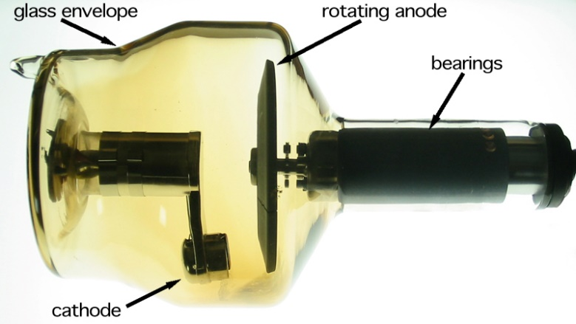
Figure 1. X ray tube.

RESULTS
The results section of the synopsis goes here. The appropriate formatting for a table is shown in Table 1.
Table 1. HVLs and calibration factors.
Target - Filter | kV | HVL (mmAl) | Calibration Factor
Mo - Mo | 25 | 0.28 | 4.89±0.01
W - Mo | 25 | 0.33 | 4.72±0.01

CONCLUSIONS
The conclusions section of the synopsis goes here. All of the citations [1] must follow the IAEA citation style as shown below. The maximum length of this synopsis is 2 pages, 800 words (including title) [2-7].
REFERENCES
[1] STEPHENSON, R., Introduction to Nuclear Engineering, 2nd edn, McGraw-Hill, New York (1958) 491 pp.
[2] GEYH, M.A., Messungen der Tritium-Konzentration in Salzlaugen, Kali Steinsalz 5 (1969) 208.
[3] INTERNATIONAL COMMISSION ON RADIOLOGICAL PROTECTION, Evaluation of Radiation Doses to Body Tissues from Internal Contamination due to Occupational Exposure, Publication 10, Pergamon Press, Oxford and New York (1968).
[4] GUTHRIE, F.E., PERRY, J.J. (Eds), Introduction to Environmental Toxicology, Blackwell, Oxford (1980).
[5] HOWLAND, G.P., HART, R.W., “Radiation biology of cultured plant cells”, Applied and Fundamental Aspects of Plant Cell, Tissue, and Organ Culture, 2nd edn (REINERT, J., BAJAJ, Y.R.S., Eds), Springer-Verlag, Berlin (in press).
[6] BURKE, S.D., HOWELL, J.P., “Impact of prolonged wet storage of DOE reactor irradiated nuclear materials at the Savannah River Site”, Proc. Topical Mtg on DOE Spent Nuclear Fuel - Challenges and Initiatives, Salt Lake City, 1994, USDOE, Washington, DC (1994) 118-124.
[7] COCHRANE, M.P., DUFFS, C.M., Endosperm cell number in barley, Nature 289 (1981) 399.

