LESSONS LEARNT IN METALLIC MATERIALS CLEARANCE PROJECTS
Garcia-Bermejo Fernandez, Rafael, De Diego Compadre, Jose Luis
Waste Management and Decommissioning Area. Nuclear Installations Support. Nuclear Division. IBERDROLA Engineering and Construction Ltd,
Avda, Manoteras, 20 Edificio C, 28050 Madrid, Spain.
E-mail address: rgfe@iberdrola.es

Abstract: The operational and decommissioning waste minimization can be achieved by appropriate management of residual materials. Two main categories are dominant in non-activated residual materials, one of them is the metallic materials the other is the building debris. The availability of specific clearance standards (i.e. clearance levels) [1] allows to define, plan, execute and closure comprehensive projects to deal with those contaminated materials. The conceptual approach is based on use of a derived quantity namely Residual Activity Index (RAI), systematic use of Data quality Objectives in different characterization stages, selection of appropriate measurement equipment to segregate and sentencing the materials and a set of Decision rules based on non-parametric tests of hypothesis. All this elements has been tested and implemented in different projects permitting to clear more than 1000 tons. Finally the data quality analysis has permitted to validate the non parametric hypothesis testing used in a cost-effective way and to demonstrate that probability distributions are contaminated distributions because the use of limits of detection of the measurement equipment.
- INTRODUCTION
During operation and decommissioning a huge amount of contaminated materials is produced. In some cases the metallic materials are correctly segregated form other contaminated materials but in some situations segregation is needed. This si typical of Electrical Cables. Once the metallic materials are separated it is necessary to design the optioneering process. The potential options are (1) to treat, handling and dispose as radioactive waste; (2) To directly clear them using an appropriate measurement equipment and (3) to treat (downsize and/or decontaminate) and finally to clear for recycling, as much as possible depending the efficiency of the decontamination procedure.
Is important to recognize that a process such the last option only can be justified if the Amount of material cleared is enough big to pay the project based in the saving of volume in the final disposal site, To minor quantities the option 1 or 2 are more appropriate because manual measurement equipment and simple tests can be used
2. METHODS
1) Quantities: The statistical process variable was defined as Residual Activity Index (RAI) (see ec,1). The Clearance Scaling Factor, CSF is determined as Upper Confidence Limit of the Median, The statistical parameter is the RAI average in the Clearance Unit (CU).
The decontamination factor DF is a statistical variable as the ratio RAI_{in}/IAR_{out. .}
2) Initial, or pre decontamination to feasible scope determination, post-decontamination to test decontamination performance and to allowing the final measurement and clearance or final surveys are required
$RAI=\sum_{i}{{C_{i}}/{{CL}_{i}}=\sum_{k}{C_{k}\left(\frac{1}{{CL}_{k}}+\sum_{l}{\frac{{CSF}_{lk}}{{CL}_{l}}}\right)}}$ ec.1.
3) A summary of the Process is depicted in fig. 1 where radiological check points are included
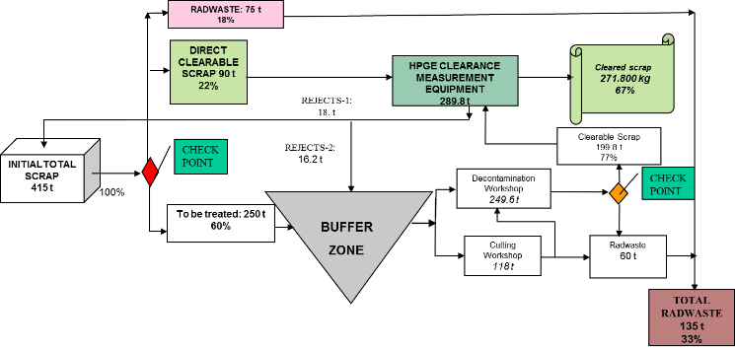
Figure 1. Scrap decontamination and clearance process.
- RESULTS
1) Initial segregation was useful to avoid unnecessary decontamination effort.
2) Use of simple decision rules MARSSIM type [2] with elevated le4vel comparison with IAR=10.
3) From 67% to more than 90% of previously contaminated scrap was cleared [1].
4) ⁶⁰Co, ¹³⁷Cs- and IAR data were fitted to asymmetrical distributions such as Weibull, Log normal or Log-logistic types but they appear mixed with degenerate distribution in 0 or limit of detection value

CONCLUSIONS
Clearance tests using small sample sizes (n<30) will be appropriate and statistically sound if they are non-parametric tests (i. e- Sign or Wilcoxon tests) and they also use robust (median based) scaling factor estimates.
REFERENCES
[1] European Commission. Recommended radiological protection criteria for the recycling of materials from the dismantling of nuclear installations. RP 89. Luxemburg 1998.
[2] USNRC. NUREG -1575 Supplement 1. Multi –Agency Radiation Survey and Assessment of Materials and Equipment Manual (MARSAME). January 2009,
[3] GARCIA-BERMEJO, R., DE DIEGO J.L. A 'Method Based Survey' Succeeds in a Spanish Scrap Clearance. Proc, WM2015 Conference, March 15 – 19, 2015, Phoenix, Arizona, USA,
[4] GARCIA-BERMEJO. R and DE DIEGO, J. L. Commissioning Methods and Procedures for Metallic Scrap Clearance. 8. International Symposium. Release of Radioactive Materials Requirements for Exemption and Clearance. October 2013, TÜV NORD Akademie. Hamburg, Germany.

