Laying the foundations for a Knowledge Management Strategy in the context of a Nuclear New Build Project

Authors: Clive Bright, Lewis Maani, John O’Keefe, Jean-Francois Schifflers
NuGeneration Ltd, United Kingdom
Abstract
This paper outlines NuGen’s strategic framework for Knowledge Management that is currently being defined in support of the Moorside nuclear new build project in the United Kingdom. The strategic context is described along with an underpinning KM model, five step knowledge process, and oversight and governance arrangements that in combination seek to deliver integrated and sustainable management of critical knowledge assets throughout the plant’s lifecycle.

Organizational context
NuGen is a UK nuclear joint venture between Toshiba and ENGIE (formerly GDF SUEZ). NuGen’s Moorside project aims to develop a new generation nuclear power station of up to 3.8GW gross capacity on land close to the existing Sellafield complex in West Cumbria, North West England, using the Westinghouse AP1000® technology.
Following successful site suitability studies in 2015 NuGen signed a land contract for Moorside with the UK Nuclear Decommissioning Authority. The studies validated the suitability for construction of three reactors.
NuGen, supported by its parent companies, is currently working on detailed plans for developing the site. Knowledge Management (KM) has been identified, from the outset, as a key strategic element and this paper outlines the current KM framework that has been developed for the Moorside project.
Strategic Aims and Objectives
In respect to KM the overall aim is to have a knowledgeable workforce in place with access to the right information and processes on a timetable that meets project delivery and is sustainable for the life of the plant.
The KM arrangements must meet regulatory and contractual requirements whilst supporting the objectives to develop, construct and operate a world-class nuclear power plant with safety as an overriding priority. The approach must ensure that this is achieved effectively at all stages of the project lifecycle.
The KM objectives which facilitate fulfilment of these aims are based on established principles developed by the IAEA [1]:
- Identify the body of knowledge essential for NuGen through the plant lifetime;
- Ensure knowledge required by NuGen is acquired;
- Ensure knowledge is used effectively;
- Ensure knowledge is shared to enable reuse and growth; and
- Develop the NuGen capability to retain the knowledge as required.
The knowledge processes must be formally embedded in the Integrated Management System (IMS) in line with regulator expectations [2,3]. Furthermore, knowledge acquisition and growth drives NuGen as a competent Intelligent Customer (IC) organisation and knowledge retention and sharing ensures effective KM through to decommissioning and beyond.

Knowledge Strategy Overview
Knowledge underpins the breadth of NuGen business activities; from expert understanding of the safety case through to maintaining life time records of plant data. Proactive KM will therefore be required to support the organisation in:
- Avoiding duplication of effort through improved collaboration, innovation and learning from experience;
- Providing more effective ways to interact with suppliers, vendors and other outside organisations;
- Reducing programme risk from loss of key resources; reducing design risk though errors and omissions and reduce construction risk through faster responsiveness by quickly finding relevant and valuable information and expertise;
- Providing a natural transition to operational readiness;
- Supporting provision of business performance data to inform and improve decision making.
The focus of NuGen’s model for KM reflects the spectrum of knowledge to be managed and the requirement for a co-ordinated business approach. The model encompasses three underpinning elements, namely:
- People
- Data and Information
- IMS Processes and Systems (IT)
The KM strategy seeks to ensure these three elements combine to deliver the core knowledge required as the business evolves through the lifecycle of Design, Preconstruction, Construction, Operations and Decommissioning. A simplified conceptual model is shown in Figure 1.

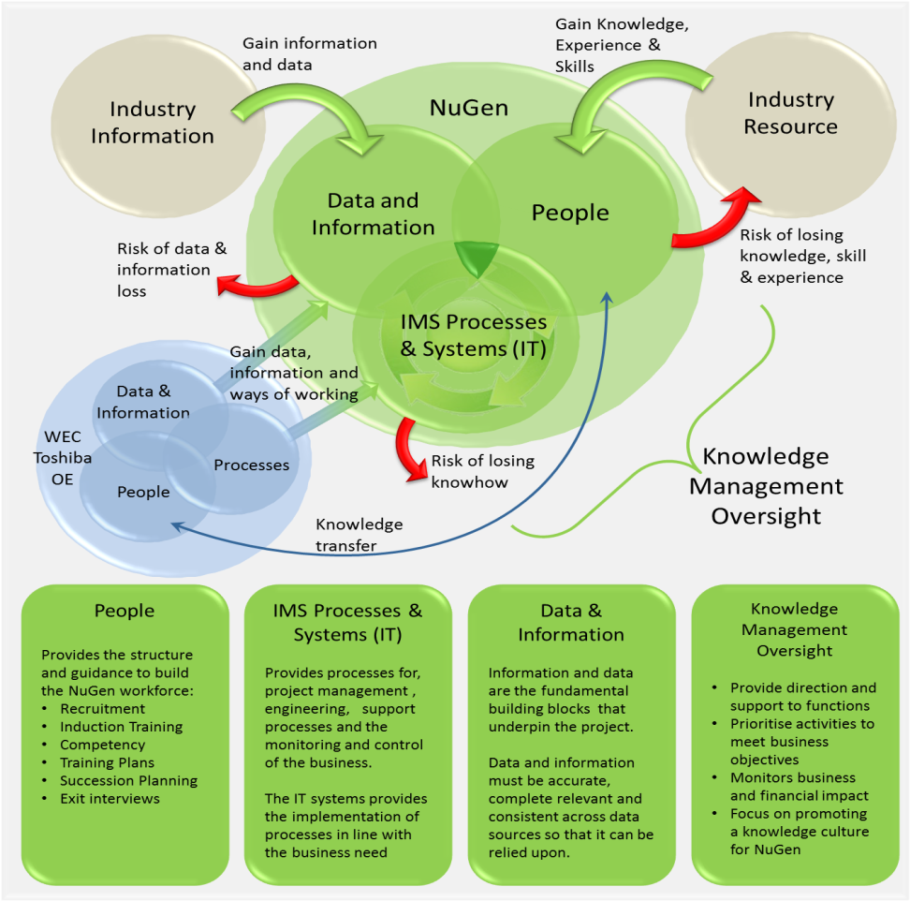
Figure 1 - NuGen Knowledge Management Model

Knowledge Management Processes
The objectives described have been used to inform a structured KM process set out in Figure 2.
With the urgent need for NuGen to develop the knowledge base the first two steps are a high priority and will be driven by process owners, function leads and workstream leads. Step one will identify the knowledge required for the project and where this can be obtained. Although it is initially difficult to ensure the requirements are comprehensive once the second step of knowledge acquisition commences these requirements can be refined. Benefits can be realised at step 3 and 4 while step 5 ensures the knowledge gained is not lost. As Figure 2 shows, each step leads to the next with the refinement process feeding back to the previous steps.
Search &
Communicate
Capture &
Learn
Apply &
Innovate
Store &
Maintain
Find &
Validate
Step 2 - Effective acquisition methods, engagement strategies, data and information transfer, training, secondments.
Step 1 - Prioritised knowledge identification driven by work-stream and data quality requirements
Step 3 - Where knowledge is used ensure it is relevant and any changes and learning are captured (design reviews, inspections)
Step 4 – Control of flow of information, make the knowledge available, easy to find and actively transfer it to others based on need to know.
Step 5 - Record knowledge in a robust form, control versions of documents & avoid duplicates. Manage organisation changes and ensure succession planning for key roles.
Identifying
Acquiring
Using
Developing
Transforming
Sharing
Disseminating
Preserving
Figure 2 - NuGen Knowledge Management Process

To remain aligned to business requirements the KM process will be set, reviewed and revised based on the programme for each function or workstream. As knowledge requirements change through the project lifecycle the balance of demands on People, Processes and Systems and Data will also change. The process also seeks to ensure that knowledge not immediately needed is retained and maintained for later use in the plant lifecycle.
The five process stages are applicable across the organisation however each function or workstream will need a tailored implementation. The implementation will require the combination and integration of IT systems, processes and people. Over the life of the plant the availability and capability of resources, tools and techniques will vary. Oversight arrangements (described in the next section) will monitor and steer the process implementation via the IMS.
Oversight and Governance
Under the direction of the NuGen Executive Management Team (EMT) Knowledge Management oversight will initially be provided by representatives from Training and Qualifications, Engineering and Design Authority. This initial team membership will ensure that the key NuGen stakeholders are clearly represented i.e. Design Authority has the responsibility for the integrity and understanding of the design and its safety basis at all stages of the project including knowledge transfer from vendors; Training and Qualifications are responsible for maintaining skills and ensuring SQEP resourcing; Engineering are responsible for the development and appropriate capture and use of design information through business processes and tools.
The rapid growth and development of NuGen as an organisation will necessitate constant review and realignment of the KM priorities to ensure they remain fit for purpose through the plant lifetime. At each major project stage the KM activities will need to adapt without losing valuable knowledge as the transition completes. As such the KM aims and objectives will need to be embedded in NuGen culture through appropriate means.
Inherent to the KM process is the requirement for a variety of business areas to take responsibility for a range of activities to ensure effective implementation. These areas include:-
- Executive Management Team (EMT) – ensuring the communication of a clear message that knowledge is a key NuGen asset and should be valued for both its immediate benefit and any future lifecycle needs.
- Knowledge Management Oversight Team - ensuring that NuGen’s KM activities are in line with business requirements and the benefits from Knowledge Management through cross functional support and the sharing of best practice are optimised.
- Talent Management - providing the necessary competency framework to support the Nuclear Baseline and to provide a business wide tool for line managers to manage the skills of their team.
- Workstream and Function Leads – facilitating identification of knowledge needs, developing local knowledge acquisition plans and co-ordinating acquisition and sharing using the best available methods.
- Programme Management Office (PMO) – facilitating, through its associated functions covering IMS and IT, the KM process and procedural elements along with the provision of technology through deployment of a broad range of appropriate information systems.
Summary
This paper has set out a conceptual knowledge model, a high level guiding process to develop and manage the critical knowledge assets, and accompanying oversight arrangement that will help monitor and steer the knowledge activities as NuGen’s Moorside project develops. Given its relative infancy, the Moorside project presents both a challenge and at the same time a significant opportunity for Knowledge Management to make a real contribution to the successful delivery of a safe and effective plant. The importance of proactive Knowledge Management embedded throughout the business is clearly understood and this is reflected in the decision to develop and drive a KM strategy from the outset.

References
[1] IAEA-TECDOC-1510 Knowledge Management for Nuclear Industry Operating Organizations, October 2006.
[2] Safety Assessment Principles for Nuclear Facilities, 2014 Edition, Revision 0.
[3] Radioactive Substances Regulation – Environmental Principles, Regulatory Guidance Series, No RSR 1, Revision 2, April 2010.

