# Establishment of Systematic Design Control/ Configuration Management Processes to Enhance Engineering Capability

Takeyuki Inagaki1, and Takehiro Hamada1

1 Tokyo Electric Power Holdings Company (TEPCO), Tokyo, Japan

E-mail contact of main author: inagaki.takeyuki@tepco.co.jp

**Abstract**

After the accident of Fukushima Dai-ichi Nuclear Power Plant in 2011, Tokyo Electric Power Company (TEPCO) launched various measures to enhance plant safety and safety culture of its employees. One of the important aspects of these measures is to enhance engineering capability and TEPCO is conducting actions to establish systematic design control/ configuration management processes as an important foundation of such engineering capability.

This paper describes how TEPCO is establishing systematic configuration management processes from three aspects, i.e. design requirement/ bases management, facility configuration control, and configuration change management. It also provides brief information of the IT systems that are being introduced and will support the systematic design control/ configuration management processes.

**1. Organizational Context**

TEPCO is the largest electric power company in Japan and owned 17 BWR units at three nuclear plants (NPPs), six at Fukushima Dai-ichi, four at Fukushima Dai-ni and seven at Kashiwazaki Kariwa, before the accident of Fukushima Dai-ichi. Since these units were constructed in rather short period, from 1971 to 1997, and plant manufacturers, mainly Toshiba and Hitachi, had very high engineering capabilities, TEPCO was highly dependent on the manufacturers in its engineering work. Important design bases, drawings and documents had been maintained by these manufacturers.

Through the Fukuhima Dai-ichi accident, however, TEPCO recognized deficiency in its engineering capability and launched measures to enhance the engineering capability of its employees. Enhancing system engineering, design engineering and authority functions were of high priority. Nuclear Power Asset Management Department was responsible for engineering work and initiated actions in 2013 to establish systematic design control/ configuration management processes as important foundation (infrastructure) for excellent engineering work.

Later, in September 2015, a serious non-conformity related to cable routing was revealed. The main control rooms (MCR) of Unit 3 and 4 of Fukushima Dai-ni and all Units of Kashiwazaki Kariwa have complex three dimensional cable route structure under their floor to separate safety cables from non-safety and from those of different safety divisions. (see Figure 1) These cables are divided by separation plates.

After the turn-over the units, many modifications, addition of new cables or route changes, have been performed. Many of them were for safety enhancement after the Fukushima Dai-ichi accident. During such modification work contractor workers put a new cable over the different safety divisions, fell down or bleach the separation plate. (see Figure 2) TEPCO engineers did not check the drawings or actual status of the cable. The first inappropriate case was found at Unit 6 of Kashiwazaki Kariwa in September 2015 and TEPCO conducted comprehensive investigations for cables of 11 Units at Fukushima Dai-ni and Kashiwazaki Kariwa, not only those under the MCR floor but also those on cable trays in the whole plants. Consequently, it was revealed that about 2000 cables were affected by those inappropriate modifications.

This problem (non-conformity) accelerated the abovementioned actions to establish the systematic design control/ configuration management process.

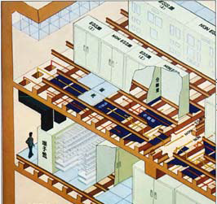　　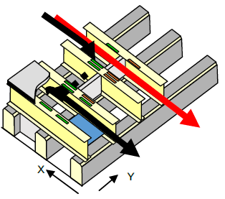

Division Labels

Division I

Division II

MCR

Floor

Vertical

Separation Plate

Horizontal

Separation Plate

Observed

Cable Route

Appropriate

Cable Route

Figure 1. Cable division structure under the floor of the MCR (Kashiwazaki Kariwa Unit 6)

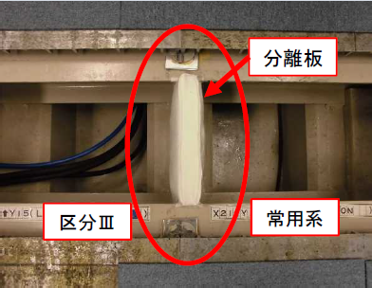 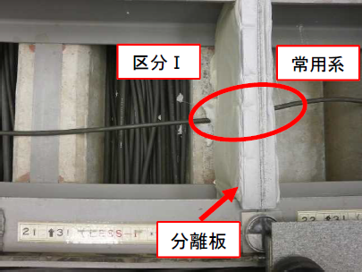

Division I

Division III

Non-safety

Non-safety

Separation Plate

Separation Plate

Appropriate Cable Lay-down Inappropriate Cable Lay-down

Figure 2. Examples of appropriate and inappropriate cable lay-downs

**2. Objectives of the action plans to establish systematic design control/ configuration management processes**

The objectives of the actions to establish systematic design control/ configuration management processes are:

* to establish and maintain in-house design authority function (to be responsible for all design and configuration changes by ourselves) and to solve over dependency on plant manufacturers,
* to ensure that plant systems, structures and components are installed, operated and maintained as designed,
* to support important plant safety programmes such as equipment qualification, ageing management, fire protection, and internal flood protection,
* to enhance engineering capability of nuclear division personnel and ultimately plant safety.

In addition, since the cable lay-down problems described in Section 1 can be regarded as a result of poor configuration management, higher priority has been put on the actions.

**3. Initiative of the action plans**

Through thorough study of relevant guidelines in the USA [1, 2] and benchmarking with utilities in the USA, e.g. Constellation Energy, TVA, Southern Company and Entergy , action plans for coming three years have been set up and approved by General Manager of Nuclear Asset Management Department and Chief Nuclear Officer (CNO). Expected status after three years and five years have been also created. Progress of the activities is periodically reported to the CNO.

Corporate functional are manager (CFAM) on design management became responsible for such establishment. Safety Enhancement Project Management Group in the department and site functional area managers (SFAMs) on design management in Kashiwazaki Kariwa and Fukushima Dai-ni NPPs are supporting the CFAM.

The action plans consist of the following three key elements:

1. Design requirements/ bases control,
2. Facility configuration information (FCI) control, and
3. Facility configuration change control.

Detailed activities of these three elements are described in the following sections.

**4. Detailed descriptions of the action plans, major challenges and current achievements**

(1) Design requirements/ bases control

To be fully responsible for design changes and component replacements from nuclear safety points of view, it is particularly important to systematically collect and manage important design requirements and their bases of safety related systems, structures and components (SSCs).

To accomplish this objective, TEPCO decided to basically follow the US practices started creating design criteria (bases) documents (DCD). The DCD is based on a system specification document and information on design bases and links to relevant information, e.g. relevant regulatory requirements, codes and standards, calculation documents, are incorporated.

Since a nuclear power plant consists of huge number of SSCs, it is impossible to create DCDs for all SSCs. It is definitely necessary to prioritize SSCs. Currently the highest priority is given on systems newly built along with nuclear safety enhancement projects and DCDs for those SSCs are being developed.

In addition, TEPCO is introducing a design requirement control system. Such a system is being used by car industry, airplane industry and nuclear power plant in some countries. It enables plant engineers to understand relations between important design requirements, their bases and actual design specifications. (See Figure 3)

Design Bases DCD (Design Requirements) Design Specifications

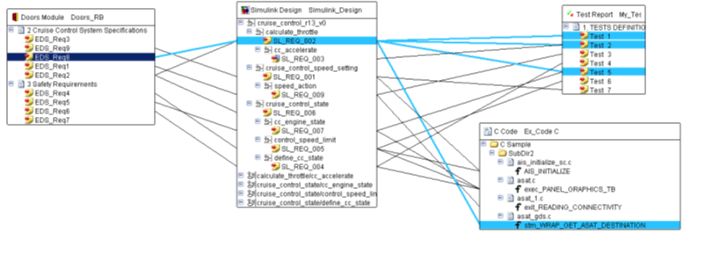Figure 3. Illustration of Design Requirement Control System

(2) FCI Control

When design change and/ or replacement of an SSC, all affected facility configuration information (documents) must be identified (impact analysis) and properly revised. To support such identification and control of revision, a design/ component document relation tree for each system is being prepared and will be installed in a new configuration management system. (see Figure 4)

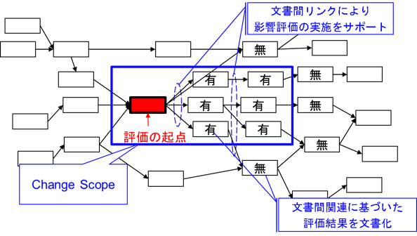

Documentation of the impact analysis result

Initial document to be revised

Support impact analysis using links between documents

Figure 4. Illustration of design/ component document relation tree and impact analysis

(3) Facility configuration change control

The main objective of the configuration management is to assure and maintain equilibrium among design requirements, facility configuration information and physical configuration (actual SSCs in the field). From this aspect, a process to recover the equilibrium after a change, e.g. design change or component replacement, has been occurred on an SSC and TEPCO is establishing an effective recovery process following the INPO Guidelines [1] and US practices. The configuration management support system is introduced to systematically perform the recovery process. (See Figure 5)

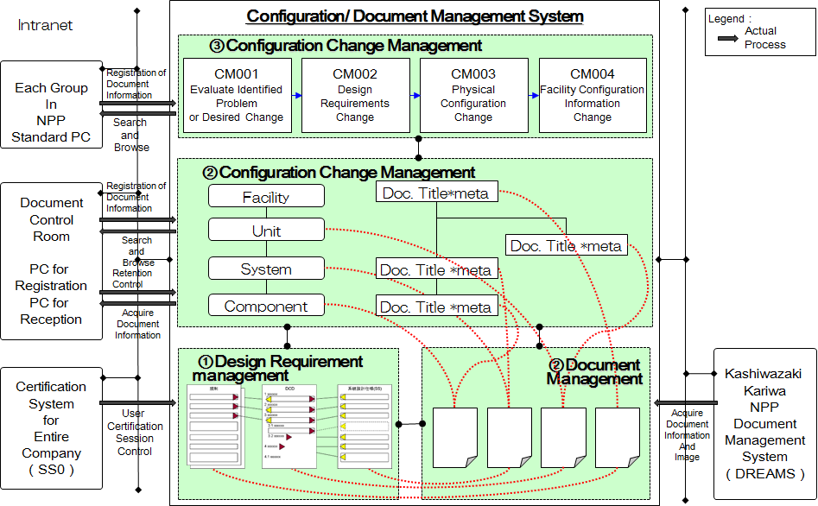

Figure 5. Configuration Management Support System

In the meantime, design specification data are being installed into a master equipment list in MAXIMO (Enterprise Asset Management System). The configuration management support system will have a link with MAXIMO.

**5. Other relevant activities**

Configuration management is one of necessary elements to establish in-house design authority function and to enhance engineering capability. Well established engineering organization and competent engineers are also crucial elements. In these regards, TEPCO nuclear power division is integrating engineering functional groups in the corporate and the plant to establish a new organization which is specifically dedicated to engineering. Education and training programmes for engineers are also being prepared following good practices in the USA.

**6. References**

References should be keyed to the text by numbers in squares brackets corresponding to the order in which they are first mentioned, and be collected in a single list at the end of the document.

1. Application of Configuration Management in Nuclear Power Plants, IAEA Safety Series No.65, International Atomic Energy Agency, Vienna 2010
2. Configuration Management Process Description, INPO AP-929 Revision 1, Institute of Nuclear Power Operations, Atlanta 2005.
3. Nuclear Facility Configuration Management Survival Guide Rev 3, Configuration Management Benchmarking Group (CMBG), 2013