Competence Map of Regulatory Body: Personal and Interpersonal Effectiveness Competences

Eduard Volkov

ROSATOM CICET, Obninsk, Russian Federation

E-mail contact of main author: Edvolkov@gmail.com

Abstract.
The paper presents implementation stages and outcomes of the project “Nuclear Facility Competences” fulfilled in JSC “Rosenergoatom” and outcomes of the project “Knowledge Management, Training and Staff Retention” fulfilled for Romania regulatory authority. The goal of the project was a development of competence profiles for nuclear power plant and corporate inspectorate key job positions. The paper is focused on personal and interpersonal effectiveness competencies for inspectorate job positions which are a part of well-known 4-Quadrant Competence Model. Each competence is described by one or two behavior scales. One can consider those competencies like common ones for organizations implementing inspection activity and could be used in human resource management processes like personnel selection, job assessment, career planning, training, mentoring.

- Introduction
Let’s consider work situation happened when the inspection round during maintenance period. The maintenance was implemented by contractor. One inspector of NPP inspector team who fulfills manufacturing supervision visited some work place of maintenance. However he did find no one contractor worker. The contractor personnel have left the work place because got an information that the inspector comes. On the work place one can see abandoned tools, blind flanges kept incorrectly, not covered apertures. The inspector having no “company” moved to the next working place and did not pay attention to this working place conditions. Another inspector in analogous situation has stopped in the working place left by contractor maintenance team. He has called for NPP operative personnel responsible for maintenance implementation in the place and has cleared that contractor workers have left the place and did not inform NPP operative personnel, broken occupational safety and health and maintenance work requirements. The contractor team has been found and inspector implemented his job. Obviously that second inspector is more successful and his activity was more efficient. Why? One could be said with great probability that personal traits of the inspector are more matured.
Regulatory body establishes regulations and controls its implementation. Following those regulations nuclear facilities reach business goals when unconditional providing of safety high level. Regulatory body activity efficiency is defined by personnel competences high level maturity and organizational processes (human resource management, knowledge management) managing a development and application of those competences.
There is well known 4-quadrant competence model for regulatory body (Figure 1) [1].

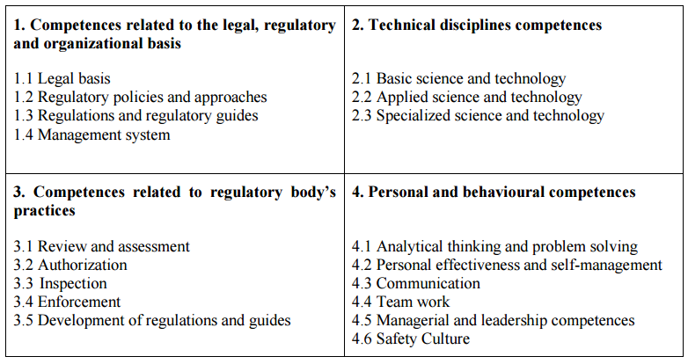
Figure 1. Quadrant model of competences for regulatory bodies

In my opinion, the “Personal and behavioural competences” quadrant is no less important than other ones. But it is studied no so deep like others. This fact has predetermined the project addressed to development personal competences for NPP key job positions including positions relevant to inspection activity.

- Project to develop personal and behavioural competence profile.
Methodologically the project was based on the practical guide to adapt competence models for work [2] and corresponding approaches in Russian Federation [3]. Duration of the project was 3 years. Around 2200 employee of 6 nuclear power plants were under investigation. Around 150 NPP key job positions were in the project focus.
In order to obtain information for analysis the following actions were fulfilled:
- interview (behaviour patterns) with NPP personnel – 1037,
- job analysis questionnaire -1513,
- focus-groups – 915,
- motivation questionnaire -734,
- job relevant documents analysis.
The project outcomes were:
- Personal and interpersonal competence dictionary consisted of 45 competences. Each competence is described in terms of work behavior (behavior scale)/
- Personal and interpersonal competence profiles.
- Dictionary of key performance indicators for NPP job positions and compartments.
- Motivation potential (number of motivators) for NPP job positions.
- Psychogram. Psychogram is a profile of psychological functions parameters. It reflects, for example, what characteristics of a worker cognitive processes are more enabled when job performance for the job position.
- Software to analyse job positions and develop competence profile.
Using any instrument for the assessment of individual characteristic and the whole work with personnel becomes meaningless, aimless without existence of the objective requirements to the staff member, presented by job contents, its nature, job conditions, parameters of acceptability.
So, this set of profiles plus professional (technical) competence profile should be considered as a unique language to manage human resources and work performance effectiveness.

- Example of inspector personal and interpersonal competence profile.
Let’s consider job position –inspector.
Below you can see text which is a part of competence job description.
3.1 Obligatory traits.
Thinking
Reproductive thinking (ability to work with logs, documents); abstract and logical thinking (ability to argue own point of view); rationality (ability to act advisedly); questioning attitude (capability to detect nonconformities and information inconsistency); analiticity (capability to analyze information).
Job relevant personal traits.
Interpersonal traits: communicativeness (skill for business conversation, capability to explain understandably, listen to other point of view); leadership and prescriptiveness; diplomacy (capacity to express an opinion frankly); skills for organization (capability to control work performance).
Self-management and personal effectiveness: accountability; self-reliance.
Motivation aspects: devotion to an organization, commitment for safety, interest in work, aspiration to high-quality work performance.
3.2 Inadmissible traits.
Cognitive style characteristics: propensity to take information as a fact without desire to structure and reorganize it; impulsivity (thoughtless decision making).
Self-management and personal effectiveness: inclination to risk.
3.3 Competence profile.
The profile contains 18 personal and behavior competences (Figure 2). The competences could have one, two or three behavior scales A, B, C. The scale level displays the competence maturity.
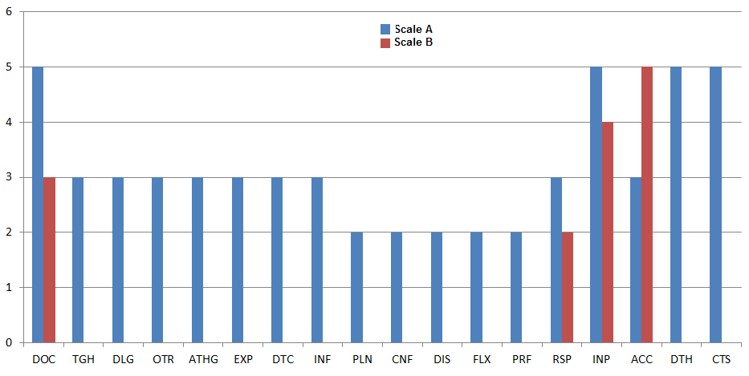
Figure2 Competence profile for “Inspector” job position.

For example, Table 1 shows description of “Work with documentation” competence level.

Table 1. “Work with documentation” competence level.
Code | Competence title | Scale Level description
DOC | Work with documentation | А.5. Be able run over and compare documentation with necessary speed.  B.3.Clearly, correctly and briefly writes own thoughts on paper, develop document by oneself.

3.4 Dictionary of used traits
Below one can see a list of the profile competences (Table 2)

Table 2. “Inspector” profile competences.
№ | Code | Competence title | Brief competence definition
 | DOC | Work with documentation | Skill to view, subscribe, compare with, search and use necessary documentation in fast and thoroughness manner. Awareness and understanding of documents logic. Ability to prepare arrangements, clear and correctly express own thoughts.
 | TGH | Thoroughness | Scrupulousness, punctuality, aspiration for completeness displaying, attention on nitty-gritty details.
 | DLG | Diligence | Стремление работника осознанно выполнять требования руководства, инструкций, распоряжений, разработанных и утвержденных программ (программы ведения оперативных переговоров, "трехкратной коммуникативности" и др.), правил (правила сохранения конфиденциальной информации и др.), регламентов и графиков (графика ремонта и др.).
 | OTR | Attitude to achievement | Aspiration for high quality of job performance, for high level of competence, desired social status.
 | ATHG | Analytical thinking | Ability to decompose facts, phenomena on parts, to understand structure, to single out the main.
 | EXP | Expert knowledge | Perfect possession of extensive knowledge volume and/or deepness, devoting to professional activity, presence of motivation to use it. Interest to different disciplines, breadth of specialization.
 | DTC | Devotion to the organization | Ability and readiness to behave in accordance with organizational values and goals.
 | INF | Influence and Impact | Aspiration to influence, convince people in order to reach an organization/ division/section/team goal. Ability to motivate, to find effective managerial style.
 | PLN | Planning and organization | Planning and active, energetic fulfillment of own suggestions, but not only a reflection. Skill to plan taking in attention possible obstacles, to try to fulfill them in time. Ability to use work time effectively.
 | CNF | Conflict management | Skills to manage conflicts in teams.
 | DIS | Self-discipline | Internal precision and orderliness. Concentration on work performance.
 | FLX | Flexibility | Ability to adapt and work efficiently in various/new situations. Capability to work with people having opposite point of view.
 | PRF | Professional preferences | Having enjoy and delight from a work performance and results. Interest in various aspects of work. Anxiety because inauspicious events.
 | RSP | Responsibility | Highly developed sense of duty and respect to own work responsibilities.
 | INP | Interpersonal interaction | Honesty, consistency, display of responsibility in interactions with people, efficient carrying out one's obligations.
 | ACC | Accuracy and order | Aspiration for order and systematization. Aspiration to put object environment to certain standard.
 | DTH | Development of others | Aspiration to teach or develop one or few people, motivate for learning.
 | CTS | Commitment to safety | Aspiration for job performance professionally and with adherence to safety requirements.

References
- INTERNATIONAL ATOMIC ENERGY AGENCY, Methodology for the Systematic Assessment of the Regulatory Competence Needs (SARCoN) for Regulatory Bodies of Nuclear Installations, TECDOC-1757, IAEA, Vienna (2015).
- SPENCER L.M., SPENCER S.M., Competence at work: Models for Superior Performance. John Wiley & Sons, Inc.
- ABRAMOVA, V., Organizational psychology, organizational culture and safety culture in nuclear industry, Obninsk, SRC “Prognoz”, Volumes 1 (2009), 2 (2011).

