Knowledge Management Tools Application in Regulatory Body Activity

Eduard Volkov

ROSATOM CICE&T, Obninsk, Russian Federation

E-mail contact of main author: Edvolkov@gmail.com

Abstract
The paper presents knowledge management tools application in regulatory authority activity. Knowledge management tools are considered as a mean to improve regulator activities efficiency.
Three case studies are considered:
- knowledge management audit procedure in the regulator (tools for knowledge management audit application, results and the audit outcomes);
- development the guide to identify causes of discrepancies and shortcomings revealed during inspections in NPP maintenance (ontologies of factors influencing on a maintenance quality and causes of discrepancies and shortcoming development);
- development knowledge portal for regulator (regulator needs which could be covered by the portal, definition and basic function of the portal, it’s functioning principles, development goals and tasks, common model, development stages).

- Introduction.
In general a role of regulatory body could be described in that way: it defines the parameters of reality and impacts organizations be more close to the reality.
The reality in nuclear industry – diversity of nuclear facilities, regulatory body, infrastructure organizations, their activities and communications, ways of nuclear energy use in the existing system of national and geopolitical relations.
One can say that there is a strong direct link between organizational culture for safety and proximity to the reality.
In order to describe (fix) the reality it is necessary to have a knowledge about physical processes, various ways of nuclear energy use, nuclear safety and security providing, equipment engineering and so on, subject to certain traits of all nuclear facility life circle stages. Moreover, it is important to have a knowledge about human being in frames of complex social technical systems, how personnel reliability could be provided, what characteristics must have organizational culture for safety and how manage them. So, in order to be effective regulatory body should have quite wide list of competences.
The reality description parameters are no other than regulators of activity performance in some professional domain, for example, generation of electricity or nuclear waste transportation. Phenomenology of those regulators is very color because too much ways to use nuclear energy. Looking at a regulatory body knowledge map we would see composition of knowledge maps of many organizations: training, project, construction, operation.
Staying on brink of the knowledge map, we can see its endlessness. However, resources the regulatory body has are not endless. Also we there are many challenges of modern times: transient workforce, information technologies progress, attitude to consider knowledge as a source of competitive advantage, retirement wave and so on.
How to resolve the contradiction? How to provide activity effectiveness on practically infinite functional field when so restricted resources and new challenges?
Implementation of knowledge management system or its elements could assist regulatory body to resolve the contradictions and efficiently answer those challenges.
Below I would like to consider few cases how to apply knowledge management system elements in frames of regulatory body activity. Knowledge audit could help an organization to reveal needs in knowledge management, ontologies - to structure information and knowledge, expert system – to formalize knowledge, informational portal – to store and share knowledge.

- Knowledge audit.
Knowledge audit is an assessment of current status of explicit and tacit knowledge resources, knowledge management relevant processes in order to find problem areas and find measures how improve it.
Project experience in knowledge management system implementation allows to define an algorithm of the knowledge audit procedure and tools.
The first stage of the audit – preparation. Auditor team identifies the organization type, architecture, knowledge types, attitude of managers, assesses organizational culture, formulates the audit goals, develops the audit implementation plan, comes to agreement with senior manager, prepares tools for data processing, develops organization personnel motivation strategy.
When IAEA supported Romanian regulatory body in development of knowledge management and capacity building frameworks to secure long-term availability of regulatory competency experts have conducted surveys of culture and staff motivation. Main objective of the approach was to obtain information about group social psychological climate, satisfaction level of motivation factors in order to estimate current regulatory body atmosphere in terms of organizational changes of knowledge management.
Following questionnaires were distributed amongst regulatory body staff:
A. Staff Motivation Potential Questionnaire. The objective of the questionnaire is to explore the job satisfaction and motivation of staff in order to identify potential factors that would both facilitate and potentially hinder the establishment of Knowledge Management System processes and also to identify what factors were perceived by organization staff as being important in achieving job satisfaction. The questionnaire includes questions on specific factors related to job satisfaction such as work responsibility, working conditions and environment, relations with team and direct manager, job interests and training. Respondents were asked to choose 5 factors out of 16 that were significant for them and rank them from 1 (most significant) to 5 (less significant). Respondents were then requested to indicate whethere such factors have improved or deteriorated in the last year.
B. Team Psychological Climate Questionnaire. A questionnaire usually is used for estimation of the team psychological climate. The psychological climate examines at an emotional level the team relations, psychological type of interactions, character of work collaboration, relationship/view to significant events of work, prevalent tone of social mood in the team connecting with work conditions satisfaction, management style and so on.
Also document analysis was implemented with a goal to find documented processes connected with knowledge management. The documents reviewed included the process and policy for implementing and evaluating training at regulatory body, annual reports, the risk assessment process, the Quality Management System and the norms related to specific aspects regulatory body activity.
Second stage – direct implementation of the audit. On the stage auditors identify available knowledge resources and organizational needs, inventory organizational knowledge, its quality and accessibility, group explicit and tacit knowledge, analyze knowledge flows (people-processes, technologies), audit employees knowledge, work with tacit knowledge.
Those following could be recommended to apply for information obtaining on the stage:
- knowledge management maturity assessment using the IAEA tool (NKM maturity questionnaire);
- interviews with managers and assessment of the results;
- focus group meetings.
When final stage auditor team develops or renew organization knowledge map, competence map, social nets, develops audit report which includes corrective action plan and recommendation to develop an organization strategy in knowledge management.

- Ontology use.
Obviously all kind of activity would be more efficient if it based on exact knowledge of the professional domain specification. For example, specification of one of regulation objects – personnel licensing procedure. The specification could be represented by ontology. Ontology is a knowledge description system in a format compatible with many representative languages [1]. Assembly of the ontologies describing all regulatory body domains is a useful tool to develop the organization information field.
In case of another regulation object – root cause analysis procedure, it is needed for regulatory body to have ontology of human errors, causes of event and so on. For example, CICET has developed ontology of factors (based on Human-Technology-Organization approach) influencing on human performance (Figure 1).
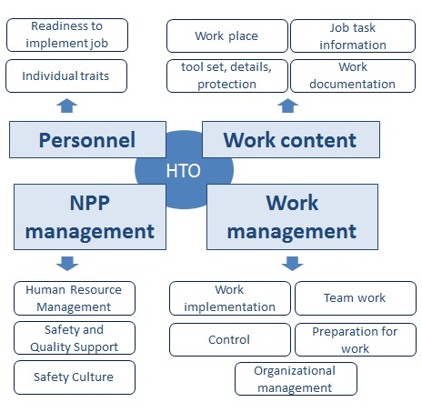
Figure 1. Ontology of factors influencing on human performance (group level of classification).
One can see on the Figure 2 only group level of those factors classification. Total amount of factors distributed in the groups is around 50.
The model is applied now to implement inspection activity and could be used in training materials development, root cause analysis, risk management and safety culture models building.

- Expert systems.
Expert system is a complex software which accumulates knowledge of a concrete professional domain specialists and replicates the experience to consult less qualified users. Let’s consider basic functions of the expert system “Inspection: documentation” with “input-output interface” (Figure 2).

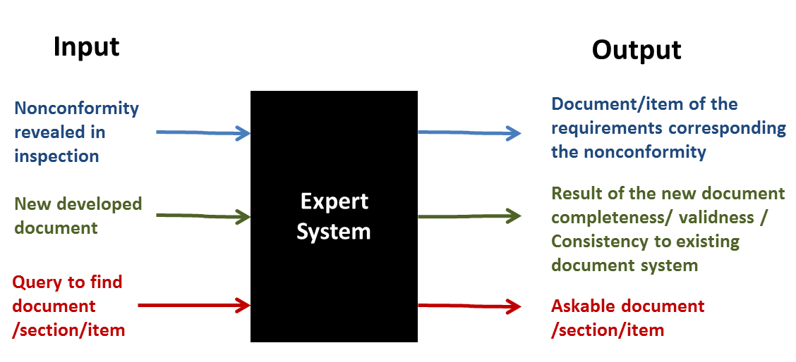
Figure 2. Main functions of the expert system “Inspection: documents”

Use of the expert system decrease, for instance, inspection reports developing time in 2-3 times.

- Information portal
Nowadays informational portal is universal decision providing access to knowledge in frame of knowledge management in the organization. Being a system uniting all existing organizational information resources the portal can fix those typical needs in the regulatory body:
- knowledge management not formalized, not planned;
- do not cover all areas of activity;
- key document translation from foreign languages;
- absence of data base for training courses;
- mentoring of young employees, no special courses for young specialists, not formalized;
- web-site is not periodically updated;
- some procedures are not applied by all employees;
- professional knowledge is stored (CD, papers) in different compartments;
- absence of library;
- no access to professional programs (e.g. list of radionuclides for dosimetry);
- no access to different databases;
- no procedure for dissemination of information from workshops, seminars, conferences etc.;
- low sharing of information;

Portal functioning principles:
- Development and use single ontology for the portal management and the information integration and indexation.
- Portal must be a daily activity tool for compartments and staff.
- Portal must satisfy basic informational needs of all users. It is developed in correspond with the needs change.
- Portal must have “on input” simple means to manipulate information, and “on output” – assembly of thematically grouped informational resources and services which oriented towards user needs.
- On the individual level portal has a system of closed informational circulation. To realize it the portal must:
    - provide user with personal access point to the organization information space,
    - have a mechanism to guarantee user being kept informed.
- Portal information streams system should support hierarchical scheme of distributed accountability. Common principle of the scheme – responsible person (info manager) controls content of information created in his compartment.
- Information structuring should be based on common industrial\official classifiers and allow logical linking related materials.
- The unification different information resources and streams within Portal will allow to realize more efficiently presentation tasks of the Portal. To realize it the Portal should:
    - Provide possibility multiple and multi-aspect use of stored informational materials for creation thematic sites and resources;
    - Have mechanism to create and support those sites for each user category.

References
- GAVRILOVA T., LAIRD D., Practical design of business enterprise ontologies. In: Bramer M., Terzyan V., Industrial Applications of Semantic Web. Springer Verlag; 61-68 (2005). Competence at work: Models for Superior Performance. John Wiley & Sons, Inc.

