Plant Engineering and Construction System with Knowledge Management

- A case study in NPP construction in Hitachi-GE NE -

M. Hamamoto, N. Nakamitsu and T. Mochida

Hitachi-GE Nuclear Energy, Ltd. (HGNE), Hitachi, Japan

E-mail contact of main author: takaaki.mochida.qx@hitachi.com

Abstract
Hitachi-GE Nuclear Energy, Ltd. (HGNE) has more than 40 years BWR plants construction experience. The company continues to develop plant engineering system and plant construction systems based on the experience and the lessons learned. Currently, these systems are integrated in a variety of knowledge bases using the latest information technology (IT). Their performance is continuously validated in the recent NPP constructions. Typical examples are shown as case studies for knowledge management. These plant engineering and construction management systems are essential to achieve the on-time and on-budget-goals in NPP construction projects.

1. Introduction – BWR Construction Experience
Over 40 years, Hitachi has constructed 20 NPP’s in Japan. The current primary product line is the Advanced Boiling Water Reactor (ABWR). Currently, four ABWRs are in operation and five units are under construction in Japan and overseas, and some more units are in the planning stage overseas, such as in the UK. This fleet construction effort is supported by the integrated experience and knowledge management based on IT in order to achieve efficient and reliable performance. 3D modeling is a key feature and “installation as pre-planned” is of the essence in high quality and on schedule construction with well organized layout design.
Some examples of advanced construction with integrated knowledge are shown in this paper as a case study.

2. Advanced Plant Integrated CAE System
Starting from manual drawing in 1970s and plastic model in 1980s, Plant Engineering is using the 3D CAD system since 1985 to improve design speed and enhance design change flexibility. This enables us to implement three construction projects almost simultaneously, confirming the benefits of the 3D-CAD engineering method. In the 1990s, the system was upgraded to cover the work from basic design to construction and maintenance using a plant engineering database and it became the “Plant Integrated CAE (Computer-Aided Engineering) System”
The design stage of nuclear power plant requires overall coordination of a broad range of engineering tasks, including conceptual design, layout design, equipment carry in/out plan, shielding plan, as well as the plant construction, operation & maintenance, and reactor decommissioning plans.
Schedule management, workforce management and QA/QC management are also important during each task phase in order to perform these tasks efficiently. Since 2005 Hitachi has further developed the "Advanced Plant Integrated CAE System" to ensure high-quality and efficient works.
This system is based not only on the plant engineering database, but also on the accumulated Engineering, Procurement & Construction (EPC) experiences and management know-how of the previous projects. Also, it is enhanced day by day through the actual projects, becoming our core in-house engineering system.
Figure 1 illustrates the outline of the Advanced Plant Integrated CAE System.
The system has several functions.
Site View Simulation helps plot plan development at the conceptual & basic design stage, giving us visualization with computer graphics technologies, supporting plot plan development in harmony with the environment, and also facilitating presentation to the customers and residents around the site.
Layout design function helps us piping the design using standard parts library and automatic parts generation. This function supports design criteria definition based on accumulated know-hows, as well as design criteria conformity checking. This also helps us in module design, providing standardized reference modules from previous projects, module engineering support as well as module effect evaluation where the effectiveness of module is evaluated in terms of its transportation and manufacturing cost and work efficiency, etc., and the best module selection is provided.
Structural analysis function helps with the structural analysis of piping, using automatic analysis data generation, including geometrical data and design conditions. It ensures conformity to JSME/ASME design codes, and supports the licensing report preparation.
Walk through simulation function provides us the final layout review in terms of constructability, operability, maintainability and total layout esthetics, as well as a disassembly plan of equipment and valves, and the customer design review.

3. Integrated Construction System
Effective use of knowledge and experience in the plant construction stage is another key in the success of the construction project. To achieve an on-schedule construction, we have four strategies: First is a reduction of on-site work, and module construction is one of the most effective methods to achieve this. We applied more than 200 modules in the latest ABWR construction, and it also contributed to shorten the construction period. Second strategy is a leveling of on-site work, which consists of an open-top and parallel construction in collaboration with the civil engineering team. The third is an improvement of on-site work efficiency with front loaded constructing engineering. And the forth is an improvement of support work efficiency. In order to realize these four strategies, we developed the “Plant Integrated Construction System”. Some functions of this system are presented in the following. [1]

3.1 Master/Sub-master Schedule Simulation
The first function of the system is master/sub-master schedule simulation. We combine our 3D model data with the construction time schedule to prepare a kind of 4D simulation with movie visualization. Figure 2 illustrates a typical example of this simulation. This function is used for the validation study and schedule adjustment of parallel construction of civil engineering works and mechanical & electrical works as well as for confirmation of delivery date and presentation to the customers and residents around the site.

3.2 Detailed Schedule Simulation
Visualization of the detailed schedule for each area of the buildings is provided. The schedule of carry-in and installation of each component and the process can be shown in this simulation. The purpose of this schedule simulation is to improve construction planning work efficiencies applying a layout-based schedule, and to support worker’s clear understanding of construction schedule with visualization.

3.3 Work Instruction System
In the construction of Nuclear Power Plant, more than 100,000 work instructions and work records are necessary and the Work Instruction System provides visualized instructions along with preplanned procedures and work progress. Also, electronic work flow and instruction record approval can be made available.

3.4 Construction Work Support System
The Construction Work Support System is a job site mobile system with i-Pad/mobile terminals. This system can provide easy access to the layout 3D data, drawing, documents and work instructions, etc., from the job site. Another support system is an application of RFID (Radio Frequency IDentification). A Product ID label with RFID is attached on the products (piping cap with pipe) at the factory shop, and then sent to the construction site. Workers in charge of warehouse management can read the information with PDA (Personal Digital Assistant device). RFID was used in the current plant construction project and it shows great improvements in shipping management, material receiving management, site warehouse management and a real-time work progress management. [2]

3.5 Electronic Installation Manual
We developed Electronical Installation Manuals both in animation version and actual installation movie version. The animation version of the Electronical Installation Manual supports the clear understanding of the installation work process. The movie version improves the quality of work, as well as the safety, and is also helpful for pre-work training, especially in the international projects. In addition, we are taking movies of our construction work in the current and the past construction projects, and preparing Electronic Installation Manual for the future construction work. The purpose of this real movie manual is to support the workers’ clear understanding of the realities of construction, which are difficult to find with animation movies. We believe that these movie manuals will be powerful tools especially in international projects, where most workers may not well be experienced in nuclear construction.

3.6 Preventive Maintenance & Service application
In addition to the construction phase of the plant, the system also has a capability to assist preventive maintenance work and services during the operation phase of the plant. One example is a carry-out simulation of equipment in the replacement work. Some large and heavy component can be replaced during plant life and this requires well-prepared planning before real site work. The simulation will provide an advanced checking for carry-out route, process, necessary devices and interferences between replacing equipment and the buildings or other devices before starting replacement works. This contributes to minimizing outage period.
Another example of application of the system is radiation dose distribution visualization. Based on the operation data, measurement, and dose calculation, the dose distribution is displayed on the 3D model with a colored illustration. Through this illustration, maintenance workers recognize high dose area and this contributes to reducing occupational dose of workers as low as practical.

3.7 Plant Dismantling & Decommissioning (D&D)
The system and data can be applicable to the planning of Dismantling and Decommissioning of the plant in the future. 3D-CAD data are created based on the as-build maintenance and operation data, which have been stored in the knowledge database. Especially, in the preliminary activities of D&D, detailed estimate of radiological and physical inventory as well as characterization is essential. Succeeding D&D work strategy, plans and procedures can be created through this system and knowledge database.

4. Conclusion
The continuous feedback of the experience and lessons learned in the past construction projects into the next project is a key for on-time and on-budget delivery of the plant. Good management and integration of past experiences and lessons learned is knowledge and it becomes effectively transferable to the next project with help of IT. In the field of the nuclear plant construction, where the project period is long and the budget is large, construction experience and lessons learned are integrated successively in the plant CAE system and the construction management system with use of the latest IT in order to achieve a better performance of the construction project.

5. References
- TATEHORA, K, et al., Enhancement and Future Development of Hitachi Integrated Construction Coordination System Integrated Specifically for On-site Field Work, Hitachi Review Vol.62 (2013), No.1.
- KAWASAKI, T, et al., Application and Benefits of Ethnographic Research, Hitachi Review Vol.62 (2013), No.6.

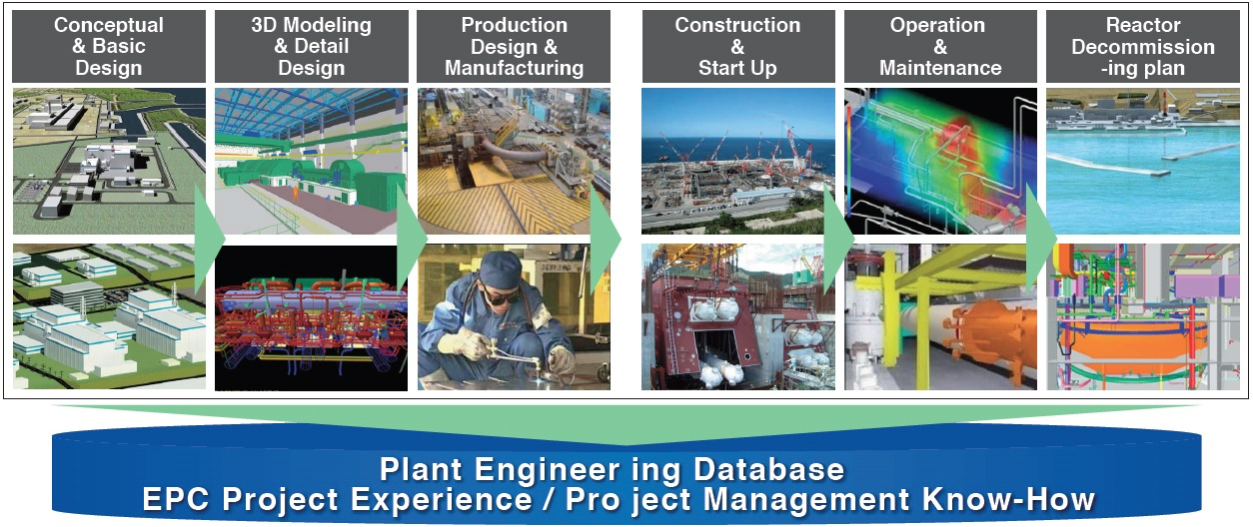

Figure 1. Advanced Plant Integrated CAE System

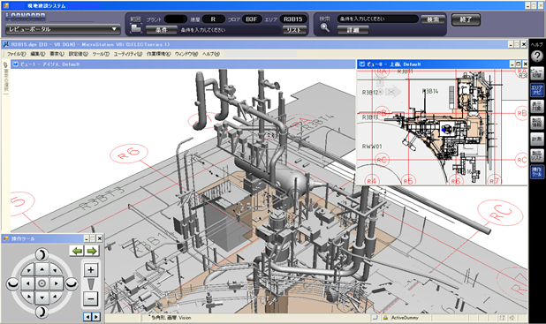

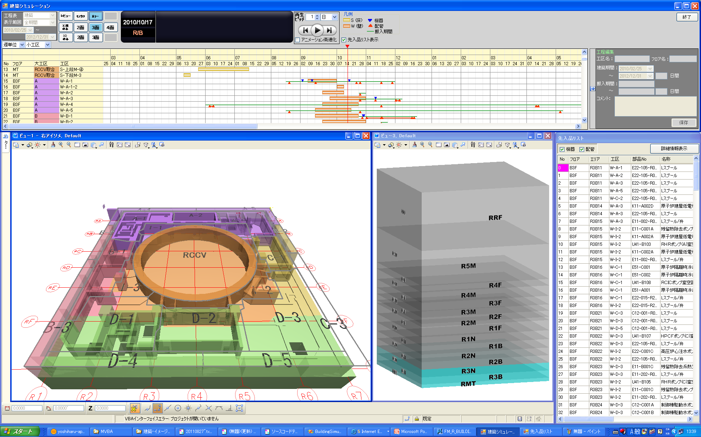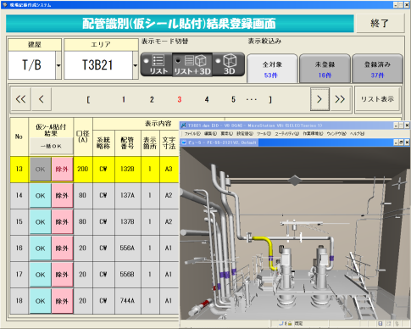

Figure 2. 4D Visual Construction System

