Integrated Management System, Configuration and Document Control for Research Reactors

B.J. Steynberg¹, J.F. du Bruyn¹

¹The South African Nuclear Energy Corporation (Necsa), Pelindaba, South Africa

E-mail contact of main author: benji.steynberg@necsa.co.za

Abstract
An integrated management system is a single management framework establishing all the processes necessary for the organisation to address all its goals and objectives. Very often only quality, environment and health & safety goals are included when referred to an integrated management system. However, within the research reactor environment such system should include goals pertinent to economic, environmental, health, operational, quality, safeguards, safety, security, and social considerations. One of the important objectives of an integrated management is to create the environment for a healthy safety culture.

Configuration management is a disciplined process that involves both management and technical direction to establish and document the design requirements and the physical configuration of the research reactor and to ensure that they remain consistent with each other and the documentation. Configuration is the combination of the physical, functional, and operational characteristics of the structures, systems, and components (SSCs) or parts of the research reactor, operation, or activity.

The basic objectives and general principles of configuration management are the same for all research reactors. The objectives of configuration management are to:
- Establish consistency among design requirements, physical configuration, and documentation (including analyses, drawings, and procedures) for the research reactor;
- Maintain this consistency throughout the life of the research reactor, particularly as changes are being made; and
- Retain confidence in the safety of the research reactor.

The key elements needed to manage the configuration of research reactors are design requirements, work control, change control, document control, and configuration management assessments.

The objective of document control is to ensure that only the most recently approved versions of documents are used in the process of operating, maintaining, and modifying the research reactor. Document control helps ensure that:
- Important facility documents are properly stored;
- Revisions to documents are controlled, tracked, and completed in a timely manner;
- Revised documents are formally distributed to designated users; and
- Information concerning pending revisions is made available.

Configuration and document management within an integrated management system are essential requirements for the safe operation, utilisation and modification of any research reactor.

Key Words: Integrated Management System; Configuration Management; Document Control; Research Reactor.

Introduction
This paper addresses the main elements and benefits of an integrated management system (IMS), and relates the IMS to configuration management and to document control within the research reactor environment.

Integrated Management System
Integrated means combined; putting all the internal management practices into one system but not as separate components. For these systems to be an integral part of the organisation's management system there have to be linkages so that the boundaries between processes are seamless. An integrated management system (IMS) is a management system which integrates all components of an organisation into one coherent system so as to enable the achievement of its purpose and mission. The IMS should provide a strong basis for business that supports the strategic direction of the organisation also to identify the risks and opportunities associated with the processes.The challenge is to integrate the different tiers of a single organisation into a facility specific integrated management system especially where the scope of work is multi-faceted and diverse.

An IMS provides a single management framework containing all the necessary processes for the organisation in an integrated manner so as to enable the organisation to attain its goals and objectives. It is important to include all goals and objectives, and to address their interaction and interdependencies in such an integrated manner that resources are optimally utilised to achieve them. These goals and objectives should address the following areas in the research reactor environment:
- economic,
- environmental,
- health,
- operational,
- quality,
- supplier management,
- information management,
- equipment management,
- safeguards,
- safety,
- security,
- resources, and
- social considerations.

The processes in an IMS should include organisational models, concepts and tools also covering human factor issues [1]. The interdependencies of the goals and objectives of the organisation, as well as that of the various processes and elements of the IMS must be recognised and aligned in the IMS. This is an important function of the IMS and assist greatly in a holistic approach to the achievement of goals and objectives.

The IMS should take cognisance of technology and technological development, and where possible and value adding, use technology to assist in the integration and use of the IMS. A user friendly face to the IMS will assist greatly in the acceptance and use of the system and as such assist in the achievement of the goals and objectives of the organisation. An electronic documentation system is one example of the use of technology in an IMS.

Since research reactors functions in an ever-changing environment, the IMS should have a robust and flexible design to take cognisance of these changes without having to change the IMS with every change in the environment. The IMS will then add value in providing continuity during these times of changes. The IMS has to meet a multitude of requirements relating to corporate policies, strategic planning, quality, conventional and radiological safety, regulatory specifications, security, commercial, resources and financial goals etc., which need to be incorporated into an overall IMS. The control of these various disciplines within the research reactor become quite complex if the procedures are to be coordinated, maintained and at the same time managed so as to achieve suitable levels of informed and trained staff in the ever-changing environment, which will ultimately ensure appropriate implementation. This becomes particularly relevant where the responsibility of implementation lies within various organisational units.

Main Elements of an Integrated Management System
The IMS must be designed to be fit for purpose and be flexible for the organisation it serves. However, the following main elements of an IMS must be contained in in one way or another in the IMS:
- Policy
- Planning
- Management responsibility and authority
- Implementation and operation
- Compliance management
- Resource management
- Process implementation
- Change control
- Performance assessment
- Continuous improvement
- Documented information
- Management review
- Transition to an IMS

Graded Approach to the Integrated Management System
Like with the implementation of various other systems, a graded approach must also be used when the IMS is designed for the organisation. This graded approach should consider the extent to which the various requirements and elements are applicable to the organisation’s IMS, and also provide guidance on the implementation logic and priorities. The graded approach should also provide for the opportunity to expand the IMS at a later stage to include more elements or address elements in more detail if so required. The following items should be considered during the graded approach:
- The extent to which integration should occur
- The political and cultural situation within the organisation
- The levels of competence necessary
- Legal and other regulatory requirements
- Organisational identified risks and opportunities
- Clear objectives for the integration project.

Internal factors
External factors
Initial and periodic
status review
Policy
Audit
Organising
Planning and implementing
Measuring performance
Flow of Information
FLOW OF CONTROL

LEGEND:

Figure 1: System Flowchart of a Generic IMS

Benefits of an Integrated Management System
Among the main benefits of an IMS are the following:
- Reducing unnecessary duplication
- Reducing paperwork
- Reducing administrative costs
- Providing a user friendly interface to the management systems
- Identify risks and reduce risks to increase utilisation and profitability
- Identify conflicting objectives and assist in balancing these conflicts
- Identify conflicting responsibilities and relationships and assist in eliminating these conflicts
- Clearly stated responsibilities and authorities
- Turn the focus onto business goals and objectives
- Gain a structured balance of authority/power
- Create a formalisation of informal systems
- Harmonise and optimise practices and thus creating consistency
- Improve internal and external communication
- Facilitate training and development of staff
- Enabling environment for a health safety culture

Safety Culture
One of the main benefits of an IMS is to create an enabling environment for a health safety culture. Since a healthy safety culture is of paramount importance for any nuclear organisation, including research reactors, this benefit is highlighted and elaborated on separately.

The IMS should provide structure and direction to the organisation in a way that permits and promotes the development of a healthy safety culture together with the achievement of high levels of safety performance. The IMS should direct the establishment of a working environment in which staff can raise safety issues without fear of harassment, intimidation, retaliation or discrimination [2].

The IMS enables a healthy safety culture by:
- The high priority given to safety is shown in documentation, communications and decision making, illustrating leadership’s clear commitment to safety.
- Safety is a primary consideration in the allocation of resources (“If we can’t do it safely, we won’t do it at all”).
- The strategic importance of safety is reflected in all the business planning processes and outcomes.
- Individuals are convinced that the safe operation of the research reactor is the top priority and nothing is more important.
- A proactive and long term approach to safety issues is shown in decision making so as to ensure sustainability of the organisation and of the research reactor.
- Safety conscious behaviour is not only socially accepted and supported (both formally and informally), but it is actively encouraged as the desired behaviour.

PDCA Cycle – Framework for Continual Improvement
The traditional Deming philosophy of Plan-Do-Check-Act (PDCA) should be followed in the IMS processes to improve achievement of goals [3]. The elements of this philosophy are:
- PLAN - Establish the objectives and processes necessary to deliver results
- DO - Implement the processes.
- CHECK - Monitor and evaluate the processes and results against objectives and specifications and report the outcome.
- ACT - Apply actions to the outcome for necessary improvement. This means reviewing all steps (Plan, Do, Check, Act) and modifying the process to improve it before its next implementation

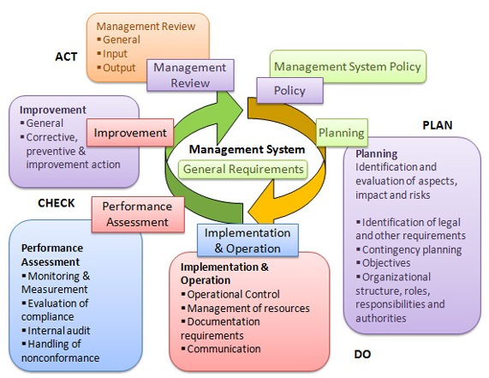
Figure 2: The Plan-Do-Check-Act Cycle

Example of an IMS Model
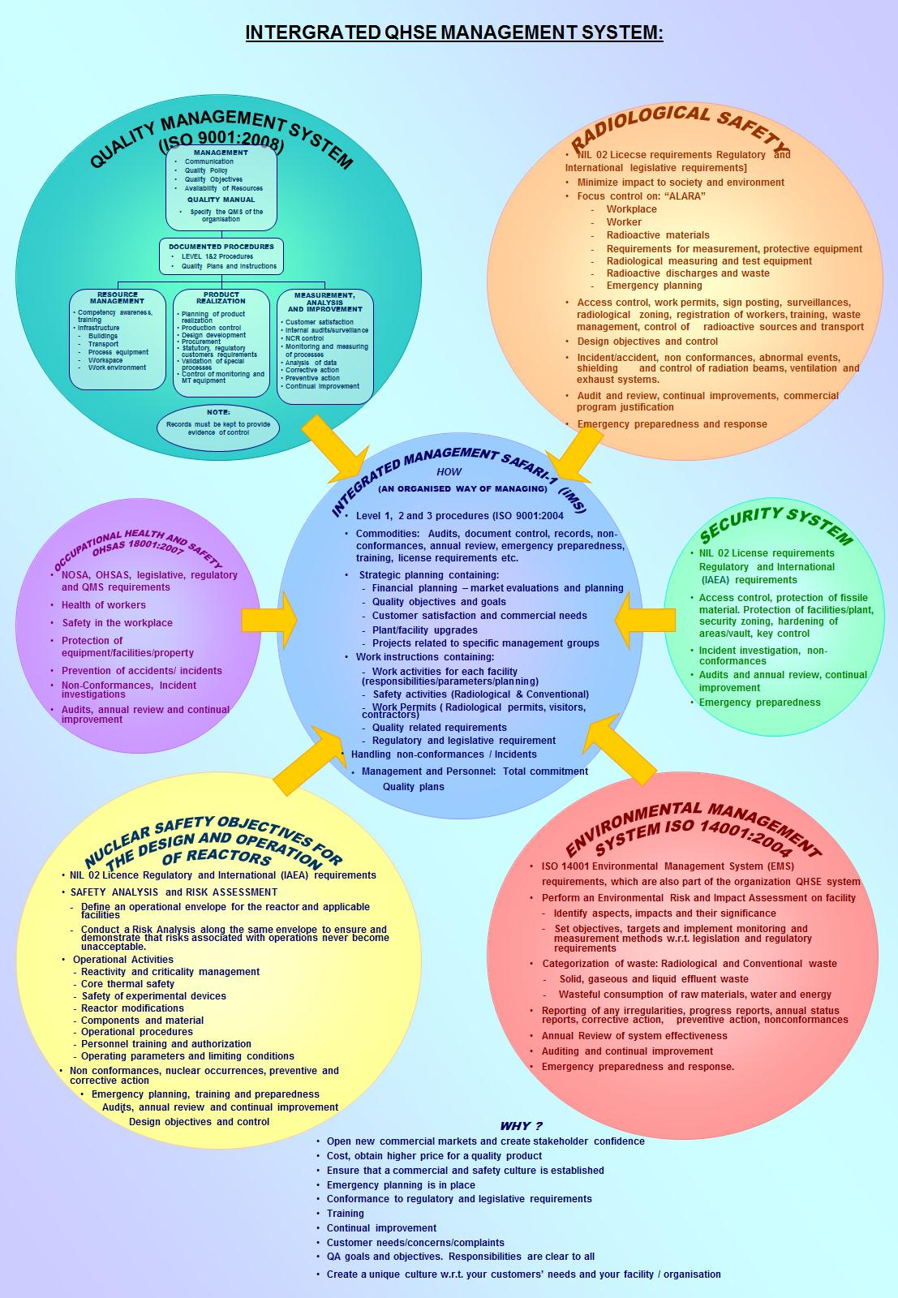
Figure 4: Example of an IMS Model

Configuration Management

What is Configuration Management?
Configuration management (CM) is the discipline establishing, maintaining and monitoring the consistency among the requirements, the physical configuration, and the technical description of a facility or product. CM is one of the main pillars of safety culture, safe operation of nuclear facilities and safe nuclear products by ensuring that the right information is available at the right time and in the right format for engineering and operations when making decisions regarding the safety of a facility, utility, SSC (system, structure or component) or product. To achieve these outcomes CM is [4]:
- a technical discipline implementing a distinct set of processes and activities over the entire lifecycle of all configuration information objects in order to
  - uniquely identify each facility, utility, SSC or product (including its functional requirements and physical characteristics;
  - capture and structure all uniquely identified configuration information defining each facility, utility, SSC or product (including the configuration information supporting and associated with the definition) in a comprehensive technical description;
  - enable traceability of the controlled successive evolution of all configuration information objects (CIOs) and its related configuration information in that description;
  - structure collected configuration information in a way that allows it to be baselined;
  - record and report on the status of all CIOs and its related configuration information;
  - verify or audit the conformance of a facility, utility, SSC or product to its technical description (which includes its controlled requirements).
- a supporting discipline, insofar CM as discipline
  - ensures that the configuration and technical description of a facility, utility, SSC or product is established, approved, maintained;
  - assists other processes/disciplines to capture and control enough of its inputs and/or outputs which may define, support or may be associated with the technical description of a facility, utility, SSC or product;
  - ensures that the correct CIOs and related configuration information are correctly marked/identified as configuration items.
- a controlling discipline by insisting on
  - capturing and controlling all CIOs and its related configuration information in the correct environment;
  - sufficient supplier configuration information to be delivered with purchased configuration items for inclusion in the applicable design description;
  - correct identification and control of changes to a facility, utility, SSC or product and its related data;
  - sufficient control of distribution or publication of configuration information.
- an integrating discipline by
  - relating information to be under configuration control in ways supporting traceability and access to correct technical and supporting information where it is used;
  - managing the information interfaces amongst other disciplines (e.g. Engineering, Licensing, Operations, Maintenance, Project Management, Procurement etc.) and the Regulator.

The Objectives of CM
- Preserving the CM equilibrium by establishing consistency among design requirements, physical configuration, and Technical Description (including analyses, drawings, and procedures) of facility, plant, SSC or product; and by maintaining this consistency throughout the life of the facility, plant, SSC or product - particularly as changes are being made.

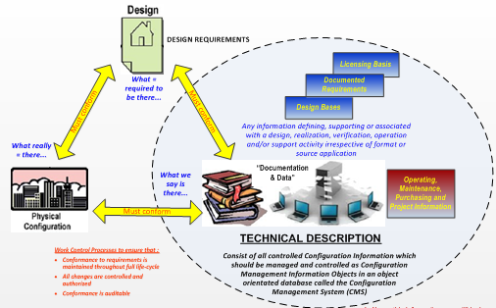
Figure 5: The Configuration Management Equilibrium

- Building up a sufficient technical description by collecting CIOs with all its defining, supporting and associated configuration information describing a facility, plant, SSC or product (complete technical description) in a single, integrated and structured environment which must have the ability to accommodate processes and supply mechanisms ensuring traceability of the successive evolution in the technical description by implementing sound CM principles including at least unique identification, revision-, change- and baseline control.
- Initiating and supporting design reconstitution where critical design information cannot be successfully and cost effectively recovered from existing storage facilities and historical document control systems. In such instances CM shall initiate a design reconstitution to obtain the recreated design information from the SQEPs (Suitably Qualified and Experienced Persons) it was assigned to for immediate capturing as part of the applicable technical description. Reconstituted information is to be immediately safeguarded by capturing is in the CM system.
- Supporting safety - in order to retain confidence in the safety of the facility, CM is the management activity that applies technical and administrative direction over the life cycle of a product, its configuration items, and related product configuration information by ensuring proper documentation of the configuration of a facility, utility, SSC or product. It provides identification and traceability, the status of achievement of its physical and functional requirements. In this way CM supports access to accurate information in all phases of the life cycle. CM supports safety culture, safe operation and safe product by having right information available at the right time and in the right format for engineering and operations.
- Consistency - the basic objectives and general principles of configuration management shall be the same for all facilities.

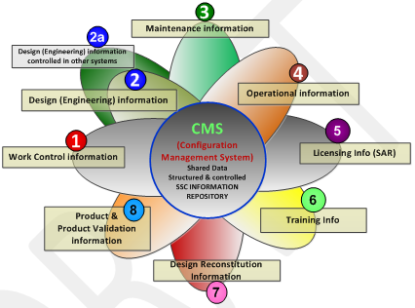
Figure 6: The Purpose of CM

Example of a CM Structure

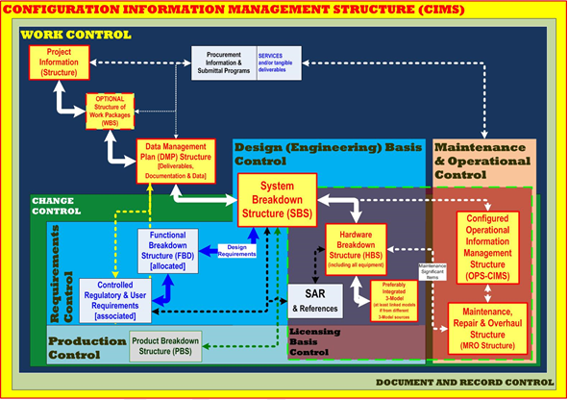
Figure 7: Example of a CM Structure [5]

Document Control
  - What is Document Control?
Document control process is the basis for any IMS and defines the hierarchy structure for document groups or order and control measures for prepare, review, check, accept and approve. Document control is the management of documents through the document life cycle to a high degree of reliability for security, version control, review cycle, visibility, availability and, most importantly, for a controlled reliable audit trail. Beyond ISO 9000, which defines document control in relatively narrow terms, document control could be viewed as a technological approach to governing document quality and mitigating risk stemming from human error in document preparation [6]. Document control is best achieved through process automation and electronic documentation control systems are commonly used by many organisations that produce complex, rule-based documents on a repetitive basis.

  - The Purpose of Document Control
The goal of document control is not to create extra work or build a bureaucracy. Instead, it is put in place to protect the value of the content of documents and to enhance the usefulness of that content to the people in the organisation who need to use it to do their work. Document control provides a framework for deciding how information is created in the organisation and how it is managed once created. The purpose of a document control method is to ensure [7]:
- Documents fulfil a useful purpose and resources are not wasted on the distribution of unimportant or useless information
- Only valid information is published and information is kept up to date
- Information is provided in a form that can be used by the audience
- Classified, confidential, or proprietary information is restricted to the people who have a real need to access it
- Information is retained that could help solve a problem, improve opportunities, avoid costly errors, or deflect potential litigation

  - Document Control Procedures
The document control process put in place to support the policy should include procedures that define the development of documents. While these procedures should not be cumbersome, they should be explicit and detailed enough to provide clear direction as to how documents should be prepared. The procedures may include essential topics such as:
- How to plan new documents; authorization, funding, establishing need
- How to prepare new documents; who prepares them, how they are drafted, how drafts are maintained
- Standards for the format and content of documents, forms, diagrams
- Document identification conventions
- Version control conventions
- Dating conventions; date of review, date of approval, date of issue, date of distribution, date of revision
- Document review procedures; who reviews, evidence of review
- Document approval; who approves, evidence of approval
- Publication; what constitutes “publishing” a document
- Printing; who prints a document, restrictions to printing
- Distribution; how is a document distributed, who does it, who checks it
- Use of documents; limitations, unauthorized copying, access to files, marking printed copy
- Revisions; identifying a need; who makes revisions, review and approval process, how are changes marked
- Amending issued documents; who creates amendments, review and approval process, identification of amendments
- Storing documents; determining location, security, access and prevention of unauthorized changes, indexing, retrieval by users, restrictions concerning paper documents vs. electronic document files, authorized and unauthorized external distribution and republishing

  - A Practical Approach to Document Control
Effective document control requires an underlying philosophy and strategy. It should be tailored to the needs of the organisation that uses it. It should be practical and it should be written. No document management strategy can be useful if it is not explicitly documented and made part of the daily routine. In organisations with the proper understanding of the significance of document management, this documented philosophy and strategy becomes a document management policy. Once this policy is defined, it should be followed with a document management process that explains how to put the policy into use.

The document management policy and process become the organisation's method of document control. In broad terms, document control provides a means of managing the development, approval, issue, change, distribution, maintenance, use, storage, security, and disposal of documents. While a document control process can be automated with a document management tool, the organisation must not allow a purchased software application to dictate its document management policy and process. To work effectively, a document control method must be adopted that makes sense for the organisation's environment and culture.

- Conclusion
There are multiple benefits in having an IMS with CM and documentation control integrated into this system. Therefore it can be stated that configuration management and document control within an integrated management system are essential requirements for the safe operation, utilisation and modification as well as up-to-date information of any research reactor.

- References
[1] INTERNATIONAL ATOMIC ENERGY AGENCY, “Application of the Management System for Facilities and Activities”, IAEA Safety Standards Safety Guide No. GS-G-3.1, IAEA, Vienna (2006).
[2] INTERNATIONAL ATOMIC ENERGY AGENCY, “Fundamental Safety Principles”, IAEA Safety Standards Series No. SF, IAEA, Vienna (2006).
[3] “Plan-Do-Check-Act (PDCA) - Implementing new ideas in a controlled way - Also known as the PDCA Cycle, or Deming Cycle”
https://www.washington.edu/research/rapid/resources/toolsTemplates/plan_do_check_act.pdf.
[4] DOE-STD-1073 - Configuration Management, 2003.
[5] SHEQ-INS-0236 Rev 0 - NECSA REQUIREMENTS FOR CONFIGURATION MANAGEMENT, Necsa Internal Document.
[6] DUCHARME, L., “What is Document Control?”, March 08, 2013,
http://www.hotdocs.com/blog/what-document-control.
[7] BALDWIN, D. A., “The Principles of Document Control”, August 17, 2014 (Updated),
http://www.davebaldwinconsulting.com/article_principles_document_control.html.

