**Lessons Learned on Strategic Planning for Enhanced Utilization of**

**Low Power Research Reactors**

C.N. Grant

INTERNATIONAL CENTRE FOR ENVIRONMENTAL AND NUCLEAR SCIENCES

[*charles.grant@uwimona.edu.jm*](mailto:charles.grant@uwimona.edu.jm)

**Abstract**.

The International Centre for Environmental and Nuclear Sciences (ICENS) was set up to be an institution with a formidable range of applications that promised to impact on Caribbean expertise and its potential to advance the application of science and technology to the sustainable development of the member countries of the University of the West Indies. Our research during the first 30 years has focused largely on environmental geochemistry and its impact on agriculture, human and animal health and mineral exploration. Our main analytical tool has been the SLOWPOKE-II research reactor used for Neutron Activation Analysis. After 31 years of successful operation with a HEU core the SLOWPOKE-II reactor at ICENS was successfully converted to LEU in September 2015. This paper reports on the lessons learned during the first 30 years of successful utilization and the strategies and policies to be adopted by ICENS over the next 30 years. In addition, the utilization of the SLOWPOKE-2 reactor for various research programmes along with detailed descriptions of the experimental facilities is also reported.

**Key Words**: NAA, SLOWPOKE, strategic planning

### The ICENS Vision and mission

From its inception the International Centre for Environmental and Nuclear Sciences (ICENS), formerly the Centre for Nuclear Sciences was envisaged as an enabler and catalyst for multidisciplinary research in Jamaica, at the centre of this would be a small research reactor. The strong belief that many of the critical socio-economic problems of Jamaica could be more effectively addressed through integrated multidisciplinary research and development programmes, was realised in 1984, when, supported by the European Union which provided a SLOWPOKE research reactor . A national group of key stakeholders was established, the committee for Peaceful Uses of the Atom (CPUA), Figure 1, with wide representation to ensure that the programmes to be adopt by the institution reflected national priorities and the needs of the university.

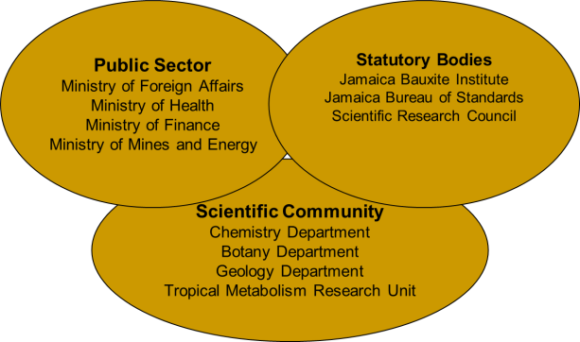

*FIG. 1. CPUA composition*

The initial research themes for the ICENS, which is a partnership between the University and the Government of Jamaica, emphasised an integrated research programme based on the Environmental Geochemistry and its effects on the biosphere and socioeconomic development, Figure 2.

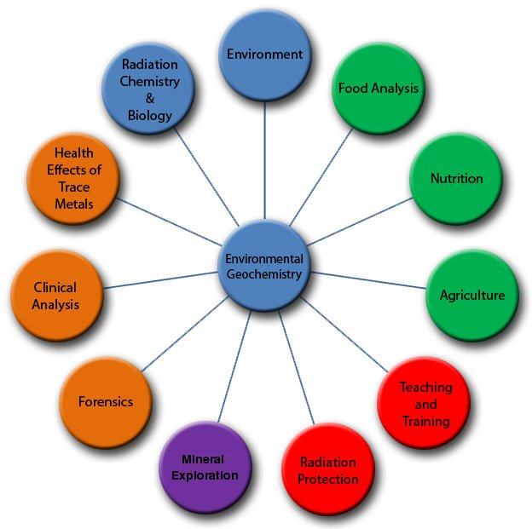

FIG. 2 Main research fields of ICENS

The analytical outputs are used to develop a powerful interactive geochemical database which combined with Geographical information systems, provides a valuable resource critical in the development of evidence based policy formulation, the so called DIKW Hierarchy, Figure 3.

FIG 3 DIKW Hierarchy

### Facility

The facility is housed at the University of the West Indies in Jamaica and is one of several specialized research units on the campus.

#### SLOWPOKE-2 reactor

The Jamaican SLOWPOKE-2 research reactor is a pool type reactor, designed by the Atomic Energy of Canada Ltd (AECL). It was originally fueled with approximately 1kg of uranium enriched to 93% 235U with a thermal rating of 20kW when operating at full power. After 31 years of operation with a HEU core the SLOWPOKE-II reactor at ICENS was converted to LEU in September 2015.

The original HEU core of the JM-1 reactor consisted of 296 fuel pins which were 228 mm long and 5.23 mm in diameter. The fuel was a coextruded uranium-aluminum alloy that was 28% by weight uranium, enriched to 93% with a mass of approximately 817g of 235U. The fuel cladding and fuel cage were constructed from aluminum. The core was encased in a 10cm-thick annular beryllium reflector and sat on a bottom 10cm-thick beryllium disc. The top reflector consisted of semicircular beryllium plates, called shims, each only a few millimeters thick. Since no adjustment to the core was allowed, burn-up was compensated for by the addition of reflector shims as necessary. There were five inner irradiation sites located in the beryllium annular reflector and one outer site just outside the annulus.

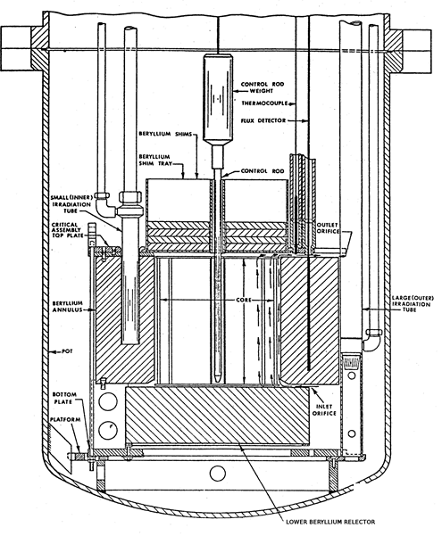With the exception of the fuel pins and fuel cage, all the components of the HEU core assembly were reused, without modification, in the LEU configuration. The LEU fuel is sintered uranium oxide pellets with an enrichment of just under 20%, while the cladding and the fuel cage is constructed from Zircaloy-4. The fuel pins, of which there are 193, are 237 mm long and 5.26mm in diameter. The total mass of uranium is ~5565 with ~1100 being 235U, as more fuel is required to achieve the same flux as the HEU configuration. The main differences between the HEU and LEU cores are highlighted in Table 1.

FIG 4. Cross section of the JM-1 critical assembly

TABLE I: COMPARISON OF THE HEU AND LEU CORES

|  |  |  |
| --- | --- | --- |
| **Parameters** | **HEU** | **LEU** |
| Fuel Meat | U-Al4 | UO2 |
| 235U Total Core Loading (g) | ~ 817 | ~1100 |
| 235U Enrichment (w/w %) | 93.18 | 19.89 |
| Density of Meat (g/cm3) | 3.45 | 10.6 |
| Meat Diameter (mm) | 4.216 | 4.166 |
| Fueled Length (mm) | 220 | 227 |
| Cladding Diameter (mm) | 5.23 | 5.26 |

#### 2.1.1 Ageing management

In reality the Jamaican SLOWPOKE fuel conversion also presents another challenge, the SLOWPOKE was never designed for 70 years active life, the proposed strategy will be the development of a computerized management system which includes a digital control system for the reactor and a series of auxiliary system monitors that will assist in determining trends in system performance and reduce catastrophic failures that could impact safety and utilization. The components will utilize as many off the shelf systems as possible, to limit the need for specialized systems, and when fully operational will enhance safety, security and efficient management of the facility, which will result in improved utilization of the reactor.

#### Analytical facilities

A key component of all programmes at ICENS is the production of high quality analytical data; this over the years has been guaranteed by having well trained staff, applying rigorous Quality Control and participating in proficiency testing programmes.

#### 2.2.1 Neutron Activation Analysis

Unlike most reactors quantification by NAA with SLOWPOKE using the in-core irradiation sites does not require co-irradiation of flux monitors or standards. The uniformity, stability and reproducibility of the neutron spectrum within the core, and with time facilitates the use of activation constants (k) according to equation (1) in which m is the mass of a particular element in grams, R is the peak area, ti, td, tc, are the times of irradiation, decay, and counting respectively, and  is the decay constant, i.e.



**Equation 1 Improved Relative Activation Equation**

Where 

with ε = detector efficiency;  = abundance of the activated nuclide; NA = Avogadro’s number = 6.023x1023;  = effective isotopic activation cross-section;  = neutron flux in ncm-2s-1; Aw = atomic weight of the irradiated element. Details on the methodology adopted for the Jamaican SLOWPOKE can be found elsewhere [1, 2].

#### 2.2.2 Energy Dispersive X-Ray Fluorescence

Energy Dispersive X-Ray Fluorescence (ED-XRF) which at ICENS is conducted using the Kevex EDX-771 X-ray fluorescence spectrometer as well as the more recently acquired Niton Handheld XRF spectrometer. This multi-element technique is particularly useful for Pb analysis as well as other elements not suitable for NAA. In addition Total X-ray fluorescence (TXRF) is also available at ICENS using the Wobistrax TXRF spectrometer and has the advantage of being able to measure ultra-trace levels in samples, particularly biological samples using very small sample mass.

#### 2.2.3 Atomic Absorption Spectrometry & Inductively coupled plasma optical emission spectroscopy

In addition to the Nuclear Analytical Laboratory there is the Solutions Analytical Laboratory which houses a number of techniques suitable for liquids and biological material. Flame and Graphite Furnace Atomic Absorption Spectrometry (AAS) is performed using the Perkin Elmer 5100PC spectrometer. Inductively coupled plasma optical emission spectroscopy (ICP-OES) is performed using a Perkin Elmer Optima 7000DV. Flow injection analysis using a Lachat© flow injection analyzer is also available in this laboratory.

**3. Utilization**

Over the last 31 years ICENS has undertaken numerous projects, shown below are the brief summaries of six such projects.

**3.1 Geochemical Mapping**

During an island wide soil survey it was found that some Jamaican soils, especially the bauxitic soils that overlie White Limestone geological group, are much enriched in several heavy metals compared with world levels [3].

|  |  |  |
| --- | --- | --- |
| FIG 5a. Zinc distribution | FIG 5b. Cadmium distribution | FIG 5c. Arsenic distribution |
| \\store\common\Maps\Maps\zinc.gif | \\store\common\Maps\Maps\cadmiumB.gif | \\store\common\Maps\Maps\arsenicB.gif |

The soil cadmium levels in particular are up to a thousand times higher than the world averages. These high levels in soils have encouraged efforts to establish relationships between plant animal and human health.

**3.2 Food Security**

FIG 6. Cadmium in yam and soil

The exact locations of over 600 paired soil and food samples were recorded by use of global positioning systems (GPS). This allowed precise plotting of maps showing Cd in soils and foods stratified by soil Cd concentrations. There were significant soil/plant Cd correlations (R2 >0.5). These data confirm the significant uptake of Cd by some foods and show that low-Cd products can be produced by judicious land use selection; a technically simple solution to meeting food standards. [4]

**3.3 Animal studies**

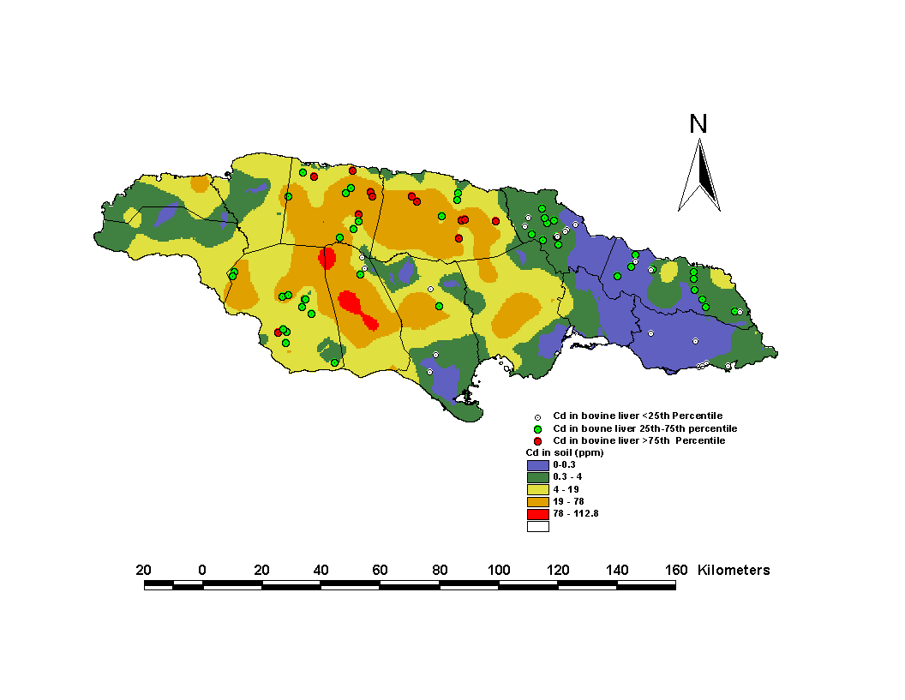

FIG 7. Cadmium in Bovine Kidney

Paired liver and kidney samples from 100 free-range cattle in different parts of Jamaica were analyzed for the essential and non-essential trace elements. The map shows that the Cd levels found in cattle kidney closely followed that of the soil on which they reared. The intake of Cd from bovine liver and kidney was estimated to be 5.2μg/day based on an Island wide survey or 7% of the Provisional tolerable daily intake. [5]

**3.4 Human studies**

FIG 8. Ca & Zn with birth weight

We evaluated the placentae of 52 Jamaican mothers with a mean age (range) 29 years (18 – 42 years) delivering singleton neonates with a mean birth weight of 3.1 kg (1.3 – 5.5 kg) at term were collected. The birth weights observed in this work are slightly less than the average birth weight found in the literature for developed countries. The distribution of birth weight follows a normal distribution with approximately 16% of the population having low birth weight , <2.500 g, with a further 4% with very low birth weight, 1.500g, more than double that of the USA at 7.6% . Birth weight is a strong predictor of an infant's chances of survival and low birth weight has also been associated with profound later life health effects, even after recovering from low weight at birth. The significant correlation (R= 0.38, P=0.007) between calcium and birth weight,correlation was also observed for Zn and birth weight (R=0.26, P=0.07), a low zinc intake has been associated with approximately a twofold increase in the risk of low birth weight [6].

**3.5 Forensic Analysis**

Investigation of beach sands from an actual court case in Jamaica involving the analysis of 35 elements by Neutron Activation Analysis identified 14 elements that could be possible geochemical markers or “finger prints” for various beach sands. Aluminum, Iron, Manganese and Scandium showed the most promise as “finger print elements” as the concentration of these elements seemed to be site specific. Figure 1 shows the variation of Aluminum in various beach sands; it clearly shows that sites B and C are similar to A (stolen beach) while sites D and E are quite different. Using this methodology we were able eliminate potential recipient beaches D and E from having received sand from donor (stolen) beach A. We were also able to determine that sites I and K [7].

FIG 9. Al variation in beach sand

**3.6 Finger nails as a bio indicator of Arsenic exposure**

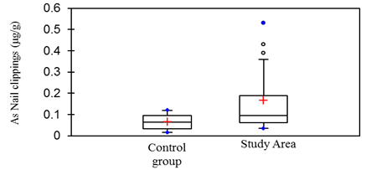Fingernail and toenail clippings (n=25) were collected from members (adults and children) of the households proximal to the to an area with elevated levels of arsenic in the soil and water with mean arsenic concentration 25.8 µg/g and 20 µg/L respectively. Nail clippings were also collected from a total of eleven (11) subjects (male and female) ranging in age from 4 to 64 years with no previous history of residency proximal to the elevated site. The distribution of age for the control group was intended to mirror the gender and age range for participants residing in the study area. Donors were asked to allow their nails to grow for at least seven days prior to sample collection and clippings were taken from all 10 fingers and toes and stored in fresh biohazard bags before analysis. Arsenic in nail clippings ranged from <0.0 3to 0.12 µg/g for the control samples (Table 6) and <0.07to 0.53 µg/g for samples from the study area. Figure 10 illustrates that the nail clippings from the study area were significantly (p-value = 0.035) higher in arsenic; however this cannot be interpreted as an indication of excessive exposure to arsenic, since all values fall within the range of 0.09 to 0.59 µg/g for normal concentration of arsenic in nail clippings [8].

**Conclusion**

After 31 years of operation the research reactor still remains the flagship analytical tool of the institution. Our convenient location on the university campus has allowed us to make use of inter-institutional (University/Government Ministries) and international collaborations to ensure that the research activities are relevant to all stakeholders; in particular, the transfer of knowledge between academia and government with a major objective being the development of the human and economic resources of the country. These collaborations include M.Phil. and Ph.D. students from the Departments of Basic Medical Sciences, Botany, Chemistry, and Geology; MSc. Students from Forensic Chemistry, teaching undergraduate chemistry students and providing courses in Radiation Physics, Radiation Biology and Radiation protection for BSc. in Diagnostic Imaging.

As we move forward with the new LEU core we will endeavour to strengthen the existing collaborations and will actively seek their input to our long term strategic plans which must now also include a strong component of ageing management and final decommissioning plans.

**References**

[1] GRANT C., LALOR G.C., VUTCHKOV M.K., “Neutron activation analysis of Cadmium in Jamaican soils,” J. Radioanal. Nucl. Chem, 237(1), 109-112, 1998.

[2] LALOR G.C., VUTCHKOV M.K., GRANT C., PRESTON J., FIGUEIREDO A.M.G. , AND FAVARO D.I.T., “INAA of trace elements in biological materials using the SLOWPOKE-2 reactor in Jamaica”, J. Radioanal. Nucl. Chem, 245(1), 2000.

[3] LALOR G.C., et al, “A geochemical atlas of Jamaica”, University of the West Indies Press, Kingston, Jamaica”, 1996.

[4] LALOR G.C., “Review of cadmium transfers from soil to humans and its health effects in the Jamaican environment”, Sci Total Environ,400, 162-172, 2008

[5] NRIAGU J., BOUGHANEN M., LINDER A., HOWE A., GRANT C., RATTRAY R., VUTCHKOV M., AND LALOR G, “Levels of As, Cd, Pb, Cu, Se and Zn in bovine kidneys and livers in Jamaica”, Ecotoxicol. Environ. Saf. [72 (2](http://www.sciencedirect.com/science?_ob=PublicationURL&_tockey=%23TOC%236770%232009%23999279997%23701252%23FLA%23&_cdi=6770&_pubType=J&view=c&_auth=y&_acct=C000060084&_version=1&_urlVersion=0&_userid=7232977&md5=bba9baa5590254c72f8edd53739628f1)), 564-571, 2009.

[6] GRANT C., LALOR G., FLETCHER H., POTTER T., VUTCHKOV M. AND REID M., “Elements in Human Placentae in Jamaica” West Indies Medical journal” , West Indian Med J, 59(5):479-485, 2010

[7] GRANT C., ANTOINE J, “Forensic beach sand study”, ICENS internal report, 2009

[8] SPENCE A, ANTOINE J, GRANT C., ”Report on the Analysis of Arsenic in Nail clippings, Soil, food, and Water Samples “, ICENS internal report, 2015