# Issues and Challenges in Research Reactors based Radioisotope Production

B. Ponsard1

1Belgian Nuclear Research Centre (SCK•CEN), BR2 Reactor, Mol, Belgium

*bponsard@sckcen.be*

**Abstract**. Research reactors play a key role in the production of radioisotopes for various applications in nuclear medicine (Mo-99/Tc-99m, I-131, Xe-133, Lu-177, Ir-192, Ho-166, P-32, Y-90, Sm-153, Re-186, Sr-89, W-188/Re-188, Sn-117m, Ac-227/Ra-223, …), industry (Ir-192, Se-75, Hg-203, …) and research. While the number of accelerators – mainly cyclotrons – is increasing specially for the production of medical radioisotopes, the supply of reactor-produced medical radioisotopes relies on a limited number of research reactors. This is the case for the production of Mo-99, a very crucial radioisotope as it decays into Tc-99m which is used in 80% of the 30 million radiodiagnostic nuclear medicine procedures carried out worldwide annually. The current situation is a major concern in the Mo-99/Tc-99m supply chain, especially after the decisions taken recently to shut down definitively the OSIRIS reactor (France) in December 2015 and to cease routine Mo-99 production at the NRU reactor (Canada) from November 2016. Current research reactors are ageing, expensive to replace and due to safety and financial issues, it is a continuing source of public and political debate. Their availability with appropriate neutron fluxes, significant operating time and economic viability are important issues to ensure a secure and reliable supply of radioisotopes in future. Successful conversion of High Enriched Uranium (HEU) into Low Enriched Uranium (LEU) for reactor fuel and targets for Mo-99/Tc-99m production are also important challenges in the coming years in the frame of the National Nuclear Security Administration Global Threat Reduction Initiative. In this context, the Belgian Nuclear Research Centre (SCK•CEN) made a strategic decision to refurbish the BR2 reactor, which is considered as a major facility worldwide for the routine supply of radioisotopes as Mo-99/Tc-99m, I-131, Xe-133, Lu-177, Ir-192, Re-186, Sm-153, Er-169, Y-90, P-32, Sn-117m, W-188/Re-188, I-125, Sr-89, … and for the development of new medical radioisotopes as Ac-227/Ra-223, ... The BR2 reactor is currently in temporary shutdown for a scheduled period of 16 months from February 2015 until June 2016 to replace mainly its beryllium matrix. The refurbishment will allow a safe and reliable operation of the reactor for another period of at least 10 years with an upgraded annual operating regime of up to 8 cycles, i.e. up to 180-200 operating days per year, subject to the economics.

**Key Words**: Research Reactors, Radioisotopes, Production.

### Introduction

Research reactors play a key role in the production of radioisotopes for various applications in nuclear medicine (Mo-99/Tc-99m, I-131, Xe-133, Lu-177, Ir-192, Ho-166, P-32, Y-90, Sr-89, Sm-153, Re-186, W-188/Re-188, Sn-117m, Ac-227/Ra-223, …), industry (Ir-192, Se-75, …) and research. While the number of accelerators – mainly cyclotrons – is increasing specially for the production of medical radioisotopes, the supply of reactor-produced medical radioisotopes relies on a limited number of research reactors. This is the case for the production of Mo-99, a very crucial radioisotope as it decays into Tc-99m which is used in 80% of the 30 million radiodiagnostic nuclear medicine procedures carried out worldwide annually. The current situation is a major concern in the Mo-99/Tc-99m supply chain, especially after the decisions taken recently to shut down definitively the OSIRIS reactor (France) in December 2015 and to cease routine Mo-99 production at the NRU reactor (Canada) from November 2016. Current research reactors are ageing, expensive to replace and due to safety and financial issues, it is a continuing source of public and political debate.

### Main research reactors involved in radioisotope production

Radioisotopes are mainly produced in research reactors and accelerators (cyclotrons and linear accelerators). The supply chain involves several steps such as the selection of the most effective target material (natural or enriched in a particular isotope), target manufacture, irradiation of the target material in a suitable facility, shipment of the irradiated targets to processing facilities, radiochemical processing of the targets or encapsulation in sealed sources, quality control and transportation of the final products to the end users. Reactors and accelerators complement each other in the irradiation process for the production of a full range of radioisotopes. A few radioisotopes are exceptions to this rule and can be produced by both facilities, as I-125, Pd-103, Sn-117m and Cu-67 for example.

The key parameters regarding the selection of a production route for the supply of radioisotopes are related to target material (physical and chemical properties) availability, production yield, specific activity, target integrity, radionuclide purity, logistics and economics. Another consideration is related to the level of undesired impurities produced as the long-lived Lu-177m (160 days half-life) in the case of the production of Lu-177 (6,7 days half-life) by activation of enriched Lu-176.

The main research reactors [1] involved in the production of radioisotopes are listed in Table I and can be classified as follows according to the available thermal neutron flux (En < 0.5 eV):

• High-Flux reactors : thermal neutron flux above 1 x 1015 n·cm-2·s-1

• Medium-Flux reactors : thermal neutron flux between 2 and 5 x 1014 n·cm-2·s-1

• Low-Flux reactors : thermal neutron flux below 1 x 1014 n·cm-2·s-1

TABLE I: MAIN RESEARCH REACTORS FOR RADIOISOTOPE PRODUCTION.

|  |  |  |  |  |  |
| --- | --- | --- | --- | --- | --- |
| **Research Reactors** | **Countries** | **First criticality** | **Power [MW]** | **Φth [** **1014****n·cm-2·s-1]** | **Operating days / year** |
| **SM-3** | Russia | 1961 | 100 | 30 | ? |
| **HFIR** | United States | 1965 | 100 | 25 | 170 |
| **BR2** | Belgium | 1961 | 120 | 12 | 190 |
| **NRU** | Canada | 1957 | 135 | 4 | 280 |
| **MURR** | United States | 1966 | 10 | 4 | 339 |
| **MARIA** | Poland | 1974 | 30 | 4 | 200 |
| **HANARO** | Republic Korea | 1995 | 30 | 4 | 220 |
| **HFR** | Netherlands | 1961 | 45 | 3 | 266 |
| **SAFARI** | South Africa | 1965 | 20 | 3 | 305 |
| **OPAL** | Australia | 2006 | 20 | 3 | 300 |
| **OSIRIS** | France | 1966 | 70 | 2 | 182 |
| **LVR-15** | Czech Republic | 1957 | 10 | 2 | 210 |
| **FRM-II** | Germany | 2004 | 20 | 2 | 240 |

The major issues and challenges in the production of radioisotopes by research reactors are related to the fact that current research reactors are ageing, expensive to replace and due to safety and financial issues it is a continuing source of public and political debate. Their availability with appropriate neutron fluxes, significant operating time and economic viability are important issues to ensure a secure and reliable supply of radioisotopes in future.

### Production of Mo-99

Radioisotopes used for diagnosis in nuclear medicine must emit gamma rays of sufficient energy to escape from the body and it must have a half-life short enough for it to decay away soon after imaging is completed. This is the case of Tc-99m which is used in 80% of the the 30 million radiodiagnostic nuclear medicine procedures carried out worldwide annually. It has a half-life of six hours which is long enough to examine metabolic processes and short enough to minimise the radiation dose to the patient. The low energy gamma rays it emits easily escape the human body and are accurately detected by a gamma camera. Its logistics also favour its use as it is available from Mo-99/Tc-99m generators. Mo-99 is characterized by a half-life of 66 hours and is currently mainly produced in research reactors by fission of U-235 from high enriched uranium (HEU) and/or low enriched uranium (LEU) targets.

**3.1 The Mo-99 supply chain**

There are only nine research reactors involved in this production on industrial scale [2]: BR2 (Belgium), HFR (The Netherlands), OSIRIS (France), LVR-15 (Czech Republic), MARIA (Poland), NRU (Canada), SAFARI (South Africa), OPAL (Australia) and RA-3 (Argentina). Their weekly irradiation capacities are given in Table II [3].

TABLE II: RESEARCH REACTORS INVOLVED IN GLOBAL MO-99 PRODUCTION.

|  |  |  |  |
| --- | --- | --- | --- |
| **Research Reactors** | **Countries** | **Targets** | **Weekly irradiation capacities [ '6-d' Ci ]** |
| **BR2** | Belgium | HEU | 7.800 |
| **HFR** | The Netherlands | HEU | 5.400 |
| **NRU** | Canada | HEU | 4.680 |
| **SAFARI** | South Africa | HEU/LEU | 3.000 |
| **LVR-15** | Czech Republic | HEU | 2.400 |
| **OSIRIS** | France | HEU | 2.400 |
| **MARIA** | Poland | HEU | 2.700 |
| **OPAL** | Australia | LEU | 1.000 |
| **RA-3** | Argentina | LEU | 400 |

After an irradiation time of about 150 hours in a research reactor and a cooling period of 12 hours, the irradiated targets are loaded into shipment containers and sent to six processing facilities [3] supplying about 95% of the bulk Mo-99 global needs: MALLINCKRODT (The Netherlands), IRE (Belgium), CNL/MDS NORDION (Canada), NTP (South Africa), ANSTO (Australia) and CNEA (Argentina). Their weekly processing capacities are given in Table III.

TABLE III: PROCESSORS INVOLVED IN GLOBAL MO-99 PRODUCTION.

|  |  |  |  |
| --- | --- | --- | --- |
| **Processors** | **Countries** | **Targets** | **Weekly processing capacities [ '6-d' Ci ]** |
| **CNL/MDS NORDION** | Canada | HEU | 4.680 |
| **MALLINCKRODT** | The Netherlands | HEU | 5.000 |
| **IRE** | Belgium | HEU | 3.500 |
| **NTP** | South Africa | HEU/LEU | 3.000 |
| **ANSTO** | Australia | LEU | 1.000 |
| **CNEA** | Argentina | LEU | 400 |

After dissolution of the irradiated targets, the extracted bulk Mo-99 is sent to Mo-99/Tc-99m generators manufacturers: MALLINCKRODT (The Netherlands and US), LANTHEUS MEDICAL IMAGING (US), GE-HEALTHCARE (UK), IBA-MOLECULAR (France), ... It is important to note that reactor irradiation capacities give only a partial view of the global Mo-99 availability and do not account for logistic issues related to targets and bulk Mo-99 shipments, ... Research reactors are not all linked to processing facilities on site which results in some regional constraints on processing capacities and in the loss of product through more decay during shipments. This is especially the case in Europe where irradiation capacities exceed processing capacities. Furthermore, processing facilities have to face some safety limitations in terms of number of targets processed per week according to potential fission gas release. For these reasons, the major risk in the Mo-99/Tc-99m supply chain in next future will be insufficient processing capacities rather than insufficient irradiation capacities. The geographical location of the main facilities currently involved in the Mo-99 global supply chain is illustrated in FIG. 1.

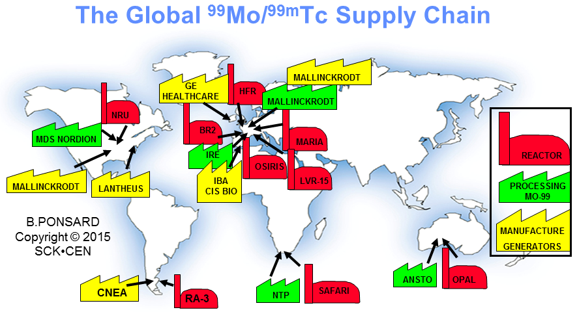

*FIG. 1. Main facilities currently involved in the Mo-99 global supply chain.*

Finally, the Mo-99/Tc-99m generators are supplied to hospitals or central radiopharmacies as shown in FIG. 2 and can be used for only 1 week because of the loss of 1% of activity per hour. In normal circumstances, this strategy of supply allows the availability of Tc-99m every day, 365 days per year, on the basis of a weekly delivery of generators all around the world. Each partner in the supply chain must thus work very efficiently to avoid losing time so that the product can be delivered as quickly as possible, taking shipment constraints into account (by road, by air, …). Nevertheless, recurrent supply shortages have highlighted the vulnerability of centering production on a limited number of ageing reactors.

**Mo-99  
Processing Facility**

**Generator Manufacture Mo-99/Tc-99m**



**Reactor Target Irradiation**

**U-235  
targets**

**Mo-99/Tc-99m generators**

**Hospitals Pharmacies**



**Mo-99  
“bulk” liquid**

*FIG. 2. The Mo-99 supply chain.*

**3.2 Issues and challenges for the production of Mo-99**

The main actors (research reactors, processors, generator manufacturers) involved in the global Mo-99 supply chain are represented in the 'Reactors and Isotopes' Working Group of the Association of Imaging Producers and Equipment Suppliers (AIPES). They provide their best efforts to achieve optimal coordination of their operations to mitigate potential shortages in the Mo-99 global supply chain and to meet the current Mo-99 global demand of about 9.000 '6-d' Ci per week as reported at the last HLG-MR meeting held in Paris in July 2015.

The AIPES 'Reactors and Isotopes' Working Group plays a key role within the Mo-99 global chain in terms of coordination and communication. As shown in FIG. 3, the AIPES annual reactor schedule follows the operating periods of the main research reactors involved in the Mo-99 global supply chain. This schedule is updated each time an issue requires reactor rescheduling to mitigate Mo-99 shortage related to maintenance operations, unplanned reactor shutdowns, target manufacture, target shipment, issues at processor or generator manufacturer level, ... The "VERSAILLES Mo-99 MODEL" has been developed and validated by AIPES in 2014 based on data provided in the OECD / NEA reports and feedback delivered by the AIPES representatives (processors and generators manufacturers) for the years 2013 and 2014. This model follows the global Mo-99 maximum weekly reactor production capacity – week by week – and is a suitable tool to assist scheduling the reactor operating periods with respect to an optimal security of Mo-99 production. Especially, the "VERSAILLES Mo-99 MODEL" helps to identify periods of increased risks for Mo-99 supply shortages and to define the optimal reactor operating periods taking into account issues as the extended scheduled shutdown of the BR2 reactor for the replacement of its beryllium matrix (February 2015 – June 2016), the definitive shutdown of the OSIRIS reactor (December 2015), the decision to cease routine Mo-99 production in the NRU reactor (November 2016), the transition period (2016 – 2017) to enable the conversion from HEU into LEU targets in research reactors and processing facilities, the entrance of new Mo-99 (Tc-99m) production sources on the market, …



*FIG. 3. The AIPES reactor schedule.*

FIG. 4 illustrates the results of the AIPES "VERSAILLES Mo-99 MODEL" applied on the year 2015. The supply of Mo-99 should be sufficient during this period subject to a reduced reserve capacity at reactor level and lesser flexibility for rescheduling in case unscheduled events would occur in the supply chain. It should also be noticed that a reactor production capacity below the 9.000 '6-d' Ci red line during a particular week does not means that the reduced Mo-99 production capacity would result into a severe Mo-99 shortage which would not be manageable by the supply chain and impact patient treatments seriously. However, the model is able to identify periods at risk which need to be further investigated at processor and generator manufacturer level.

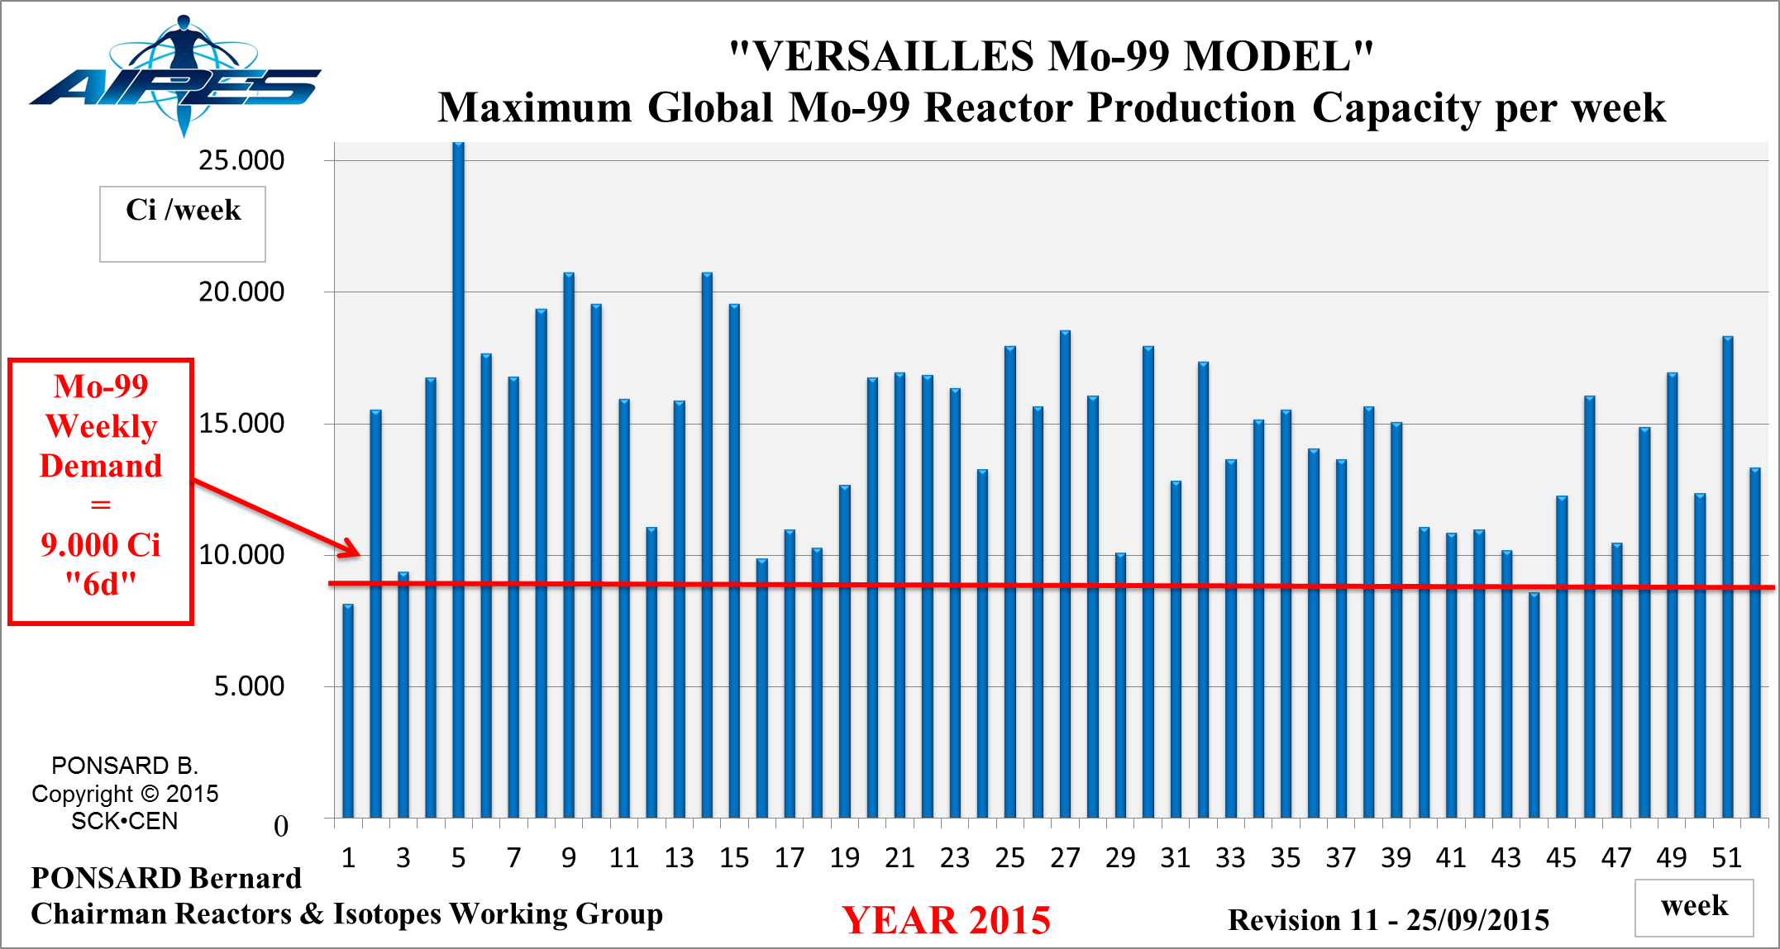

*FIG. 4. The AIPES "VERSAILLES Mo-99 MODEL" applied to 2015.*

The definitive shutdown of the OSIRIS (France) reactor at the end of 2015 and the decision taken by the Government of Canada to cease Mo-99 production at the NRU (Canada) reactor from November 2016 will result in a reduction of about 30% of the global Mo-99 production capacity by the end of 2016. The restart of the BR2 reactor after refurbishment (FIG. 5 & 6) is scheduled in July 2016. Its operating regime could be upgraded from currently 5 up to 8 operating cycles per year depending on the economics, i.e. up to 200 operating days per year from 2017. Other potential reactor-based and non-reactor solutions are currently under development for the secure supply of Mo-99 and Tc-99m in the medium to long-term future.

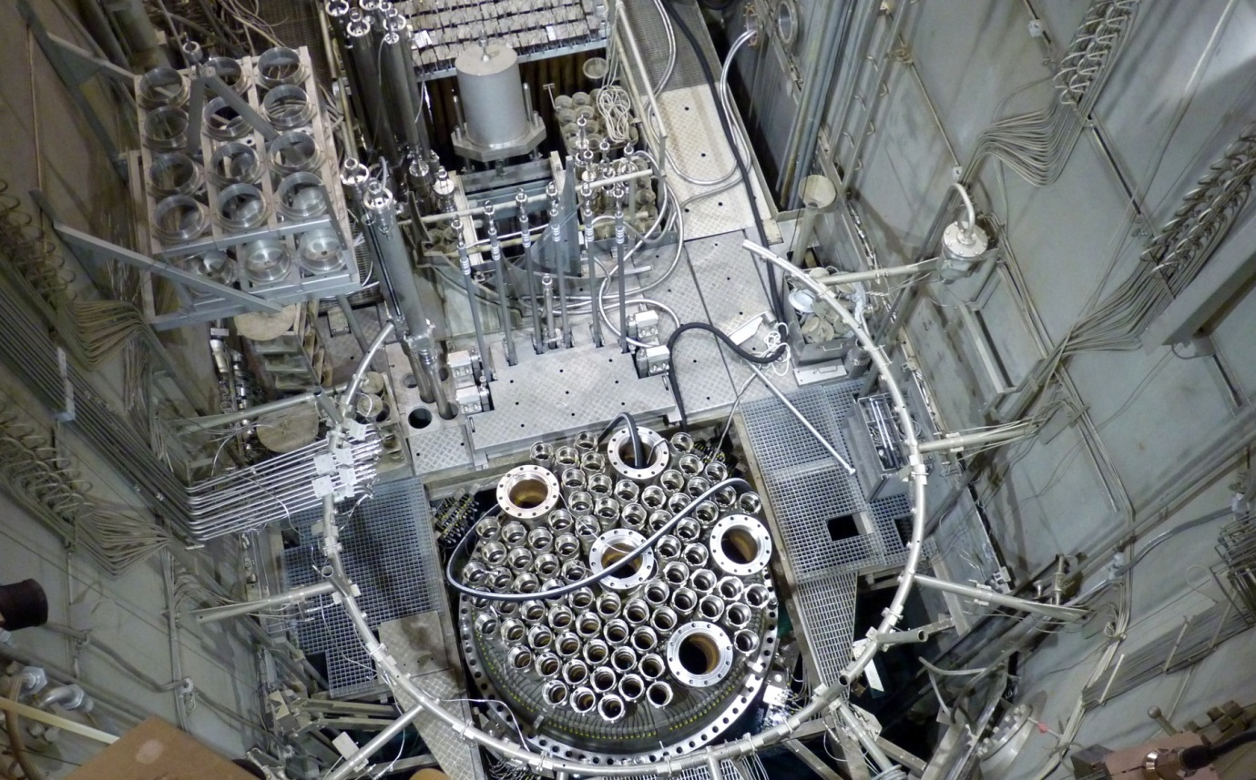

*FIG. 5. Unloading of the beryllium matrix from BR2's pressure vessel (April 2015).*

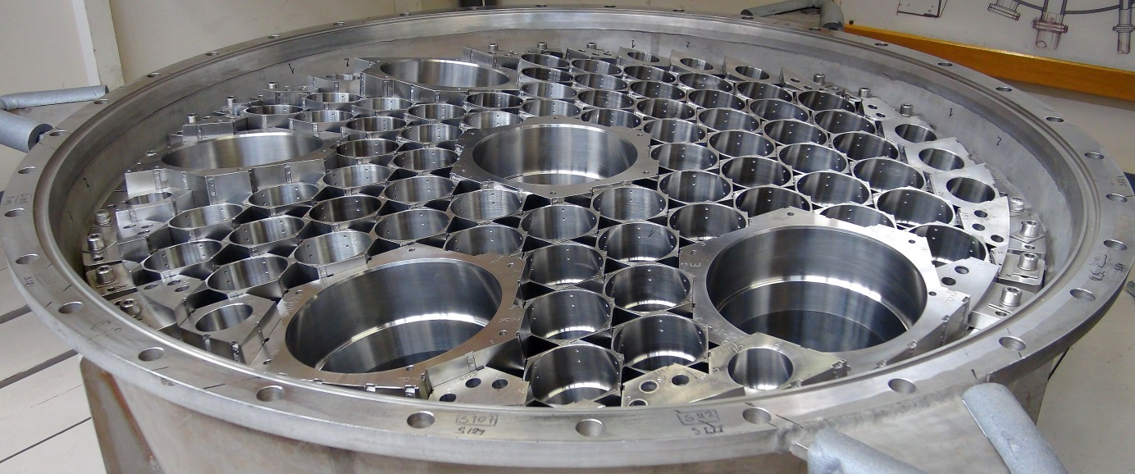

*FIG. 6. New beryllium matrix installed in BR2's mock-up pressure vessel (August 2015).*

### Production of other radioisotopes than Mo-99

Research reactors are not only producing Mo-99 but also various radioisotopes for therapeutic (Lu-177, Ir-192, Y-90, …) and palliative (Sr-89, Sm-153, Re-186, Re-188, …) treatments in nuclear medicine, and for industrial applications (Ir-192, Se-75, …). The availability of research reactors with high neutron fluxes and large irradiation volumes will remain a major concern in future. This is especially the case for the production of medical radioisotopes as Re-188 requiring the production of Tungsten-188 (W-188) by double neutron captures with low cross-sections. Highly enriched (up to 97%) W-186 targets need to be irradiated for several weeks in High-Flux reactors (high thermal neutron fluxes above 1 x 1015 n·cm-2·s-1) as SM-3 (Dimitrovgrad; Russia), HFIR (Oak Ridge; USA) and BR2 (Mol; Belgium) to achieve specific activities higher than 1 Ci/g [4]. The industry is facing the same issues for the production of Ir-192 and Se-75 sealed sources requiring specific activities above 500 Ci/g and 1000 Ci/g respectively for gammagraphy in Non Destructive Testing (NDT) applications.

### Conclusion

Although cyclotrons can produce complementary radioisotopes and further research can result in the development of alternative production routes for several reactor-produced radioisotopes, it will not be sufficient to make research reactors redundant in the next few decades. However, the ageing of the main research reactors involved in the global supply chains of medical and industrial radioisotopes makes secure supply difficult. The main challenges for research reactors regarding the production of medical and industrial radioisotopes in the period 2015-2020 and beyond will be to maintain enough reliable irradiation capacity through safe and reliable operation and to develop replacement projects (MYRRHA, PALLAS, …) to ensure continuity of production in the future supply chains.

### References

1. KRIJGER, G., PONSARD, B., HARFENSTELLER, M., WOLTERBEEK, H., NIJSEN, J., “The necessity of nuclear reactors for targeted radionuclide therapies”, Trends in Biotechnology, Volume 31, Number 7, pp. 390-396, July 2013, Elsevier Ltd., DOI/10.1016/j.tibtech.2013.04.007, ISSN 0167-7799.
2. PONSARD, B., “Status and Future of Mo-99 Supply”, 19th International Topical Meeting on Research Reactor Fuel Management, RRFM-2015, Bucharest, Romania, April 19-23, 2015, European Nuclear Society, ENS RRFM 2015 Transactions, 371-377, ISBN 978-92-95064-23-2, April 2015.
3. NEA/SEN/HLGMR (2015) 5, “The Supply of Medical Radioisotopes – 2015 Medical Isotope Supply Review : Mo-99/Tc-99m Market Demand and Production Capacity Projection, 2015-2020”, OECD/NEA, <https://www.oecd-nea.org/med-radio/supply-series.html>, August 2015.
4. PONSARD, B., MIRZADEH, S., KNAPP, F.F.(RUSS), “Production of Tungsten-188 in the BR2 Reactor in collaboration with ORNL”, 8th IIS International Symposium on the Synthesis and Applications of Isotopes and Isotopically Labelled Compounds, Boston, Massachusetts, USA, June 1-5, 2003. Book edited by John Wiley & Sons, 2004, International Isotope Society, “Synthesis and Applications of Isotopically Labelled Compounds", Volume 8, 103-106, ISBN 0 470 86365 X.