Feasibility Study for a New Research Reactor Project

In-Cheol LIM, Hee-Taek CHAE¹

¹Korea Atomic Energy Research Institute (KAERI), Daejeon, Korea

E-mail contact of main author: iclim@kaeri.re.kr

Abstract. The number of new comer countries interested in developing a program to introduce their first research reactor has grown significantly. In addition, the number of projects to introduce a replacement research reactor or to expand the national research reactor capacity has increased as well. A feasibility study should be conducted to demonstrate that a nation or an organization is in a position to make a decision on whether to proceed with the new research reactor project or not. The activities for a feasibility study or the contents of a feasibility study report may depend on the countries, stakeholders, or backgrounds of the research reactor projects. However, basically, the feasibility study should include an analysis of the costs, benefit, and risk involved in the realization of the results of the strategic plan. The feasibility study of KJRR(Ki-Jang Research Reactor) project was performed by following a guideline of KDI(Korea Development Institute) on feasibility study and the project started in 2012. KJRR is in the stage of construction permit review.
Key Words: Research reactor project, feasibility study, KJRR

Introduction
The number of new comer countries interested in developing a program to introduce their first research reactor has grown significantly. In addition, the number of projects to introduce a replacement research reactor or to expand the national research reactor capacity has increased as well. Thus, a guideline for the overall process of a research reactor project has been requested, and the IAEA published a guidebook in 2012, which is often called a milestone document[1]. As shown in FIG. 1, this guide specifies three phases before operation, a pre-project phase, a project formulation phase, and an implementation phase. For phase 1, i.e., the pre-project phase, a preliminary strategic plan should be prepared, and the report should show that there is sufficient need at the national level to justify the research reactor project. Another output of phase 1 should be a feasibility study report which demonstrates that a nation or an organization is in a position to make a decision on whether to proceed with the new research reactor project or not. This report will show all of the obligations and commitment involved and should include a long-term national strategy.
The activities for a feasibility study or the contents of a feasibility study report may depend on the countries, stakeholders, or backgrounds of the research reactor projects. However, basically, the feasibility study should include an analysis of the costs, benefit, and risk involved in the realization of the results of the strategic plan. In addition, the feasibility study should include a comprehensive assessment of all 19 national infrastructure issues described in the Milestone document.
This paper suggests the general scopes of feasibility study and shows a Korean example which is a feasibility study for KJRR project[2]. In addition, the status of KJRR project is briefly described.

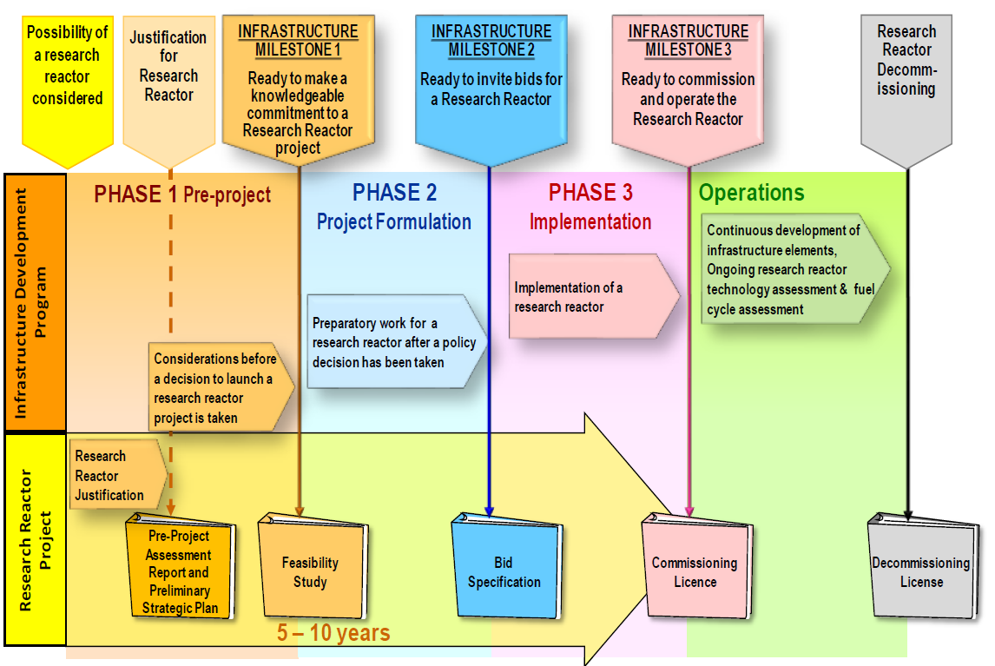
FIG.1. Phases of Research Reactor Project[1]

Scope of Feasibility Study for Research Reactor
The activities for a feasibility study or the contents of a feasibility study report may depend on the countries, stakeholders, or backgrounds of the research reactor projects. However, basically, the feasibility study should include an analysis of the costs, benefit, and risk involved in the realization of the results of the strategic plan. In addition, the feasibility study should include a comprehensive assessment of all 19 national infrastructure issues described in the Milestone document. This means the feasibility study report will incorporate and update the pre-Project Assessment and Preliminary Strategic Planning and integrate these with the analysis of the obligations, commitments and resources required [1]. As for the cost analysis, the project cost, the cost for operation and maintenance, the fuel cycle cost, and the decommission cost should be included. The difficulties in the cost and benefit analysis are in that the study should provide a prediction of the life time of the facility and in that a research reactor is a custom-design product, which makes it very difficult to find good references for the cost estimation. The best way to overcome these will be to make many experts involved in the analysis and to have enough time for sharing ideas and having discussions. The benefit from a research reactor may be a direct benefit such as the revenue from the sales of the products or services. For a research reactor, most of the benefit may be indirect such as a contribution to the basic research and to training and education. In addition, there are many different ways to count an indirect benefit. The choice of analysis method will be a decision of the study team, and should depend on the background of the research reactor project. The risk analysis should involve the analysis of technical, social, and financial risks. What is more important than the analyses of the costs, benefit, and risk is believed to be the strategic decision or intention of the project. If a research reactor project is strongly recommended and supported, many good ideas will be proposed during the feasibility study and will be accepted for a positive decision. There should be prerequisites of a feasibility study and they will be a justification of project, a definition of functional specifications for a research reactor, the organization in charge of a research reactor project, the organization in charge of feasibility study and preferred sites.

Feasibility Study for Korean New Research Reactor Project
The procedures of feasibility study for a project of a national organization such as KAERI are as follows;
- An organization submits a project proposal to the relevant ministry. The project proposal includes a pre-project assessment and preliminary strategic plan. For the case of KAERI, the relevant ministry is MSIP(Ministry of Science, ICT and Future Planning).
- MSIP reviews submitted proposals and the selected proposals are submitted to MOSF(Ministry of Strategy and Finance), which is in charge of budget and finance of the Korean government.
- MOSF reviews the proposals submitted by all the ministries of government and selects the proposals for which feasibility studies are conducted.
- There are two independent governmental institutes for feasibility study. In general, KDI(Korea Development Institute) conducts a study for construction project and KISTEP(Korea Institute of S&T Evaluation and Planning) does one for R&D project.
For a national construction project, the feasibility study aims to enhance fiscal productivity by launching large-scale public investment projects based on transparent and objective project evaluations. The National Finance Act of 2006 provides the legal framework of feasibility study. The feasibility study rule was introduced in April 1999 as a public sector reform initiative in the wake of the financial crisis of Korea during 1997 and 1998. All new large-scale projects with total costs amounting to 50 billion Won or more are subject to feasibility study. As shown in FIG.2, a feasibility study conducted by KDI consists of background study, economic analysis, policy analysis, balanced regional development analysis and Analytical Hierarchy Process(AHP)[3]. Most of feasibility study results are directly reflected to a budget formulation.
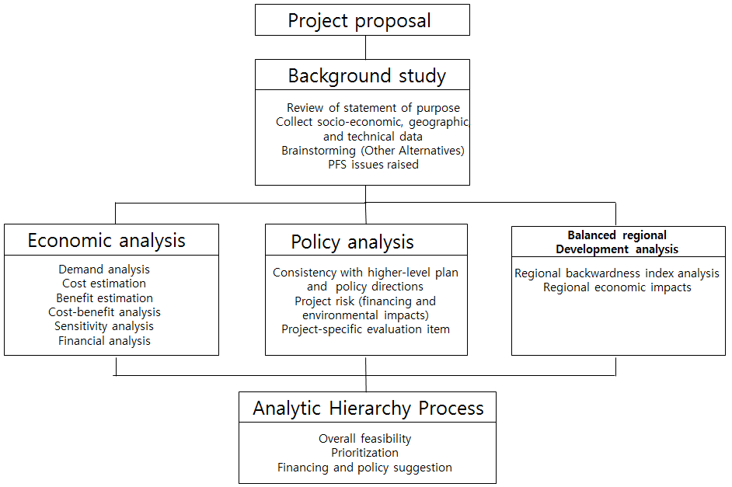
FIG.2. Scope of Feasibility Study by KDI in Korea[3]
The main purposes of KJRR were as follows [2];
- To fulfill the self-sufficiency of RI demand for Mo-99 and to provide the capacity for export
- To increase the neutron transmutation doping(NTD) capacity considering the increase of the use of power device using NTD silicon for green cars and renewable energy utilization
- To validate national research reactor technologies such as U-Mo plate type fuel, bottom-mounted control rod drive mechanism which will enlarge the research reactor system engineering capability of Korea
The feasibility study of KJRR had emphases on the analyses of technical issues, costs and benefits arising in the course of project and in the operation and utilization afterwards. The technical issues were whether the technical provisions were enough to realize the project. Analyses were performed for the costs of site preparation, construction, commissioning, operation, ageing management of facility, waste treatment, spent fuel management and decommissioning. As for the benefit analysis, the incomes from selling RIs and providing NTD services and the economic effect of new technology development were considered. The life time of the facility was considered to be 50 years for economic analysis. As KiJang county hosted the facility, the support from the local government and the effect of project to the local economy were analysed. An AHP analysis was conducted to hear the opinion of experts on the cost/benefit analysis, strategic review and the effect of project to the local economy. The overall study result was positive and KDI recommended to invest the national fund for the KJRR project. MOSF submitted the result to the National Assembly of Korea and the final decision to conduct the project was made in Dec. 2011.

Status of KJRR Project
The Korean Nuclear Safety Act was amended in May 2014 to make the licensing procedure of research reactor change from one step licensing to two step licensing: A construction permit(CP) and operating license(OL) issuance became separate. Following the conceptual and basic design of facilities conducted from 2012 to 2013, the licensing application for the construction permit was submitted to the NSSC(Nuclear Safety and Security Commission) of Korea on 25 November 2014 and is being reviewed by the Korean regulatory expert institute, KINS. Planned project milestones considering the licensing processes are shown in FIG. 3. It is possible for the project period to be extended depending on CP and OL review.
23 months
2
3
Application of
Construction
Permit
(’14.11)
First
Criticality
(‘18.3)
Construction
Permit
(’16.10)
12
Application of
Operating License
(’16.12)
Operating
License & Fuel
Loading
(’17.12)

FIG.3.Brief KJRR Project Milestones[4]
Procurements of the safety related equipment and components such as the reactor structure assembly, CRDM, man-machine interface system(MMIS), PCS pumps, HXs, and valves are being conducted by KAERI. The construction specifications and design documents for construction are being prepared by a selected architectural engineering company and the bidding process for construction is expected to start at the end of 2015[4].

Concluding Remarks
The feasibility study of a research reactor is a very important step for the decision and success of a project. The activities for a feasibility study or the contents of a feasibility study report may depend on the countries, stakeholders, or backgrounds of the research reactor projects. However, it should include the benefit, cost and strategic evaluation for the nation and a relevant local government.
As the milestone document for research reactor by IAEA [1] recommended, a feasibility study was performed for KJRR in making the decision of national investment. The application for construction permit of KJRR was submitted in May 2014 and the procurements of major equipment are in progress.

References

- INTERNATIONAL ATOMIC ENERGY AGENCY, Specific Considerations and Milestones for a Research ReactorProject, NP-T-5.1, Vienna (2012)
- I.C. LIM and et al., “Plan of New Research Reactor Construction In Korea”, presented at the ICRR 2011, Nov. 14-18, Rabat, Morocco(2011)
- H. PARK, “Preliminary Feasibility Study: Performance and Challenges”, presented at the Int. Seminar on Improving Public Investment Management for Large-Scale Government Projects”, May 22-23, Seoul, Korea(2007).
- H.T. CHAE and et al., “Project Status of Ki-Jang Research Reactor in Korea”, to be presented at the ICRR 2015, Nov. 16-20, Vienna, Austria(2015)

