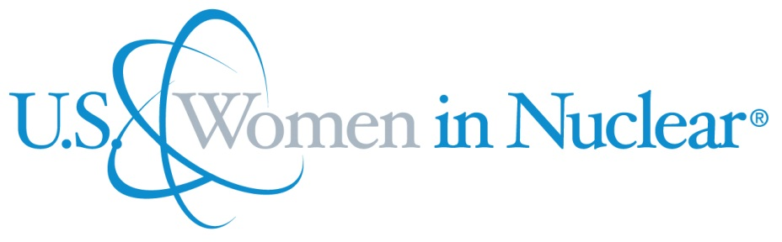

U.S. Women in Nuclear
Chapter president | U.S. WIN does not have a Chapter President
Chapter board members | The U.S. WIN Steering Committee members are: Marsha Bala (Idaho National Lab), Carol Berrigan (Nuclear Energy Institute), Victoria Dennis (Tennessee Valley Authority), Susan Downs (Talen Energy), Savannah Fitzwater (National Nuclear Security Administration), Angie Howard (Howard-Johnson Assoc.), Jhansi Kandasamy (PSEG Nuclear), Susan Korn (Exelon), Brenda Petrilena (Westinghouse), Sarah Risley (Pacific Gas and Electric), Meredith Werley (Duke Energy)
Number of members | 7,361 members and 67 local chapters as of July 2015
Chapter accepted by WiN Global | 1999
Nuclear power infrastructure | The U.S. has a large nuclear energy infrastructure with 99 operating reactors. 34 are boiling water reactors (BWRs) and 65 pressurized water reactors (PWRs). They generated 19.5 percent of U.S. electricity (797.1 billion kilowatt-hours) in 2014. These plants generate 63 percent of America’s carbon-free electricity.  The U.S. is currently building 5 new nuclear plants. Two each in South Carolina and Georgia and one in Tennessee. 74 of today's 99 operating reactors have received 20-year license renewals to operate for a total of 60 years, and many other reactors have applied for or announced intentions to renew their licenses for another 20 years. In 2014, the Vermont Yankee nuclear plant closed due to economic reasons.
Nuclear medical applications | Nuclear medicine is in wide use at facilities across the U.S. According to the American Nuclear Society, about one third of patients admitted to hospitals in the U.S. undergo at least one medical procedure that uses radioisotopes. Cumulatively, more than 15 million diagnostic tests and several hundred thousand therapeutic treatments are conducted each year.
Waste management philosophy | By law, the U.S. Department of Energy is responsible for developing a disposal facility for the long-term management of used uranium fuel from America's nuclear power plants.
Research | Nuclear research in the U.S. is conducted at national laboratories, universities, research reactors and private companies. This research covers a wide variety of areas such as: nuclear reactor technologies, fuel cycle technologies, waste management, advanced modelling and simulation, materials, space power systems, nuclear forensics, fission, industrial and medical applications.
Post-Fukushima | In the United States, the nuclear energy industry and the independent regulator, the U.S. Nuclear Regulatory Commission, took immediate steps to make nuclear facilities even safer than before the accident at Fukushima.  The industry quickly implemented a safety enhancement strategy to ensure that plants have the additional equipment needed to respond to extreme natural events such as the tsunami in Japan. The industry initiative will provide additional sources of water and electric power to keep the reactor and used fuel pool cool if electricity from the grid is unavailable, as it was in Japan. Additional generators, batteries, water pumps and other emergency equipment have been purchased at each site. In addition, regional response centers in Tennessee and Arizona will maintain more emergency equipment that can be dispatched quickly to any facility that needs it.  These enhancements follow additional safety measures that were implemented following the 2001 terrorist attacks. Safety enhancements made over more than 40 years, including new processes and procedures based on lessons learned from the accidents at Three Mile Island in 1979 and in Japan in 2011, have resulted in sustained high levels of safety.  The industry is implementing additional safety measures required by the Nuclear Regulatory Commission through 2016.

