 | 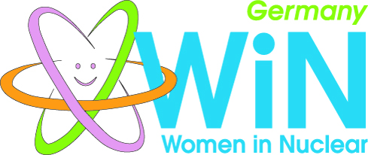

WiN Germany
Chapter president | Jutta Jené
Chapter board members | NPP, suppliers, utilities, research centres, consultants
Number of members | 234
Chapter accepted by WiN Global | November 2008
Nuclear power infrastructure | - 8 NPPs still in operation  - 3 research reactors (thermal power >50kW):  BER II; FRM II; FRMZ  - 4 waste management facilities:  Asse, Gorleben, Morsleben, Konrad (still project)  - Interim storages required by law at all NPP sites, research reactor sites and other nuclear facilities including medicine
Nuclear medical applications | Nuclear medical applications & research cover a wide range of diagnostic possibilities and focuses also on the assessment of brain functions, for example:  - Universitätsklinikum Düsseldorf in cooperation with Research Center Jülich  - tumour treatment facility at FRM II
Waste management philosophy | - Federal Government in charge of finding and building  safe final repositories  - Waste producer pays for necessary expenses  - New site selection for a HAW repository  - New law on final repository site selection adopted July 2013  - A committee with representatives of science and social  groups as well as from federal and state level was appointed  to answer key questions and develop criteria  - A final repository cannot be expected to be in operation  before 2050
Research | Karlsruhe Institute for Technology; Helmholtz-Zentrum Dresden-Rossendorf, Berlin & Geesthacht; Research Center Jülich; FRM II are still performing research on nuclear waste management, safety, materials or on nuclear fusion
Post-Fukushima | After Germany’s phase-out decision in 2011, the eight “older” NPPs were shut down immediately followed by Grafenrheinfeld June 27th 2015; remaining 8 NPPs will be shut-down stepwise till 2022
Energiewende = energy transition | “German Energiewende” has not been completed so far!

