 | 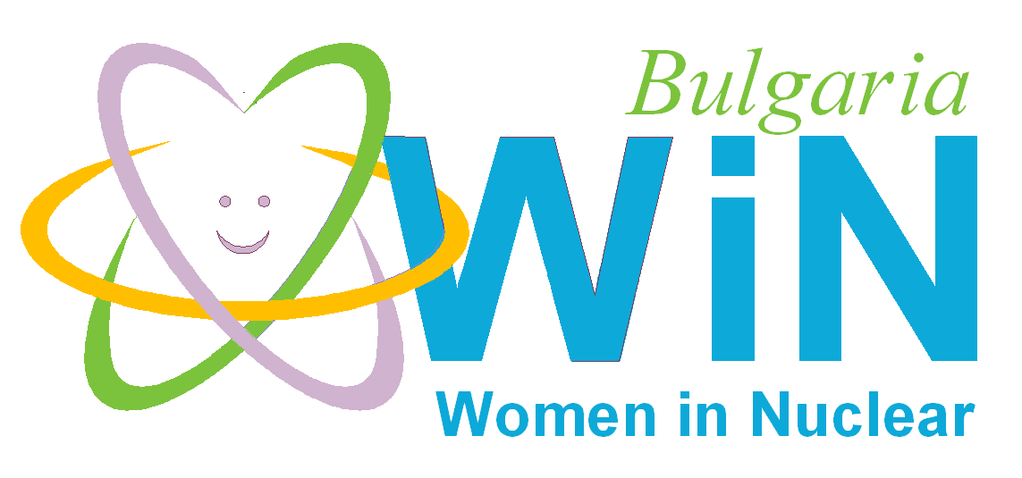

WiN Bulgaria
Chapter president | Radka Atanasova Ivanova
Chapter board members | WiN Bulgaria chapter board members are  NPP Kozloduy, State Enterprise for Radioactive Waste, Bulgarian company in nuclear energy, Spent Fuel Storage Facility
Number of members | 155
Chapter accepted by WiN Global | 1993
Nuclear power infrastructure | NPP Kozloduy  4 units, WWER 440 MW - shutdown for decommissioning  2 units, WWER 1000 MW - in operation  1 unit WWER 1000 MW - in planning phase  NPP Belene 2 units WWER1000 MW - under construction; but the project was stopped  Waste management  Repository for low & intermediate level waste -– 1 unit in operational phase,-State Enterprise for Radioactive Waste at NPP Kozloduy.  In planning phase– 1 unit - "Radiana" at Kozloduy to build a national repository for low and intermediate level radioactive waste  Repository for high level waste -in operational phase 1unit  1 Storage building in Novi Han for RAW from medicinal and research applications
Nuclear medical applications | - 2 cyclotrons
Waste management philosophy | Building a facility for treatment and conditioning of solid RAW with a high volume reduction factor at KozloduyNPP;  In planning phase - "Radiana" site at Kozloduy, for the building of a national repository for low and intermediate level radioactive waste
Research | Research Reactor 1 unit (2 MW) in reconstruction as a Cyclotron Physics Laboratory in INRNE.
Post-Fukushima | No change in public perception of nuclear
Main activities of the Bulgarian WiN chapter are:
- Mentoring and Training – work with young generations
- Public acceptance
- Participating in nuclear conferences
- Social activities

