 | 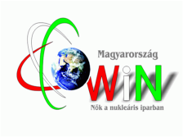

WiN Hungary
Chapter president | Ágota Szabó
Chapter board members | 2 vice presidents (Milla Kiss Zoltánné, Katalin Radnóti)
Number of members | 42
Chapter accepted by WiN Global | Established in 1994
Nuclear power infrastructure | 4 VVER Units in Paks, 2 research reactors (Budapest)
Nuclear medical applications
Waste management philosophy | Interim Spent Fuel Storage (nearby Paks NPP, storage for 50 years, air-cooling by natural circulation)  National Radioactive Waste Repository in Bátaapáti (40 km from Paks– already in operation since 2012).  The Radioactive Waste Treatment and Disposal facility in Püspökszilágyi for low- and intermediate-level wastes exclusively of non- nuclear power plant origin.
Research | Research Reactor - Energy Centre of Hungarian Science Academy (Budapest)  Research Reactor -Budapest Technical University
Post-Fukushima | Post-Fukushima action plan in process in Paks, no big changes

