 | 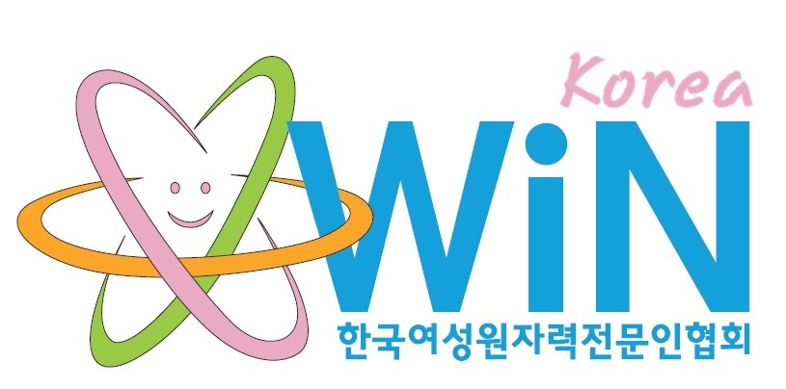

WiN Korea
Chapter president | Dr. Rena Lee, Nuclear Engineer, Professor of Ewha Womans University Hospital
Chapter board members | The twenty five Board members of WiN Korea are working for the KAERI (Korea Atomic Energy Research Institute), the NSASC (Nuclear Safety and Security Commission), the KINS (Korea Institute of Nuclear Safety), the KHNP (Korea Hydro & Nuclear Power Co.), the KNEA (Korea Nuclear Energy Agency), the KEPCO-ENC, the KORAD (Korea Radioactive Waste Agency), DOOSAN Eng., Nuclear Medicine or Oncology in the hospitals, Universities, etc.
Number of members | 480 members: 17 members were increased since 2014. Among them, 457 are WiN Global members.
Chapter accepted by WiN Global | November 7th 2000
Nuclear power infrastructure | Number of NPPs: 24 units in operation (21,716MW, 20 PWR and 4 PHWR) in the 4 regions. Four are under construction and another 4 are under approval process for construction: 1 of 4 are under commissioning test. There are no decommissioning or decommissioned nuclear power reactors so far, but Kori #1 is planned to phase out in June 2017. Ten more are planned to construct until 2021 and 2022.]  The radioactive waste disposal facility completed the first phase of construction with 6 silos for 100,000 drums out of 800,000 drums in June 2014. The first 16 drums of radioactive wastes disposed on 13 July 2015. Three thousand drums is planned to dispose until the end of 2015. Korea Radioactive Waste Agency (KORAD) announced that the second phase of the facility will be completed by 2019 as near-surface disposal with 125,000 drums.
Nuclear medical applications | Number of Research Reactors: 4 (2 in operation, 1 in decommissioning and 1 decommissioned)
Waste management philosophy | “World’s best eco-friendly radwaste management” is the key value of waste management. Vision of Korea Radioactive Waste Agency (KORAD) is “Best Safety, Best Trust & Global KORAD.” Its management policy is Extensive, Integral and Innovative to win public confidence with the top level safety.
Research | Korea Atomic Research Institute is running various research projects such as Sodium-cooled Fast Reactor (SFR), Very High Temperature gas-cooled Reactor (VHTR), System-integrated Modular Advanced ReacTor (SMART: 330MWt) in the field of nuclear reactor.  In the field of nuclear fuel, Dual-cooled Fuel for PWR, Next Generation Fuels for Research Reactor and LWR MOX Fuel. Pyroprocess Technology, Direct Use of spent PWR fuel in CANDU reactors (DUPIC) and High-level Waste Disposal Research in the field of fuel cycle. KAERI has research reactor called HANARO. It has various research projects in relevant with HANARO.
Post-Fukushima | Korea evaluated all the Npps in their safety after Fukushima accident. 56 items for enhancement were produced. 40 items were completed until 2014. The rest will be finished until 2015. The nuclear infrastructure in Korea has not currently changed but Korea government decided to phase out one reactor, the Korea’s first nuclear reactor (turnkey-based by Westinghouse), Kori #1 in 2017 when it finishes its first licensed period of life-extended operation.

