 | 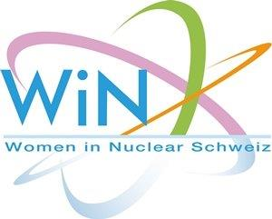

WiN Switzerland
Chapter president | Helena Loner
Chapter board members | Helena Loner / nuclear power plant KKL  Ruth Schmid / communication swissnuclear  Sara Tania Mongelli / radioactive waste disposal Axpo Power AG
Number of members | 47
Chapter accepted by WiN Global | 1995
Nuclear power infrastructure | 5 NPPs at 4 sites  1 research reactors (University Lausanne)  1 interim storage facility  No mines
Nuclear medical applications | There are several university hospitals which do also research.  At PSI: Centre for Proton Therapy, cooperation with the University Children’s Hospital in Zürich. It operates the worldwide first compact scanning gantry for the irradiation of deep-seated tumours and ocular melanoma with proton beam.
Waste management philosophy | Intermediate storage in one central surface facility (ZWILAG) and on plant sites (no export allowed). Future deep geological repository in opalinus clay within northern Switzerland. Site selection ongoing, decision due around 2020, construction starting around 2030, storage from 2050 onwards.
Research | Nuclear research and education is still done at the federal technical universities ETH Zurich (Prof. Prasser) and EPFL Lausanne (Prof. Pautz), as well as at Paul Scherrer Institute, Nuclear Energy and Safety Dept. Focus: decommissioning, materials ageing, fuel cladding, fluid dynamics.
Post-Fukushima | Switzerland took part in the EU-stress tests. The results were outstanding. Further safety technical improvements were implemented following ENSI demands (enhancing of safety margins). However, already in late spring 2011 the Federal Government decided to phase out nuclear and push new renewable production (subsidies).
 | Swiss nuclear energy is in a difficult market situation. The massive German subsidies for new renewables have destroyed the central European electricity prices. Phase outs for economic reasons are becoming more and more likely.

