Evaluation of sealing performance of metal gasket used in dual purpose metal cask subjected to an aircraft engine missile

K. Shirai, K. Namba, M. Wataru, T. Saegusa
Civil Engineering Laboratory, Central Research Institute of Electric Power Industry

Abstract. In order to investigate of the integrity of the lid structure of the metal cask during the extreme impact loads due to aircraft crash, two impact scenarios for aircraft engine crash onto the metal cask without impact limiters are considered for both, a vertical impact onto the lid structure and a horizontal impact hitting the cask. The horizontal impact test using scale model engine of aircraft and the vertical impact onto the head of the full-scale metal cask were executed. From these experimental results, it seems that the loss of the inner pressure of the cask cavity may be avoided in the impact event with the horizontal and vertical orientation even if the severe impact load was applied on to the metal cask due to aircraft engine crush. Moreover, in order to evaluate the deformation response of the metal gasket subjected to the accidental loads measured during experiments, the impact analysis by LS-DYNA code was executed.

Introduction
After the terrorist attack in 2001 in USA, safety assessment for airplane crash to important nuclear facilities as severe accident has been actively conducted in USA and Germany[1]. In Japan, as to airplane crash, it depends on its probability whether it is considered in design. If it exceeds 10⁻⁷/facility/year, it shall be taken into account in the design as “credible external accident”. In this paper, a civilian airplane is assumed to crash on a storage facility as a severe accident of “credible external event”. First of all, we considered an impact condition so that a highly rigid engine (hereafter, engine) penetrates the storage facility via local fracture of the facility and hits a storage cask. Then, we conducted tests of horizontal impact assuming a missile simulating the engine hit the cask in order to evaluate its containment performance of the cask against the impact. Furthermore, we simulated the horizontal impact test using the impact analysis code LS-DYNA in order to reproduce the impact behavior and the containment performance[2][3].

Horizontal impact test to scale model cask

Containment Structure of Metal Cask
Fig. 1 shows overview of a metal cask. Metal gaskets (hereafter, gaskets) are installed between the cask body and the lids to assure containment. Pressure inside the cask cavity is maintained negative in order to prevent radioactive materials to leak from inside of the cask. Fig. 2 shows the overview of the metal gasket. The metal gasket is subjected to a thermal loading due to the heat generated from the spent fuel in the cask. The spring back force of the metal gasket may be deteriorated due to creep deformation of aluminum jacket of the gasket and the containment performance may deteriorate. Therefore, the effect
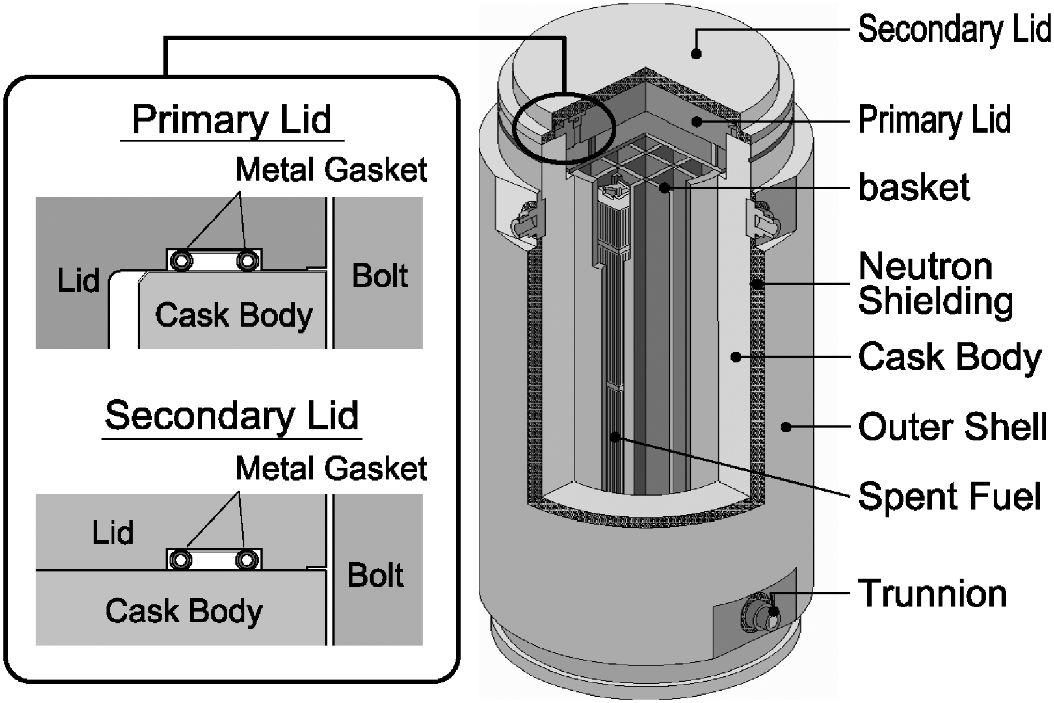
FIG. 1. Overview of a metal cask

of stress relaxation due to the thermal loading to the gasket was taken into account.

Assumed Impact Condition
The airplane was assumed Boeing 747 most often used in the assessment in USA and Germany. The missile was assumed a rigid engine of the airplane. When a Boeing 747 crashes to a storage facility with a wall thickness of 85 cm with a speed of 90 m/s (same as the requirement of the type C package in the IAEA transport regulations) that exceeds the landing speed of 280 km/h (77 m/s), the engine is expected to penetrate the wall of the storage facility. This penetration was evaluated by the Degen formula[4] that was used to evaluate penetration of a rigid missile into the concrete wall of the reprocessing facility at Rokkasho village in Japan. The residual speed after the penetration was calculated as 60 m/s using the formula in the “Guidelines for the Design and Assessment of Concrete Structures subjected to Impact” by UKAEA[5]. Fig. 3 shows time histories of force by aircraft engine crash with a speed of 60 m/s obtained through the impact analysis.

Test Conditions

Impact Posture
The impact direction of the missile against the cask lid could be mainly horizontal or vertical. In this case, we conducted tests so that a missile impacts horizontally on the upper edge of the cask in the vicinity of the lid. The cask was a scaled model down to 2/5 (hereafter, scale cask).

High Speed Missile
The missile was accelerated by a force by gunpowder and loaded impact force to the scale cask. The mass and the expected speed of the missile were determined using the engine specification and similarity law. The mass was 288 kg and the impact velocity was 60 m/s. Fig. 4 shows the converted

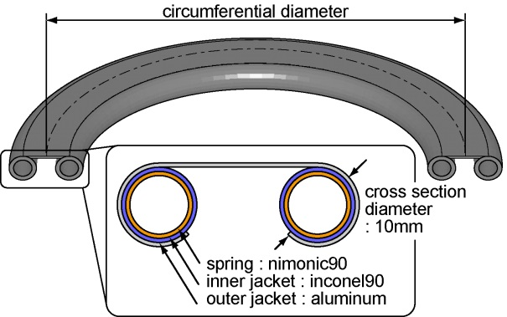
FIG. 2. Overview of metal gasket

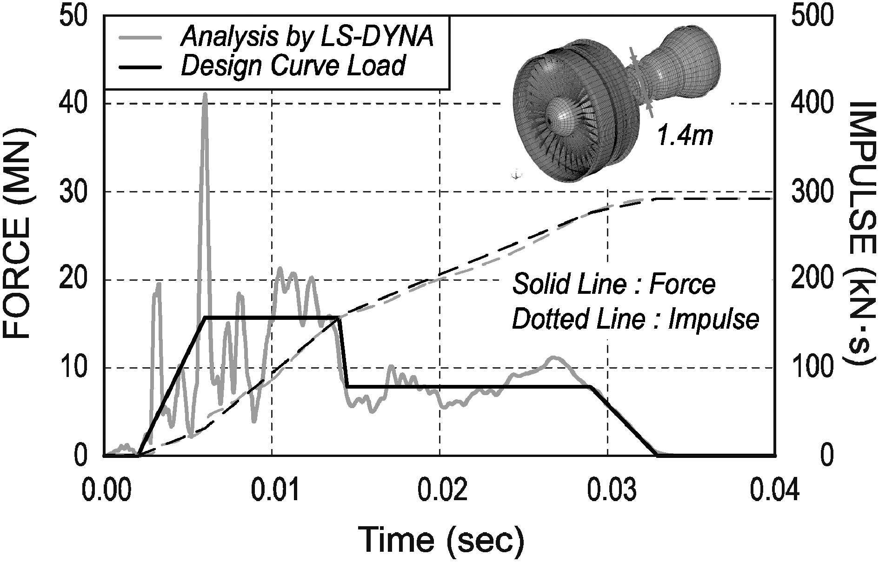
FIG. 3. Time histories of force by aircraft engine crash with a speed of 60 m/s

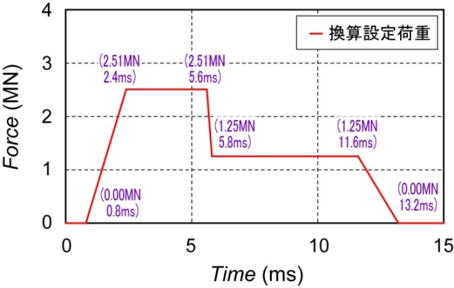
Converted force
FIG. 4. Converted force
Shock absorber
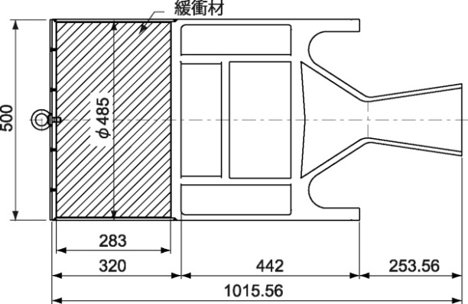
FIG. 5. Overview of the missile

force according to the similarity law. Shock absorber was installed inside the missile so that the loading duration (about 12 ms) of the converted force becomes equal to the impulse. The material of the shock absorber was incombustible and light weighted aluminum alloy that is foamed and has thin-walled cell structure (cylinder of ϕ485mm×h283mm, density of 0.28g/cm³, and material property of Al-10Zn-0.3Mg). Fig. 5 shows the overview of the missile.

Scale Cask
The scale cask is scaled down cask by 2/5 of a full size cask, as shown in Fig. 6. The scale cask has a cylindrical shape with an outer diameter of about 0.9 m, height about 1.9 m, and mass about 4.5 tons. The containment performance is secured by metal gaskets installed between the cask body and the lid. Although the real cask has two lids, the scale cask for the test had only one lid assuming that the two lids will undergo the same force and behave similarly at the impact. The scale cask for the test will represent conservative behavior. In addition, the diameter of the metal gasket of the scale cask was about 6.1 mm in order to secure the reliability of the containment performance of the scale cask.

Apparatus of the Horizontal Impact Test
The apparatus of the impact test consisted of launcher, launcher base, concrete base, protection cage that prevent the missile and the target from dispersion and protect measurement devises, etc., as shown in Fig. 7.

Horizontal Missile Impact Test

Thermal Load to the Gasket
Thermal load was given to the scale cask in the vicinity of the lid with thermal insulator and electric heater. The heating condition to the metal gasket was 174°C×32.5 hrs. This condition is expressed by LMP = 9618 using the following equation.

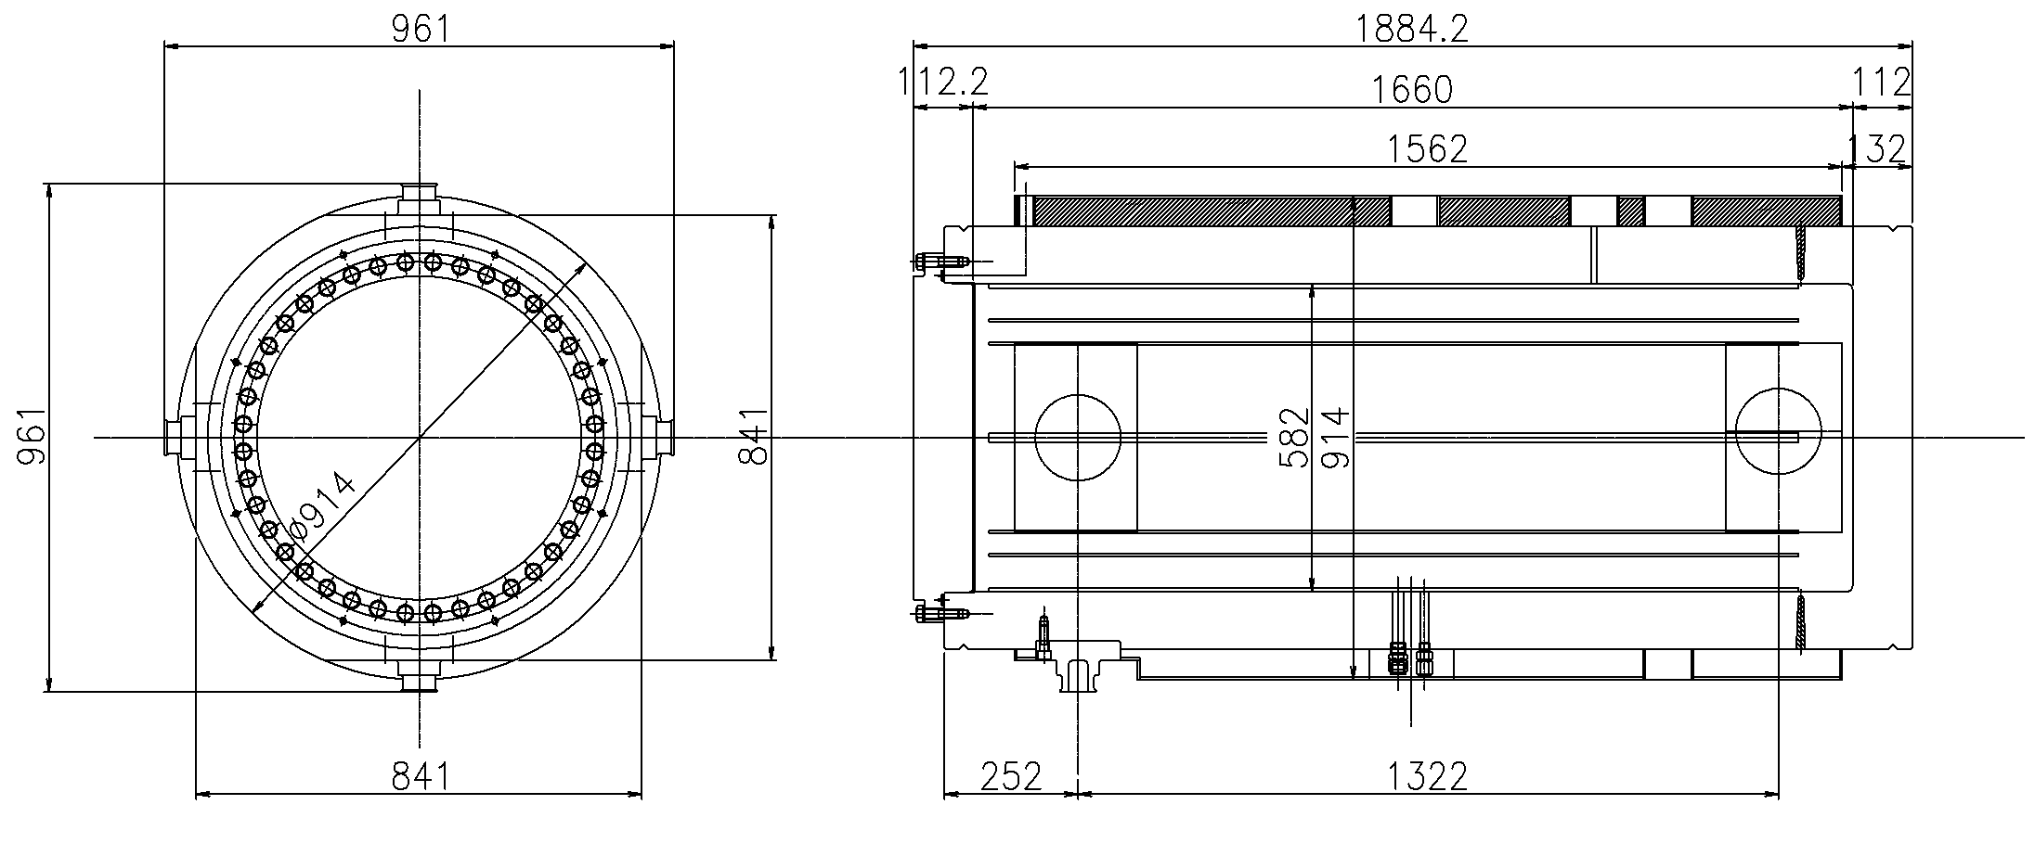
FIG. 6. Overview of the Scale Model Cask

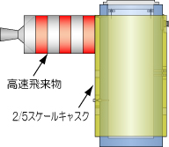
Engine Missile
2/5 Scale Cask
FIG. 7. Outline of the horizontal missile impact test
LMP=T (C + log t) (1)
T：Absolute temperature（K）, t：Time（hr）, C：Constant（=20）
The temperature of the real cask and the lid decreases with time due to the decay heat of the spent fuel. Assuming the initial temperature of the cask being 120°C, 115°C, 105°C, the thermal load condition (LMP = 9618) is equivalent to that the real cask undergoes ageing of 4 to 60 years. Finally, the impact test was conducted after the test body was cooled down to the ambient temperature.

Leak Test
After the lid of the scale cask was closed, leak tests were conducted to secure that the scale cask satisfies the required containment performance The leak tests were conducted after placing the cask on the frame, before and after the heating, and before the impact test. In any cases, we confirmed that the leak rate was less than 1.0×10⁻¹⁰ Pa·m³/s.

Results of the Horizontal Impact Test
Although the axial stress of the lid bolts slightly increased, the increment was as small as about 7 % and significantly small as compared with the yield stress of the material (890MPa). Thereby, we concluded that the generated stress was within the elastic region. The maximum sliding displacement generated in this test was about 0.6 mm and accumulated sliding displacement that is discussed later was about 1.0 mm. Helium leak rate at the gasket right after the impact increased rapidly from 8.2×10⁻¹¹ Pa·m³/s to 4.0×10⁻⁶ Pa·m³/s. Then, the leak rate gradually decreased and converged to about 1.0×10⁻⁶ Pa·m³/s at 20 hours after the impact test.

Leak Rate Evaluation of a Full-Scale Cask

Evaluation Method of Leak Rate
With respect to the confinement function of casks used for interim storage, Atomic Energy Society of Japan shows “Method to evaluate leak rate of metal gasket at its post storage transportation” in its interpretation to “Standard for Safety Design and Inspection of Metal Casks for Spent Fuel Interim Storage Facility” (AESJ-SC-F002: 2010)[6]. It proposed that evaluation should be made each for opening displacement and for lateral sliding displacement. For instantaneous leakage at drop or tipping over event, the leakage can be evaluated by the lateral sliding if “the stresses generated at lid flange, cask body flange, and lid bolts retaining a metal gasket” are within the elastic region. Here, the opening displacement means displacement of lid movement in the vertical direction against the containment flange, as shown in Fig. 8. When one estimates the leak rate from accumulated lateral sliding, one should use a relationship between leak rate of the gasket with thermal load and sliding displacement. The relationship between leak rate of the gasket with thermal load and sliding displacement of a gasket with diameter of 10 mm was obtained on instantaneous leak test using a 1/10 scale model of a lid structure[7], as shown in Fig. 9.

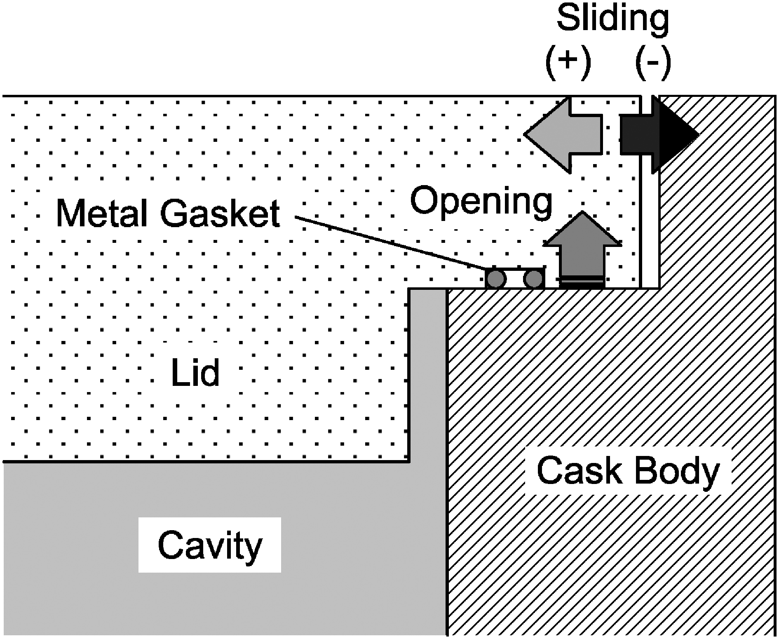
FIG. 8. Sliding and opening displacement of cask lid

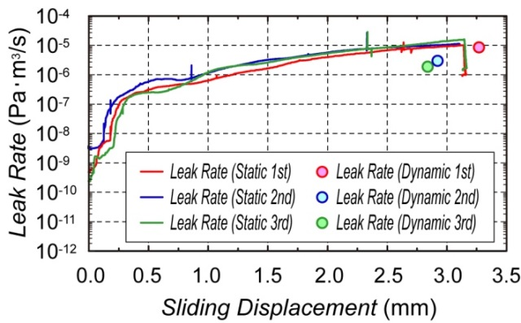
FIG. 9. Leak rate and lateral sliding displacement

Estimation from Accumulated Sliding
We estimate leak rate of a full-scale cask from the relationship between leak rate and sliding displacement that was calibrated for a full-scale cask. The accumulated sliding displacement of the scale cask by the impact test was about 1.0 mm, which is 2.5 mm for the full-scale cask. Leak rate corresponding to the sliding displacement of 2.5 mm is estimated as 7.9×10⁻⁶ Pa·m³/s from the relationship shown in Fig. 9. Assuming the diameter of the metal gasket of the full-scale cask be 10 mm, the leak rate of the full-scale cask is estimated as 3.5×10⁻⁵ Pa·m³/s.

Analysis of Impact Response at the Horizontal Impact Test
Since the scenario of the missile impact could be assumed in many ways including the impact angle to the cask, leak rate and response behaviour should be evaluated efficiently using numerical analysis. Therefore, the horizontal impact test was simulated with respect to leak rate and response behavior by an analysis in order to confirm reproducibility of the numerical analysis. Three-dimensional analytical code was LS-DYNA Ver. 970 (for PC). By the analysis of the horizontal impact test, we confirmed that no plastic zone exceeding 0.2 % was found in the lid flange, cask flange, and lid bolts retaining the metal gasket, and that they were within the elastic region. The analytical results were in good agreement with the test results as shown in Table 1.

Table 1. Comparison of analytical result and test result
Item | Analysis | Test
Sliding | Max. 0.64mm  Accumulated 0.96mm | Max. 0.59mm  Accumulated 1.05mm
Opening | Max. 0.03mm | Max. 0.02mm
Bolt Stress | Max. 253MPa | Max. 259MPa
Estimated Leak Rate of Full-Scale Cask | 7.3×10⁻⁶ Pa·m³/s | 3.5×10⁻⁵ Pa·m³/s

Vertical Impact Test to Full-Scale Partial Model Cask

Test condition

Impact Posture
In the vertical impact test, we conducted tests so that a missile impact vertically on the center of the secondary lid of the cask lying horizontally. Fig. 10 shows the outline of the vertical impact test.

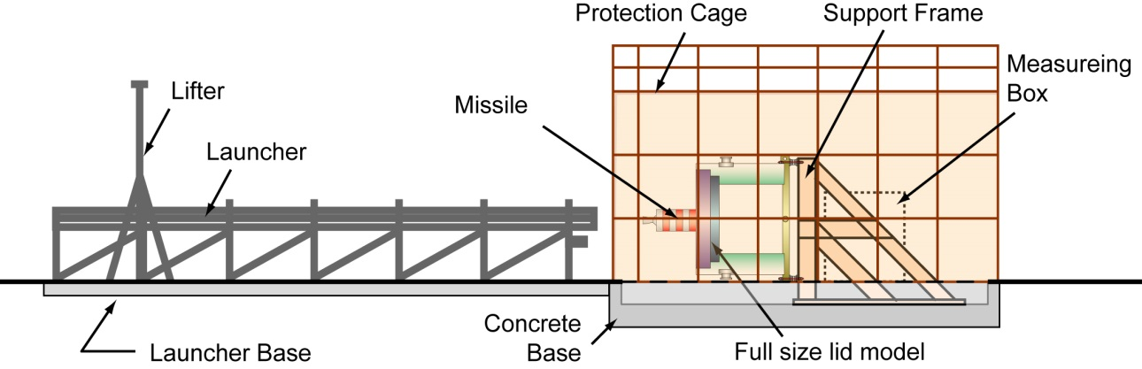
FIG. 10. Outline of the vertical impact test

High Speed Missile
Conditions of the missile (missile structure, velocity etc.) were determined so that the impact damage is equivalent to that by the assumed force. The force was adjusted by the shock absorber attached to the missile similar to that used for the horizontal impact test in the previous section. Fig.11 shows the overview of the missile used for the vertical impact test. The absorber had a cylindrical shape with dimension of ϕ485mm ×h141.5mm. The mass was designed to be 298 kg and the impact speed was 65 m/s. The real product weighed 302.5 kg.
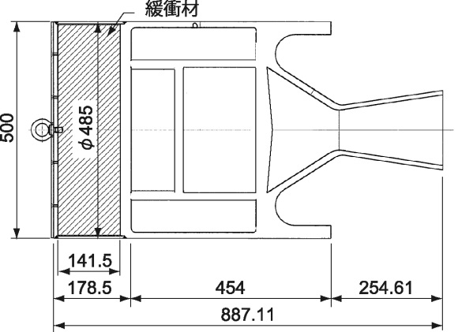
Shock absorber
Shock absorber
FIG. 11. Overview of the missile

Lid Model
The lid model was cut from a full-scale transport/storage cask that can install 69 BWR spent fuel assemblies and has double lid structure, and a bottom plate was welded to the cut surface. Fig. 12 shows the test model cut from the full-scale cask. The lid model has the dimension of about 2.8 m in diameter, about 1.8 m in length, and weighs about 36 tons (Cask body 27 tons, primary lid 4 tons, secondary lid 5 tons).The lid structure consists of primary and secondary lids forming a space between the two lids. The containment is secured by a metal gasket with aluminum coating (Cross sectional diameter is 5.6 mm for the primary lid and 10 mm for the secondary lid).

Test condition

Results of the Vertical Impact Test
Fig. 13 shows the measurement results of the vertical impact test. The maximum acceleration generated at the cask body was about 50 G. The maximum acceleration of about 280 G was generated at the primary lid and a bending vibration of about 400 Hz was cyclically generated. Measurements of the secondary lid were not available due to failure of wires. The axial stress of the secondary lid increased by about 100 MPa, which is within the elastic region and the lid bolts were sound. While, the axial stress of the bolts for the primary lid did not change before (average 311.0 MPa) and after (average 308.5 MPa) the impact test.
The leak rate of the primary lid gasket was less than 1.0×10⁻¹⁰ Pa·m³/sec before the impact test and increased right after the impact up to 1.43×10⁻⁷ Pa·m³/sec at maximum and gradually restored. On the other hand, the leak rate of the secondary lid gasket was less than 1.0×10⁻¹⁰ Pa･m³/sec before the impact test and exceeded the detection limit of 1.0×10⁻³ Pa·m³/sec right after the impact test and was not measured. Replacing the detector and measurement after three hours, the leak rate of the secondary

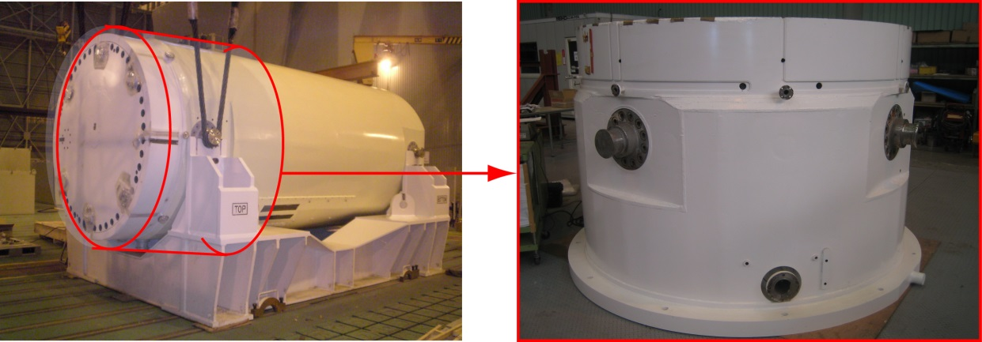
(Full-scale cask) (Test model cut from the full-scale cask)
FIG. 12. Cask lid model
lid gasket was 7.25×10⁻⁷ Pa·m³/sec.
The pressure between the two lids, vibrated by the bending of the lids and decreased to 298 kPa (gauge pressure) finally, which was 306 kPa before the impact test. The decrease of 8 kPa will be due to the leak of Helium gas.
Vertical displacement of the primary and the secondary lids showed similar response. They were about 0.13 mm for the secondary lid and about 0.2 mm for the primary lid. The cyclic displacement of the primary lid would have been accompanied by the cyclic bending vibration of the lid.

Analysis of Impact Response at the Vertical Impact Test
The vertical impact test was simulated with respect to the response behavior of the cask by an analysis in order to confirm reproducibility of the numerical analysis and evaluate the behavior of the lid with the metal gasket. Three-dimensional analytical code for the numerical analysis was LS-DYNA Ver. 970 (for PC). Fig. 14 shows analytical results on lateral sliding displacement and vertical displacement for the primary and the secondary lids. The analytical results were in good agreement with the test results.
Fig. 15 shows time history of the lid opening displacement as a result of the numerical analysis. The opening displacement of the primary lid at the initial stage of the impact showed a displacement as small as about 0.02 mm and gradually the vibration attenuated to the initial value. On the other hand, the opening displacement of the secondary lid showed a displacement as large as about 0.4 mm and still exceeded 0.1 mm even at the end of the analysis of 20 msec. Generally speaking, the spring back displacement of the aluminum gasket is 0.08 mm, which indicates possible leakage due to the lid opening at the impact. On the other hand, the integrity of the secondary lid bolts had been confirmed and the opening displacement vibration would converge to the initial position. Therefore we can conclude that the pressure decrease due to the lid opening is small and negligible for the containment performance of the cask. These observations are proof of the fact of the rapid increase of the leak rate right after the impact and the leak rate was below 1×10⁻⁶ Pa·m³/sec three hours after the impact test.

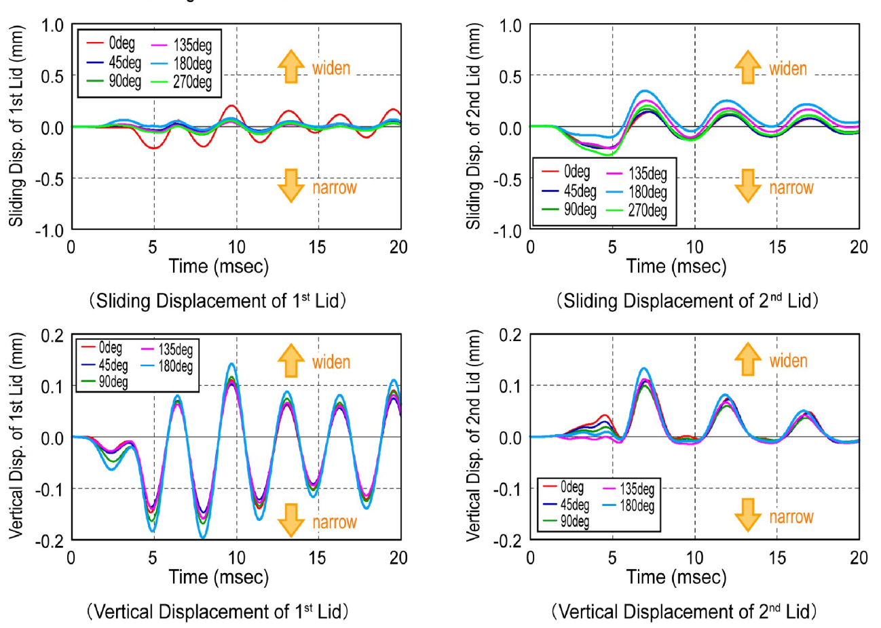
FIG. 13. Measurement results on lid displacement at the vertical impact test

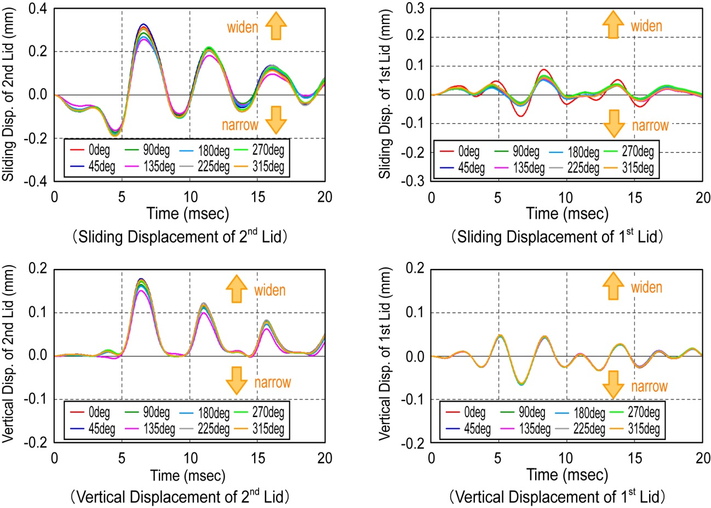
FIG. 14. Analytical results on lid displacement

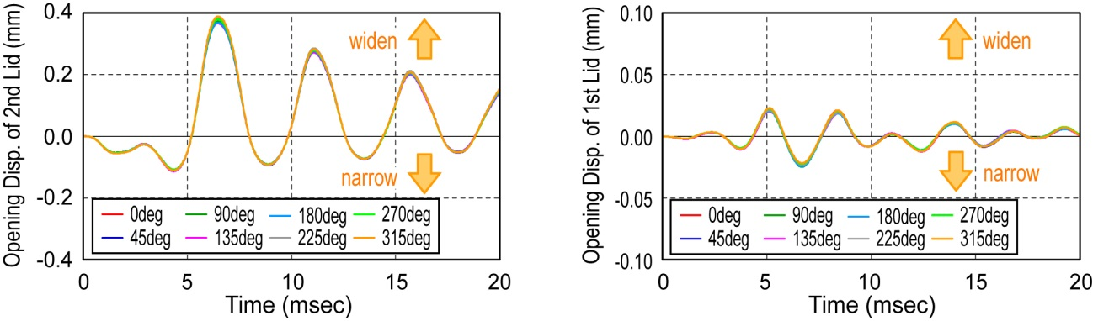
FIG. 15. Analytical results of lid opening at the vertical impact test (LS-DYNA)

Evaluation of Leak Rate
The analytical results showed that the lid opening displacement did not affect the containment performance of the cask and the structural materials of the flange for the secondary and the primary lid were within the elastic region. The numerical analysis as shown in Fig. 14 showed the accumulated lateral sliding displacement of the primary lid was 0.336 mm at maximum at 0 degree position and that of the secondary lid was 0.958 mm at maximum at 45 degrees position. While the measurements of the sliding displacement of the primary lid as shown in Fig. 13 was 0.724 mm at maximum at 0 degree position and that of the secondary lid was 1.018 mm at 270 degrees position. The analytical results showed less value for the primary lid at 0 degree position, but the other results were almost in good agreement with the measurements.
Finally, we can estimate the leak rate from the accumulated sliding displacement and the previous section 2.4. The leak rate was 3.07×10⁻⁷ Pa m³/s for the primary lid and 1.15×10⁻⁶ Pa m³/s for the secondary lid. These values were almost equal to those of the measurements. Thereby, we could confirm the applicability of the evaluation method.

Conclusions
In order to investigate of the integrity of the lid structure of the metal cask during the extreme impact loads due to aircraft crash, two impact scenarios for aircraft engine crash onto the metal cask without impact limiters were considered for both, a vertical impact onto the lid structure and a horizontal impact hitting the cask,. The horizontal impact test using scale model engine of aircraft has been executed and leak rate from the metallic gasket in the cask also measured at the impact in the test. The vertical impact onto the head of the full-scale metal cask has been also executed. From these experimental results, it seems that the loss of the inner pressure of the cask cavity may be avoided in the impact event with the horizontal and vertical orientation even if the severe impact load was applied on to the metal cask due to aircraft engine crush. Furthermore, it is found that the impact analysis code LS-DYNA could reproduce the impact behavior and the containment performance of the metal cask sealing system under the extreme impact loads due to aircraft crash.

Acknowledgements
These researches were conducted under the contract from Nuclear and Industrial Safety Agency of the Ministry of Economy, Trade and Industry of the Japanese government.

References
[1] | B. R. Thomauske: Realization of the German concept for interim storage of spent nuclear fuel -Current situation and prospects-, WM´03 Conference, Tucson, AZ, USA, (2003).
[2] | K. Namba, K. Shirai, and T. Saegusa: “Evaluation of sealing performance of metal cask subjected to horizontal impact load due to aircraft engine”, J. Japan Society of Civil Engineers, Vol.66, No.2, p.177-163 (2010).
[3] | K. Namba, K. Shirai, and T. Saegusa: “Evaluation of sealing performance of metal cask subjected to vertical impact load due to aircraft engine”, J. Atomic Energy Society of Japan, Vol.9, No.2, p.183-198 (2010).
[4] | Degen P.P., “Perforation of reinforced concrete slabs by rigid missiles, Journal of the Structural Division, Proceedings of ASCE, Vol.106. No.ST7, July, (1980).
[5] | P. Barr: Guidelines for the Design and Assessment of Concrete Structures subjected to Impact, Wigshaw Lane, Culcheth Cheshire,WA3 4NE, (1990).
[6] | Atomic Energy Society of Japan: “Standard for Safety Design and Inspection of Metal Casks for Spent Fuel Interim Storage Facility” (AESJ-SC-F002: 2010).
[7] | K. Namba, K. Shirai, T. Saegusa, and K. Shimamura: “Numerical analysis on containment performance of metal cask subjected to impact from air craft”, Journal of structural engineering, Vol.55A, (2009).

