Role of KINS for Emergency Preparedness and Response in Korea

Seung-Young Jeong, Ph.D,

Department Head of Nuclear Emergency Preparedness and Response,
Korea Institute of Nuclear Safety (KINS),
62 Gwahak-ro , Yuseong-gu, Daejeon, 305-338, Korea, k504jsy@kins.re.kr

Abstract

This paper reviews the important role of Korea Institute of Nuclear Safety (KINS) for emergency preparedness and response in Korea. The KINS performs the regulation on the safety performance and radiological emergency preparedness of the nuclear facilities and radiation utilizations. The radiological emergency preparedness in Korea is based on the Act on Physical Protection and Radiological Emergency which stipulate a national preparation against radiological emergency. Also, KINS has set up the “Radiological Emergency Technical Advisory Plan” and the associated procedures such as an emergency response manual in consideration of the IAEA Safety Standards GS-R-2 and GS-G-2.1. The Radiological Emergency Technical Advisory Center (RETAC), which is in charge of providing technical advice on radiological emergency response, dispatching technical advisory teams to the affected Off-site Emergency Management Center (OEMC), initiating emergency operation of 128 nation-wide environmental radioactivity monitoring stations in accordance with the Nationwide Environmental Radioactivity Monitoring Plan, coordination and control of off-site radiation monitoring, offering radiation monitoring cars, and monitoring the response activities of the operator, will be organized by KINS for the response of emergency situations. Moreover, so as to efficiently implement technical support activities for protection of the public and the environment in a nuclear or radiological emergency of a nuclear power plant, the “Atomic Computerized Technical Advisory System for a Radiological Emergency” (AtomCARE) has been developed and is in operation. Through the system, any nuclear or radiological emergency and its consequences can be quickly verified and assessed, and subsequently, comprehensive management of the information related to public protective actions is also made possible. Recently, The KINS published the report (2013) to adapt the Precautionary Action Zone (PAZ) and Urgent Protective Action Planning Zone (UPZ) applying the IAEA guidelines and reflecting the lessons learned from Fukushima Daiichi NPP accident and was legislated in the Radiological Emergency Act.

A. Introduction

The foundation of radiological emergency preparedness and response of Republic of Korea lies in the Act on Physical Protection and Radiological Emergency of Nuclear Installations, etc.(APPRE) as well as the Framework Act on the Management of Disaster and Safety which defines disaster management at the national level. The Nuclear Safety and Security Commission(NSSC), the regulatory authority, supervises the regulation of nuclear installation and the radiological emergency preparedness and response to implement the APPRE. The Korea Institute of Nuclear Safety(KINS), the technical support organization, conducts the regulatory activities such as review and inspection in accordance with laws, regulations and guides related to nuclear safety and radiological emergency preparedness and response.

The legal and regulatory framework for emergency preparedness and response is prescribed in the APPRE. The NSSC is a competent authority having overall responsibilities and the leading role relating to radiological emergency preparedness and response of the Korean government. The NSSC has established the National Radiological Emergency Plan, pursuant to the APPRE and local governments concerned make their Local Radiological Emergency Plan in accordance with the National Radiological Emergency Plan.

B. National Scheme of Radiological Emergency Preparedness and Response

The emergency response organizations of Korea consist of the followings: the Central Safety Management Committee headed by the Prime Minister; the National Emergency Management Committee(NEMC) and the Off-Site Emergency Management Center(OEMC) run by the NSSC; the Local Emergency Management Center(LEMC) operated by the local government; the Radiological Emergency Technical Advisory Center(RETAC) run by the KINS; the National Radiation Emergency Medical Center(NREMC) run by Korea Institute of Radiological & Medical Sciences(KIRAMS) and the Emergency Operations Facility(EOF) managed by the nuclear operator. The KINS provides technical support for the radiation emergency response by establishing and operating the RETAC and KIRAMS provides medical service to cure and treat for patients and the public by the REMSC as shown in Figure 1.

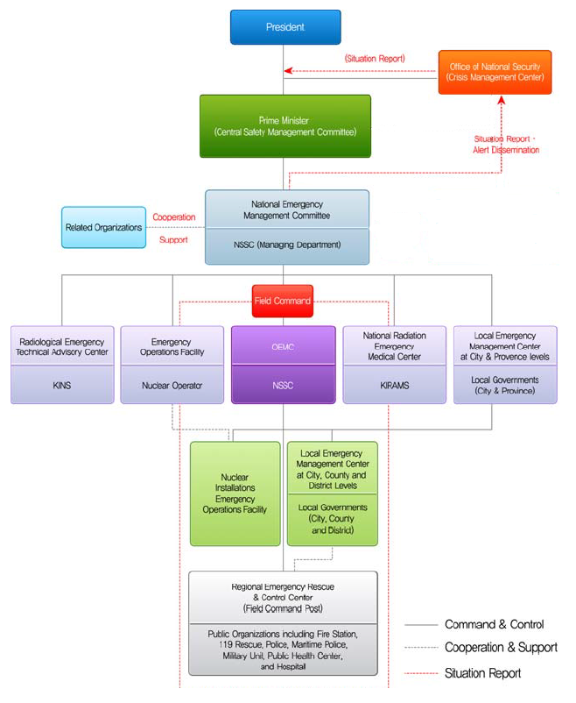
Figure 1. National Radiological Emergency Response Scheme
The central government has a responsibility to control and coordinate the countermeasures against radiological disaster. The NSSC installs and operates the OEMC, which is chaired by the standing member (Secretary General) of the NSSC. It consists of experts from the central government; local governments; local military and police; fire-fighting and educational institutes; nuclear safety expert organizations, radiological medical service institutes; and the nuclear operator. The OEMC has a responsibility to perform coordination and management of radiological emergency response such as accident analysis, radiation/radioactivity detection, and decision-making on public protective actions (sheltering, evacuation, food restriction, distribution of thyroid protection medicine, and control of carrying-out or consumption of agricultural, live-stock and fishery products). The OEMC consists of seven working groups, and Joint Disaster Countermeasures Council is established as an advisory body to the director of OEMC. Joint Information Center is operated as one of the working groups to provide accurate and coordinated information about radiological disaster. The LEMC, established by the local governments concerned, implements the OEMC's decision on protective measures for residents. It also takes charge of coordination and control of emergency relief activities utilizing local fire stations, police stations and military units. When an accident occurs, the operator of nuclear installation is responsible for organizing an Emergency Operations Facility and for taking measures to mitigate the consequences of the accident, to restore installations, and to protect the on-site personnel.

On the other hand, the central government has operated the national radiological emergency medical treatment system for coordination and control of radiological medical services. The system consists of the National Radiological Emergency Medical Center (NREMC) and primary and secondary radiological emergency medical hospitals designated by the region. The KIRAMS establishes National Radiation Emergency Medical Center(NREMC) and administers the national radiological emergency medical system in case of radiological emergency. The national emergency response steps are shown at Figure 2.

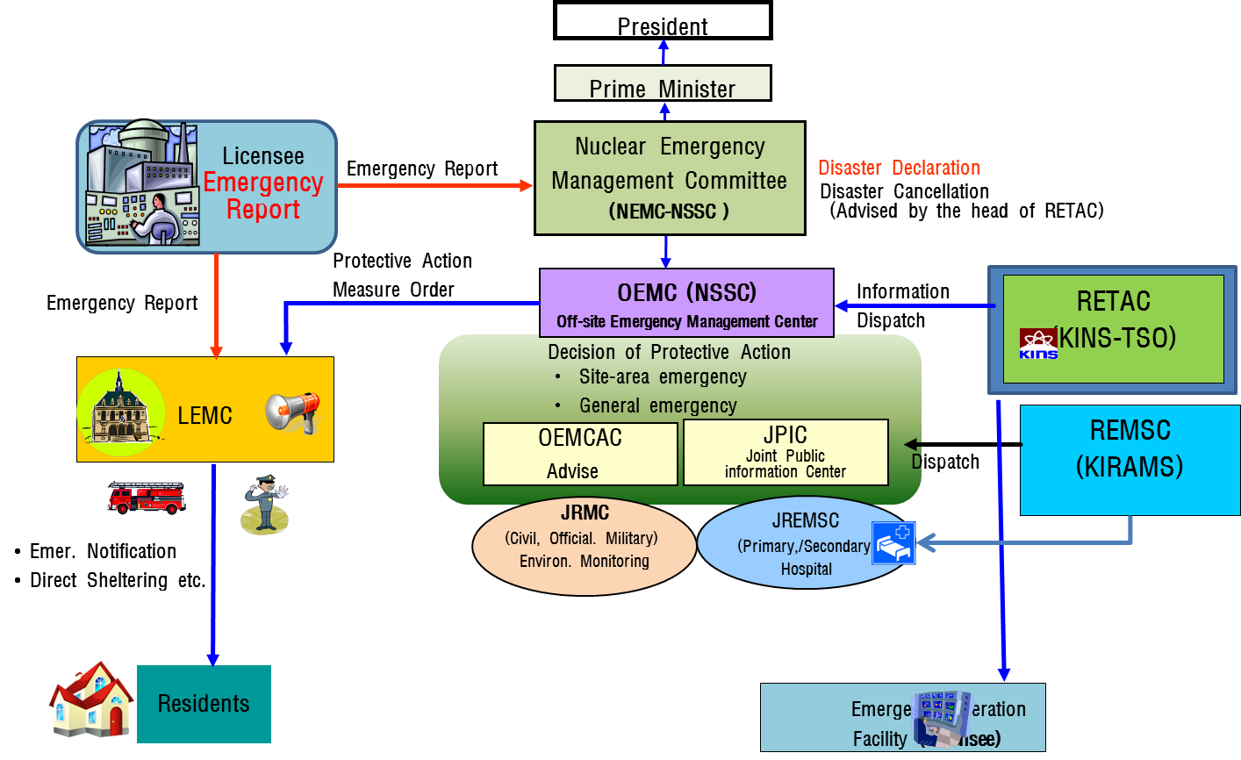

Figure 2. National Radiological Emergency Response Steps

C. Emergency Preparedness and Response by KINS

The KINS performs safety regulation not only to conform the safety and emergency preparedness of nuclear installations, but also technically advice to government for emergency management in case of the accident at nuclear installations. For regulation of emergency preparedness of nuclear installations, the KINS reviews ‘the Radiological Emergency Plan of Nuclear Licensee’ to issues the operational license and inspect the emergency preparedness of nuclear installations annually. The regulatory activities are entrusted from NSSC as prescribed by the Presidential Decree.

The KINS is appointed to give the technical advice to government for the radiological accident management of nuclear installations. In case of accident, the KINS organizes Radiological Emergency Technical Advisory Center (RETEC) to provide the technical advice on radiological emergency response and dispatches the technical advisory teams to the OEMC at affected site. Also, the RETAC initiates the emergency operation of 128 nation-wide environmental radioactivity monitoring network in accordance with the Nationwide Environmental Radioactivity Monitoring Plan. The KINS coordinate to organize the Joint Radiological Monitoring Center to conduct the off-site radiation monitoring and provide radiological status to OEMC center and RETAC of KINS for decision making of public protective measures. It has an agreement with the Nuclear/Biological/Chemical Defense Command for prompt response in the initial phase of a radiological emergency.

The KINS also has developed the Atomic Computerized Technical Advisory System (AtomCARE) for a Radiological Emergency. Currently it is operated in order to effectively provide various technical supports for the public and environment protection in radiological emergencies. The AtomCARE permits not only the rapid analysis and evaluation of radiological emergencies and radiation impacts but also the comprehensive management of information about several measures to protect the public. Its configuration is represented in Figure 3.

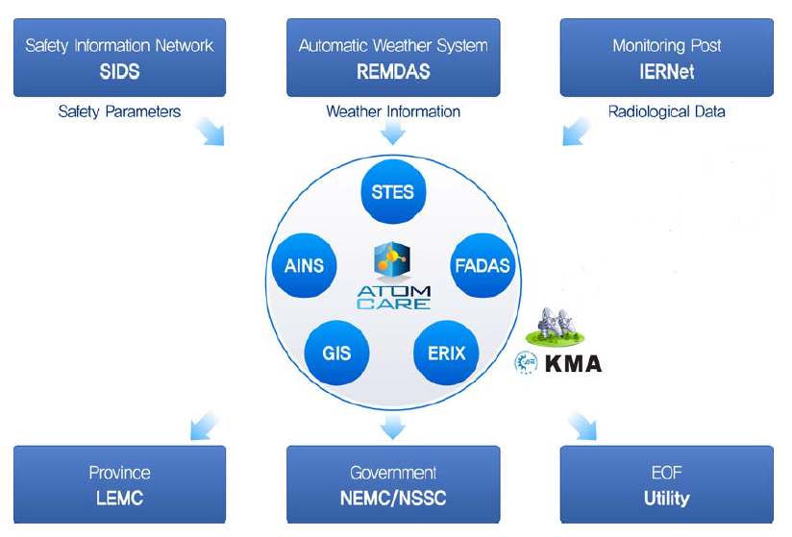 | • SIDS  • IERNet  • REMDAS  • AINS  • STES  • FADAS  • GIS  • ERIX  • KMA  • LEMC  • NEMC  • EOF | : Safety Information Display System  : Integrated Environmental Radiation  Network  : Radiological Emergency Management  Data Acquisition System  : Automatic Information Notification  System  : Source Term Evaluation System  : Following Accident Dose Assessment  System  : Geographic Information System  : Emergency Response Information  Exchange system  : Korea Meteorological Administration  : Local Emergency Management Center  : National Emergency Management  Committee  : Emergency Operations Facility
Figure 3. Atomic Computerized Technical Advisory System for the Radiological Emergency (AtomCARE)

The KINS is continuously monitoring nationwide environmental radiation and dose rates and also it monitors routinely radiation contamination of airborne particles, fallouts, rain, farm products, soil, water and milk for early detection of abnormal situation or symptoms and also for a timely response to them. The KINS has also been operating Automated National Environmental Monitoring Network since 1997. A total of 128 radiation monitoring stations are interconnected to the central monitoring station at the KINS on this network (Figure 4). The national environmental monitoring results open to public through web (http://iernet.re.kr) and application of smart devices (eRAD@now). The KINS annually provides training and education program to the technicians working at local radiation monitoring stations and conducts inter-comparison analysis with foreign institutes periodically for improving the quality of radiation monitoring. KINS conducts radiation analysis for 137Cs, 3H, 90Sr and 239+240Pu after taking surface seawater samples at 21 designated points (8 points at the East Sea, 7 at the South Sea and 6 at the West Sea) once or twice a year as shown in Figure 4. At some points the analysis is also performed for seawater from different depth, maritime organism (fish, shells and seaweeds) and seabed sediments.

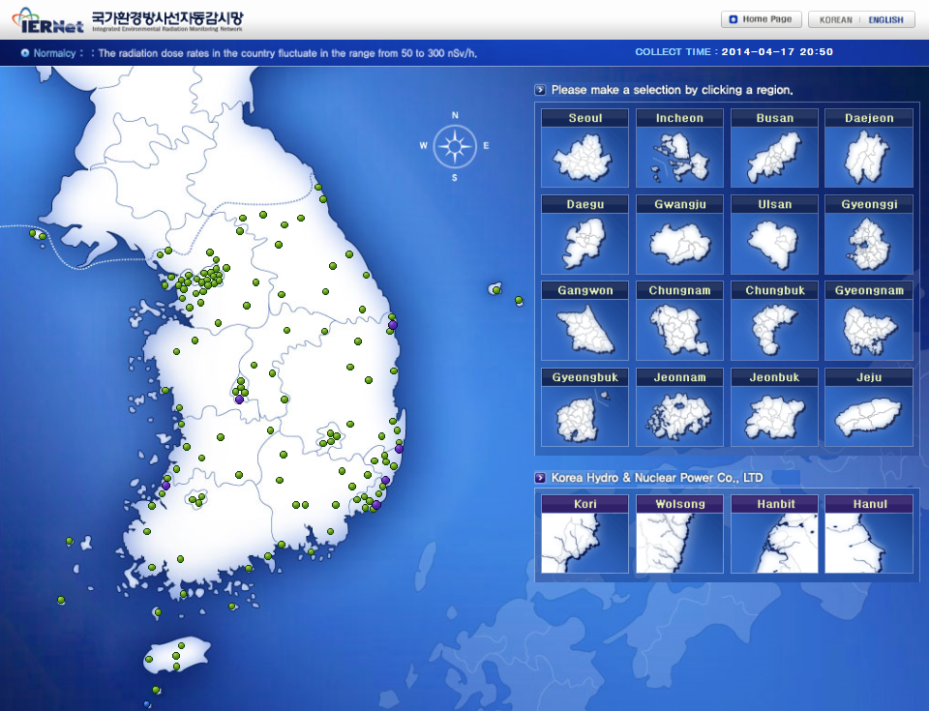 | 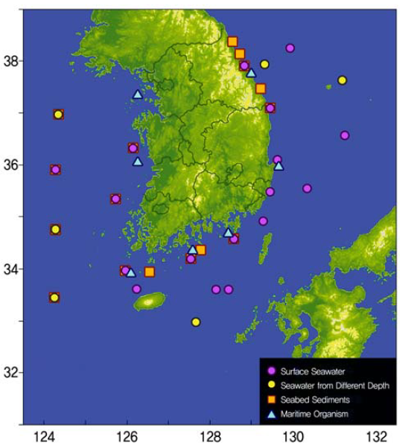
Figure 4. National Environmental Radiation Monitoring Network (http://iernet.kins.re.kr)

D. Lessons Learned from Fukushima Accident and Reflecting Activity

The KINS had operated the RETAC during Fukushima accident not only to monitor accident progression, radiation environmental condition, an air stream trajectory, but also to assess domestic impact including radiation environmental condition and public heath impact.

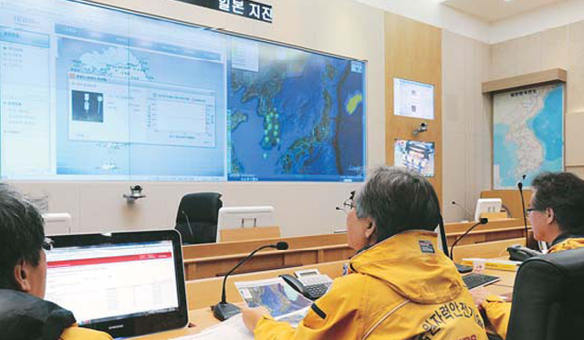 | 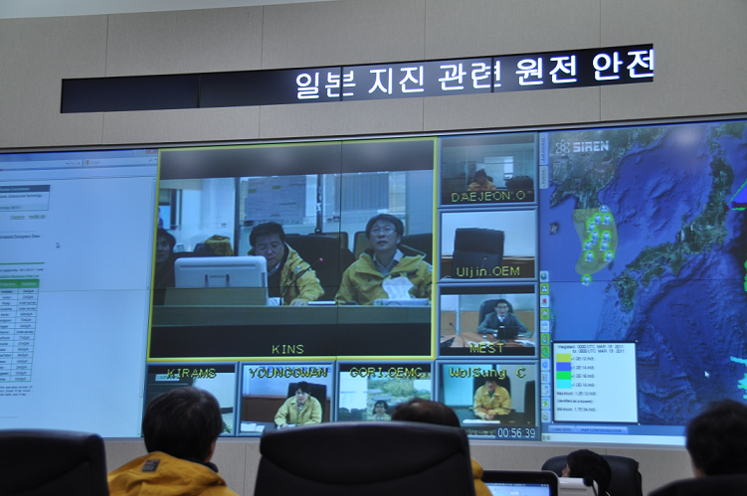
Figure 4. Activity of KINS-RETAC during Fukushima Accident.
The KINS and related expert organization dispatched to the 4 international airports and 2 seaports for radiation surveillance to immigrants from Japan. About 400,000 immigrants were surveyed voluntarily and only a few people were identified for light surface contamination.

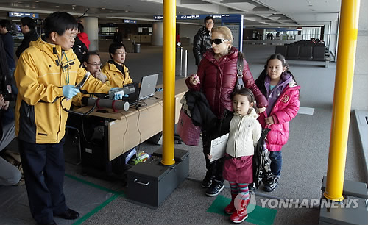 | 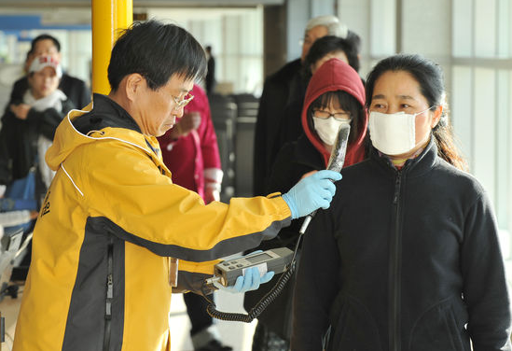
Figure 5. Radiation Surveillance at the Airports and Seaports

The environmental radiation monitoring strengthened after Fukushima accident. As a 1st step (since March 11, 2011), the period of ambient radiation level monitoring was changed from 15 minutes to 5 minutes, the period of airborne radioactivity monitoring increased from monthly to weekly, and continuously meteorological observation for air trajectory and diffusion analysis were conducted by KINS-RETAC. As a 2st step (since March 28, 2011), the period of airborne radioactivity monitoring increased from weekly to daily, and γ-spectrometry for every rain sample and drinking water were surveyed. As a result of these activities, several enhancements were made to effectively response the emergency situation. First, the environmental monitoring stations were increased from 70 to 128 during last three years.

The KINS also has enhanced the Atomic Computerized Technical Advisory System (AtomCARE) for a Radiological Emergency. First, safety parameters transmission from nuclear installation to AtomCARE system changed to fiber optic cable and dual transmission system. Using these safety parameters, Safety Information Display System (SIDS) was improved to display the operational status and accident progression of the NPPs. Also, The REMDAS system improved to collect meteorological information (wind speed, direction, temperature, precipitation, etc.) from the Korea Meteorological Administration (KMA). The FADAS, following accident dose assessment system for estimating doses to public from an expected exposure, was improved for estimating domestic as well as oversea region.

The KINS has conducted the research by characteristic assessment of Korea nuclear installations taken into account radiological consequences of severe accidents with radical progressions and conservative assumptions, and review the IAEA standards and the lessons learned from Fukushima accident. As a result, The KINS suggested the adoption of the Precautionary Action Zone (PAZ) and the Urgent Protective action Planning Zone (UPZ) instead of the Emergency Planning Zone (EPZ). For more prompt and effective protection of the public in case of a radiological emergency, the revision of the radiological emergency planning zone is in the works to divide the existing Emergency Planning Zone (EPZ) into the PAZ and the UPZ for applying the safety standards of the IAEA and to reflect the Fukushima lesson learned.

Consequently, the APPRE law adopted the PAZ (3~5 km) and UPZ (20~30 km) from the NPP sites May 21, 2014. Therefore, public of PAZ area will be evacuated at general emergency situation, and then public dose assessment result will be applied for public protective action using General Intervention Level (GIL), and after radiological substance released from nuclear installation, the result of urgent environmental monitoring and Operational Interventional Level (OIL) will be used to decide public protective measures.

E. Special Safety Inspection after Fukushima Accident

The safety inspection team consisted of experts from KINS, the industry, academia, and research institutes conducted the special safety inspection just after Fukushima accident and issued 50 action items to all operating nuclear installations in Korea based on defense-in depth approach. The action items were to minimize the impact of extreme natural disaster, to make available emergency power and ultimate heat sink, and to eliminate the likelihood of severe accident and avoid hydrogen explosion. Among 50 action items, eleven action items were identified in region of emergency response and medical system for amending the radiological emergency plan to response the accident of multiple units and for improving emergency response of nuclear installation. The action items to respond to a natural disaster beyond the design basis and simultaneous emergencies at multiple units were identified as follows:
- Securing additional thyroid blocking agent for protecting residents near a nuclear power plant,
- Amending the radiation emergency plan to include such events as the simultaneously issuing an emergency alert at multiple units,
- Securing additional equipment in preparation for an event where in the emergency is prolonged,
- Securing additional radiation equipment for emergency medical treatment organizations,
- Reinforcing radiation emergency exercise,
- Devising a means for securing necessary information in case of a prolonged loss of electrical power,
- Securing countermeasures for protecting maintenance workers,
- Improving emergency response facilities,
- Amending the procedure of public information releasing in case of a radiological emergency,
- Evaluating protective measures for residents who live beyond the EPZ, and
- Reinforcing the performance of emergency public address system.

The licenses submitted implementation plan of 50 action items and will be completed by end of 2015. Additional action items for phase 2nd of lessons learned from Fukushima is under consideration with lessons learned from international communities, self-evaluation of licensee, and applying defense in depth perspective.

Summary

The March 2011 nuclear accident of Fukushima raised public concerns over the safety of nuclear facilities and emergency preparedness in Korea. As the need for securing and improving the safety of nuclear facilities and emergency preparedness, the special inspections conducted on the nuclear facilities to determine the steps needed to cope with severe plant damage caused by an earthquake or tsunami beyond expectation. The licensee has the plan to complete the implementation of action items by 2015. Also, KINS as a regulatory body and emergency response organization has conducted several activities to enhance the emergency preparedness and response including improving AtomCARE and environmental monitoring system. The KINS has reinforced the radiological/radioactive environment monitoring system across the country to ensure prompt and effective protective measures for the public, and proceeds to revise the law and system to adopt the concepts of the Precautionary Action Zone (PAZ) and the Urgent Protective action Planning Zone (UPZ) instead of the Emergency Planning Zone (EPZ). The KINS will continuously make an effort to enhance the national strategy for better response radiological accident.

REFERENCES

[1] Act on Physical Protection and Radiological Emergency on Nuclear Installation of Korea.
[2] IAEA General Safety Guide No. 2, Criteria for Use in Preparedness and Response for a Nuclear or Radiological Emergency.
[3] IAEA General Safety Guide No. 2.1, Arrangements for Nuclear or Radiological Emergency.
[4] National Report for 2nd Convention on the Nuclear Safety Extraordinary Meeting, Republic of Korea, May of 2012
[5] International Atomic Energy Agency, “Preparedness and Response for a Nuclear or Radiological Emergency”, General Safety Requirements Part 7, (Draft DS457), IAEA, 2013.

