A State University in TSO Role: Fundamental Contribution to Nuclear Safety and Security Regime at National Level through Provision of Commensurate Education, Training and Scientific/Technical Expertize – Experience of Montenegro

S. Jovanovic¹

¹University of Montenegro, Centre for Nuclear Competence and Knowledge Management

E-mail contact of the author: bobo_jovanovic@yahoo.co.uk, jogi@rc.pmf.ac.me

Abstract. Addressing safe and secure utilization of radiation sources in small countries is a specific issue in many sense – given modest (but only seemingly not demanding!) scope of activities/facilities, from one side, and limited resources/capabilities of the state, from the other. Starting from the premise that safety and security must be paramount, thus not compromised by any means at any moment, country’s limited resources (institutional, human, financial) should be used in the most meaningful (focussed, efficient and effective) way towards achieving that aim. This is responsible attitude both to its own people and to complying with international obligations and norms in the field. Two categories/principles emerge crucial in this respect: commensurateness and competence. All stakeholders are implied: users, regulators and technical support organizations (TSO). The multi-facet role of a state university in providing TSO services is discussed in the light of the above. Education, training and scientific/technical expertise are emphasized, as well as the role of IAEA and European Union support (e.g. through networking, e-learning, equipment and expertise provision, project frameworks, HRD schemes, etc.) in generating adequate capabilities and creating a sustainable system in the country. Some particular experience of Montenegro is outlined.

Introduction
There are, in principle, two major aspects of addressing nuclear safety and security in small countries: institutional/legal framework and knowledge/competence/expertize provision. As to Montenegro, the former is relatively well established/functional, mainly thanks to the IAEA assistance in the past decade (and will not be addressed in this paper), while the latter trails somewhat behind [1] and will be dealt with.
Successful implementation of international norms on the safety and security of radioactive sources requires a number of prerequisites at the State level, including adequate legal, institutional, financial, technical and human resources. Among these, it is often taken for granted that necessary knowledge and competence do exist per se. However, this is not always the case, just the contrary – time, efforts and resources are frequently wasted because these fundaments are not set solid at first.
Montenegro is a small, developing and “non-nuclear” country – the use of radiation sources being modest and limited to a few ordinary applications (primarily in medicine). Even though, there is (or will be in the foreseeable future) a significant need in nuclear knowledge, competence and expertize – directly or indirectly related to nuclear safety and security issues. It goes about the following, the list being not exhaustive [2]:

- medical applications (diagnostics, radiotherapy, palliation, sterilization of equipment/ consumables/blood products, etc.);
- radiation protection, including various dosimetry services (occupational, patient, public, environment);
- radioecology, analytical and monitoring services and other environment-related topics;
- low/medium activity radioactive waste management (including newly licensed storage)
- industrial, geological, hydrological, agricultural, biochemical and archaeological applications (non-destructive testing, various gauges, radioisotope labelling, harmful insects sterilization, etc.);
- scientific and educational uses of radiation sources;
- cultural heritage preservation and investigation;
- legislative and regulatory aspects, including complying to international safety/security norms and joining international conventions in the field;
- preparedness and response to radiological and nuclear emergency situations;
- technical maintenance and QC/QA of radiation sources;
- combating illicit trafficking of nuclear and other radioactive materials;
- nuclear forensics;
- security systems based on X-ray and other nuclear methods;
- nuclear knowledge management;
- introduction/promotion of some future topics (e.g. nuclear power for electricity generation and sea water desalination);
- consultancy provision to stakeholders;
- public information and communication with media, etc.

University of Montenegro
So far, there is an apparent shortage of adequate nuclear knowledge in the country. The shortage varies from one field to another – some topics are getting more interest and support (primarily those related to establishing/strengthening regulatory infrastructure, both legal and institutional) than the others.
University of Montenegro (UoM) is the only state university in the country and the only one providing higher education, scientific research and expertise in natural and technical sciences, including nuclear/radiation-related ones. It is the statutory obligation of UoM to do so, and to do it in a manner commensurate with country needs. By far the most relevant expertise in the country is either concentrated at UoM or is deriving out of it. It goes therefore without saying that UoM has fundamental role in meeting national nuclear/radiation-related goals, safety and security included.
Finding itself in a triangle between
- narrow scope of radiation activities/facilities (seemingly/deceptively not demanding),
- limited resources available in the country and
- domestic responsibility and international norms/obligations in the field of nuclear safety and security,

a small country will likely recognize two principles to be followed in order to meet its goals in a realistic (focussed, effective and efficient) way: commensurateness and competence. Being competent and finding the right measure (“not less, not more”) is thus imperative for all stakeholders in the field – users, regulators and TSOs. Again, UoM is expected to have the pivotal role in both.
To the above aims, Centre for Nuclear Competence and Knowledge Management (UCNC) was established at University in 2009, with support from IAEA (Nuclear Energy Department, Nuclear Knowledge Management Section) [3]. Subsequent IAEA expert mission re-affirmed the steps undertaken and encouraged the activities foreseen (FIG. 1) [1].

Making the most of IAEA and EU assistance
Small issues in big countries are often big issues in small countries. IAEA offers the unique and equal opportunity for all Member States to come up with their issues and seek for cooperation/assistance in order to cope with the problems; there are numerous modalities in pursuing these goals.
Montenegro became independent country and IAEA member state in 2006. It has since successfully participated in various IAEA activities, including several cycles of technical cooperation (TC) projects. In the beginning the focus was on developing regulatory infrastructure (legal and institutional) and upgrading capabilities in medical application of radiation sources (diagnostics and therapy). Given the fact it is also an “ecological state” (as defined by the first article of its constitution), emphasis was put on environmental protection as well (radioecology and application of nuclear techniques in environmental measurements/monitoring). Security was addressed through participation in dedicated activities organized by the IAEA, with emphasis on combating illicit trafficking of nuclear and other radioactive materials, including upgrading border police capabilities.
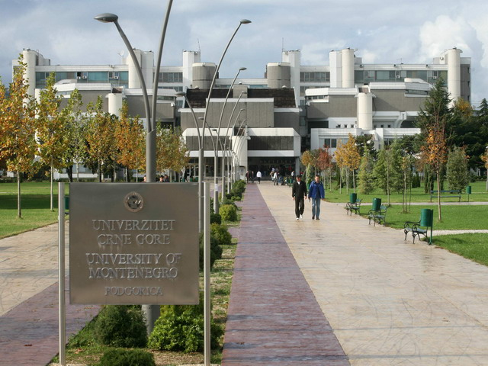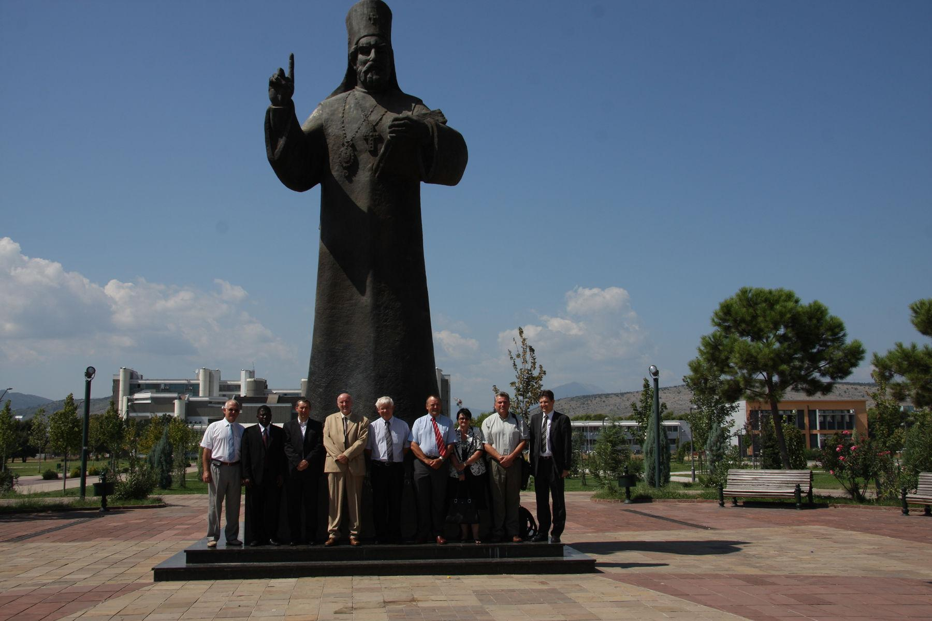
FIG.1 University of Montenegro campus (left) and IAEA Expert Mission to the UCNC, 2009 (right)
Being in the accession/negotiation process to the European Union (EU), Montenegro is also in position to benefit from various mechanisms existing in the EU to strengthen capacities in non-power applications of nuclear energy, safety and security of radiation sources in particular. In this sense, our positive experience with IAEA cooperation was affirmatively reflected/accepted during negotiations on Chapter 25 – Science (in particular cooperation with EURATOM), which was the first to be opened and preliminarily closed in the negotiations.
It is the policy of the country (institution in charge is Ministry of Science) to approach cooperation with the two (IAEA and EU) in the way that activities complement and resonance with each other, rather than overlap or redund – fortunately/helpfully, it is already in the mechanisms of IAEA and EU for the most part. This is reflected inter alia in the latest Country Program Framework (CPF), specifying priorities in TC for the period 2014-2020, with human resource development (HRD) among the first priorities [4]. Note that the CPF period coincides with the final stage of Montenegro accession to EU.

Networking
Networking is becoming increasingly important for building/sustaining national bodies of knowledge, competence and expertize in nuclear/radiation-related issues. This is particularly valid for those countries whose domestic resources are limited and/or where no critical mass of the above three constituents exists, which could enable the system to sustain on its own. IAEA-based international networks for nuclear security education (INSEN) and training&support (NSSC), even relatively recent, proved pivotal/fundamental in this respect [5,6]. At UoM (Department of Physics) we have launched several targeted educational courses at post-graduate level, following INSEN guidelines (see further); the pioneering educational materials developed within the network represent the basic literature for both students’ and lecturers’ use [7].
UoM participates actively in the IAEA nuclear knowledge management (NKM) activities and makes use the information system (INIS) and networks when sourcing relevant information. UoM is also national contact point for INES (International Nuclear and Radiological Event Scale) and has trained staff for properly reporting in case of incident/accident [8].
Worth mentioning is also UoM membership in the IAEA-supported Nuclear Instrumentation Laboratory Network (NILNET), where information/experience/opportunities in the highly technical field are shared. We also expect to be among the first ones to participate in Internet Reactor Laboratory (IRL) – a novel/advanced distance learning tool in nuclear physics and engineering which will supposedly be based in the National Institute for Nuclear Science and Technology (INSTN/CEA), Saclay, France.

Education – the fundament of competence
As a result of our INSEN activities, curricula for several nuclear safety and security related courses were developed and courses were introduced (as part of optional courses menu) into post-graduate educational programmes of Applied Nuclear Physics at the University of Montenegro, Department of Physics. Currently, these include [9]:
- Fundamentals of Nuclear Safety and Security
- Radiation and Nuclear Security – Practical Aspects
- Nuclear Forensics
- Nuclear Physics for Regulators
- Nuclear Knowledge Management

In addition, awareness about nuclear safety and security issues (education and training in particular, but also the need for commensurateness) rose considerably among academic staff. However, it is our impression that this was not the case (at least not to the same extent) among other stakeholders (regulatory bodies, relevant ministries and police departments, emergency centres, etc.) – we are determined to strive for improving that in future.
UoM offers a number of laboratory services, primarily for educational/training purposes, but also for TSO-oriented routine measurements, monitoring of radioactivity and radiation parameters in the living, working or outdoor environment, etc. Laboratory for nuclear spectrometry has inter alia classic NaI and HPGe detector systems, and a very high sensitivity anti-coincident spectrometer, while environmental laboratory offers atomic absorption spectrometer, medical QC/QA control devices, radon equipment, etc. All of these are at students’ permanent disposal, either for routine laboratory exercises or for diploma/master/ doctoral practical work [10].
Last but not least, while striving for competence, clear distinction should be made between education and training. Education builds up knowledge, while training develops ability to its practical application; both knowledge and training are necessary for competence. Most importantly, training cannot replace education – training is meaningful only when superposed onto an adequate education. Messing up these terms may lead to a false perception of knowledge and competence (quasi-knowledge and quasi-competence) – in a long run this is inevitably going to compromise safety and security (FIG. 2)
FIG. 2 Education as the fundament of competence and competence vs quasi-competence

Conclusion
Summarizing the above, UoM current position and perspective for the future in terms of TSO is aimed to:
- becoming national centre of competence/expertise in nuclear/radiation-related issues;
- assessing, creating, preserving and transferring nuclear knowledge (NK), according to Montenegro needs;
- offering consultancies and technical support services to regulatory authorities and other relevant stakeholders;
- being advisory body to the government for nuclear/radiation-related issues and
- focal point for dissemination and exchange of NK, in particular with the IAEA;
- promoting nuclear applications for peaceful purposes, in particular medicine, industry, agriculture and environmental protection;
- being national radiation protection centre;
- developing curricula for nuclear/radiation-related studies at all levels;
- supporting young students and scientists in nuclear field and facilitate their mobility/ exchange with reputed institutions abroad and
- delivering proper and timely information/assessments/comments to the public and media on relevant nuclear/radiation-related subjects.

In pursuing these goals, UoM will continue to benefit from the assistance of the IAEA (through various modalities IAEA offers), as well as from the EU (through even more modalities/programmes available to accessing countries). In doing so, the two sources of assistance are expected to be met with a sense of complementarity and/or synergy rather than overlapping and/or redundancy. It is assumed that the state support – currently limited due to economic/financial crisis – will be available in the measure of the country’s commitment to its IAEA membership and EU integrations.

Acknowledgements
The author wishes to thank his colleagues from the Centre for Nuclear Competence and Knowledge Management, as well as the University of Montenegro Rectorate, and Ministry of Science, Department of International Relations, for their collegial attitude, understanding, knowledgeable cooperation and continuous support in various ways.

References
- INTERNATIONAL ATOMIC ENERGY AGENCY, Knowledge Assist Mission to Montenegro, 2-4 September 2009, End-of-Mission Report, IAEA-605-L2.33.7-MNE, 2010-06-16.
- JOVANOVIC, S., paper presented at International Conference on Challenges Faced by Technical and Scientific Support Organizations (TSO) in Enhancing Nuclear Safety and Security, 25-29 October 2010, Tokyo, Japan.
- JOVANOVIC, S., University Centre for Nuclear Competence and Knowledge Management, Establishment Elaborate, July 2008, Univ. of Montenegro, Podgorica.
- INTERNATIONAL ATOMIC ENERGY AGENCY, Country Programme Framework Montenegro 2014-2020, IAEA TC, Podgorica/Vienna (2014).
- INTERNATIONAL ATOMIC ENERGY AGENCY, International Nuclear Security Education Network (INSEN) http://www-ns.iaea.org/security/insen-network.asp
- INTERNATIONAL ATOMIC ENERGY AGENCY, International Network for Nuclear Security Training and Support Centres (NSSC) http://www-ns.iaea.org/security/nssc-network.asp
- INTERNATIONAL ATOMIC ENERGY AGENCY, Educational Programme in Nuclear Security, IAEA Nuclear Security Series No. 12, Vienna (2010) http://www-pub.iaea.org/MTCD/publications/PDF/Pub1439_web.pdf
- INTERNATIONAL ATOMIC ENERGY AGENCY, International Nuclear Events Scale (INES) http://www-ns.iaea.org/tech-areas/emergency/ines.asp
- UNIVERSITY OF MONTENEGRO, Faculty of Mathematics and Natural Sciences, Accredited Educational Programmes (in Montenegrin), Podgorica (2012) http://www.pmf.ac.me/index.php?page=InformacijePrikaz&tip=aktuelnost_fakultet&id=4f2f2b68af1f6
- EUROPEAN ONLINE LABORATORY, page Montenegro http://www.reak.bme.hu/munkatarsak/dr-doczi-rita/european-online-laboratory-eol/montenegro.html

