Experience on the Assessment of Exercises for Emergency Preparedness and Response at the Centre for Accelerator Science and Technology

Syarip ¹, Aris Bastianudin ¹, Tegas Sutondo ¹

^{1.} Center for Accelerator Science and Technology (CAST), National Nuclear Energy Agency (BATAN), Fax.62-274-489762, Jl. Babarsari POB 6101 Yk bb, Yogyakarta 55281, INDONESIA

E-mail contact of main author: syarip@batan.go.id

Abstract. According to the national rule, the Centre for Accelerator Science and Technology (CAST) should have a program and plan for radiological emergency preparedness and response (EPR) with at least practically exercised annually. The exercise scenario for year 2013 was a fire occurred in the area of reactor ventilation system, followed by an explosion causing two victims need to be evacuated. Government agencies such: nuclear regulatory body, local police department, hospital, fire brigade, local government, emergency response division, university staff, etc. have been participated. The exercise focused on key emergency responder coordination and critical decision-making processes for integrating local government assets necessary to protect public health following a radiation incident. The whole exercise monitored through video monitoring system from the central alarm station (CAS). The assessment of the exercise showed that the victims, can be evacuated within 9 minutes and the event can be overcome within 20 minutes. In general, the advantages and the objectives of the EPR exercises have fulfilled. This result in accordance with the general objective of EPR exercises i.e.: test & validate plans and procedures, test the readiness of response capabilities, and increase the confidence and skill of personnel. In addition, exercises allow emergency response staff to identify weaknesses so they can improve performance during an actual response. The experience on actual response have been proven when big earthquake with acceleration of 0,15g hit the reactor complex in 26 May 2006, and a big eruption of mount Merapi in 5 November 2010 which is the worst eruption since 1872, as well as eruption of mount Kelud in 14 February 2014. During those external events, the EPR team members have been working with a good performance.

Introduction
This paper describes the experiences on the assessment of exercises for EPR at the CAST. CAST is currently operating nuclear facilities such as accelerator neutron generator, electron beam machine, uranium purification laboratory, and Kartini research reactor. Therefore, CAST must have a program and plan for radiological emergency preparedness and response (EPR) with at least practically exercised annually. The primary goals of preparedness and response for nuclear or radiation emergency: to ensure that arrangements are in place for an effective response at the scene and, as appropriate, at the local, regional, national and international levels. Ensuring that, for reasonably foreseeable incidents, radiation risks would be minor; for any incidents that do occur, to take practical measures to mitigate any consequences for human life, health and the environment [1].
CAST is located at the central Java surrounded by several active volcanoes and the most active volcano is mount Merapi 30 km away from the CAST. Java is the most dense populated and a relatively small island in Indonesia, it has a highest concentration of active volcanoes (45 active volcanoes). Mount Merapi has erupted more than 80 times [2]. The International Association of Volcanology and Chemistry of the Earth's Interior has named Mount Merapi as a Decade Volcano since 1995 because of its high volcanic activity [3]. The recent worst eruption was the eruption of mount Kelud in 14 February 2014. Even the mount Kelud located about 300 km away from the reactor site, but the dust was thick enough covering the reactor complex. Therefore, the external events such earthquakes and volcano eruptions is an important things to be considered in the emergency preparedness of CAST nuclear facilities.
The method used in this paper is through an observation and overview, evaluation, and assessment on the emergency exercises and even on the real emergency events within the period of 2006 - 2013.
As a regulation mandatory, CAST through CAST Emergency and Preparedness Response (EPR) Team has conducted exercises simulating radiological emergencies relating to Kartini research reactor operation. Then the assessment on the exercise performed accordingly. CAST hosted an EPR exercises for emergency conditions (on- and off-site) annually. The exercise was to evaluate the initial response to the incident and the management of the consequences associated with external events such as earthquakes and volcano eruptions, terrorism, and work incidents.
While in the recent decade the terrorist threat is also increasing and should be accommodated in the safety-security analysis, and emergency preparedness and response, therefore, the local design basis threat has been established and revised periodically [4,5].

Exercise Scenario and Implementation
Monday, December 23, 2013, the EPR team held an integrated exercise with the scenario as follows: when the reactor was operating and there was a visit from students of 15 people, and along with it there is a component repair work (iron door) near the blower room using the welding equipment done by 2 people. Suddenly there was an explosion in gas tube welding equipment resulting in faulty ventilation systems and fire followed. The two people injured in the blast, whiles, CAS officers saw this incident and immediately report to Head of Nuclear Security Unit, then forwarded to Head of CAST. In the mean time, the in incident is also seen by blower technician on duty, then he immediately report to the reactor supervisor and the supervisor ordered to shutdown the reactor and report the incident to the Head of Reactor Division and forwarded to the Head of CAST.

A state of emergency was announced through a paging system and the alarm sounded. The emergency is then handled by the EPR team (task force) of CAST. The EPR Task Force consisting of several well-trained people in their respective fields, namely, the Radiation Protection Task Force, Medical Assistance, Fire Brigade, SAR, Security and Logistics Assistance.

The exercise was participated by several government agencies such: nuclear regulatory body (BAPETEN), local police department, hospital, fire brigade, local government, emergency response division, university staff, etc. The exercise focused on key emergency responder coordination and critical decision-making processes for integrating local government assets necessary to protect public health following a radiation incident. The whole exercise monitored by video system from the central alarm station (CAS).
Figure 1 and Figure 2, shows the situation when worker using welding machine, victim, evacuation of victim, medical assistance team, and fire brigade, as well as an evaluation meeting.
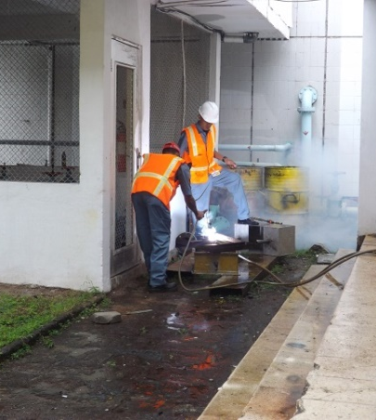 | 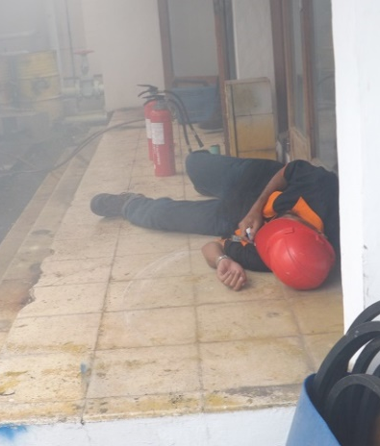 | 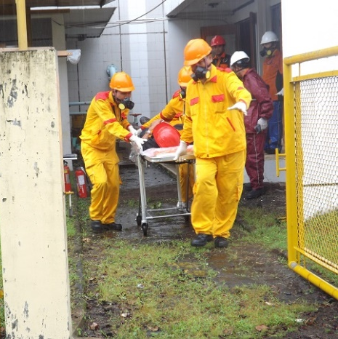
Fig. 1. Worker using welding machine, victim, evacuation of victim.

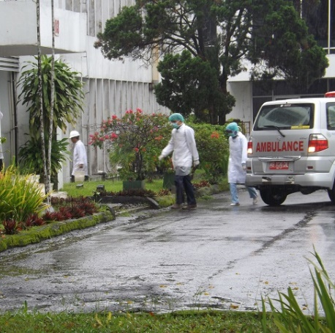 | 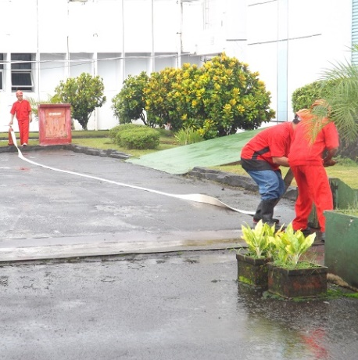 | 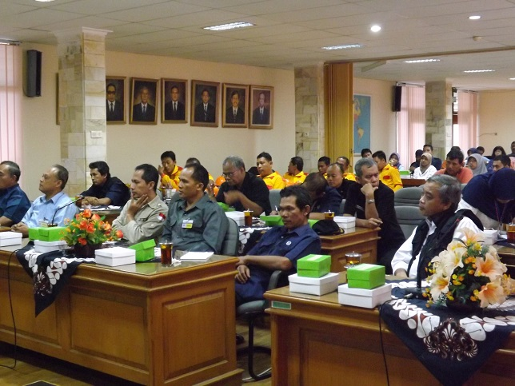

Fig . 2. Early medical asisstance team and fire brigade in action, and evaluation meeting.

Discussion
The assessment of EPR exercise showed that within around 9 minutes the victims can be evacuated successfully, and the event can be overcome within 20 minutes. The evaluation team members agreed that all EPR team members participated actively and seriously in the exercise. Some input and suggestions come from evaluating members, the Local Police Department suggest that it needed an additional ambulance, and standard operating procedure (SOP) be improved after evaluation. The Local Disaster Mitigation Agency (LDMA) suggesting that CAST prioritize to make contingency plans together with LDMA. While, the representatives from the university suggest that a copy of the exercise manuscript should be given to evaluating guests in order to know the exercise scenario, and safe limit should be more emphasized. The relevant local organizations agreed to enhance the response arrangements in an emergency as well as in the post emergency phase.
The EPR organizational structure consisted of several task forces such as described in Fig. 3. There are seven task forces i.e.: Medical, SAR, Electricity and Water Assistance, Radiation Protection, Fire, Vehicles and Logistics Assistance, and Security Task Forces The Head of CAST is responsible for overall activities, the Head of Safety Division act as EPR Executive Coordinator, while, Nuclear and Reactor Committee act as an evaluator. All activities should be reported to BATAN Head office and to BAPAETEN (National Nuclear Regulatory Agency). The Head of CAST should make coordination with related institutions such as Local Police Department, LDMA, Hospitals, Universities, etc. The exercise is also worthwhile to test whether the organization structure is appropriate enough in handling the emergency situation.

EPR Responsible
Head of CAST
BATAN Head Office
BAPETEN
Related Institutions

EPR Executive Coordinator

Medical Task Force

Security Task Force

Fire Task Force

Radiation Protection Task Force

Electricity and Water Assistance Task Force

SAR Task Force

Vehicles and Logistics Assistance Task Force

Nuclear & Reactor Safety Committee
Notes:
Commad Line
Reporting Line
Coordination Line
Fig. 3. Organization Structure EPR of CAST

In general, the advantages and the objective of exercises of EPR have been met [6]. This result is in accordance with the general objectives of EPR integrated exercises i.e.: test and validate plans and procedures, test the readiness of response capabilities, and increase the confidence and skill of personnel. In addition, exercises allow emergency response staff to identify weaknesses so they can improve performance during an actual response. Interagency exercises also allow the various agencies' personnel to become familiar with each other and learn to coordinate and operate together [7].
The evaluation to the EPR team members in implementing their tasks in the previous years was also evaluated. We realize that the experience on handling the emergency in actual event in the past is a good feedback for improvement. The experience on actual response of EPR team members of CAST have been proven when big earthquake with acceleration of 0,15g hit the reactor complex on 26 May 2006, and a big eruption of mount Merapi in 5 November 2010 which is the worst eruption since 1872, as well as eruption of mount Kelud in 14 February 2014. During those external events, the EPR team members have been working with a good performance and that, the organizational structure of EPR is appropriate enough. [8].

Conclusion
Based on the experience explained in the above discussion, it can be concluded that the radiation emergency response team has been carrying out its duties during the emergency condition with a good performance. The assessment of the EPR exercise in 2013 showed that the overall emergency event be overcome within 20 minutes. In general, the objectives of EPR exercises have fulfilled, despite of the evaluation result shown that there were several recommendations. This result is in accordance with the general objective of EPR exercises i.e.: test & validate plans and procedures, test the readiness of response capabilities, and increase the confidence and skill of personnel. In addition, exercises allow emergency response staff to identify weaknesses so they can improve performance during an actual response. The experience on actual response have been proven when big earthquake with acceleration of 0,15g hit the reactor complex on 26 May 2006, and a big eruption of mount Merapi in 5 November 2010 which is the worst eruption since 1872, as well as eruption of mount Kelud in 2014. During those external events, the EPR team members have been working with a good performance. The relevant local organizations agreed to enhance the response arrangements in an emergency as well as in the post emergency phase.

References
- Guidelines of Implementation of Emergency Plan and Preparedness, Decree of Chairmen of BAPETEN No. 5-P / 2003, BAPETEN 2003.
- "Merapi Eruptive History". Global Volcanism Program. Smithsonian Institution. Retrieved 10 March 2014.
- The International Association of Volcanology and Chemistry of the Earth's Interior, http://www.iavcei.org/. Retrieved March 2014.
- Prospects for Nuclear Security Partnership in Southeast Asia, the James Martin Center for Nonproliferation Studies (CNS, Monterey, United States), Monterey/ Moscow/ Vienna, May 2012
- SYARIP, Design Basis Threat Analysis and Implementation of the Physical Protection System at Nuclear Facility of BATAN Yogyakarta, Journal for Safeguards Technology, Vol.1. No.1. Oct. 2005, ISSN 1907-0535.
- “Nuclear Installation Safety Review Committee”, Doc. No.: LKIN 04/APB, BATAN Yogyakarta, January 2014.
- United States Environmental Protection Agency, http://www.epa.gov/radiation/rert /exercises.html. Retrieved on March 2, 2014.
- SYARIP, et al, Experience on the Implementation of INSARR Recommendations on Seismic Analysis and External Events Assessment of Kartini Research Reactor, Proceedings of an International Conference on Research Reactor Safe Management and Effective Utilization, Rabat, Morocco, 14-18 Nov. 2011, IAEA, Vienna, September 2012.

