**Post Fukushima Activities at AECL**

S.J. Bushby1, T. Nitheanandan1, J. Ball1, and W.C.H. Kupferschmidt1

1Atomic Energy of Canada Limited, Chalk River Laboratories, Chalk River, Ontario, Canada

*E-mail contact of main author:* [*kupferschmidtw@aecl.ca*](mailto:kupferschmidtw@aecl.ca)

**Abstract**. Atomic Energy of Canada Limited (AECL) is Canada’s premier nuclear Science and Technology (S&T) organization. AECL’s capabilities have been utilized extensively to provide technical support to government and industry partners as the events of Fukushima unfolded. They continue to play a role in supporting longer-term S&T for both the industry and the regulator to demonstrate defense in depth for Canadian nuclear facilities.

# Introduction

Atomic Energy of Canada Limited (AECL) is Canada’s premier nuclear Science and Technology (S&T) organization with unique capabilities that can be applied to fulfilling public-policy obligations (such as informing regulation), and delivering on commitments to the nuclear sector, both domestically and internationally.

With the divestiture in 2011 of the part of the company responsible for designing and building CANDU reactors, AECL now focuses on three primary roles:

* Managing radioactive waste and addressing decommissioning responsibilities;
* Performing science and technology activities to meet core federal responsibilities; and,
* Supporting Canada’s nuclear industry through access to S&T facilities and expertise on a commercial basis.

A significant portion of the Canadian nuclear Research and Development (R&D) capacity resides at AECL’s Chalk River Laboratories (CRL) – Laboratories that for over 60 years have provided the science and technology supporting the safety design of CANDU power reactors. The expertise and test facilities at CRL contribute to all three roles and leverage additional capability from the international community through Canada’s participation in cooperative programs led by International Atomic Energy Agency (IAEA) and the Committee on the Safety of Nuclear Installations (CSNI).

The sections that follow will discuss two aspects of how AECL has responded to the Fukushima event, and will continue to do so in the future.

The first aspect relates to the work and analyses required to ensure that CRL itself can ably respond to a significant event. The CRL site comprises 3700 hectares located along the Ottawa River. Like many national laboratories in other countries, CRL contains numerous research labs, nuclear facilities and waste management areas – all of which have a significantly different risk profile compared to a power reactor under a Fukushima-like event. The most notable of the CRL facilities in this context is the 135 MW (thermal) National Research Universal (NRU) reactor.

The second aspect relates to a strong S&T support system at CRL, particularly the capabilities (people and facilities) that can be used to inform regulation. As a way of managing the capabilities or core competencies resident at the Labs, AECL has very recently introduced the

concept of “Centres of Excellence”. Ten Centres of Excellence have been identified (listed below), and most capture capabilities that to some extent buttress much of our understanding of severe events in CANDU reactors, and/or contribute to Canada’s nuclear emergency response capability.

1. Nuclear and Radioactive Material Management,
2. Irradiation and Post-Irradiation Services,
3. Nuclear Safety, Security and Risk Management,
4. Radiation Biology, Radioecology and Dosimetry,
5. Materials and Chemistry in Nuclear Applications,
6. Advanced Nuclear Fuels and Fuel Cycles,
7. Systems Engineering,
8. Advanced Computing, Modelling and Simulation,
9. Hydrogen and Hydrogen Isotopes Management, and
10. Environmental Remediation and Nuclear Waste Management.

# Support for AECL’s Site License and the Federal Nuclear Emergency Plan

Since Fukushima, AECL has mobilized an integrated project team (the Fukushima Response Project), which has been focused on improving AECL’s emergency response capability and implementing a Severe Accident Management Program (SAMP) for the CRL site. AECL’s Fukushima Response Project is comprised of a wide variety of requirements and recommendations originating from AECL internal, Canadian Nuclear Safety Commission (CNSC) and World Association of Nuclear Operators (WANO) reviews of the lessons learned from the Fukushima accident. AECL is also participating in Canadian industry groups and international organizations to understand how the lessons learned from the Fukushima Daiichi accident are being addressed. However, it is important to note that there are several fundamental differences between Nuclear Power Plants (NPPs) and NRU, and SAMP elements developed by our industry partners for NPPs cannot be directly applied. Consequently, much of the SAMP development work at AECL has been unique to NRU and the CRL site.

Significant progress has been made to date. AECL has completed an assessment of its readiness to address its response capability to design basis events in NRU and to Beyond Design Basis Events (BDBEs) potentially affecting major facilities (including NRU) at CRL. AECL has procured and commissioned portable equipment to augment our response to prolonged loss of power and loss of cooling accidents and are actively assessing further improvements to this capability. The technical basis and analysis of severe accident progression in the NRU reactor has been completed and a set of severe accident management guidelines have been prepared for NRU. Further, the equipment needed and organizational changes that are required to fully support the implementation of SAMP and to mitigate severe accidents in NRU has been identified and the changes are being implemented.

The Project is in the process of completing the training and developing the validation activities (e.g., tests, drills and exercises). It is expected that this activity will culminate with a SAMP validation exercise currently planned for 2015. A feature of many of these exercises is validation of AECL’s abilities to fulfill its roles defined in within the Federal Nuclear Emergency Plan.

# Strengthening of a Technical Support System at AECL to Meet Post Fukushima Challenges.

## Short-term Actions

Many of AECL’s capabilities were brought to bear on numerous short-term actions that arose as a result of Fukushima. Immediately following the earthquake and accident, AECL, in partnership with other federal agencies, provided technical support to Japan in the areas of Radiation Biology, Radioecology and Dosimetry, to estimate dose to the public from the accident.

The CNSC convened a task team immediately after Fukushima to review and ensure that Canadian reactor safety cases are adequate, and credible protective provisions had been put in place for risks associated with external events. The conclusions of the assessment were that Canadian NPPs are safe and pose a very small risk to the health and safety of Canadians or to the environment. However, a number of improvements and three high level actions were identified to strengthen defense in depth. These high level actions were:

* Licensees should systematically verify the effectiveness of, and supplement where appropriate, the existing plant design capabilities in beyond-design-basis accident and severe accident conditions.
* Licensees should conduct more comprehensive assessments of site-specific external hazards.
* Licensees should enhance their modelling capabilities and conduct systematic analyses of beyond-design-basis accidents.

AECL was also involved in subsequent activities to support Canadian licensees to undertake these activities. For example, AECL provided design assessment support to the CANDU Industry Integration Team (CIIT) which was established to respond to the WANO and CNSC recommendations. Part of this role involved assisting offshore licensee’s (e.g., Cernavoda) meet the requirements of offshore regulators.

From an S&T perspective, AECL was also involved in several activities with the Canadian industry. A large part of AECL’s support role is by way of its strong partnership with Candu Energy, the private sector company that now owns the CANDU reactor commercial business. The laboratory has also been supporting licensees through the CANDU Owners Group (COG; an industry association that conducts collaborative R&D in support of its utility members) by contributing to the S&T effort that has underpinned the case for continued operation of Canadian NPPs. Post-Fukushima research needs from these partners have spanned a range of activities ranging from: hydrogen management; demonstrating the efficacy of in-vessel retention; refining calculations of spent-fuel bay heat generation to ensure adequate cooling during postulated station black-out scenarios; and, evaluating reactor instrumentation for use in severe accident conditions. Each one of these topics requires unique capabilities belonging to one of the ten Centres of Excellence.

## Intermediate and Long-Term Actions

# Research Informing Regulatory

As noted above, the second primary role for the restructured AECL is to perform S&T activities to meet core federal responsibilities. This newly-defined role enables AECL to interact directly with the CNSC in many S&T areas. This interaction will mature over the next couple years, but one current focus has been on the regulatory research associated with severe-accident behaviour.

Several new projects were initiated following Fukushima, the first of which was to generate a web-based reference document on plant-specific severe accident analysis results and plant design information in a searchable electronic form for the Emergency Operations Centre (EOC) at the CNSC. The document is called the Nuclear Power Plant Accident Handbook [1]. The CNSC’s Emergency Operations Centre (EOC) assesses on-site and off-site consequences during an event. The objective of the CNSC’s EOC is to ensure appropriate actions are taken to limit the risk to health, safety, security and the environment. The handbook provides readily available reference material for CNSC technical staff involved in EOC operations, and enables them to find site-specific and accident-specific details in addition to providing expert advice to the EOC team during an accident progression. A Graphical User Interface (GUI) software application is currently available to provide necessary drawings, databases and calculations.

In addition to the Accident Handbook, a joint activity between AECL and CNSC has contracted the development of animation software, GRaphical Animation Package Extension (GRAPE). The software provides a user-friendly interactive interface to the Canadian Industry’s MAAP-CANDU severe accident code and thus helps study the effect of implementing severe accident management measures in a nuclear power plant. The software is now being tested at AECL and CNSC. GRAPE accesses the simulated transient plant conditions (e.g., pressures, temperatures, and the concentrations of water, steam, hydrogen, and fission products) in various plant components such as the pressurizer, fuel channels, fuel bundles and containment during a simulation and displays the values on the screen to provide an overview of the accident progression and the plant response. The user can also intervene in the accident progression in an interactive mode to assess “what if” scenarios of operator actions, such as opening/closing valves and starting/stopping pumps.

Additional activities performed under the umbrella of R&D informing regulation are staff training in safety analysis codes, third party review of hydrogen safety analysis, development of a predictive model to assess flame dynamics, and analysis of emergency cooling of a severely degraded core.

AECL also works with the CNSC in international activities undertaken by the IAEA and the Organization of Economic Cooperation and Developments (OECD’s) Nuclear Energy Agency. Recent OECD NEA Fukushima activities include leading an activity on hydrogen mitigation and modelling, and participation in activities on containment filtered venting, and development of rapid running software for post accident dose assessments.

An annual AECL-CNSC Nuclear Safety Technology seminar and information exchange has taken place for the past four years. The purpose of the seminar is to promote the exchange of current R&D information between the two organizations and to shape S&T priorities for future research activities. Presentations are usually made by research staff from AECL and technical specialists from the CNSC on topics of mutual interest. The 2014 seminar (entitled PHWR Safety 2014) was extended to international participants operating Pressurized Heavy Water Reactors in a workshop format. The workshop was held in Ottawa, Canada, in partnership with CANDU Safety Association for Sustainability (CANSAS), IAEA, Canadian Nuclear Society, and Korean Nuclear Society. The workshop received more than 40 technical papers, with a strong technical focus on S&T progress to address lessons learned from Fukushima. The workshop successfully pooled a cross-section of international PHWR safety analysts, scientist and regulators to share their experiences in the generation, development and sustainability of expertise, training and knowledge to meet emerging regulatory R&D needs and explored potential for mutual cooperation and sharing of R&D results.

# Research for Canadian Industry

AECL’s capability in Nuclear Safety and Security has been utilized extensively by the Canadian industry to address post-Fukushima actions of interest to the CNSC.

The integration of industry efforts through COG drew upon parallel R&D activities to address the uncertainties associated with BDBEs in CANDU reactors. COG had already developed a severe-accident program focusing on developing an understanding of phenomena identified as poorly understood yet having a large impact on retention of severe accident progression. One of the key differences between Light Water Reactors (LWRs) and CANDU is the abundance of water in the CANDU moderator and end-shield cooling system that could cool a molten core, thereby promoting “in-vessel retention” (IVR); i.e., reactor core elements (corium) are retained inside the reactor vessel because of external water cooling. IVR is an inherent feature of a CANDU, in that it requires no operator intervention by virtue of the reactor’s unique geometry, larger heat sink availability, and materials composition.

An additional element of the original COG program was to investigate the behaviour of Passive Autocatalytic recombiners under BDBE conditions. Post Fukushima, this program was expanded to include a more aggressive schedule for addressing gaps in severe accident progression phenomena, evaluation of reactor instrumentation for severe accident conditions, and development of methods to calculate heat generation in fuel storage bays. In particular, significant effort has been undertaken within the CANDU Owners group to accelerate experiments that investigate challenges to IVR. The program utilizes the capability sustained in AECL’s Nuclear Safety and Security Centre of Excellence.

The same Centre of Excellence has also performed experiments to evaluate whether the critical heat flux across the end-shield of a CANDU reactor is sufficient to ensure that a molten core would be retained for a substantial time after a complete loss of power *(see FIG. 1)*.

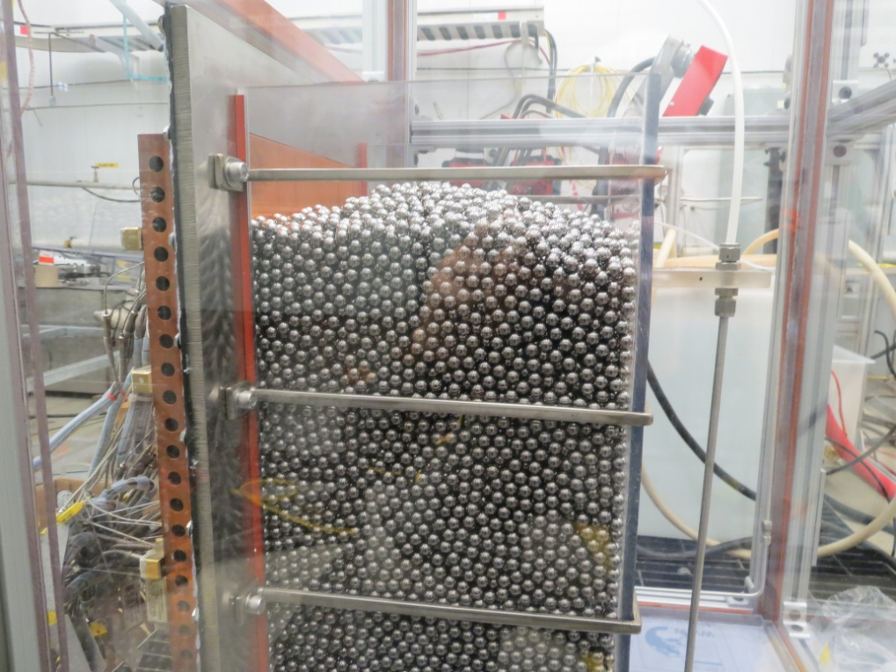

*FIG. 1: Facility to Measure Critical Heat Flux in the End Shields of CANDU Reactors.*

# Summary

AECL is Canada’s premier nuclear S&T organization, and as such, CRL is home to much of the S&T expertise that supports the safe behaviour of CANDU reactors under normal operating conditions or postulated BDBE events. The Laboratories’ broad expertise is captured in ten newly-defined “Centres of Excellence”, which highlight the technology areas that must be actively managed to ensure that the S&T capabilities resident at AECL are enduring and continue to address the long-term S&T needs of the Canadian industry and Regulators, as well as support federal obligations for emergency response.

AECL has historically informed regulation by providing technical support to Canadian licensees. However, with the revised mandate for the labs resulting from the divestiture of AECL’s commercial reactor division, it is now possible for CRL to collaborate more directly with the CNSC on a range of technical activities, some of which could not be contemplated previously.

In response to the Fukushima event, AECL developed a Severe Accident Management Program that is somewhat unique to CRL, since the SAMP elements developed by Canadian NPPs cannot be directly applied to CRL facilities that have a different risk profile under a postulated BDBE.

# References

1. COLE, C., NITHEANANDAN, T., BROWN, M.J., PETOUKHOV, S.M., and WOOD, A., “CNSC Nuclear Power Plant Accident Handbook”, 2012 ANS Winter Meeting and Nuclear Technology Expo, San Diego, California, USA, November 11-15, (2012).