Challenges of Nuclear Power Safety
L.A.Bolshov
Nuclear Safety Institute of Russian Academy of Sciences, Russia
E-mail: bolshov@ibrae.ac.ru

Abstract. Major accidents at nuclear power plants are counted on fingers and they led to no population life losses (Three Mile Island, Chernobyl). The latest accident at Fukushima went with no victims of radiation, while the Great Eastern Earthquake and the following tsunami in 2011 took about 20,000 lives. The conclusion suggests itself: the nuclear accidents are not related directly to losses of lives, but are perceived by public much more seriously than a mega-tsunami event. The public perception of nuclear accident consequences, by orders exceeding actual damages, goes hand in hand to inadequate perception of the radiation risks by the overwhelming majority of society. The urgent matter of the world nuclear community is to formulate the main purpose of nuclear safety more precisely: ensuring that there is no severe damage to society in case of any accident, which may or may not involve loss of human lives or health. Two complementary tasks are to be solved to achieve the above goal. The first task is to reduce the probability of a severe accident to an acceptable level and ensure the advanced national and international emergency response systems. The second task, however, in our opinion, is far from being recognized well enough, namely: education of public achieving a civilized perception of radiation risk issues that shall be a responsibility of national governments and be conducted in concert with other nations. If a country decides to go towards the nuclear generation, and its government approves this step, the government should take a responsibility to protect and educate people in this matter. International Convention on Nuclear Safety should be extended by the education provision.

The Nuclear Safety Institute of the Russian Academy of Sciences IBRAE RAN) has been established in the USSR after the Chernobyl accident to enable the competent specialists "outside the nuclear industry" to study the safety issues and transform their results into programs, codes, and recommendations for practical nuclear applications.

It should be said that after the Chernobyl accident, the safety requirements have been significantly tightened. In fact, these requirements should not make distinctions between radiation hazardous facility and any other hazardous industrial facility such as chemical, metallurgical or any other. Surely, a facility should provide supervisors with convincing evidence of compliance with these requirements.

This is exactly what we have successfully been engaged in with the State Corporation "Rosatom", "Rosenergoatom" Concern (Russian NPP Operator) and "RosTechNadzor" (Russian Regulator) and with many foreign partners for already 25 years.

Another important direction of studies is justification of protective measures to reduce radiation exposure for the public and assess their efficiency that is determined by the costs spent to prevent the collective dose of 1 man-Sievert.

The Chernobyl accident lessons learnt showed that among the most efficient measures the top line is occupied by such a simple measure as closing windows on April 26 and 27, 1986, in Pripyat town, while the additional resettlement in 1990-1991 is on the other side of the efficiency scale: the population was moved from the areas, from which nobody should have been relocated according to all scientific knowledge, but unfortunately the ideas that were far away from science prevailed.

Based on scientific recommendations, only 17,000 people from the areas with contamination above 40 Ci/ km²should have been relocated, and that would have been quite enough. Then, 28 years ago, 200,000 people were moved from their homes, and 8 million people were “labelled” as the Chernobyl victims in Russia, Ukraine and Belarus. Each of those people was deeply stressed and considered him or her dying and countered the days left. Though, in fact, their doses in most cases were negligible.

This is not just our original point of view, but is a position of the Russian and world science. The UN Scientific Committee reports on the Radiation Effects for 1998, 2000 and subsequent years after the Chernobyl accident confirm this view [1-3]. The UN report clearly states that the Chernobyl radiation exposure did not affect the health of the public, all the events that have been reported and expected, cannot be applied to the field of public health priorities, but rather - to the field of radiation epidemiology, i.e. 2-3 orders lower.

Another example gives an additional evidence of nuclear industry safety. Let’s compare the summarized data of lethal cases in the whole power engineering industry, including nuclear energy, and in particular, 31 professional casualties of the Chernobyl accident. All other power engineering areas (coal, gas, hydropower ones), if summarized, totals 80 thousand people for 30 years (see Fig. 1) that died only in major accidents, with victims above five people, while the nuclear sector, if takes into account all the activities related to the use of nuclear power and all accidents at all nuclear installations, not necessarily NPP, including the accidents during medical procedures with ionizing radiation sources, totals 59 deaths for sixty years, and at nuclear power plants - the same 31 (see Fig. 2). Thus, the number of deaths in nuclear and non-nuclear sectors of power engineering differs by the order of four. Nevertheless, the accidents at Chernobyl, Fukushima and Three Mile Island NPPs are still in minds and on the tongues not only within the "nuclear" community, but also among the public of most countries, while people use to very quickly forget about the accidents that happen in the coalmines and at pipelines.
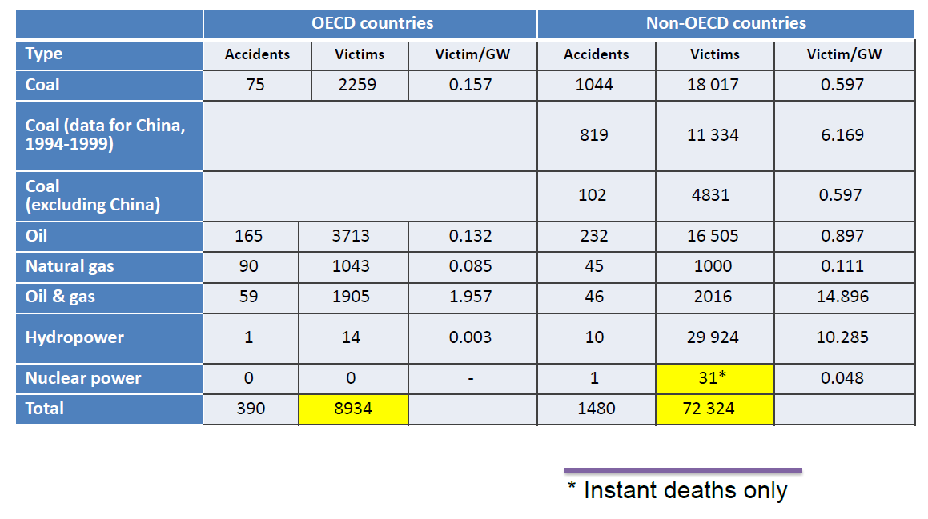
Fig.1. Summary Data for Major (> 5 Victims) Accidents in the Power Industry in 1969–2000 (Table 2, Chapter 5, p.35 in [4])

Ten years after the Chernobyl event, we conducted a case study among quite educated group of the Russian society (see Fig. 3). We asked about the number of instantaneous deaths of the Hiroshima bomb attack, and the answers were true within ± 30%. As for the radiation effects, the people’s concepts about its threat were overestimated by 2-4 thousand times. The professional community persistently communicates this information to the public, we keep on explaining how safe is the nuclear technology, and people do not believe us.
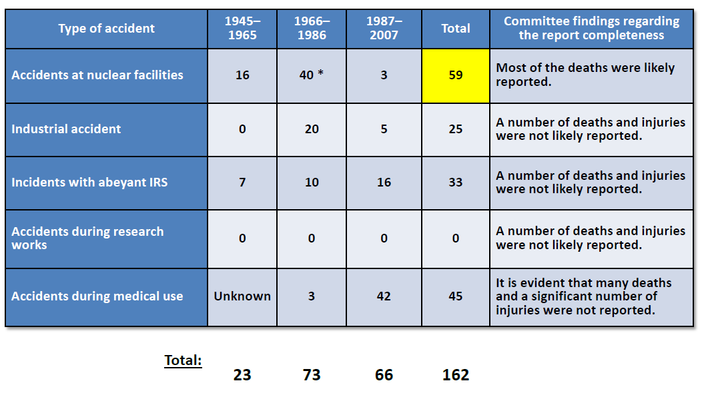
Fig.2. Number of deaths in radiation incidents apart from violent actions and nuclear tests (Table 10 р.52, Annex R.671 in [3])
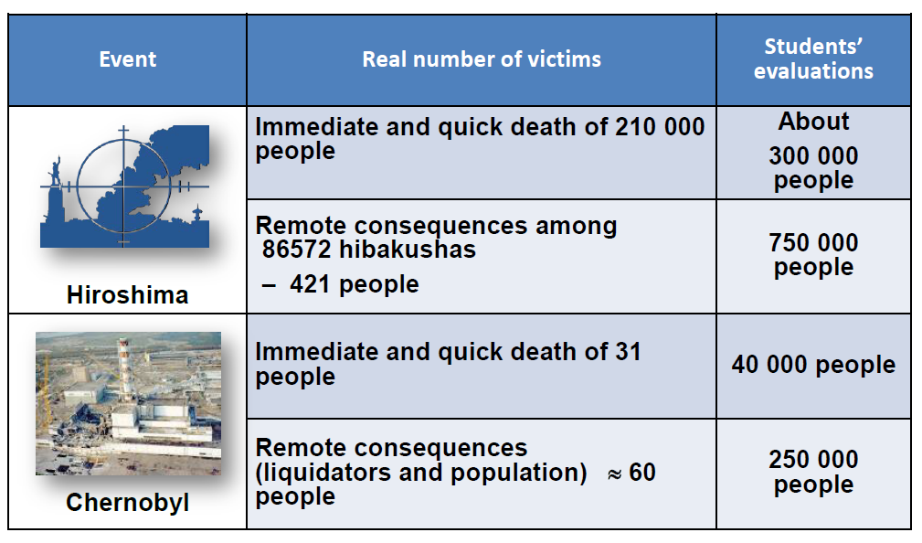
Fig.3. Results of the case study “What do you know about the victims of military and peaceful atom?”

Recently, we have repeated the study; the situation has changed only a little in spite of numerous efforts of various structures within the nuclear industry to educate the public.

Apparently, something is wrong in managing the nuclear safety issues. Let’s repeat that the analysis of the largest accidents (Three Mile Island, Chernobyl and Fukushima) shows that there were no victims among the population. Nevertheless, the public is highly worried, changes priorities, and undermines the economy. Accidents with core melt, but with low or no overexposure, tend to have wide-ranging consequences and the reason for that - ignorance, contradictory norms of radiation protection, and poor communication to the public.

Probably, the statement of the main safety problem – to "protect the public from the excessive exposure doses" is a weak criterion and is formulated imprecisely. In this regard the main goal of nuclear safety should be reformulated and defined as the prevention of significant impacts on the community, which may not involve the loss of life or health. In this case, the problem of reducing the likelihood of severe accident shall be addressed in regulatory documents.

Of course, a lot has been done since the Chernobyl accident; a large scope of work has been performed to upgrade the nuclear power plants, to train operators, to develop simulators and codes for safety analysis inside and outside a power plant. Comprehensive systems of radiation monitoring and emergency response in those Russian districts, where the radiation hazardous facilities are located, have been established to enhance the preparedness of administrative structures, forces and facilities to respond to radiation emergencies and to make population to react more adequately.

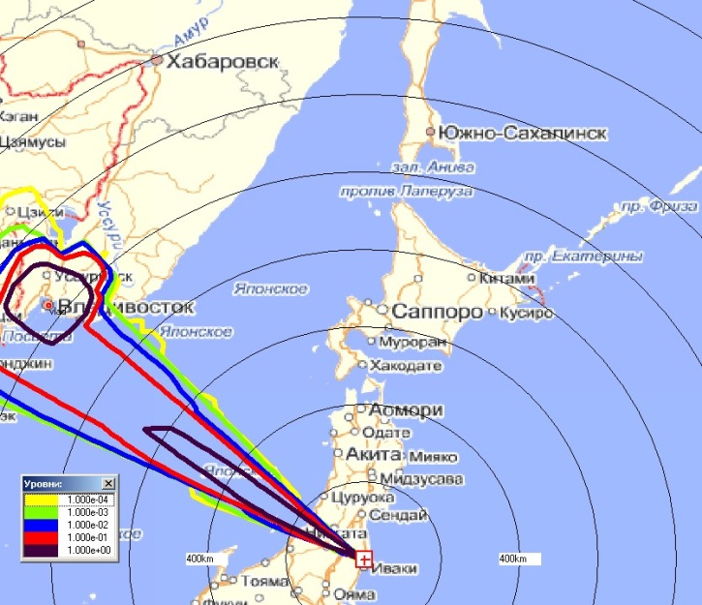
Now let us analyze the Fukushima accident lessons learnt. Using all available tools, our scientists and engineers during the very first days of the accident managed to give a competent analysis of the emergency development consequences and ensure the Russian Government that the events at Fukushima would not affect the Russian Far East under any circumstances (Fig.4). It was a tough statement, for which we were ready to respond, and we proved to be right. We were able to predict what would happen with the units, what date and time each of three units would explode, and the prediction appeared to be very close to what actually happened (Fig. 5). Using the codes that were developed after the Chernobyl accident, we were able to assess the distribution of radioactive substances and contamination in Japan (Fig. 6). Together with the colleagues from different countries, we tried our best to keep the Japan from repeating the mistakes that we made after the Chernobyl accident, but we failed in spite of our findings and conclusions were accurate, that was proved by subsequent measurements.

The Fukushima accident brought no casualties among the public. As for the evacuation of population, we are learning the same lesson as in Chernobyl: about 12 thousand people were to be relocated from the area with the annual dose of 100 mSv for the first year, but instead, all people from a vast territory were evacuated that was a very expensive measure forcing many of them to suffer.

There could be no debates on necessity to ensure the technical safety; all required measures shall be in place:
Fig.4. The worst scenario of the accident development at Fukushima NPP-1:
Wind speed - 10 m/s, wind direction - 115 degrees, category of stability - E, local rainfall near Vladivostok with intensity of 10 mm/h. Conclusion: gross annual effective dose (children, 1-2 years old) is within 10 mSv
- Reactor units should be protected from severe, though unlikely, accidents by all developed and advanced means.

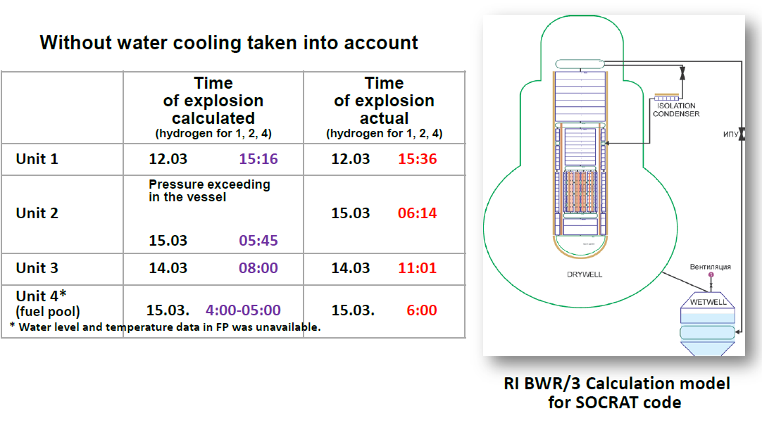
Fig. 5. Analysis for Fukushima-1 NPP units 1–3 and spent fuel pool using the SOCRAT code
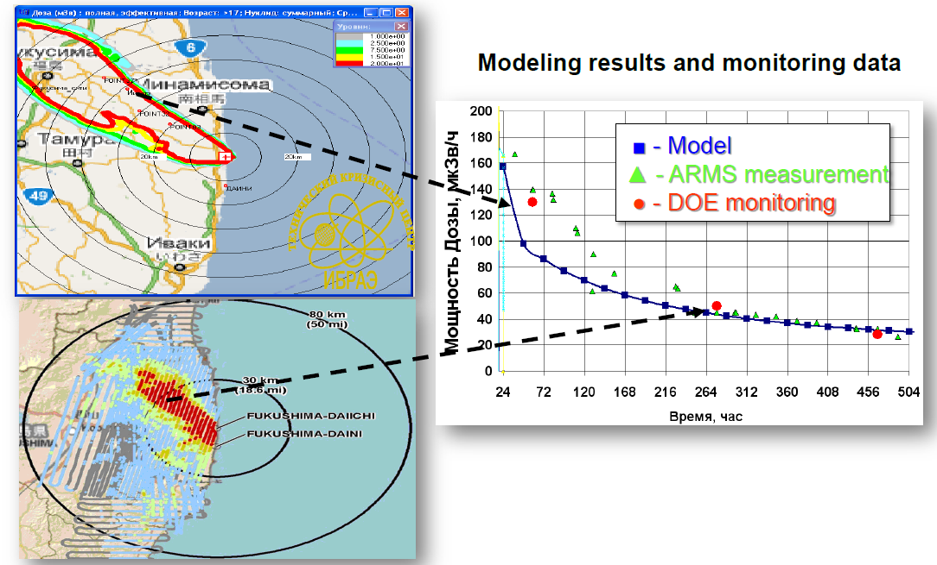

Fig.6. Atmosphere transfer modeling with account of detailed weather data in Japan using the NOSTRADAMUS code. X-axis shows the time in hours, and Y-axis – dose rate in µSv/hour. Data on ARMS measurements are taken from [5], and DOE data – from [6]

- The national technical centers must provide the appropriate and detailed assistance in emergency response in timely manner; to render a professional support to municipalities and governmental agencies in immediate and precise assess of the situation, accurate predictions, information and education of public through the media.
- The regulatory documents shall be harmonized. It is absolutely necessary to eliminate hundredfold gap in radiation protection standards, since presently, in contrast to other threats such as chemical carcinogens that are regulated at the level of real danger, the permitted exposure levels for the population are about one hundred times less than the dose level, at which the first radiation effects could be observed. International organizations recommend even higher levels to ensure the mitigation activity in the radiation emergency conditions. In a real situation, after an accident or even a small incident, it is very difficult to follow the appropriate standards, if much more strong standards do exist. Any responsible leader, who cares about the people, chooses, as a rule, the most rigid standards, and, as a consequence, even an incident with limited effects grow into a sort of a global disaster.

Education and information of the public by the industry concerned is not efficient. To interact with the public effectively, the outreach programs should be developed and should be informative, long-term and intended for different groups of the population. These programs should take into account the philosophical basics of communication on technological accidents. Specificity of diverse scientific, technical and medical concepts and emphases on key points should be carried out continuously using the simple and understandable language.

Such problem cannot be solved by specialists of the nuclear industry or the experts in interaction with mass media. It is the state/Government that should be engaged in education of the population, and it should not act alone, but in concert with other states, expanding international cooperation in this area under the auspices of an influential international organization.

The following provision should be enforced: any country that decides to go towards the creation and development of nuclear power must take the responsibility at the governmental level for the education of the population on the said subject. It is necessary to develop the laws, rules and regulations, to establish the regulatory authorities, as well as to get down to public education on radiation safety in all seriousness, because people are not protected, if they react inadequately, and population protection is the state's responsibility.

International Convention on Nuclear Safety should be supplemented with a provision of education of population.

If the problem of population education is solved, damage from an accident is limited only by the cost of a power plant and remediation works. Calculations show that the damage can be fully covered by insurance payments, if all nuclear power plants in the world will take part in mutual insurance of nuclear risks.

References

[1] UNSCEAR Report to the General Assembly “Sources, Effects and Risks of Ionizing Radiation”, 1988, Annex G, “Early effects in man of high radiation
doses', Appendix “Acute radiation effects in victims of the Chernobyl accident”.
[2] UNSCEAR Report to the General Assembly “Sources and Effects of Ionizing
Radiation” 2000, Vol. II “Effects”.
[3] UNSCEAR Report to the General Assembly “Sources and Effects of Ionizing
Radiation”, 2008, Vol. II, Annex D “Health effects due to radiation from the
Chernobyl accident”. N.Y., 2011.
[4] NEA/OECD, “Comparing Nuclear Energy Risks with Those from Other Energy Sources, 2010, NEA No. 6861.
[5] Disaster Prevention and Nuclear Safety Network for Nuclear Environment, www.bousai.ne.jp/eng/.
[6] US DOE, “Radiological Assessment of effects from Fukushima Daiichi NPP, April 18, 2011, http://www.slideshare.net/energy/radiation-monitoring-data-from-fukushima-area-04182011.

