Emergency Preparedness and Response in China

LIU Hua¹, LIU Yuanyuan^{2, *}, Guo Cai², Lin Quanyi², YUE Huiguo²

¹National Nuclear Safety Administration, Ministry of Environmental Protection (NNSA/MEP), Beijing, P. R. China
²Nuclear and Radiation Safety Center, Ministry of Environmental Protection (NSC/MEP), Beijing, P. R. China
*E-mail contact of main author: liuyuanyuan@chinansc.cn

Abstract. In this paper, we introduced the regulatory framework, including regulatory body and its TSOs, legal system, and summarized Chinese activities for Fukushima accident. Then, management system for nuclear and radiation accident emergency preparedness and response (EPR) as well as environmental radiological monitoring in China were presented. In addition, this paper introduced the improvements made by the government to enhance emergency capability after Fukushima accident. Finally, it described the activities of NNSA/MEP and its TSOs in emergency.

General Information
After Fukushima accident, china continues to develop nuclear industries, but involves focuses on nuclear safety. Our president XI Jinping instructed the government to put nuclear safety as a part of integrated national security. That means nuclear safety becomes more and more important in China. We drafted nuclear safety plans that guide our future activities to a top level guideline for our safety improvement and safety activities and we insist to develop continuously nuclear energy in China. That is all the general policy after Fukushima.
What regulators fully inspect and regulate nuclear power plant (NPP)? Currently, we have 13 sites, 20 units in operation and 28 units under construction. In 2020, NPPs will reach to 58GWe in operation and 30GWe under constructing. Besides, currently we have 19 research reactors, 110,000 radioactive sources in use and 140,000 spent sources in storage. For the nuclear fuel cycle, 20 facilities are being used for manufacture, nuclear material and etc. For the rad-waste, we also have 2 operating disposal sets for low level and medium level, and 1 new set under construction. Except for the low level and medium level waste, some temporary storage for the radioactive sources also have been established for each province, one temporary storage in one province. That means 31 storage sets in China.

1.1 Regulatory Body and Its TSOs
For the regulatory body, as shown in Fig. 1, NNSA is in the family of MEP and consists of four departments. Wherein, three departments related to the technical aspects, one department related to the international cooperation, and other departments like human recourses located in the MEP. There are mainly two TSOs to support regulator, one is NSC, and the other is radiological monitoring technical center (RMTC). Also 6 regional national reconnaissance offices (NROs) are located in the whole county.
For the human resources, currently we have about 1000 staffs in centre government level, 85 staffs in NNSA, 331 staffs in 6 regional offices, 600 staffs in NSC and 100 staffs in RMTC. Regarding the budget of NNSA, the regular budget is 200 million RMB in 2011 and it almost increased to the double 390 million RMB in 2014.
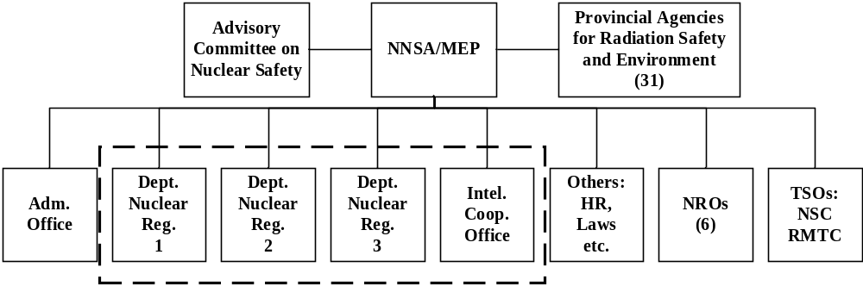
FIG. 1 Nuclear safety regulatory body and its TSOs in China

1.2 Nuclear Safety Legal System
Regarding to the regulation system, China has 1 law in the top and 7 administrative regulations in the second level, including the nuclear facility safety supervision, nuclear material safety, nuclear emergency, radioactive source safety, transportation safety, nuclear equipment safety and rad-waste safety. Furthermore, there are 27 departmental rules, and 89 safety guides under these departmental rules.

Activities for Fukushima accident
During the Fukushima accident, the regulator coordinated with the TSOs, especially the NSC, and conducted the radiological monitoring national wide. Meanwhile, NNSA also conducted accident analysis, as shown in Fig. 2, released the information to the public, drafted nuclear safety plan. And the meantime, NNSA conducted safety examination national wide, safety margin assessment and took safety improvement actions similar with other counties after Fukushima.
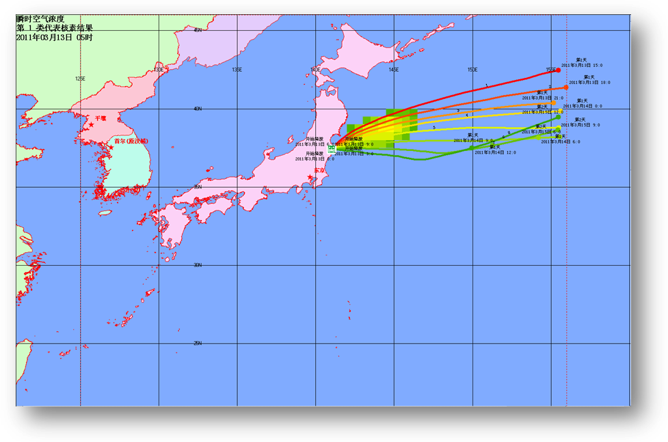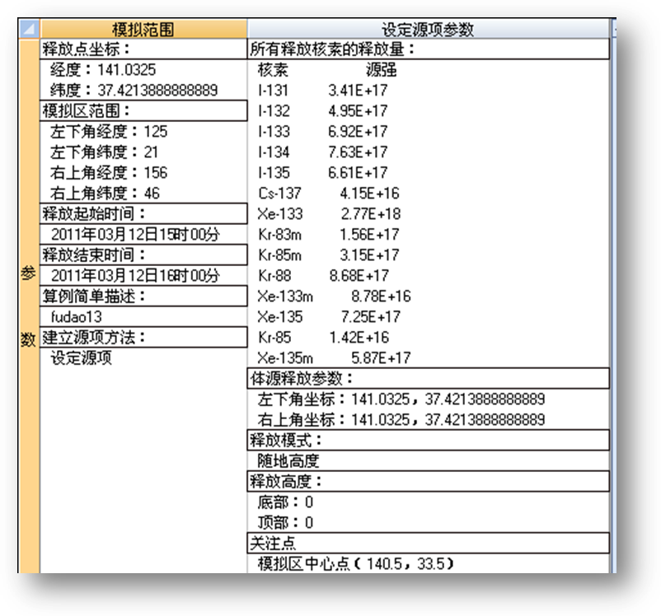
FIG. 2 Consequence assessment results during Fukushima with domestic software RANCON
Monitoring data from the environment is a significant work during the Fukushima, as shown in Fig. 3, because it is a strong tool to let the public understand whether the environment is polluted or not. We issued the results of gamma dose rate continuous monitoring, gamma spectrometry analysis for artificial radioactive aerosol, iodine in air, soil samples, water samples, dry/wet deposition, and biological samples. All of these monitoring data and related information was published and daily updated on web-site of NNSA/MEP.
In addition, NNSA/MEP will publish statement on nuclear safety culture soon. This is the common position for the regulator government agencies and nuclear industries and it is keep in line with the international practice and summarizes Chinese practice. This statement includes 8 elements: policy levels’ safety commitment, management levels’ attitudes and demonstration, responsibilities and participation of the individuals, organizational learning, complemented management system for the quality assurance, proper working climate, questioning attitude and experience feedback, harmonious public relations.
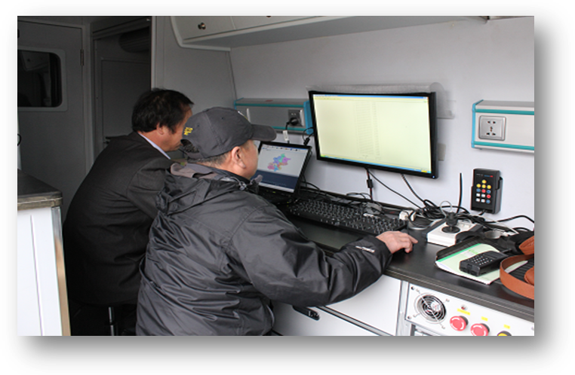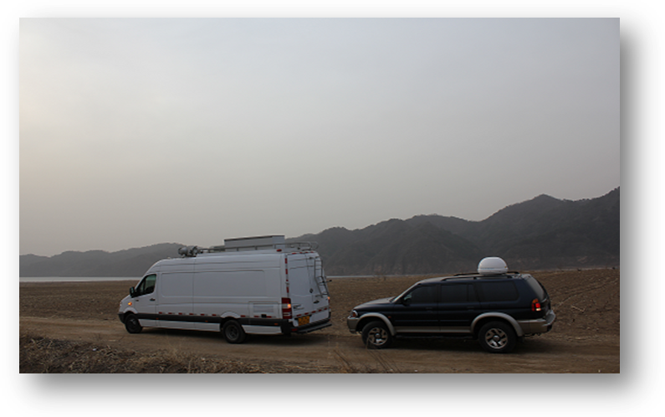
FIG. 3 Environmental radiological monitoring during Fukushima

Emergency Management System

3.1 Emergency Law and Regulation
According to the Chinese law, we have two laws regarding the emergency. One law is the general law on Emergency Response; the other is law on Prevention and Control of Radioactive Pollution. There are two regulations under the law, one is Emergency Management for Nuclear Accidents at Nuclear Power Plant, and the other is Safety and Protection of Radioisotopes and Radiation Devices. Under these two laws, two accident managements are established, regarding the nuclear accident and radiological accident respectively. Furthermore, the system also contains basic safety standard for ion-radiation and safety of radiation source and related NNSA safety guides on EPR.

3.2 Nuclear Accident Management
For nuclear accident management, according to the laws and regulations, we have 3 levels of emergency plans: National Nuclear Emergency Plan, Provincial Nuclear Emergency Plan and NPP Nuclear Emergency Plan. All plans are revised based on lessons learned from Fukushima accident, and emergency capacity are enhanced.
- National Nuclear Emergency Plan
China established National Nuclear Emergency Coordination Committee (NNECC), which is leading by China Atomic Energy Authority (CAEA), and regulators are the members of the Committee, totally 24 ministries involved. In the plan, NNSA organize and coordinate national level emergency, approve provincial emergency plans, guide and support provincial emergency activities, arrange emergency training and exercise, contact with IAEA emergency center for any nuclear accident.
- Provincial Nuclear Emergency Plan
China also established Provincial Coordination Committee. This Plan is approved by NNECC and provincial government is the leader of the Provincial Coordination Committee, and related agencies involved. In the plan, provincial government organize and coordinate provincial level emergency, implement provincial emergency plans including information, monitoring, assessment, traffic control and other protection actions, arrange emergency training and exercise.
- NPP Nuclear Emergency Plan
The most important plan is the utility’s plan and this plan reviewed and approved by NNSA. In the emergency plan (EP) of the utility: emergency organization is established and plant manager take full responsibility during emergency, EPR is described in the plan, and related procedures are established, NPP maintain emergency capability including hardware and software, and arrange emergency training and exercise. That is all the activities following our standards and guidelines which are all from IAEA’s safety standards, so China almost can keep the similar EPR with the international level.
In addition, after Fukushima Fast Emergency Assistant Team (FEAT) has been established by China National Nuclear Corporation (CNNC) and China Guangdong Nuclear Power Company (CGNPC) two group nuclear companies under the request of regulator and national energy of administration (NEA), and this team is a national level from the industry to provide outside support to the utilities. FEAT located in Qianshan NPP and Daya Bay NPP separately, with emergency equipment, with 200 engineers, operators and maintenance workers from different NPPs, and three-year rotation. By the end of 2014, FEAT will possess practical abilities of emergency response assistance.
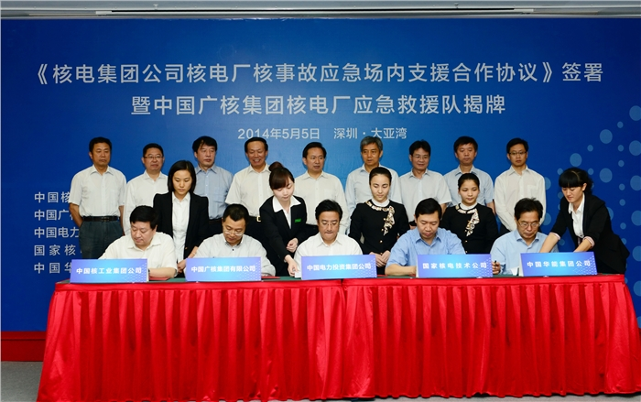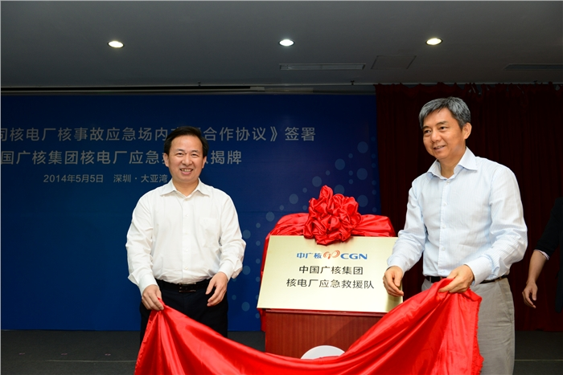
FIG. 4 Five companies signed mutual assistant agreement on May 2014

3.3 Radiological Accident Management
Regarding the radiological accident management, also according to the laws and regulations, there are 3 levels emergency plan for radiological accidents: NNSA/MEP Radiological Emergency Plan, Provincial Radiological Emergency Plan and Facility Radiological Emergency Plan. All plans are revised after safety examination, and emergency capacity are enhanced. The only difference between nuclear and radiological accident management is from the national level. MEP is the leading organization, but for the provincial and facility level are almost the same with the nuclear accident management.
- NNSA/MEP Radiological Emergency Plan
NNSA/MEP is leading organization. Deal with organize and coordinate Level 1 radiological accident, that means based on the IAEA radioactive source category, for the category one accident. Regarding the rest category 2-4, most responsibilities are belong to the provincial and facilities. NNSA provides guide and support to provincial environmental protection agency (EPA) when accident, report to the State Council and information release to public, emergency training and exercise. In addition, accident investigation and enforcement are based on grade regulation by NNSA/MEP or provincial EPA. Digital emergency response network has been established among NNSA/MEP, TSO and provincial EPA.
- Provincial Radiological Emergency Plan
This plan is approved by provincial government, and provincial EPA is leading organization, police and provincial heath department involved. Provincial EPA organize, command and action for Level 2-4 radiological accidents, report to the NNSA/MEP and information release to public, arrange emergency training and exercise and radiological monitoring.
- Facility Radiological Emergency Plan
This plan is graded approval during licensing by NNSA/MEP or provincial EPA. Emergency organization is established and manager of the licensee take full responsibility during emergency. Also in the plan, EPR are described, and related procedures are established. Facility has responsibilities to maintain emergency capability and arrange emergency training and exercise.

Environmental Radiological Monitoring System
In china, National Environmental Radiological Monitoring System (NERMS) is established by NNSA/MEP and RMTC provides technical support. Monitoring data come from provincial environmental protection agencies and licensees. Three kinds of monitoring are carried out:
- Environmental quality monitoring: 831 monitoring points, wherein 157 are auto monitoring equipment. As shown in Fig. 5 (a).
- Source monitoring: auto monitoring gas & liquid effluent around 18 nuclear sites. As shown in Fig. 5 (b), we can see about 10 to 20 monitoring points have been located around the NPP which can reflect the daily operation and catch any release from the NPP.
- Mobile emergency monitoring: operated by RMTC, NSC and provincial EPA. Currently, we have 20 vehicles/labs in-service in some important region, equipped with large-sized NaI survey spectrometry, aerosol sampler, meteorological instrument, GPS, high purity Ge spectrometry, alpha spectrometry and other portable sampling and measurement instruments.
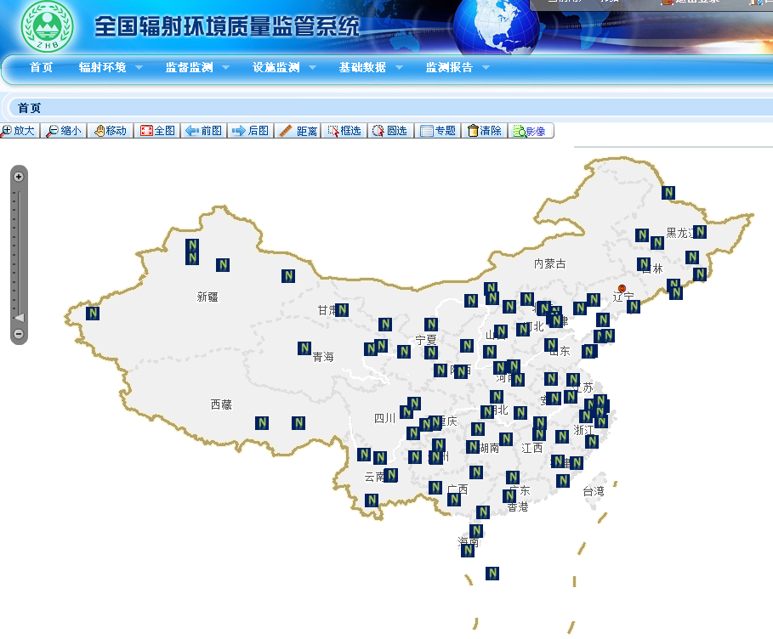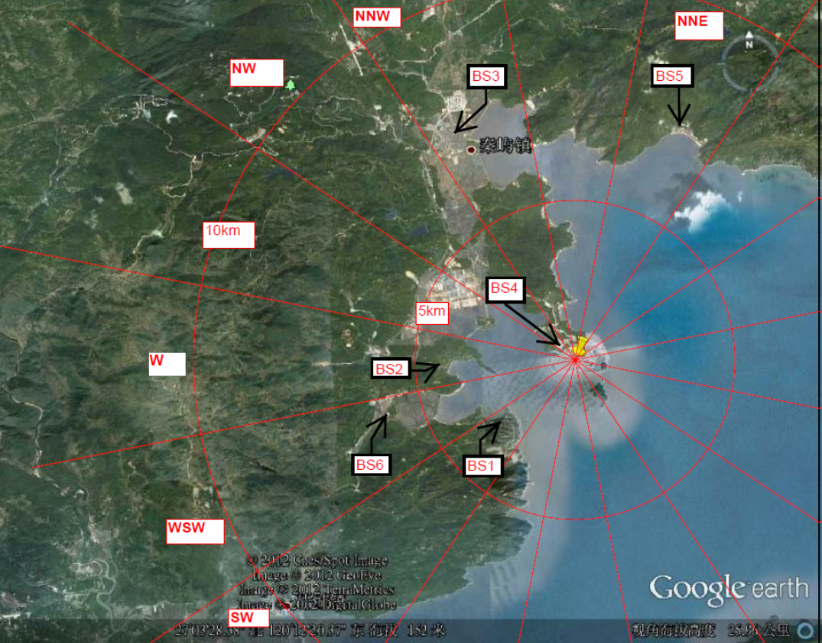
- (b)
FIG. 5 (a) Auto-monitoring for environment quality, (b) source monitoring Point for NPP

Enhance Emergency Capability
After Fukushima accident, NNSA/MEP conducted a comprehensive safety examination on nuclear installations and radioactive sources. Weaknesses have been identified, some related to emergency capability. Moreover, Nuclear Safety Plan that is approved by State Council and published to the general public. One of the important issues of the plan is to enhance emergency capability. The activities related to emergency capability enhance include:
- Improving emergency plans in different levels.
- Responding to external disasters and ensure water and electricity supply during accident. During the safety improvement, NNSA seal all of the insulations to prevent external disasters and increase emergency diesel generator, water pump and etc.
- Established real time data collection and assessment ability in NSC.
- We Improving emergency management center, increase communication with the utilities, Real time data collection and consequence assessment, software and etc.
- Improving severe accident management guide (SAMG) and keeping an on-site engineering maintenance team for each NPP.
- Establish off-site assistant team, FEAT.
- Enhancing Emergency radiological monitoring by licensees and EPAs.

NNSA/MEP and Its TSOs Activities in Emergency
According to emergency plan, as a regulator, the emergency activities include:
- Revising emergency plan.
- Enhancing communication and real-time data collection, including safety parameters, meteorological data, and radiological monitoring data.
- Enhancing accidents analysis, consequence evaluation and assessment.
- Improving NNSA/MEP Emergency Decision Support System.
- Conducting inspection and enforcement for licensee’ response activities.
- Implementing emergency trainings, drills and exercises.
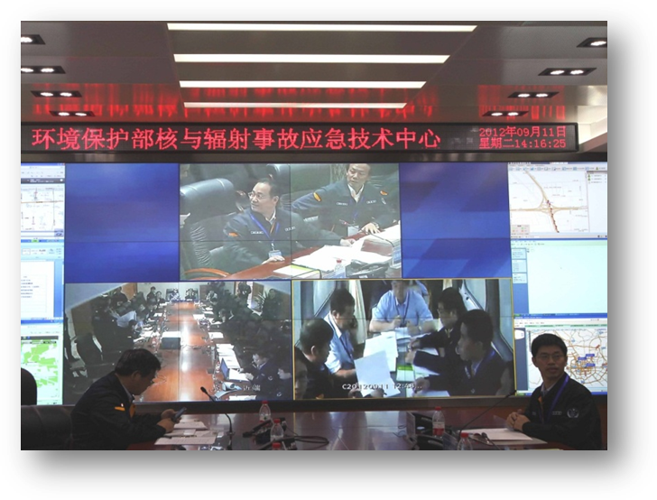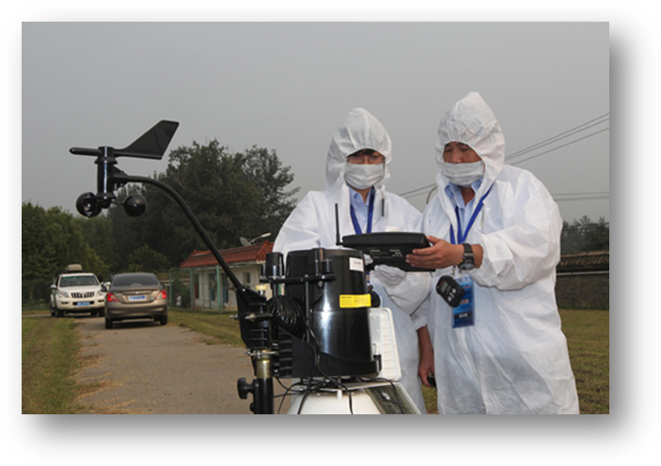
FIG. 6 Comprehensive exercises on radiological accident in 2012

Conclusion
Chinese emergency system for nuclear and radiation accidents has been well established, and lots of improvements have been made after Fukushima accident. TSOs in China have provided and will provide fully technical support to regulator. Further enhance TSO technical capacity is still needed.

