**Enhancement of Nuclear Safety In Seismic Analysis For TRR-1/M1 After Fukushima Daiichi Accident**

K. TIYAPUN1, A. REONGRATSAMEE2

1Reactor Center, Thailand Institute of Nuclear Technology (Public Organization)

2Faculty of Civil Engineer, Chulalongkorn University

*E-mail contact of main author: Kan.okrat2008@hotmail.com*

**Abstract**. After the Fukushima Daiichi Accident, IAEA recommended for strengthening the reactor safety by conducting the seismic analysis of the reactor. The Thai Research Reactor-1/Modification 1 (TRR-1/M1) is an open pool type TRIGA-Mark III using light water as a coolant, moderator, reflector and shield with concrete biological shield and four neutron beam tubes. The maximum power of TRR-1/M1 is licensed at 1.3 MW. TRR-1/M1 uses two types of low enriched uranium TRIGA fuel elements; 8.5% wt. uranium and 20% wt. uranium. The major achievement for Thailand Institute of Nuclear Technology (TINT) as a Technical and Scientific Support Organization (TSO) for the TRR-1/M1 includes the seismic analysis. The Computer Programs which were used in the study including SAP2000 and PCA Column. The TRR-1/M1 seismic analytical results, under different critical combinations of dead load, live load and seismic load, indicate that the maximum stress that will develop in the beam and column is significantly lower than the member strength. This can be explained by the interaction of the reactor pool and its building that effectively shorten the overall structure period and reduces the member forces. It can be concluded that both the reactor pool and its building structure can withstand from earthquake loading and consequently no strengthening measure is required for the structures under consideration. The further analysis of the reactor is considered the detailed analysis related to other reactor safety aspects.

### Introduction

The TRR-1/M1 is located in Bangkok, the capital of Thailand. The reactor site is next to Kasetsart University and the total area of the site is about 13,000 m2. TRR-1/M1 was constructed more than 50 years and during that time the site specific design basis earthquake was not considered in the design of the reactor building. In addition, after the Fukushima accident, International Atomic Energy Agency (IAEA) recommended to have several analyses including the seismic assessment and external events analysis in order to strengthening the reactor building and reactor pool against earthquake. Considering the ground motions, the seismic qualification and the seismic analysis of the TRR-1/M1 was conducted.

### Description of the Reactor

The TRR-1/M1 core utilizes approximately 20% enriched UZrH fuel which is loaded into two types of fuel elements: 8.5% wt and 20% wt uranium. The TRR-1/M1 fuel element is clad with 304 stainless steel. TRR-1/M1 is an open pool type TRIGA – Mark III using light water as a coolant, moderator, reflector and shield with concrete biological shield and four neutron beam tubes. The nominal power of TRR-1/M1 is 1.3 MW. The TRR-1/M1 core is located in the reactor pool and heat generated by fission process is cooled by natural circulation of the pool water which in turn is dissipated by means of heat exchanger and cooling tower arrangement. The TRR-1/M1 experimental facilities include four neutron beam tubes, a graphite thermal column, a rotary specimen rack, a pneumatic transfer system, and several in-core and out-core irradiation positions. Figure 1 shows the perspective view of the TRR-1/M1 structures.

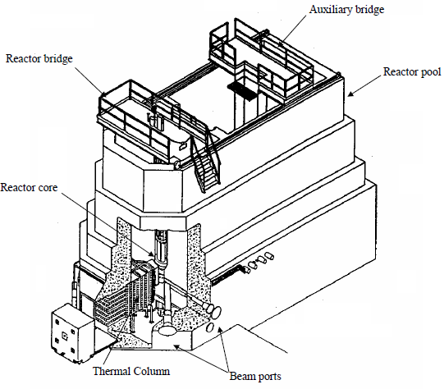

*FIG. 1. Perspective View of TRR-1/M1 Structures*

#### Objective of the Study

TRR-1/M1 has been designed to comply with the most Thai safety regulation. The defence in depth approach provides the facility with multiple levels of protection against the accidental release of radioactive materials and ensures compliance with the fundamental safety objective. To achieve the reliability and the operational availability, IAEA recommended stringent criteria particular attention to seismic performance of the reactor building to impose on the structural design of TRR-1/M1 after the Fukushima accident. The study can provide useful preliminary data for automatic shutdown system of the reactor upon the detection of an earthquake. Therefore, it is crucial to study the effect of earthquake loading on the reactor pool and its building.

### Seismic Hazard Studies

* 1. Seismic History

The structures in north-western part of Thailand, including Bangkok and its vicinity area, must be designed for seismic loading. The critical active fault that can have significant effect on building in Bangkok is in the Karnchanaburi province which has the potential to create an earthquake of 7.0 to 7.5 Richter magnitudes. In addition, the subsurface condition of Bangkok area is of soft soil type which can result in the amplification of the seismic wave. Thus, it is necessary to study the seismic response of the reactor pool and its building. These studies used both deterministic and probabilistic methodologies in order to predict the Peak Ground Acceleration (PGA) and its associated Design Response Spectrum (DRS) for the Safe Shutdown Earthquake (SSE) events. The seismic-prone area in Thailand has an epicenter in the north-western and outskirts of the west coast. For the present seismic analysis of reactor pool and its building, past recorded seismic data and information on the specific active faults, e.g., Srisawasdi fault and Chedisam-ong fault in Karnchanaburi province, etc, were used.

* 1. Design Response Spectrum Analysis

### The analytical method adopted in this study was proposed by Cornell (1968)1 which was adopted by US Geological Survey (USGS) with the return period of 475 years and 2475 years for Seismic level 1 (SL-1) and Seismic level 2 (SL-2), in accordance to IAEA standard (NS-G-3.3)2, and Safety Reports Series No. 413 respectively. The method provided outcrop horizontal acceleration and structural response accelerations at different natural frequencies of the structure. Using this approach, it indicates that the horizontal acceleration response spectrum is 0.05g for an occurrence of 2% in 50 years (the return period of 2475 years). To develop the design response spectrum, the dynamic characteristics of soil layers (i.e. shear wave velocity) were investigated. Twenty eight seismic time-history analyses were used to construct the response spectrum. It was found that soil profile at the studied location can significantly amplify the structural response, in particular for structures with period at or lower than 1 second. As shown in Figure 2, the maximum value of the response spectrum, occurring at the structural period of 0.7 to 0.8 second, which was estimated to be 0.27g and 0.37g for median response and 84th percentile response, respectively.



*FIG 2. Horizontal Acceleration Response Spectrum from 28 Seismic Time History Analysis*

### Three Dimensional Spectral Analysis

* 1. Nondestructive Test

### Non-destructive tests which used in this study were rebound hammer and ultrasonic pulse velocity measurement which was performed on the reactor pool and the building to obtain an upper bound estimate of the concrete compressive strength. The results from the rebound hammer shown that the compressive strength of the inner reactor pool is 29 MPa, outer reactor pool is 36 MPa, reactor building is 52 MPa, respectively. The results from using ultrasonic pulse velocity measurement indicated an in-situ compressive strength of the inner reactor pool is 39 MPa, outer reactor pool is 54 MPa, and reactor building is 70 MPa. Therefore, the value used in the analysis was conservatively taken as 20.5 MPa, the same value specified in the original design drawing.

* 1. Three Dimensional Mathematical Model

### The response spectral approach has been adopted for determining the structural actions imposed by the SSE events on the Reactor Building (RB). For this study, 3D mathematical models for the RB has been developed using SAP2000 analysis program.4 The SAP2000 model, beam, plate/shell and brick finite elements have been used to represent linear, planar and solid zone of the structure, respectively. Concrete shear walls which are the main lateral load resisting elements of the reactor pool and the RB are modelled using shell elements which both in and out of plane response characteristics included. Figure 3 shows the three dimensional shell element model of the reactor pool.



*FIG. 3. Three Dimensional Shell Element Model of the Reactor Pool*

* 1. Equivalent Static and Dynamic Analysis

### The structures were analyzed using a combination of equivalent static and dynamic procedures. The results from the combination of equivalent static shown that the maximum tensile stress of the concrete reactor pool obtained from the load combination analyses were lower than the allowable tensile strength. The dynamic procedure used in this study involved time-history analysis. The hydrodynamic forces in a reactor pool are evaluated using mechanical analog in the form of spring mass system, which simulate the impulsive and convective mode of vibration of water in the reactor pool. Liquid in the lower portion mostly contributes to impulsive mass and liquid in the upper portion undergoes sloshing motion. The sloshing and the hydrodynamic pressure estimation were analyzed as shown in Figure 4. The results shows that the calculated minimum and maximum base shear with natural period were less than the combination of equivalent static method. Therefore, the reactor pool can withstand the seismic-induced loading that might occur.

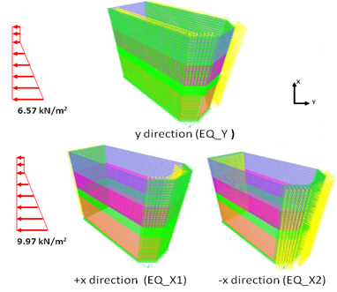

*FIG. 4. Seismic Induced Pressure along x and y Directions*

* 1. Interaction of the Reactor Pool and the Reactor Building

### A 3D finite element model of the TRR-1/M1 reactor building was generated using appropriated solid, shell, beam and spring elements. Finite element stress analysis was conducted under quasi-static seismic loads derived from the response spectral analysis of the reactor building. The finite element model of the reactor building is shown in Figure 5.



*FIG. 5. Structural Model of TRR-1/M1 Reactor Building*

To capture the interaction of the reactor pool and its building, a model consisting of the reactor pool (with contained water) attached to the building with flexible foundation was developed. Water in the reactor pool is modeled as an equivalent system of masses and springs. The structural of the reactor building with the water was modeled using SAP2000 including the beam column elements and shell elements as shown in Figure 6.

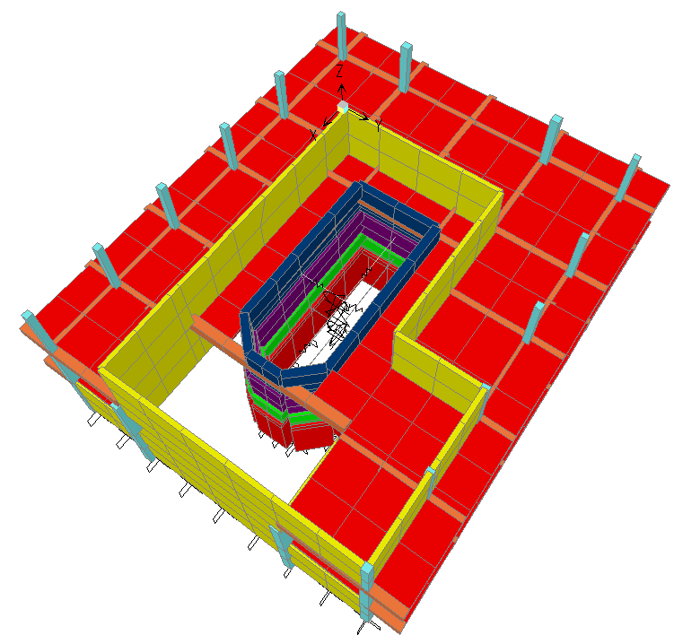

*FIG. 6. Structural Model of TRR-1/M1 Reactor Building with the Water inside the Reactor Pool*

The computational of the nominal axial compression strength (Pn) and the nominal moment strength (Mn) was used. Load moment (P-M) strength interaction diagrams have been used for the design of reinforced concrete column.5 The design and investigation of reinforced concrete column was analyzed using PCACOLUMN program. The response spectral wall stresses have been used directly to check the adequacy of the walls in diagonal compression and to design reinforcements to resist diagonal tensions and out of plane bending. Analyzed tensile and compressive stresses were examined to ensure adequacy of the concrete and its reinforcements. The combination stresses due to different load cases indicated that the maximum stress which will develop in the beam and column is significantly lower than the member strength. This result can be explained by the interaction of the reactor pool and its building, which effectively shorten the overall structure period and reduces the member forces.

### Conclusion

In response to the Fukushima Daiichi accident and the resulting from the IAEA recommendations, the re-evaluation of TRR-1/M1, which is categorized as hazard category 3, according to the Safety Reports Series No. 41 was carried out. The seismic analysis reassessment was performed using deterministic methods for re-evaluation the structural strength, integrity and stability of the reactor building under the various load combination and load factors with set limits on stress, strain or deformation. The results show that the reactor and the building structure are acceptable within the design margin for external events under the loads combinations due to normal operation and anticipated operation conditions. The results from mass system model based and 3D SAP2000 analysis show that the reactor pool and its building structure provide sufficient seismic safety. The results from this re-evaluation can be used to confirm the adequacy of the design and to account for the seismic event hazard. For further details in the future, the ageing effect of the reactor should be considered including corrosive actions and other ageing degradation process, surveillance and testing to assess the degradation of structures, systems, components and development of a preventive maintenance program.

### References

1. Cornell, C.A., “Engineering seismic risk analysis”, Bulletin of the Seismological Society of America 58 (1968) 1583–1606.

2. INTERNATIONAL ATOMIC ENERGY AGENCY, Evaluation of Seismic Hazards for Nuclear Power Plants, IAEA Safety Standard Series No. NS-G-3.3, Vienna (2002).

3. INTERNATIONAL ATOMIC ENERGY AGENCY, Safety of New and Existing Research Reactor Facilities in Relation to External Events, IAEA Safety Reports Series No. 41, Vienna (2005).

4. SAP2000, “Integrated Software for Structural Analysis and Design”, Computers and Structures, Inc., (2012).

5. ACI American Concrete Institute, “Design Handbook in Accordance with the Strength Design Method”, American Concrete Institute, Farmington Hills, MI, (1997).