PAPER TITLE IN TIMES NEW ROMAN 12 POINT

BOLD CAPITALS, NOMORE THAN 40 CHARACTERS

PER LINEINCLUDING SPACES (use style ‘TITLE’)
Subtitle if needed in Times New Roman 12 point bold
Italic, sentence case (use style ‘SUBTITLE’)

A.N. AUTHOR (use style ‘Author name and affiliation’)
Organization
Town/City, Country
Email: address@correspondingauthor.com

A.N. OTHER-AUTHOR
Organization
Town/City, Country

OR (in case of many authors):
A.B. AUTHOR¹, C. AUTHOR¹, D. AUTHOR¹, E.F. AUTHOR², G. AUTHOR³, H. AUTHOR³, I. AUTHOR³, J. AUTHOR⁴, K. AUTHOR³, L AUTHOR¹, M.N. AUTHOR³, O. AUTHOR², P. AUTHOR⁴, Q. AUTHOR⁴

¹Organization, Town/City, Country
²Organization, Town/City, Country
³Organization, Town/City, Country
⁴Organization, Town/City, Country

Corresponding author: A.B. AUTHOR, address@correspondingauthor.com

INTRODUCTION: (use style ‘Introduction title’) This is an example of how to format a brief introduction for previewing. The title is Times New Roman 11 point bold, indented by 1 cm. The text is Times New Roman 11 point, with a first line indent of 1 cm. It should not contain information not included in the paper. The introduction should not contain references, equations, or the word ‘we’. Write ‘the paper’, not ‘this paper. Use ‘Body Text’ Style for normal text. (use style ‘Body Text’)

OVERVIEW (use style ‘Heading 1st’)
This is an example of how a body text should be formatted. The text above shows how the running head, title, subtitle (if applicable), author names and affiliations, and abstracts should be formatted. The text should be edited in English (United Kingdom) by setting the review language. The heading immediately above this paragraph is a first level paper heading; it is Times New Roman 11 point regular capitals. The body text of the paper is Times New Roman 11 point regular, with a first line indent of 1 cm.
Please use these examples to format your paper. Applying the styles from Styles Ribbon saved in this document to your text should format it correctly. Your word processing software may also contain a tool such as a ‘format painter’ that will enable you to copy the formatting from the example text to your own text. Alternatively, the information given in this template should enable to select the correct format for each section.

originality, copyright and publication
The text of a paper submitted to this conference must be original with any material from copyrighted works (including illustrations, tables, and text quotations) included with the permission of the copyright holder. The contributor should, therefore, make sure that any permissions and rights required to publish any third-party content have been obtained and that all published material is correctly referenced.
The content of a paper is expected to have been written by the stated authors and the paper itself must not have been published before and be under consideration for publication by another entity (if this is the case, please contact the Conference Organizer for further information). All papers will be scanned to ensure originality; if they are found to contain non-original text, only their abstract will be included in the proceedings.
Papers will only be included in the proceedings if the IAEA Form B has been submitted prior to the conference. If the Form B is not received, only the abstract may be included in the proceedings, but this may also be omitted.

headings AND SUBHEADINGS
If you need to subdivide the sections of your paper, use the headings shown below. You can use second and third level paper headings. To subdivide further, please use lists numbered (a), (b), and so on, but this is usually not necessary in a paper of normal length.

Second level paper heading (use style ‘heading 2nd’)
A second level paper heading is Times New Roman 11 point bold, in sentence case.

Third level paper heading (use style ‘heading 3rd’)
A third level paper heading is Times New Roman 11 point italic, in sentence case.

PAGE AND SECTION BREAKS
If you need to move a heading to the following page, please use a page break (usually found in word processing software under the ‘insert/page break’ menu). Please do not press return several times to move text onto a new page.

TABLES
Tables must be numbered consecutively and include a table heading. There is no full stop at the end of the heading. IAEA style is to use table borders and lines sparingly. Tables must be mentioned and cross-referenced in the text and should be inserted following the end of the paragraph in which they are mentioned, or on the next page if there is not enough space. Tables are formatted in Times New Roman 9 point regular. Please use the three-line table format, minimizing the use of excessive lines for a cleaner presentation. For an example, see Table 1.
When a table extends across multiple pages, ensure that the header row is repeated at the top of each page to maintain clarity and readability. Additionally, you may adjust the table layout or font size to minimize page breaks but avoid overcrowding the content.

TABLE 1. EXAMPLE TABLE (Use style ‘Table Title’)
Column 1 | Column 2 | Column 3
Align text left | Centre text | Centre text
Align text left | Centre text | Centre text

FIGURES
The figures you use in your publication must be original. If they have been published elsewhere (even in other papers authored by you or one of your co-authors) they cannot be used unless a permission is obtained and sent with the paper.
The figures must be numbered consecutively and mentioned in the text in the order in which they are numbered, using the abbreviation Fig. They should be inserted into the paper without a border and immediately below the paragraph in which they are mentioned, or on the next page if there is no space. They should have a caption, which is set in Times New Roman 9 point italic; the caption should be centred if it is a single line (use style ‘figure caption’) or aligned left if it is two lines or more long (use style ‘FIG-LONG’). An example of a caption can be seen below Fig. 1. Note the capitalization of ‘Fig.’ in the figure caption. Proper reference of a figure should be provided and must be cross referenced in the figure’s caption.
Figures should be placed ‘centre aligned’ and ‘in line with text’. Provide the high-resolution figures with legible text in them. Text in figures should use black colour to ensure legibility.

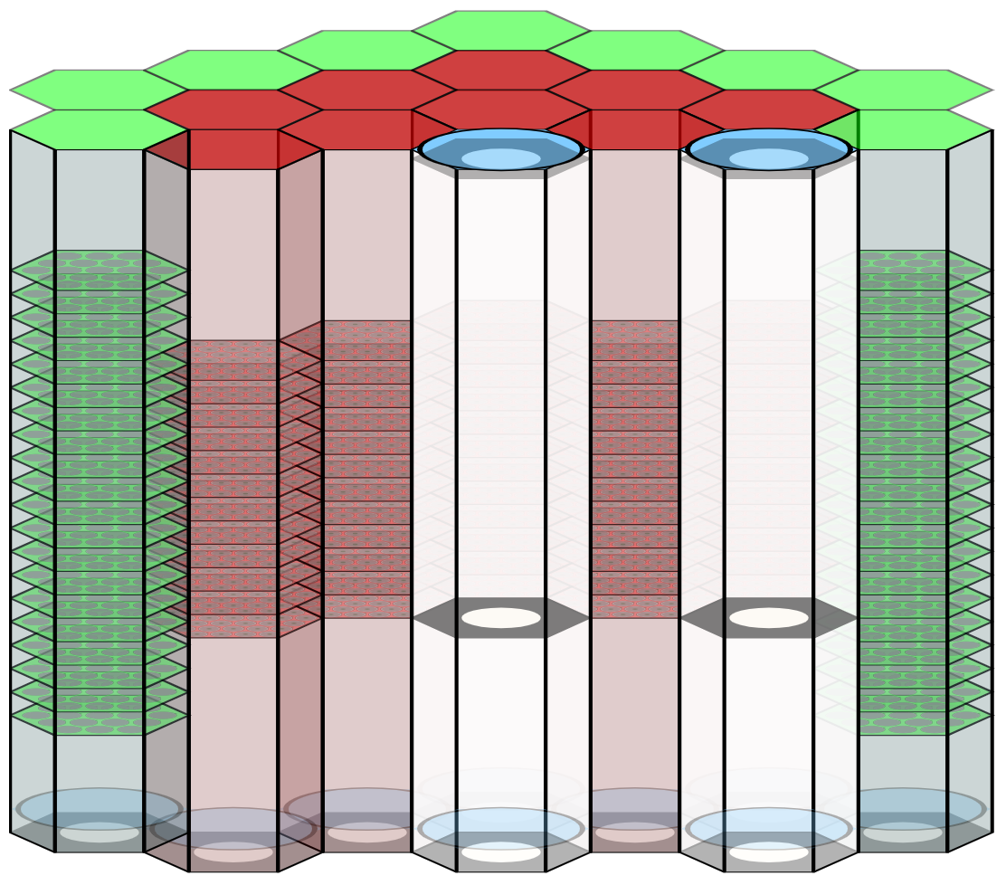
Fissile
core
Core
Flow-suspended absorber rods
Low
flow rate
Nominal
flow rate
Absorber
Absorber
Fig. 1. PSS flow levitated rods for BN-800 (courtesy of Mr V. Kriventsev, IAEA). (use style ‘Figure Caption’)
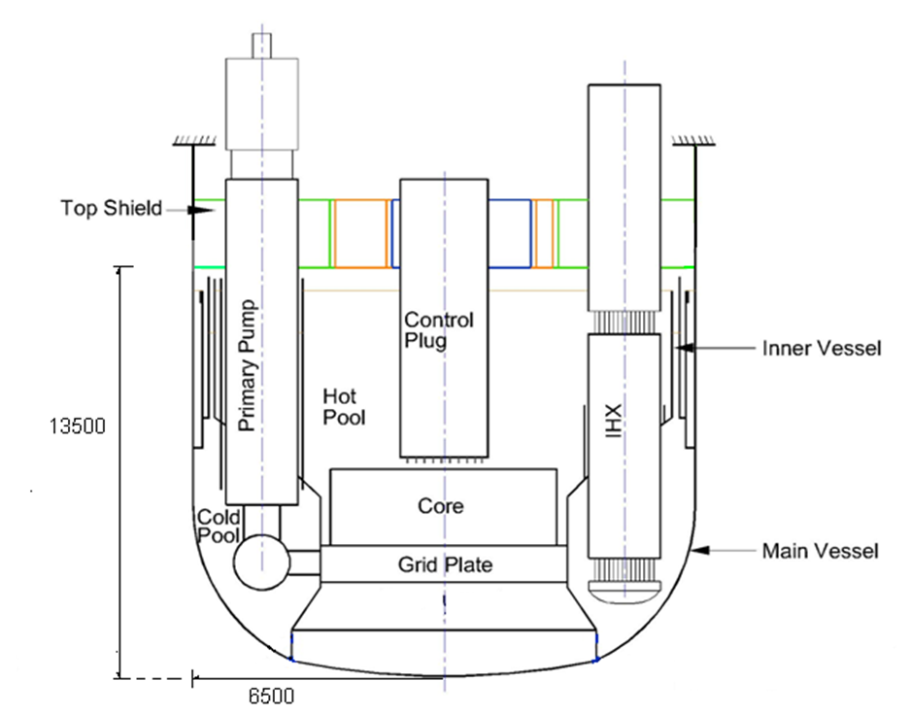
Fig. 2. Two and more lines figures caption: Schematic of Reactor Assembly Section through IHX and PUMP (adapted from FR17 paper [12]) (use style ‘FIG-LONG’)

REFERENCES
In accordance with good academic practice, reference sources should be cited in the text to support the assertions it contains. IAEA style is to use numbered references in square brackets. There are different formats for sources such as books [1], internal reports [2], personal communication [3], unpublished data [4], single chapters from books [5], journal articles [6], websites and on-line databases [7], papers from a proceeding [8], presentations including slides and handouts [9], and INFCIRCs [10]. Sources ‘in preparation’ or ‘in press’ use these terms in place of the year. When citing academic and research papers, Digital Object Identifier (DOI) is essential to include for each reference. Titles are given in their original languages if these use Latin alphabets, or translated into English for languages that do not use Latin alphabets. Please see the reference list below for examples of how to format the sources numbered [1–14]. The text in the reference list is Times New Roman 9 point regular.

Further information

Author affiliation
Put the email address after the affiliation of the corresponding author, whether he or she is the first author or not. Please put the name of the authors’ organization(s) in English. Do not give the organization’s street address or postal code. For international organizations, no country is given. Please use the name of the country as it is given in the IAEA Member State list (for example, use ‘Russian Federation’, not ‘Russia’).
If there is a long list of author names and some of them are from the same organizations or same States, please seek advice from the conference organizer on how to format such a list to save space.

Bulleted lists
If you use a bulleted list in your paper, please format it as below:

- First bullet point; (use style ‘List Emdash’)
- Section bullet point;
- Third bullet point.

If you need to use subpoints, please use this long line format:

- First bullet point.
- Second bullet point.
- First subpoint; (use style ‘List bulleted’)
- Second subpoint.
- Third bullet point.

Please note the punctuation at the end of the points.

Numbered lists
If you use a numbered list in your paper, please format it as below, noting the punctuation at the end of the points:
- First bullet point. (use style ‘List Numbered’)
- Section bullet point.
- First subpoint;
- Second subpoint.
- Third bullet point.

Please use (a), (b), etc., unless your text refers to the points elsewhere as ‘the first point’, ‘the second point’ and so on — in this case, please use (1), (2), etc.

General formatting
Only the font Times New Roman should be used in the paper. The font Symbol should never be used in files intended for publication as it is not a Unicode font and letters may change during production (for example, μSv may print as mSv if the character μ is inserted in Symbol font).
Underlining should not be used. Bold and italic may be used for emphasis but should be used sparingly. Paragraph line spacing is 12 point for 9 point text, 13 point for 10 point text and 14 point for 12 point text, as used in this example paper. Only one space is used following a full stop.
Footnotes should be used only where necessary. They should be inserted at the end of each page, and not at the end of the paper as endnotes.
Pages should not have half-page or full-page blank spaces. Section should not be moved to new pages if there is space available on the previous ones.
Units should not be mixed with complete spelling and abbreviations of units: “MW/m3” or “megawatt per cubic meter”, not “megawatt/m3”. Spell out units when they appear in text: “. . . a few tons”, not “. . . a few T”.
Reactor power should be given as 500 MW(e) for electrical power and as 1500 MW(th) for the thermal. Instead of U, Pu, Na, use uranium, plutonium, sodium; Both “UO₂” and “uranium dioxide” are acceptable. Specific isotopes should be specified with the mass number in superscript followed by the elemental symbol: ²³⁵U
Scientific notation should be represented by standard format a×10^{n}, where a is a decimal between 1 and 10, and n is an integer. For example, express 53,000 as 5.3×10⁴ instead of 5.3E4. This format is more appropriate for formal documents, papers, or reports and avoids the simplified E-notation.
Equations should be typed using either the Times New Roman or the Symbol font (please no other font). Equations should be centred, and their numbers should be aligned left as in the example below.
$Re=\frac{uD_{h}}{ν}=\frac{ρuD_{h}}{μ}$, | (1)
where $ρ$ is the density, $u$ is the velocity, $D_{h}$ is the equivalent hydraulic diameter, and $μ$ and $ν$ are the dynamic and kinematic viscosity respectively.

ACKNOWLEDGEMENTS (use style ‘unnumberd headings’)
The heading of the acknowledgements section is Times New Roman 11 point bold capitals, centred. The acknowledgements section is an optional section and can be used to list funding bodies and other sponsors of the research, and to mention people who supported the research but whose contribution was not of a type to merit authorship of the paper.
Example: The data and information presented in the paper are part of an ongoing IAEA coordinated research project on “Transition from Forced to Natural Circulation Experiment with Heavy Liquid Metal Loop – CRP-I31038”.
References
- AUTHOR, A., Book Title in Title Case, Series No. if applicable, Publisher, Place of Publication (Year),
https://doi.org/10.digital-object-unique-identifier (use style ‘Reference list’)
- AUTHOR, A., Internal Report Title in Title Case, internal report, Organization, Location, Year.
- LETTER-WRITER, A., Organization, personal communication, Year.
- RESEARCHER, A., Organization, unpublished data.
- CHAPTER-AUTHOR, A., “Title of chapter in sentence case”, Book Title in Title Case, Publisher, Place of Publication (Year),
https://doi.org/10.digital-object-unique-identifier
- AUTHOR, A., AUTHOR, B., AUTHOR, C., Journal article title in sentence case, Abb. J. Title 1 (< volume number in bold) 2 (< issue number) (Year) 120–123, https://doi.org/10.digital-object-unique-identifier
- AUTHOR, A., Title of Web Page or On-line Database in Title Case (Year),
www.webpage.com/exact-subpage-being-cited
- AUTHOR, A., “Paper title in sentence case”, Conference Title in Title Case (Proc. Int. Conf. Place of Conference, year), Publisher, Place of Publication (Year),
https://doi.org/10.digital-object-unique-identifier
- PRESENTER, A., “Title of presentation in sentence case”, Paper No., paper presented at Organization seminar on subject, Location, year.
- Title of INFCIRC in Title Case, INFCIRC No., IAEA, Vienna (Year).
- INTERNATIONAL ATOMIC ENERGY AGENCY, Passive Shutdown Systems for Fast Neutron Reactors, Nuclear Energy Series No. NR-T-1.16, IAEA, Vienna (2020).
- ARUL, J. et al., “Source term estimation for radioactivity release under severe accident scenarios in sodium cooled fast reactors”, Fast Reactors and Related Fuel Cycles: Next Generation Nuclear Systems for Sustainable Development FR17 (Proc. Int. Conf., Yekaterinburg, 2017), IAEA, Vienna (2018), Paper CN245-335.
- Virgili N., Kriventsev V., Progress of the IAEA CRP on Benchmark of Transition from Forced to Natural Circulation Experiment with Heavy Liquid Metal Loop, Presentation delivered by IAEA at the Second Research Coordination Meeting of the IAEA CRP I31038 on Benchmark of Transition from Forced to Natural Circulation Experiment with Heavy Liquid Metal Loop, October 2023, Vienna, Austria (2023)
- DI PIAZZA, I. et al, Benchmark specifications for NACIE-UP facility: non-uniform power distribution tests, rev. 2, IAEA CRP-I31038, Vienna, Austria (2023)

Text in a footnote is Times New Roman 9 point regular.

