The potential for thorium recovery as a co-product of processing magmatic rare earth element deposits

B.S. Van Gosen and D.B. Stoeser

U.S. Geological Survey (USGS)
Denver, Colorado
U.S.A.

Abstract. Thorium (Th) can be obtained as a co-product of processing deposits of rare earth elements (REEs). The REEs and Th are chemically associated in magmas that form REE-rich alkaline intrusive rocks and carbonatites. An example is the Mountain Pass mine and ore processing operations of MolyCorp, Inc., in southeastern California, which is the only active REE mine in the United States. The ore is a carbonatite containing an average REE oxide content of 7.98 percent. Monazite is an accessory mineral, giving the ore a Th content of about 0.025 percent. After ore processing to capture the REEs, Th is carried with other residues into the tailings impoundment. A second example is the Bear Lodge REE project of Rare Element Resources in northeastern Wyoming. The deposits occur in an altered carbonatite-alkaline intrusive complex. The ore averages 3.11 percent REE oxides and about 0.12 percent Th. The company stated their processing will “selectively isolate and economically remove thorium.” As a third example, UCore Rare Metals plans to mine REE-rich, thin vein-like dikes at the Bokan Mountain alkaline intrusive complex on Prince of Wales Island in southeastern Alaska. The “vein-dike” deposits average 0.65 percent REEs; about 40 percent are the heavy REEs. A U.S. Geological Survey study during 2013 and 2014 by the authors found Th in thorite and Ti±Nb±Y oxide minerals in these vein-dikes. Bulk sampling revealed Th contents of about 0.06 to 0.07 percent. The three REE ore bodies examined herein as case studies display the potential for Th as a co-product, but presently considered a waste product that will be either lost or difficult to recover.
1. Introduction
In magmatic systems, the large sizes of the rare earth element ions (⁺3) and thorium ions (⁺4) impede their ability to fit into the structure of the common rock-forming minerals, which have coordination sites best suited for smaller cations. Elements such as the REEs that do not tend to participate in the early mineral formation processes are referred to as incompatible elements or high-field strength elements. In magmatic systems, the incompatible elements can also include zirconium (Zr), hafnium (Hf), niobium (Nb), tantalum (Ta), titanium (Ti), phosphorus (P), scandium (Sc), and uranium (U). As a result, when common silicate minerals crystallize—feldspars, pyroxenes, olivine, and amphiboles—most of the rare earth elements (REEs) and thorium (Th) tend to preferentially remain in the melt. These elements concentrate in differentiated magmas, such as melts that form alkaline intrusions and carbonatites, which are the most common hosts for REEs. Successive generations of this process, referred to as crystal fractionation, increase concentrations of REEs and Th in the remaining melt until individual REE- and Th-rich minerals crystallize. Thus, high-grade Th deposits are often high-grade REE deposits.

Due to above normal concentrations of Th in REE ore bodies, Th can be a considered as a co-product of developing REE deposits, that is if a market emerges for Th as a nuclear fuel. Currently, Th within REE deposits in the United States is treated as a radioactive contaminant, not as a potential commodity. Separation and stockpiling of Th from the residue streams of REE production provide a possible method to economically obtain Th, if it becomes a viable commodity.

This presentation evaluates the Th content in three REE deposits in the United States; these include one deposit that is actively mined and processed for recovery of REEs (Mountain Pass, California) and two projects with plans to produce REEs in the foreseeable future (Bear Lodge project, Wyoming, and Bokan Mountain project, Alaska). Currently, these three projects focus on REEs as their economic commodity. This paper estimates the amounts of Th that could be recovered as a co-product commodity during the processing of the deposits for REEs.

2. Case studies

2.1 Mountain Pass mine, California

The Mountain Pass operation of MolyCorp, Inc., in southeastern California is the only active REE mine and processing facility in the United States (Fig. 1; http://www.molycorp.com). The mine reopened in late 2010 after an eight-year hiatus. The orebody is a massive carbonatite intrusion—the Sulphide Queen carbonatite—that reportedly contains 16.7 million metric tons of proven and probable reserves averaging 7.98 percent total REE oxides [1]. This carbonatite is thought to be the largest REE resource in the United States. The Sulphide Queen is a calcite-dolomite-barite-strontianite carbonatite [2, 3]. The primary ore mineral is bastnaesite [(REEs)CO₃F], forming 10–15 percent of the carbonatite ore body, plus lesser REE contributions from the mineral parisite [Ca[(REEs)₂(CO₃)₃F₂] [2,3]. The Sulphide Queen is the only known carbonatite where the REE ore minerals—bastnaesite and parisite—are interpreted to have crystallized directly from the magma, thus representing primary magmatic mineralization [4]. In the other carbonatites, the REE-bearing minerals are interpreted to have formed by secondary processes, such as hydrothermal events (as displayed by the next case study—the Bear Lodge carbonatite-intrusive complex).

Monazite [(REEs)Th(PO₄)] is an accessory mineral in the Sulphide Queen carbonatite, varying in amounts from a trace mineral to locally abundant within the ore body; the monazite gives the ore a Th content of about 0.025 percent. In 2011, bulk sampling (about 1 metric ton) of high-grade REE carbonatite ore collected in the mine by the U.S. Geological Survey (USGS) found an average Th content of about 0.025 percent (elemental weight percent) (unpublished author data). This estimate of Th content is nearly identical to the thorium concentrations found in an earlier geochemical study of this carbonatite [5].

Applying an estimated Th concentration of 0.025 percent within the Sulphide Queen carbonatite, this suggests that each metric ton of ore mined and processed at Mountain Pass contains, on average, about 0.25 kg of Th. This estimate of Th content in the Sulphide Queen orebody is certainly an approximation based on limited sampling; monazite concentrations may prove to vary considerably across the carbonatite as mining progresses. At this time (2014), when the carbonatite of Mountain Pass is mined, processed, and the REEs are separated, the Th moves with other residues into the tailings impoundment. Thus, it would require further processing of the tailings in order to recover the Th in the future.

2.2 Bear Lodge project, Wyoming

The Bear Lodge project of Rare Element Resources Ltd. is located in the Bear Lodge Mountains near Sundance in northeastern Wyoming. This project is currently in an advanced stage of permitting for their proposed REE mine and processing plant (http://www.rareelementresources.com/). Based on considerable exploratory drilling over the last several years, the company reports total measured and indicated resources of 15.2 million metric tons of ore averaging 3.11 percent total REE oxides in the district. Within this total REE resource they identified a high-grade zone of 5.4 million metric tons containing 4.72 percent total REE oxides, applying a cutoff grade of 3 percent total REE oxides [6].

The Bear Lodge REE deposits occur in hydrothermal alteration of an Eocene carbonatite-alkaline intrusive complex [7]. The REE deposits are hosted by diatremes composed of fragmented, highly altered trachyte and phonolite intrusive rocks, which are cross cut by carbonatite and siliceous carbonatite dikes, veins, and stockwork veinlets [6]. The primary REE ore minerals are ancylite and REE-fluorocarbonates of the bastnaesite group, and important Th-bearing accessory minerals are monazite and cerianite [(Ce,Th)O₂] [6, 7].

In 2011, Rare Earth Elements permitted the USGS to sample an exploration trench excavated into ore at the site of the proposed open pit mine (Fig. 2). The sampling found Th concentrations that average about 0.11–0.12 percent (elemental weight percent). Although this sampling must be considered a
Figure 1. The Mountain Pass mine of Molycorp, Inc., in southeastern California. This is the only active REE mine in the United States (in 2014). The ore body is a carbonatite intrusion, thought to represent the largest REE resource in the United States. The mine is located at latitude 35.47853 North, longitude 115.53181 West (datum, WGS84).
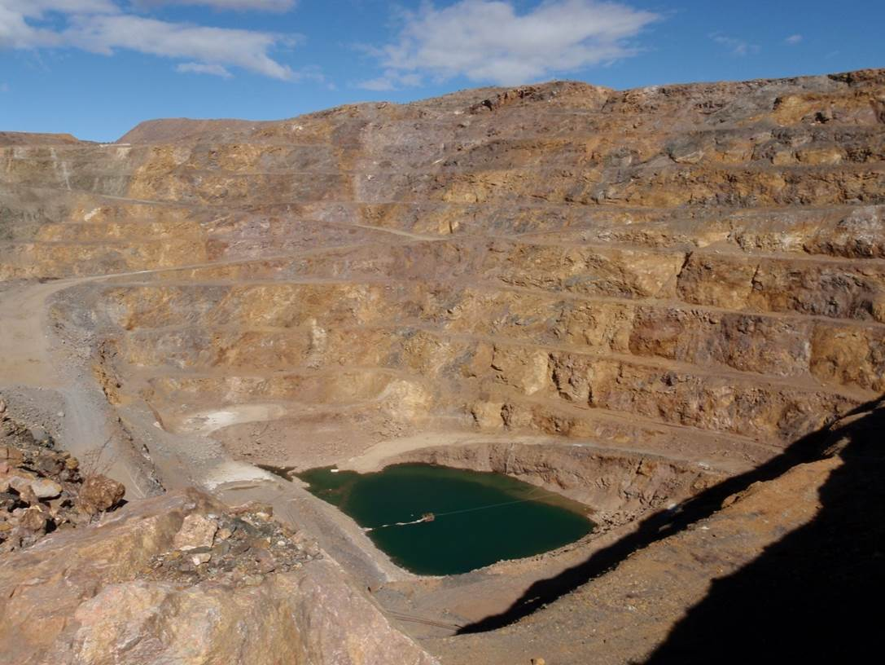

Figure 2. Bull Hill in the Bear Lodge Mountains, near Sundance, northeastern Wyoming. Bull Hill is composed of REE-mineralized, hydrothermally altered diatreme breccia in the upper part of an alkaline-carbonatite intrusive complex. The hill is the site of the proposed open pit REE mine planned by Rare Element Resources. The exploration trench is located at latitude 44.48983 North, longitude 104.44525 West (datum, WGS84).
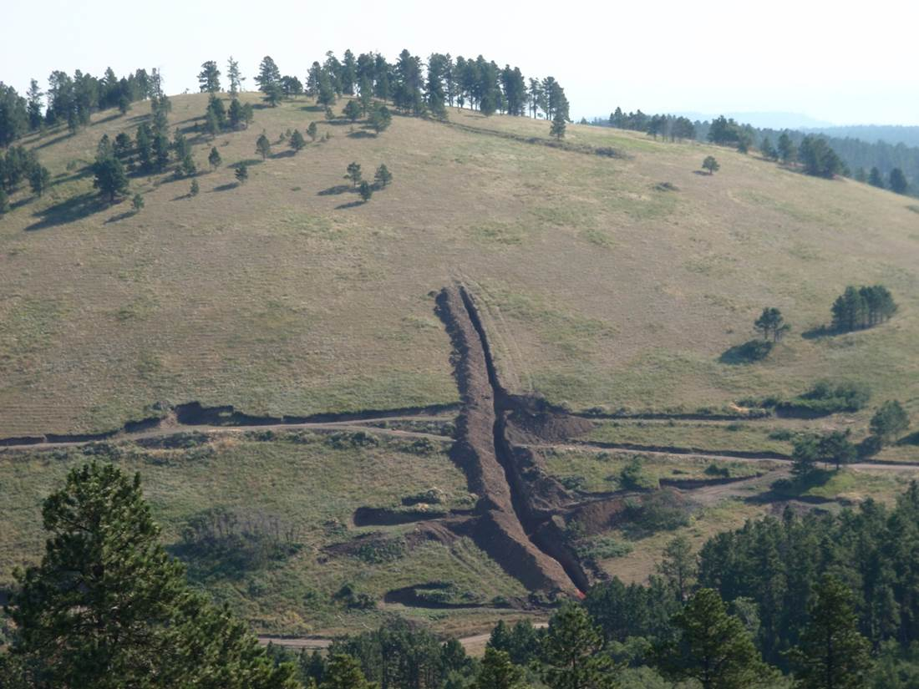
Exploration trench
reconnaissance investigation, it suggests that each metric ton of ore material in the upper part of the deposit contains about 1 kg of Th.

In a press release of January 21, 2014, the company announced that pilot testing of their proposed ore processing technology identified a process to “selectively isolate and economically remove thorium.” Their proposed processing procedures were filed as a utility patent application with the U.S. Patent and Trademark Office; the patent currently (July 2014) awaits evaluation and approval. Separation and capture of Th from their waste stream was designed into their ore processing plan due to concerns of radioactivity generated by Th-bearing waste materials. The company states the Th will be disposed of by a third party, in an unspecified manner. Thus, the segregated Th may become either unavailable or difficult to obtain in the future.

2.3 Bokan Mountain, southeastern Alaska

As a third example of coexisting REEs and Th, the exploration company UCore Rare Metals Inc. (http://ucore.com/) plans to mine REE-Th-rich, vein-like dike deposits associated with the Jurrasic Bokan Mountain alkaline intrusive complex in southern Prince of Wales Island in southeastern Alaska (Fig. 3) [8]. The ore target is a series of thin, REE-rich dikes that crop out along Dotson Ridge on the southeast flank of Bokan Mountain. The ore zone is formed by numerous alkaline dikes exposed side-by-side across a zone about 50 meters wide. Individual vein-like intrusions (thin dikes) occur either as closely spaced sets that are a few millimeters to 50 cm wide, or as single dikes that are individually 40 cm to several meters thick; these intrusions are separated by earlier-formed, unaltered Silurian-Ordovician quartz monzonite (Fig. 4), granite, quartz diorite, and diorite. The REE-bearing dikes of Dotson Ridge follow a linear shear zone along its strike for a distance of at least 1 km [8, 9]. These REE-rich intrusions are informally described by the company as “vein-dikes” due to their vein-like appearance. These vein-dikes are particularly enriched in the heavy REEs, which compose about 40 percent of the total REEs. Based on a multi-year drilling program, UCore Rare Metals reports inferred resources for the Dotson Ridge vein-dike zone of 5.2 million metric tons averaging 0.65 percent total REE oxides (http://ucore.com/). The company plans to exploit only the REE resources with no plans to recover the Th.

The vein-dike features of Dotson Ridge show evidence of early alkaline magmatic injection with subsequent orthomagmatic hydrothermal alteration [8; and unpublished author studies]. As a result, the vein-dikes contain a complex ore mineralogy with evidence of hydrothermal overprinting of primary magmatic phases; more than 30 REE-Y-bearing minerals representing multiple generations have been identified [8, 9; and unpublished studies by the authors]. Detailed mineralogical study of the Dotson Ridge vein-dike system by the USGS revealed that Th and U are dominantly sited in thorite and a complex suite of Ti±Nb±Y oxide minerals, including fergusonite, polycrase, and aeschynite. These oxide minerals along with Y-silicates are the primary heavy REE-bearing minerals of the deposit.

Limited bulk sampling (about 1 metric ton) of the Dotson Ridge ore zone by the USGS in 2011 revealed Th contents of about 0.066 percent (elemental weight percent), which includes barren rock between the mineralized veins. Although only an approximate estimate, the USGS sampling suggests that each metric ton of ore mined and processed from the deposit would contain, on average, about 0.66 kg of Th. To address environmental concerns of radioactivity, the company suggests in their proposed plan of operations that the mine waste materials will be encased in concrete, which will be used to backfill the mine openings after mining is completed.

3. Discussion

In the ore processing and waste disposal procedures for the three REE development projects described above, Th and its radioactivity must be addressed due to environmental permitting requirements. However, in the operational design for two of these projects, the companies dilute the Th with waste products, thereby adding complexity to recovering the Th in the future.
Stockpiling of Th in the United States is not occurring today for at least a couple of reasons:

- Presently there is no significant market for Th as a commodity. For example, according to the USGS, in 2013 in the United States “the estimated value of thorium compounds imported for consumption by the domestic industry was [only] $54,000” [10, p. 166].
- The stockpiling of Th in the United States requires special permits and licenses; these difficult-to-obtain permits are required in order to store radioactive materials, including Th-rich materials. Thus, companies have little incentive at this time to stockpile Th-oxide or Th-rich wastes while waiting for a Th market to arrive.

In the future, separation of Th from the residue streams of REE mining and ore processing provides a possible economic solution to obtaining Th resources for nuclear fuels. As shown by the three case studies described above, Th is available for recovery from magmatic REE deposits. If a need and associated market should develop for Th, then the co-production of Th from the development of REE deposits provides a means for Th supply.

4. Acknoweldgments

The authors thank MolyCorp, Inc., Rare Element Resources Ltd., and UCore Rare Metals Inc. for the opportunities to visit and sample their deposits. (Any use of trade, product, or firm names is for descriptive purposes only and does not imply endorsement by the U.S. Government.)

Figure 3. Bokan Mountain is the core of the Jurassic Bokan Mountain peralkaline granite complex, southern part of Prince of Wales Island, southeastern Alaska. A REE-rich vein-dike system, about 50 meters in total width, occupies a linear shear zone along Dotson Ridge. Bokan Mountain is located at latitude 54.9159 North, longitude 132.1548 West (datum of WGS84).
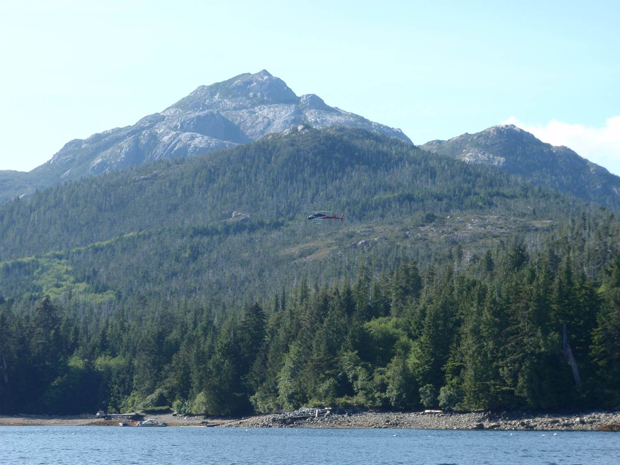
Dotson Ridge
Bokan Mountain
Figure 4. Example of REE-rich vein-dikes within the Dotson Ridge deposit, Bokan Mountain, Alaska. These altered intrusions contain more than 30 REE-Y-bearing minerals, and at least 7 Th-bearing phases. This deposit has been explored and drilled recently by UCore Rare Metals.
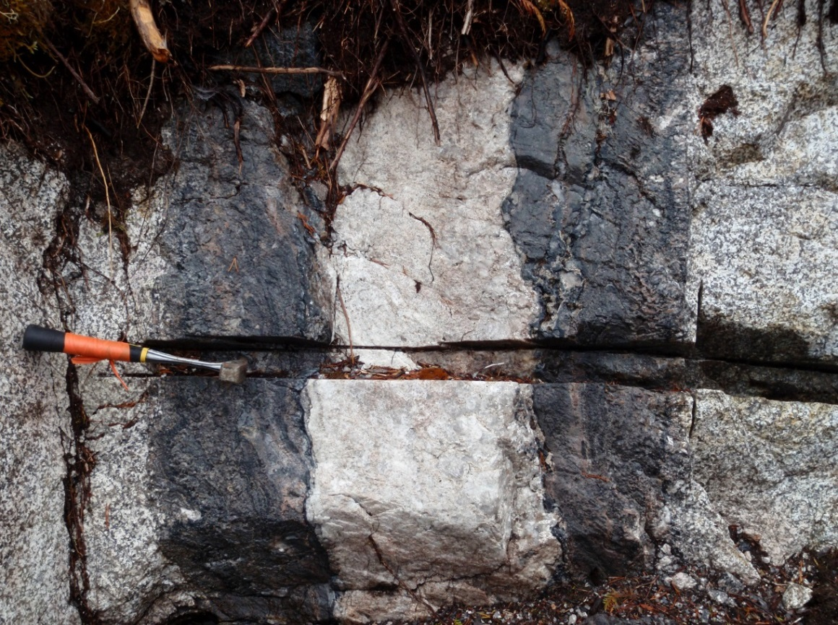
Quartz
monzonite
“vein-dike”
Quartz
“vein-dike”
Quartz
monzonite

REFERENCES

[1] | MOLYCORP, INC., Molycorp’s rare earth reserves at Mountain Pass increase by 36%, Molycorp, Inc., press release, 9 April 2012.
[2] CASTOR, S.B., et al., Mountain Pass rare earth deposit, California, in Betting on industrial minerals—Proceedings of the 39th Forum on the Geology of Industrial Minerals, Reno/Sparks, Nevada, May 18–24, 2003 (Castor, S.B., et al., Eds.), Nevada Bureau of Mines and Geology Special Publication 33 (2004), pp. 68–81.
[3] CASTOR, S.B., The Mountain Pass rare-earth carbonatite and associated ultrapotassic rocks, California, The Canadian Mineralogist 46/4 (2008) pp. 779–806.
[4] MARIANO, A.N., Economic geology of rare earth elements, Chapter 11, in Geochemistry and mineralogy of rare earth elements (LIPIN, B.R., et al., Eds.), Washington, D.C., The Mineralogical Society of America, Reviews in Mineralogy 21 (1989) pp. 309–337.
[5] STAATZ, M.H., et al., Thorium resources of selected regions in the United States: U.S. Geological Survey Circular 824 (1980) 32 p.
[6] RARE ELEMENT RESOURCES, Bear Lodge Project, Rare Element Resources company website (2014), http://www.rareelementresources.com/
[7] ANDERSEN, A.K., et al., Rare earth element zonation and fractionation at the Bear Lodge REE deposit, Wyoming, Geological Society of America Abstracts with Programs 45/5 (2013) p. 42.
[8] DOSTAL, J., et al., The early Jurrasic Bokan Mountain peralkaline granitic complex (southeastern Alaska)—Geochemistry, petrogenesis and rare-metal mineralization, Lithos 202–203 (2014) p. 395–412.
[9] BARKER, J.C., and VAN GOSEN, B.S., Alaska’s rare earth deposits and resource potential, Mining Engineering 64/1 (2012) p. 20–32.
[10] GAMBOGI, J., 2014, Thorium, U.S. Geological Survey Mineral Commodity Summaries (2014) pp. 166–167. Available at http://minerals.usgs.gov/minerals/pubs/commodity/thorium/

