Geological 3-D modelling and resources estimation of the Budenovskoye uranium deposit (Kazakhstan)

 | A. Boytsovª†, T. Heynsª‡, M. Seredkin^{b}§
ª | Uranium One Inc, Toronto, Ontario, Canada
^{b} | CSA Global Pty.Ltd, Perth, Western Australia, Australia

The Budenovskoye Deposit is the biggest sandstone-hosted, roll front type uranium deposit in Kazakhstan and in the world. Uranium mineralization occurs in the unconsolidated lacustrine-alluvial sediments of Late Cretaceous Mynkuduk and Inkuduk horizons. It is currently under commercial production by Karartau and Akbastau ISL mines, both owned by Kazatomprom and Uranium One in equal shares. The latest geological modelling and resource estimation done shows a significant increase in total uranium resource tonnage at both mines when compared to the March 2012 NI 43-101 resource estimate: at Karartau Measured and Indicated resources increased from 11,695 tonnes of U to 63,839 tonnes of U while at Akbastau from 13,598 tonnes of U to 47,292 tonnes of U. It has also added 55,766 tonnes of U to the Karatau Inferred Mineral Resource category. The updated mineral resource estimate is the result of having available an extensive database, adding latest exploration results, and applying 3-D modelling techniques. The modelling of roll front type uranium deposits, specifically aimed at ISL mining, has accounted for its own specific requirements. Mineral resources estimation was based on 0.04 m% grade x thickness cut-off. The relationships between geophysical logging data and laboratory analyses were identified in order to define resource estimation parameters based on gamma log, electrical logging methods and disequilibrium studies

Introduction
Roll-front sandstone uranium deposits can be extracted using in situ leaching (“ISL”), also known as in sity recovery (“ISR”) method with low operational costs. The production share from the Kazakhstan roll-front sandstone-hosted uranium deposits mined using the ISL method comprised 36% of the world total in 2013. South Kazakhstan hosts a number of large unique roll-front sandstone type uranium deposits including Budenovskoye, Inkai, Mynkuduk, Akdala, Kanzhugan, Moinkum, Uvanas, Kharasan, Karamurun, Irkol, Zarechnoye.
CSA Global has completed modelling and resource estimation of Budenovskoye deposit for Uranium One Inc. The methodology of modelling these types of roll-front uranium deposits has been substantially improved.

Geological features of roll-front uranium deposits in South Kazakhstan
Roll-front sandstone-hosted uranium mineralisation in South Kazakhstan is spatially and genetically associated with the pinch-out boundary of a regional reduction/oxidation zone of strata bound oxidation in permeable sediments. The mineralisation is associated with significant thicknesses (10–50m) of highly permeable horizons, which are continuous over tens to hundreds of kilometres.
In plan, the uranium deposits present as weaving ribbons of various widths and lengths as controlled by the interface between oxidatised and reduced sediments (FIG. 1), also known as the redox zone. Multi-stage bodies and extended limbs consisting of a number of mineralised lenses, which are also found in abundance between the limbs, are typical of the deposit structure and reflect the complexity of the enclosing rock sequence [1], [2].
Each of the identified uranium deposits are located within a single sedimentary horizon, which can be correlated between vertical sections. The mineralised bodies consist of several morphological elements (FIG. 1), including [1], [2]:
- the main roll-front with well-distinguished “nose” parts;
- mineralised “wings” (or “limb”) elements; and
- “satellite” or “residual” bodies located in the rear of the main rolls.

An important feature of uranium-mineralised bodies is the change in the proportion of uranium and radium relative to its position in the roll shape ore body (FIG. 1). Uranium concetrations dominates in the nose parts and decreases in the wings, and radium dominates in the residual bodies and forms radium halos (which show as anomalies containing no uranium based on gamma-ray logging results). Radium and uranium ratio is described by the radioactive equilibrium factor (“REF”).
Sometimes the mineralised bodies show increased carbonate grade (to 3%), which results in extra acid consumption.
All mentioned geological features of deposits should be taken into account for modelling.

Modelling roll-front uranium deposits
A serious challenge in estimating grades in roll-front deposits is identifying variable radiological responses influenced by the position of the mineralised interval relative to the redox front and to what extent disequilibrium is present within the deposit.
The initial downhole geophysical data is recorded at 10 cm increments. These intervals are too narrow for radiological factors determination and to do effective modelling . To negate this issue, intervals were composited over the full thickness of the mineralisation with division into sands and clays.
Modelling divided the bodies into mineralised horizons based on the geometry of the mineralisation (noses, wings, and roll residuals) and whether the mineralisation occurs within permeable sands or clays, where mineralisation is non-extractable by ISL methods.
It is important to determine the radium cut-off grade for different geochemical zones and quantify a radioactive equilibrium factor (“REF”) for conversion of apparent radium grade x thickness (“GT”) into uranium contents.
Lastly, for ISL deposits, the depletion of Mineral Resources is measured not by how much rock is removed, as is the case with most traditionally mined resources, but rather by lowering of the uranium grade and productivity.

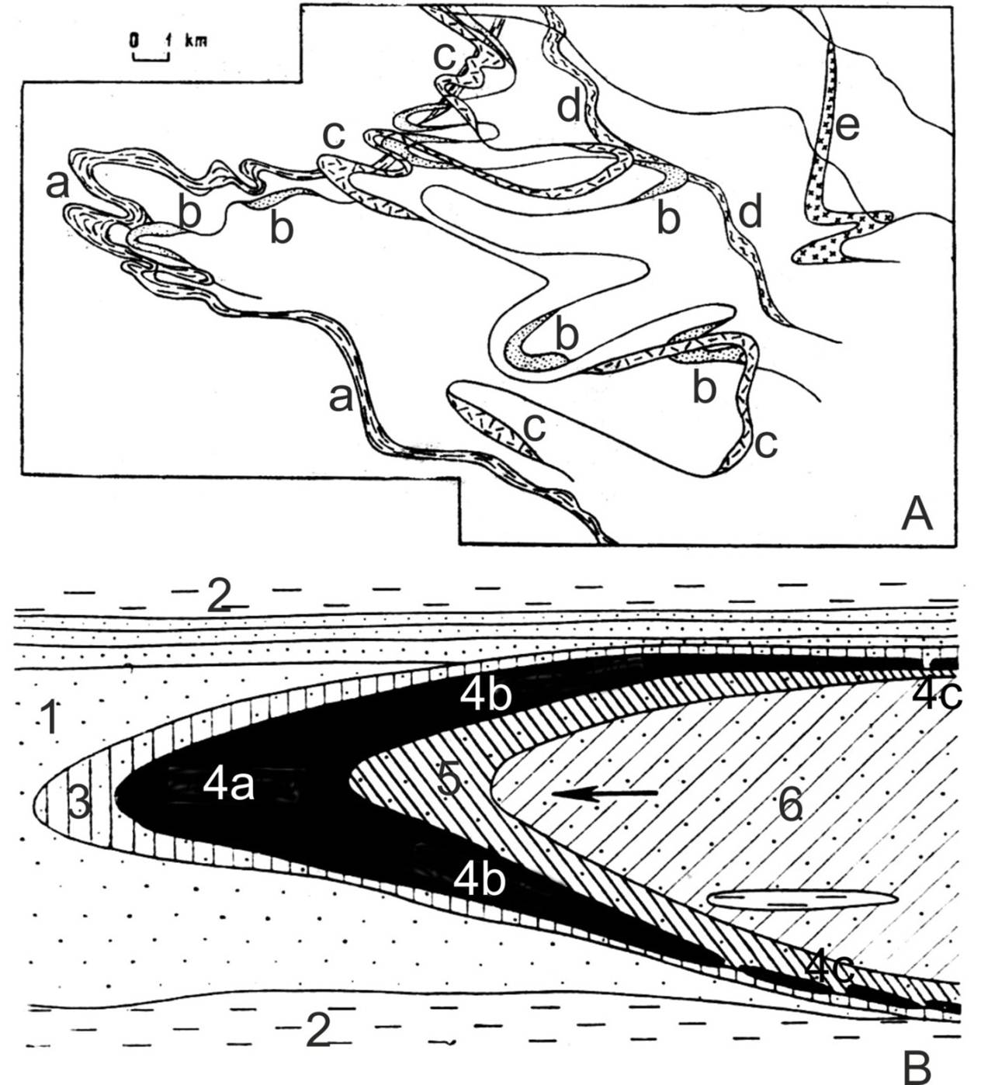
FIG. 1. Geological features of roll-front uranium deposits in South Kazakhstan in plan (A) and section (B) (Brovin et al., 1997): a-e – weaving ribbons of roll fronts on the different levels, 1 – reduced penetrable sediments (mainly sands), 2 – impenetrable sediments (mainly clays), 3 – diffuse radium halo, 4 – uranium mineralised body (4a – nose part, 4b – wing parts, 4c – residual parts), 5 – remaining radium halo, 6 – oxidised penetrable sediments, arrow – direction of solutions flow

Delineation of Mineralised Intervals
Geophysical data (i.e., wireline logging) is the primary means of defining uranium mineralised intervals. The uranium values need to be corrected using number of modifications, which are determined according to the standart operating procedure of JSC Volkovgeologiya (see details and references in [3], [4]) including corrections for:
- Thorium and Potassium (usually constant and low for South Kazakhstan deposits);
- Radon (Radioactive Equilibrium between Radium and Radon), usually constant; and,
- Radium (disequilibrium – REF), usually quite variable in South Kazakhstan deposits.

REF is defined in two steps:
- Definition of cut-off grades for radium equivalent to 0.01% U for establishing of boundaries of mineralised intervals. It depends of geochemistry of host sediments: oxidised or reduced.
- A correction for REF = С (radium) / С (uranium) is introduced to calculate uranium grade after establishing mineralised interval boundaries and calculation of average radium grade. It depends on the morphology of mineralised bodies – whether noses, wings, or residuals.

Geological interpretation
Interpretation of roll-front style uranium deposits (amenable to in situ recovery) has specific requirements, which are listed below:
- Modelling of mineralised horizons by creating surfaces;
- Defining mineralised intervals using gamma-logging that takes into consideration radium cut-off grades, which are also dependent on the location of the mineralised intervals in the oxidized or reduced sediments;
- Division of interpreted mineralised bodies into nose, wing and residual parts accounting for the geochemical composition of the host sediments; and
- Interpretation of clay horizons, in order to define mineralisation that cannot be extracted by ISL methods.

The interpreted mineralised envelopes are then divided into morphological elements – i.e., nose, wing, and residual parts as well as into mineralised horizons as follows:
- Intervals where mostly reduced rocks are developed both in the mineralised interval and above and below are attributed to the nose zone;
- Intervals where reduced rocks are developed in the mineralised interval and mainly on one of its sides (either above or below) are attributed to the limb; and,
- Intervals where there are mainly oxidised rocks developed above or below the mineralised interval are attributed to the residual part; the mineralised interval itself can be represented both by reduced and oxidised rocks.

The roll nose parts defines the redox front location. The definition of redox fronts is very important for understanding the geological structure of a deposit. The wing and residual parts of rolls are located in the rear part of redox fronts. Mineralisation ends abruptly in the frontal part of the redox fronts usually. Radium halos can be distributed deep into the rear parts of roll fronts – exhibiting gamma activity but no uranium mineralisation. Prompt fission neutron (PFN) logging is used for direct uranium measurement and can be useful for exploration of these parts.
The interpretation of clay horizons is usually carried out after interpretation of the mineralised envelopes. This interpretation is based on core logging and electrical methods – resistivity logging and spontaneous polarisation logging. Clay horizons should be subconcordant with mineralisation. Sometimes it is necessary to correct the mineralised bodies after lithological interpretation.

Block modelling
Industry standard approaches of geostatistical analysis, compositing, block modelling and grade estimation are used for the roll-front uranium deposits in South Kazakhstan. The uranium and carbonate grades as well as REF are estimated for the block model (also other minor elements such as Se, Sc, Re, REE, etc. can be estimated).
There is one important feature in the methodology of resource estimation for these deposits.
For ISL deposits it is important to use a metal accumulation index (grade x thickness or “GT”) to define the cut-offs for resource estimation, whereas the classical approach is to only use grade cut-offs in resource estimation. For example, the mineralised interval with U grade 0.04% and 10 m thickness (GT = 0.4 m%) is better for ISL than mineralised interval with U grade 0.10% and 3 m thickness (GT = 0.3 m%).
A gridded model is generated for each wireframe in order to estimate GT, based on block models. The vertical extent of the cells of the gridded model depends on the thickness of mineralisation. GT is calculated by multiplying the vertical size of the cells by the uranium grade. Gridded models are two-dimensional. In order to estimate the GT in three-dimensional space, it is necessary to compare each cell of the gridded model with a column of cells in the original (classical) block model. This was completed by indexing of the block model cells by comparison with the cells of the gridded model.
Lower and upper wings are estimated separately due to different wireframe modelling nose and wing parts of rolls.

Accounting for Depletion in ISL mining
In conventional open pit or underground mining, the depleted volume of ore can be physically surveyed. In ISL operations, the host rock remains undisturbed while uranium mineralisation is dissolved by the leaching solution. Leaching contours and the dynamics of uranium leaching process can be determined by creating a model that describes solution hydrodynamics and dissolution of uranium.
For the purposes of producing a global Mineral Resource estimate for a mine it is considered sufficient to volumetrically delineate contours of production blocks and to deduct the depleted metal (recovery and in situ loss) from the Mineral Resources. Grades and GT will decrease proportionally because the volume of rock mass remains.
Delineation of the production blocks is completed in plan projection using the location plans of production wells. The vertical boundaries of the production blocks are determined using the intervals of setting screens in the production wells.

Mineral Resources
Table 1 shows the recent estimate of the Mineral Resources for the Budenovskoye deposit, as of June 30, 2013.

Table 1. Estimate of Mineral Resources for the Budenovskoye Deposit, as of June 30, 2013
Category | Volume | Tonnes | Productivity (GT) |  | Grade |  | Mineral Resources
 | ‘000 m³ | ‘000 t | m x % | kg / m² | U, % | U₃O₈,% | Tonnes U | M lb U₃O₈
Measured | 43,227 | 73,487 | 0.46 | 7.8 | 0.072 | 0.085 | 52,646 | 136.88
Indicated | 38,692 | 65,777 | 0.46 | 7.8 | 0.088 | 0.104 | 58,485 | 152.06
Measured & Indicated | 81,919 | 139,264 | 0.46 | 7.8 | 0.080 | 0.094 | 111,131 | 288.94
Inferred | 58.177 | 98,901 | 0.37 | 6.2 | 0.095 | 0.111 | 93.623 | 243.42
Note:
1. Mineral Resources based on 0.04 m% (grade x thickness) cut-off per hole
2. Mineral Resources categories are based on CIM definition
3. Depletion estimated using losses of 10%
4. Measured Mineral Resources based on exploration drilling density of 50 m x 200 m (excluding residual mineralised bodies)
5. Indicated Mineral Resources based on exploration drilling density of 50-100 m x 400 m (excluding residual mineralised bodies) and 50 m x 200 m for residual mineralised bodies

The presented geological modelling and resource estimation resulted a significant increase in total uranium resources tonnage at both mines when compared to the March 2012 NI 43-101 resource estimate: at Karartau measured and indicated resources increased from 11,695 tonnes of U to 63,839 tonnes of U while at Akbastau from 13,598 tonnes of U 47,292 tonnes of U. It has also added 55,766 tonnes of U to the Karatau Inferred Mineral Resource category. The updated mineral resource estimate is the result of having available an extensive database, adding latest exploration results and applying 3-D modelling techniques.

Conclusion
Roll-front uranium deposits are quite difficult to model due to complicated mineralised bodies shapes and radiological complexity. The method of modelling discussed above allows creation of relevant geological models for the largest sandstone hosted deposit in the world. The average differences between resource estimates based on exploration drill holes and from production wells are less than 5% in this approach. A significant positive economic impact from using geological model and improved resource estimation approach is expected.

References
[1] | BROVIN, K., GRABOVNIKOV, V., SHUMILIN, M., YAZIKOV, V. “Prediction, research, exploration and resource estimation of uranium deposits for in-situ recovery” (in Russian), “Gylym”, Almaty, 1997.
[2] | INTERNATIONAL ATOMIC ENERGY AGENCY, Manual of acid in situ leach uranium mining technology, Vienna, 2001
[3] | SEREDKIN, M., BERGEN, D. “Technical NI 43-101 report for Akbastau Uranium Mine designed for Uranium One Inc.”, Perth, Vancouver, 2013
[4] | SEREDKIN, M., BERGEN, D. “Technical NI 43-101 report for Karatau Uranium Mine designed for Uranium One Inc.”, Perth, Vancouver, 2013

† Present Address: Uranium One Inc, 1710 - 333 Bay Street Toronto, ON, M5H 2R2, Canada, Alexander.Boytsov@uranium1.com
‡ Present Address: Uranium One Inc, 1710 - 333 Bay Street Toronto, ON, M5H 2R2, Canada, Thys.Heyns@uranium1.com
§ Present address: Level 2, 3 Ord Street, West Perth, WA 6005, Australia, Maxim.seredkin@csaglobal.com

