Steady-state Fluid Flow as a Complementary Driver of Mineralization and Redistribution at Unconformity-type Uranium Deposits in the Athabasca Basin, Saskatchewan, Canada

Gerhard Ruhrmann
Private Consulting Firm

Abstract. Seismic pumping has been proposed as driving force for fluid flow causing fluid-rock and fluid-fluid interaction and attendant ore precipitation in deposits related to the Lower Proterozoic unconformity in the Athabasca Basin. Related strain-fluid modelling shows that multiple seismic pulses were necessary to generate the observed ore masses by tapping kilometre-scale U-reservoirs. The 3D flow modelling presented here covers the intermittent seismically calm periods during which the fluid flow was regionally driven by other mechanisms. The results from paleo-hydrogeological simulation of regional steady-state flow in a typical unconformity-related uranium deposit setting suggest the formation of zones amenable to fluid-fluid, fluid-rock and fluid-ore interaction at the Middle/Lower Proterozoic unconformity near an incompletely sealed structure. The contrast of hydraulic conductivity of the structure and that of wall rocks determines the vertical position of potential reaction zones relative to the unconformity. Highly permeable structures result in reaction zones below the unconformity while smaller contrast leads to reaction zones above the unconformity without having to invoke respective dilatant and compressive seismics. Basinal fluids driven by regional gradients entering mineralized structures may have caused the resorption of existing U-mineralization and in reaction with reducing basement rocks, the reprecipitation of U-ore along the structure.

Introduction
It is general consensus that the oldest mineralization event (approximately 1,590 Ma) in the Athabasca Basin and subsequent remobilization and resetting of radiometric ages correlate with far-field, continent-wide tectonic events []. On a local scale, numerical modelling [, ] shows that faulting in a dilational regime may have driven oxidized uraniferous basinal fluids into reducing basement environment. In a compressional setting, basement fluids would have been injected into Athabasca Group rocks thereby precipitating uranium out of oxidizing basinal fluids. The results of transient modelling of porosity and permeability development during a faulting event [] suggested that multiple seismic pulses were necessary to generate the observed ore masses by tapping kilometre-scale reservoirs [].
The fluid flow model based on steady-state conditions presented here rests on the following premises:
⎯ Regional flow in the basin during interseismic phases is quasi-steady state driven by one or several forces including sediment compaction, clay dehydration, meteoric infiltration and salinity or temperature-caused density differentials. Large-scale, i.e. several times larger than deposit size, thermal convection cells were shown to be reasonable in >5 km thick basin fill above a 30 km thick crust []. Numerical modelling of the fluid pressure regime suggests that fluid overpressure in a moderate range may have contributed to the flow of oxidizing fluids in the basal part of the basin [].
⎯ Each faulting episode disturbs temporarily the regional flow, which recovers within a certain time span []. The length of the recovery period is controlled by gradient, permeability and storativity of the fault material and wall rock, and may persist only tens to hundreds of years [].
⎯ The length of time between major faulting events followed by a recovery period is sufficiently long for steady-state conditions to re-establish.
⎯ Repeated rupturing in active faults results in increased fracture porosity of fault zones [5].
⎯ Accordingly, fault zones may provide conduits for steady-state fluid flow between recurrent faulting events.
The model presented here does not take into consideration the effects of gases or differential fluid densities.

Approach
Steady-state groundwater flow was investigated using a generic numerical flow model of a typical unconformity-related uranium deposit configuration in the Athabasca Basin. The model consist of an assemblage of basement rocks overlain by sedimentary rocks of the Athabasca Group and intersected by a strike-slip or reverse fault. The model was portrayed by MODFLOW-96, a computer program that numerically solves the three-dimensional groundwater flow equation for a porous medium using a finite-difference method [, , , , ]. The data input and post-processing of results were facilitated by the use of PMWIN [, ], version 8.0.34 (2011), an integrated graphical user interface for MODFLOW []. The current package of PMWIN and the visualization software is copyrighted by Simcore Software.
The model consists of more than 50,000 active cells in 26 layers. The cell size ranges from 5 x 5 m in fault zones to 100 x 100 m in the surrounding wider area. Fig. 1 depicts the model dimensions and Fig. 2 the vertical discretization across the centre of the fault.
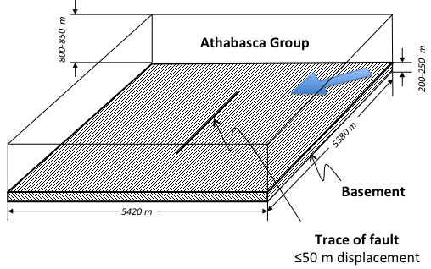
FIG. 1. Model dimensions. The arrow indicates the general direction of regional flow
The basement and Athabasca Group rocks are treated as a continuum, i.e. spatially defined values of hydraulic conductivity and porosity were assigned. This approach is valid as long as the microfracture and fissure spacing is sufficiently dense that the fractured medium acts in a hydraulic fashion similar to granular porous medium []. The fault was simulated by assigning a hydraulic conductivity larger than that of the neighbouring medium. Table I provides an overview of parameters used and their sources [18] and [].
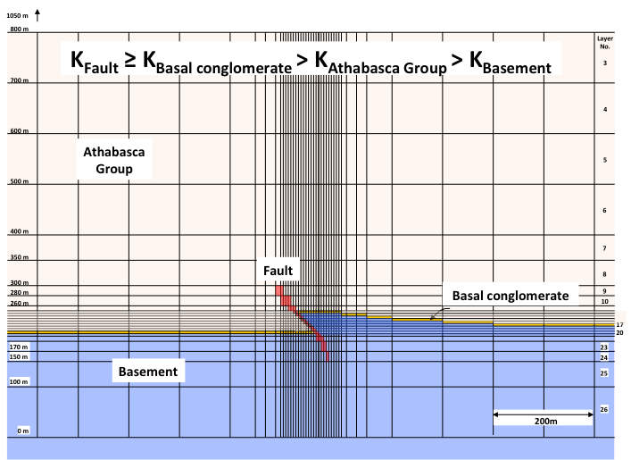
FIG. 2. Vertical discretization across the centre of the reverse model fault
Advective flow modelling was performed with PMPATH [], version 8.0.31, a particle tracking program based on MODPATH [] (Pollock (1988) that reads the model data file and simulation results from MODFLOW.
Table I. Hydraulic flow model parameters
 |  | Sand and Sandstone | Conglo-merate | Lithified basal conglomerate/  fanglomerate | Crystalline rock | Structure
Saturated horizontal hydraulic conductivity  (m/s) | [18] | 1 x 10⁻¹⁰  to  1 x 10⁻² | 1 x 10⁻³ to 1 | n.d. | 1 x 10⁻⁸  to  1 x 10⁻⁴ | n.d.
 | mean values [19] | 7.3 x 10⁻⁶ | n.d. | n.d. | 3.6 x 10⁻⁷ | n.d.
 | Model input | 1 x 10⁻⁶ | n.a. | 1 x 10⁻⁵ | 1 x 10⁻⁷ | 1 x 10⁻³  to  1 x 10⁻⁵
Saturated vertical hydraulic conductivity (m/s) | Model input | 1 x 10⁻⁸  to  1 x 10⁻⁷ | n.a. | 1 x 10⁻⁶  to  1 x 10⁻⁵ | isotropic conditions
Transmissivity (m²/s) | Model input | calculated by the model software (hydraulic conductivity x thickness of confined, saturated layers)
Boundary Condition | Constant head cells along the model boundary in all layers provide a gradient of 1 % across the model block
n.d. = no data, n.a. = not applicable

The boundary conditions are defined by constant head cells that control a gradient across the model block. The gradient was oriented at an oblique angle to the structure. No initial vertical gradients were set. A regional gradient of 1 % was selected out of a range of approximately 0.2 % to 2 % determined from data on (a) regional advective flow velocities ranging from 1 m/a to 10 m/a [] and several metres per year thermal convection rates [6], (b) an effective porosity of 5 %, and (c) an assumed hydraulic conductivity of 1 x 10⁻⁶ m/s for sandstone.
MT3DMS, a modular three-dimensional transport modelling tool [] was utilized for the simulation of advection and dispersion of fluids containing 500 μg/L U [] originating from a structure-hosted mineralized body. MT3DMS allows the input of mass loading. The multispecies capabilities were not utilized. MT3DMS establishes the transport flow field on the basis of the output head and cell-by-cell flow data computed by MODFLOW. MT3DMS has the capability of modelling changes in the concentrations of groundwater solutes due to advection, dispersion, diffusion, and some chemical reactions including equilibrium-controlled linear or non-linear sorption, and first-order irreversible or reversible kinetic reactions. Due to the generic character of the model presented here the sorption function was not used.
The solution algorithm is based on ‘Upstream Finite Difference Method’, which tracks particles moving through the active flow field. A transport step-size of one day was used, which meets the applicable criteria at given velocities and grid discretization (Courant number = 0.75 and Peclet number <2 in the high resolution zones of the model block). As a solver, a ‘Generalized Conjugate Gradient Solver’ was implemented. This configuration produces results that serve as a first approximation considering the general uncertainty of the input parameters.
Solute transport was simulated as advection modified by dispersion and diffusion in order to circumscribe the extent of a hydrogeochemical plume in groundwater stemming from mobilized ore and alteration products. The dispersion and diffusion parameters were gathered from various literature sources [18, , ]. All parameters are summarized in Table II.
Table II. Model input data relevant to advection and solute transport
 |  | Sand and Sandstone | Conglo-merate | Diagenetically altered basal conglomerate | Crystal-line rock | Structure
Porosity (%) | [18] | 5-30 | 25-40 | n.d. | 0-10 | n.d.
Effective porosity (%) | [22] | n.d. | n.d. | n.d. | n.d | 1-5
 | Model input | 5 | n.a. | 5 | 1 | 10
Uranium concentration in fluids near mineraliza-tion (µg/L) | [24] | 0.3 - 530
 | [22] | 4 - 12
 | Model input | 500
Mechanical dispersion coefficient (m) | [18]  [25] | As linear velocities are expected to be around 3 x 10⁻⁷ m/s to 4 x 10⁻⁷ m/s [6, 22], molecular diffusion is likely to contribute to dispersion
 | Model input | Longitudinal
 |  | 1 | n.a. | 1 | 1 | 1
 |  | Transverse
 |  | 0.1 | n.a. | 0.1 | 0.1 | 0.1
Effective molecular diffusion (m²/s) | [18] | 1 x 10⁻¹¹ to 1 x 10⁻¹⁰ for non-reactive species in clay
 | [26] | 2.6 x 10⁻¹² to 1.2 x 10⁻¹¹ for U species dissolved from UO₂ in bentonite
 | Model input | 5 x 10⁻¹¹ | n.a. | 5 x 10⁻¹¹ | 5 x 10⁻¹¹ | 5 x 10⁻¹¹
Boundary Condition | Constant-concentration cells (1 µg/L) on upstream boundaries
n.d. = no data, n.a. = not applicable

Modelling results
Robustness of model
The variation of hydraulic conductivities within the ranges given in Table I shows the modelling results to be robust.
Effects of a structure on the regional flow pattern
Fig. 3 illustrates the flow patterns that result from the effects of a structure on an otherwise undisturbed flow field in the basin fill and in basement rocks.
An open structure modifies the regional flow pattern (blue arrow = general flow direction) by deforming equipotential lines (a) and causing low pressure and high velocities in its vicinity as indicated by closely spaced stream lines (b, f).
Flow patterns generated by the model confirm earlier proposals [, ]. Blue = higher U-concentration, green = lower U-concentration released from a source in the potential mixing zone depicted in (e).
Basinal fluids (red) enter basement rocks (d, f) and basement fluids (blue) enter rocks above the unconformity (u/c) shown in yellow (b, e, f).
Both basin- and basement-hosted U-sources are available to being scavenged near open faults by steady-state flow of oxidizing fluids (d, f). This is consistent with the findings in the Millenium U-deposit [].
Location of potential reaction zones
Fluid flow patterns under steady-state flow conditions suggest the presence of reaction zones in the basement (d, f), where uranium bearing basinal fluids enter a reducing basement environment. Reaction zones are likely to form also at the unconformity and in the sandstone (e), where the parallel orientation of adjacent basin and basement-derived high-velocity streamlines suggest turbulent flow conditions amenable to mixing, attendant reduction and precipitation of tetravalent uranium. This is consistent with the observed distribution of mineralization. The localization of mixing zones above, at or below the unconformity depends on the conductivity contrast between structure and wall rock. The mixing zones form at greater depth with increasing conductivity contrast (d versus b).
Mobilization of mineralized and reactive solutes
Basinal fluids entering mineralized structures cause the redistribution of existing U-mineralization (c, g, h) and in reaction with basement fluids, the re-precipitation along the structure (e).
The distribution of solutes shown in (c), (g) and (h) would explain the localization of alteration haloes caused downstream of mineralization by uranium depleted solutions reacting with wall rock.

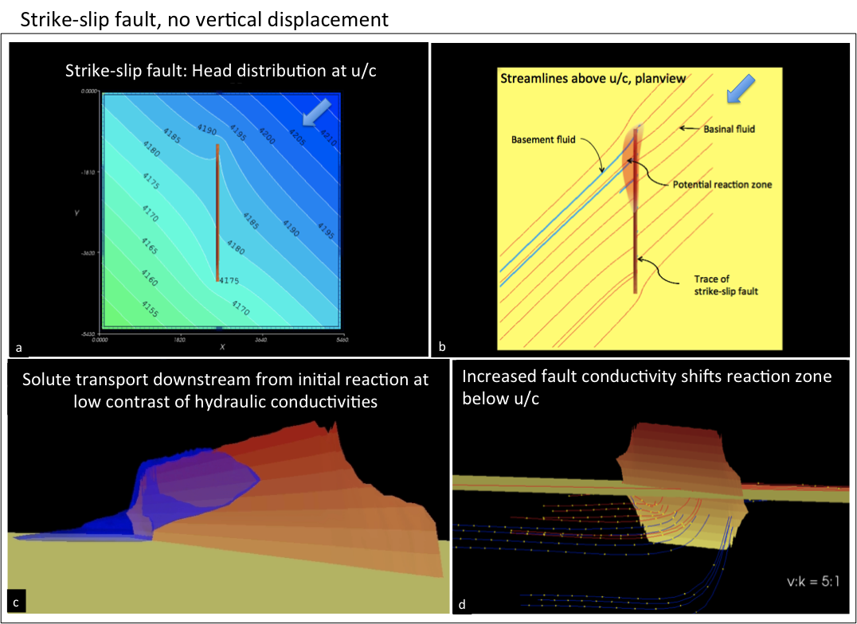
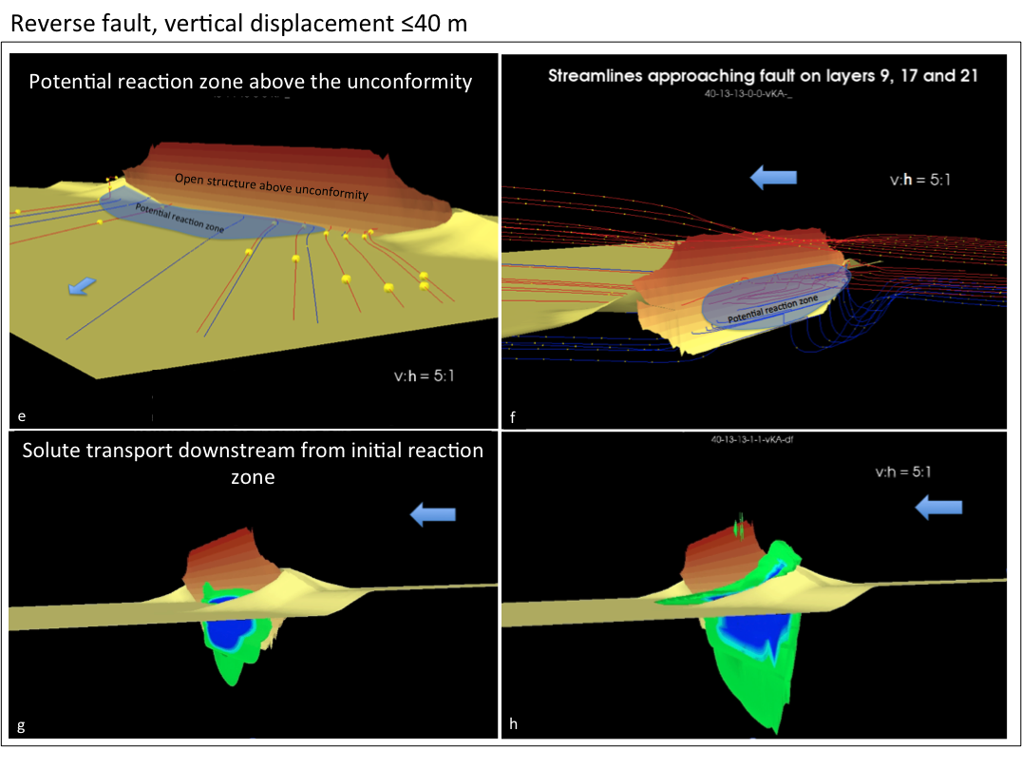
FIG. 3. Modelling results

Conclusions
The fluid flow patterns under steady-state flow conditions determine the location of potential mixing zones and locales of mineralization and alteration in the basement, at the unconformity and in the Athabasca Group. The modelling results indicate that the localization is a function of the hydraulic conductivity of a structure relative to the surrounding rocks.
U-sources in the basement as described for instance for the Millenium U-deposit [29] could be located within the range of scavenging fluids crossing the unconformity in the upstream area of an orebody. Conversely, oxidizing basinal fluids entering a mineralized structure may have caused the resorption of U-mineralization, observed in the field as “worm rock”, and in reaction with basement fluids, the reprecipitation along the structure. Conceptual flow paths previously depicted [27, 28] can be confirmed by steady-state numerical simulation.
The generic model presented here may be converted to deposit-specific flow models by quantifying the range of most likely gradients, hydraulic conductivities, flow velocities, location and volumes of catchment spaces in the basin fill and basement rocks. Transport parameters could be modified to match the results from mass balance calculations of deposits in the Athabasca Basin as performed for instance at the Shea deposit [22]. The integration of flow-relevant information from geological, geochemical, geophysical and structural models as presented in [22, , and ] into this flow model could further the understanding of unconformity-related uranium deposits.

Acknowledgements
The author would like to express his sincere appreciation to the late Franz-Josef Dahlkamp, who reviewed a previous version of the paper and who pointed out essential metallogenic aspects. Scott Donald scrutinized the modelling technique and provided valuable advice. Klaus Lehnert-Thiel and Brigitte Boldt-Leppin are thanked for their helpful comments and suggestions. Irvine Annesley brought up recent developments in modelling genetic processes and was always available for constructive discussions. Last but not least, Hanns Föhse improved the present version of the paper by giving valuable editorial hints.

REFERENCES

Hochheimer Weg 3, 53343 Wachtberg, Germany
[] ALEXANDRE, P., KYSER, K., THOMAS, D., POLITO, P., MARLAT, J., Geochronology of unconformity-related uranium deposits in the Athabasca Basin, Saskatchewan, Canada, and their integration in the evolution of the basin. Mineralium Deposita, 44 (2009) 41-59.
[] Jebrak, M., Faure, S., Modelling of paleostress in unconformity-related uranium deposits. In: Cuney, M., Proceedings of an International Conference Uranium Geochemistry 2003 - Uranium deposits - Natural Analogs - Environment, Nancy, France (2003) 187-188.
[] Schaubs, P., Ord, A., Annesley, I., Madore, C., Quirt, D., Thomas, D., Portella, P., A comparison of the McArthur River and Cigar Lake unconformity-related uranium deposits, Saskatchewan, Canada: insight from deformation – fluid flow models. Structure, Tectonics and Ore Mineralization Processes, Townsville (2005).
[] Sheldon, H.A., Ord, A., Evolution of porosity, permeability and fluid pressure in dilatant faults post-failure: implications for fluid flow and mineralization. Geofluids (1997) 5, 272–288.
[] Matthäi, S.K., Roberts, S.G., Transient versus continuous fluid flow in seismically active faults: An investigation by electrical analogue and numerical modelling. In: Jamtveit B, Yardley B (Eds): Fluid flow and transport in rocks - mechanisms and effects (1997) 263-295
[] Raffensperger, J.P., Garven, G., The formation of unconformity-type uranium ore deposits 1. Coupled groundwater flow and heat transport modeling. American Journal of Science, 295 (1995) 581-636.
[] CHI, G., BOSMAN, S., CARD, C., Numerical modeling of fluid pressure regime in the Athabasca basin and implications for fluid flow models related to the unconformity-type uranium mineralization. Journal of Geochemical Exploration 125 (2013) 8-19.
[] Cui, T., Yang, J., Samson, W., Formation of unconformity-related uranium deposits: perspectives from numerical modeling. GeoCanada 2010 -Working with the Earth, Calgary, Alberta, Canada (2010).
[] Matthäi, S.K., Fischer, G., Quantitative modeling of fault-fluid-discharge and fault-dilation-induced fluid-pressure variations in the seismogenic zone. Geology, 24, 2 (1996) 183-186.
[] McDonald, M.G., Harbaugh, A.W., A modular three-dimensional finite-difference ground-water flow model: Report prepared by U.S. Department of the Interior, U.S. Geological Survey, National Center, Reston, VA (1984).
[] McDonald, M.G., Harbaugh, A.W., A modular three-dimensional finite-difference ground-water flow model: Technical report, U.S. Geol. Survey, Reston, VA (1988a)
[] McDonald, M.G., Harbaugh, A.W., A modular three-dimensional finite-difference ground-water flow model: U.S. Geological Survey, Techniques of Water-Resources Investigations, Book 6, Chapter A1, (1988b).
[] Harbaugh, A.W., McDonald, M.G., User’s Documentation for MODFLOW-96, an update to the U.S. Geological Survey modular finite-difference groundwater flow model: U.S. Geological Survey Open File Report 96-485 (1996a).
[] Harbaugh, A.W., McDonald, M.G., 1996a, Programmer’s Documentation for MODFLOW-96, an update to the U.S. Geological Survey modular finite-difference groundwater flow model: U.S. Geological Survey Open File Report 96-486 (1996b).
[] Chiang W.-H. Kinzelbach W., 3D-Groundwater Modeling with PMWIN: First Edition. Springer Berlin Heidelberg New York. ISBN 3-540 67744-5, (2001).
[] CHIANG, W.H., 3D-Groundwater Modeling with PMWIN. A simulation system for modeling groundwater flow and transport processes: Second Edition. Springer Berlin Heidelberg New York (2005).
[] CHIANG, W.H., KINZELBACH, W., 3D-Groundwater Modeling with PMWIN A Simulation System for Modeling Groundwater Flow and Transport Processes (2nd ed.), Springer Verlag (2005).
[] FREEZE, R.A., CHERRY, J.A., Groundwater: Prentice-Hall, Inc., Englewood Cliffs, N.J. 07632, ISBN 0-13-365312-9 (1979).
[] UNLAND, W., HOLL, N., 1980, Dewatering of planned Key Lake open pits in northern Saskatchewan: CIM Bulletin (1980) 91-99.
[] CHIANG, W.H., KINZELBACH, W., PMPATH. An advective transport model for Processing Modflow and Modpath: Geological Survey of Hamburg, Germany (1994).
[] POLLOCK, D.W., Semianalytical computation of path lines for finite difference models: Ground Water, 26, 6 (1988) 743-750.
[] LE CARLIER DE VESLUD, C., CUNEY, M., LORILLEUX, G., ROYER, J.J., JÉBRAK, M., 3D modeling of uranium-bearing solution collapse breccia in Proterozoic sandstones (Athabasca Basin, Canada) - Metallogenic interpretations. Computers and Geosciences 35 (2009) 92-107.
[] ZHENG, C., WANG, P.P., MT3DMS: A modular three-dimensional multispecies model for simulation of advection, dispersion and chemical reactions of contaminants in groundwater systems: Documentation and Users Guide, Contract Report SERDP-99-1, U.S. Army Engineer Research and Development Center, Vicksburg, MS (1999).
[] RICHARD, A., PETTKE, T., CATHELINEAU, M., BOIRON, M.C., MERCADIER, J., CUNEY, M., DEROME, D., Brine–rock interaction in the Athabasca basement (McArthur River U deposit, Canada): consequences for fluid chemistry and uranium uptake: Terra Nova, 22, 4, (2010) 303-308.
[] KONIKOW, L.F., The secret to successful solute-transport modeling: Ground Water 49, 2 (2011) 144-159.
[] MOORE, S.M., SHACKELFORD, C.D., Uranium diffusion in soils and rocks: Proceedings Tailings and Mine Waste 2011, Vancouver, BC (2011).
[] WHEATLEY, K., MURPHY, J., LEPPIN, M., CUTTS, C., CLIMIE, J.A.: Advances in the genetic model and exploration techniques for unconformity type uranium deposits in the Athabasca Basin - In: Ashton KE, Harper CT (Eds.), Proceedings of the MinExpo ’96 Symposium - Advances in Saskatchewan Geology and Mineral Exploration, Saskatchewan Geological Society, Special Publication No. 14 (1996) 126-136.
[] ALEXANDRE, P., KYSER, K., POLITO, P., THOMAS, D., Alteration Mineralogy and isotope geochemistry of Paleoproterozoic basement-hosted unconformity-type uranium deposits in the Athabasca Basin, Canada: Economic Geology 100 (2005) 1547-1563.
[] FAYEK, M., CAMACHO, A., BESHEARS, C., JIRICKA, D., HALABURDA, J., Two sources of uranium at the Millennium uranium deposit, Athabasca Basin, Saskatchewan, Canada. GeoCanada 2010, Calgary (2010).
[] SKIRROW, R.G., JAIRETH, S., HUSTON, D.L., BASTRAKOV, E.N., SCHOFIELD, A., VAN DER WIELEN, S.E., BARNICOAT, A.C., Uranium mineral systems: Processes, exploration criteria and a new deposit framework. Geoscience Australia Record 2009/20, 44 (2009)
[] POTMA, W., FISHER, L., SCHAUBS, P., CLEVERLEY, J., CORBEL, S., LAU, I., PHANG, C., HOUGH, R., JSU – ERA Ranger Mineral System Project Final Report. CSIRO National Research Flagships, Minerals Down Under. Northern Territory Geological Survey, Record 2012-004 (2012).
[] ANNESLEY, I.R., REILKOFF, B., TAKACS, E., HAJNAL, Z., PANDIT, B., A Regional Multi-scale 3D Geological Model of the Eastern Sub-Athabasca Basement, Canada: Implications for vectoring towards unconformity-type uranium deposits. URAM2014, Vienna (2014).

