Research Progress and Prospect of Cr Coated Cladding Using in CNNC
Yongjun Jiao, Chunyu Yin, Liang He, Zhenhan Hong
National key laboratory of nuclear reactor technology, Nuclear Power Institute of China, Chengdu, 610213，China

Chromium(Cr)-coated zirconium cladding has become a leading candidate material for the accident-tolerant fuel (ATF) cladding in recent engineering activities after more than a decade of technological developing. Extensive research has been conducted worldwide, covering the preparation process, performance evaluation, and test verification. The commercial reactor irradiation of Cr-coated cladding fuel rods has been conducted, marking an important transition from technology research and development to engineering application. As one of the main player in nuclear fuel domain, CNNC has developed it’s own Cr-coated zirconium cladding based on N36 zircalloy, and loaded some of this type of claddings into CF3 fuel assembly, achieving the in-pile irradiation of the ATF characteristic assembly (Cr-coated cladding,) in 2021, the irradiation in NPP completed in Nov. 2024. The poolside examinations have showed excellent appearance after unloading from the reactor core.
The whole scenario of Cr-coated N36 alloy zirconium cladding developing and the prospects of its using are discussed in this paper. The multi-arc ion plating and high-bonding anti-radiation coating preparation technology of Cr-coated cladding has been established, a large-scale full-size cladding tube coating arc ion plating equipment has been developed, and a small batch of high-quality Cr-coated cladding has been manufactured recently and are going to be loading next year.
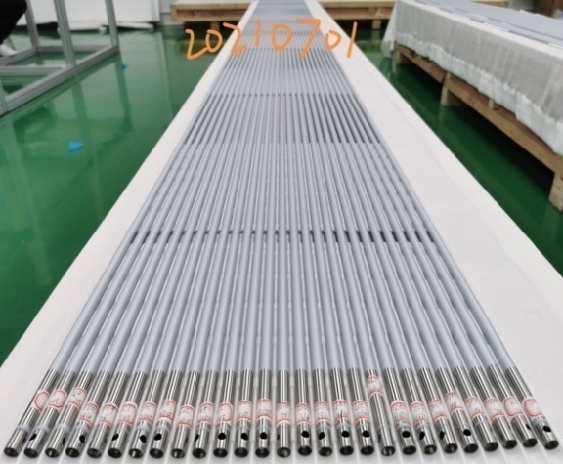
Fig. 1. A small batch of full-size Cr-coated cladding
During the development of Cr-coated cladding, key out-of-pile performance tests and verifications were carried out, mainly including:
- Long-term corrosion studies of coated tube samples in the high-temperature and high-pressure simulated power plant water (360℃/18.6MPa, B=200mg/kg, Li=1.24mg/kg) showed that the corrosion rate of the Cr coating was one order of magnitude lower than that of the zirconium alloy (Fig. 2);
- The Cr coating would not peel off from the zirconium substrate under high-temperature oxidation conditions, demonstrating good adhesion performance;
- After being held in a vacuum quartz tube at 700℃-1300℃ for 10 minutes and then rapidly cooled to 100℃(boiling water), the samples remained intact, with no cracking or peeling of the coating observed (Fig. 3);
- Compared with uncoated tubes, the tensile and burst performance of Cr-coated cladding did not change significantly, but the creep and fatigue performance change was not negligible;
- Cr-Zr interdiffusion and eutectic melting would occur in Cr-coated cladding at high temperatures (Fig. 4), especially the eutectic melting phenomenon requires further study.
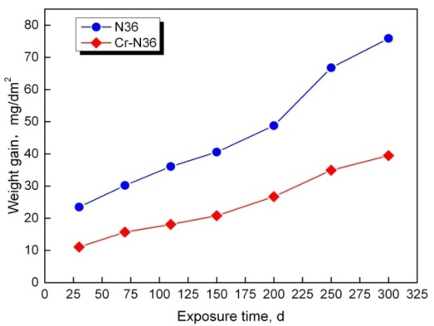
Fig. 2. the corrosion of Cr-coated cladding in the simulated power plant water
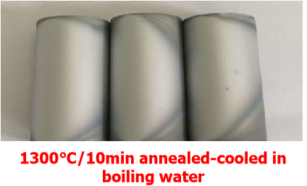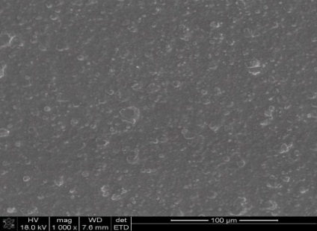
1300℃ →100℃
Fig. 3. Microscopic surface morphology of coated tube specimens after thermal shock
Fig. 4. Thickness variation of the metal compound layer
In November 2021, the commercial reactor irradiation of the Cr-coated cladding characteristic assemblies was started. By November 2024, the irradiation was completed and the fuel assembly was unloaded. The poolside inspections indicate that the Cr-coated cladding had excellent corrosion resistance in the reactor (Fig. 5).
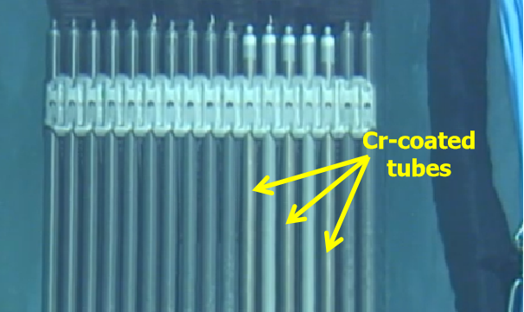
Fig. 5. Poolside inspection of Cr-coated fuel rods
In order to solid the basis for full scale deploying of coated cladding, the hot cell examinations and the loading of some leading fuel assemblies are in plan. At the same time, the using strategies and economical are researched. The analytical results are going to be presented in thia paper.

