IAEA
IAEA Extended Abstract Template
Technical Meeting on Advanced Technology Fuels: Progress on their Design, Manufacturing, Experimentation, Irradiation, and Case Studies for their Industrialization, Safety Evaluation, and Future Prospects
IAEA NFE TEAM
Vienna, 2025

Role of ATF in enhancing SMR performance

K. SHIRAVN
Massachusetts Institute of Technology
Cambridge, MA USA
Email: kshirvan@mit.edu

Corresponding author: K. SHIRVAN,kshirvan@mit.edu

INTRODUCTION
There are 62 commercial reactors under construction today (July, 2025) with 3 under 400 MWe: Russian BREST-OD-300 lead cooled factor reactor, Chinese ACP100 water-cooled reactor and Argentinian CAREM water-cooled reactor concepts. Soon, the American BWRX300 design will join this Small Modular Reactor (SMR) list for construction in Canada. Ontario Power Generation (OPG) has released their final investment decision for the first unit of BWRX300 SMR at $7.7 billion CAD or $18,750/kW USD in total cost (including interest) [1], higher that what First-of-a-Kind large reactors have realized in the western countries. In case of China and Canada, the SMRs are being demonstrated for use in future sites with more limited grid size, given the noted superior economics of larger reactor on dollar per MW-hr basis. Unless innovations are implemented in the current SMR offerings, the market will continue to globally prioritize larger reactors.
One of the reasons SMRs struggle to compete in the market economically is their lack of economy of scale. The nuclear island of BWRX300 compared to ESBWR, a reactor certified by U.S. regulator that the BWRX300 is based upon is shown in Fig. 1. Despite the >5x lower power output, the BWRX300 building is only 20% smaller by volume. Similarly, the NuScale multi-module design features a nuclear island footprint that is larger than an AP1000. Interestingly, the NuScale nuclear modules were initially licensed to 45 MWe. Utilizing the exact same nuclear island volume, the designers were able to leverage the available margins in the core and uprate the design to 77 MWe (70% increase) [2].
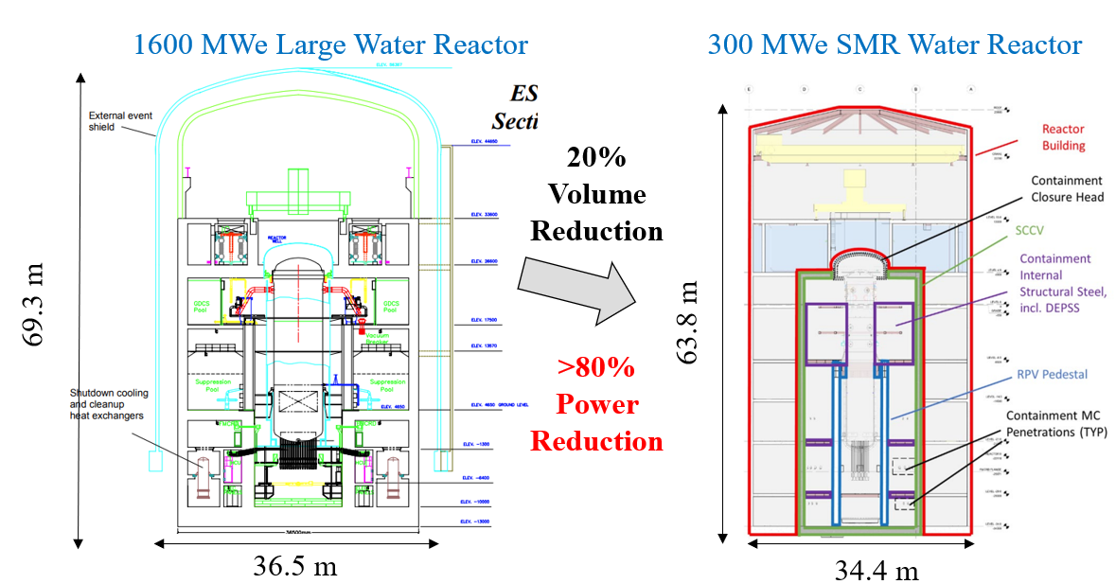
Fig. 1. Schematic of ESBWR (left) and BWRX300 (right) [Figures taken from https://www.nrc.gov/docs/ML0217/ML021770054.pdf and https://www.opg.com/documents/dnnp-application-for-a-licence-to-construct-a-reactor-facility-pdf/].
The significant power uprate to the NuScale reactor was feasible as the core thermal power density was increased from 40 MW/m³ to 70 MW/m³, still below the typical power density of large pressurized water reactors at around 100 MW/m³ [3]. Similarly, the BWRX300 is designed at a 40 MW/m³ power density, much lower than the uprated existing BWRs in the U.S. at 65 MW/m³. Therefore, increasing the power density of SMRs can be an effective way of reducing their cost per MW. Given the large inventory of water per thermal power in an SMR compared to a large reactor, increasing its core power density beyond that of a large reactor may even be feasible [4], giving it an economic saving boost needed to increase their potential role in future of nuclear energy. However, from fuel performance point of view, the power density of the core is limited to 118 MW/m³ for 18-month cycle PWR (110 MW/m³ for 24-month cycle) when utilizing the existing UO₂ and Zircaloy in a 17x17 assembly [5]. While for BWRs, the power density is limited to 70 MW/m³ for a 24-month BWR by using the conventional 10x10 fuel lattice [6].
This paper overviews the impact of introducing Advanced Technology Fuels (ATFs) to SMRs (mainly water-cooled), in order to improve their performance while meeting their promised safety goals. Specifically, the application of coated zircaloy cladding, SiC cladding, helical-cruciform fuel, internally and externally cooled annular fuel, Thorium fuels, increasing the BWR and PWR lattice size will be discussed. Almost in all cases, the application of ATFs and/or increase in power density will require fuel enrichment of greater than 5%. Therefore, application of LEU+ and HALEU for SMRs will also be covered.

ATF Concepts

Coated Cladding
The leading ATF coated cladding concept globally is the Chromium metal coating for Pressurized Water-cooled Reactors (PWRs) [7]. The coating provides corrosion protection during normal operation, reducing oxidation by order of magnitude. Consequently, the hydrogen pickup will also be reduced, though not as much due to initial ingress of hydrogen while the protective Chromia layer slowly forms. The consequence of the reduced hydrothermal corrosion is more margin for cladding failure to different transients and postulated accidents. For Boiling Water Reactors (BWRs), recently MIT proposed a CrNb coating that has shown promising results under irradiation conditions with similar mentioned benefits as Cr coating [8]. The other normal operation benefit of the coatings is its likely higher wear resistant given its higher hardness. Both corrosion and wear can limit the total time a fuel can stay in the core. This is very relevant to SMRs that target longer than normal fuel cycles (e.g., 5 years or more). The reason for longer fuel cycle is that SMRs are typically not for big electric markets and given lack of skilled labour and potential for SMR being the only reactor in a country, performing frequent refuelling outages could be overbearing to the owner/operator. In some SMR designs such as its application to commercial maritime, it is highly desirable to avoid refuelling all together and design a core that will last the lifetime of the ship (25 to 30 years). Therefore, a coating could be enabling for long fuel cycles while no sacrifice is made on core outlet temperature.

Since SMRs are generally not loss of coolant limited due to their smaller or elimination of piping and reactor pressure boundary penetrations, critical heat flux (CHF) becomes a more limiting parameter that will set their power density [4]. The coating has shown both oxidation and creep resistance at high temperature. By allowing the cladding to survive the CHF events for PWR and BWR SMRs, substantial thermal margin can be unlocked to enable power uprates [9].

SiC Cladding
SiC provides similar benefits as the coating with added benefit of higher melting points and high radiation resistant. On latter, it can enable SMRs to achieve higher burnups than is possible in LWRs since lower power density of SMRs results in lower strain gradient and thus lower stresses in the cladding. A higher power density will result in similar limitation as large reactors, except a shorter fuel length for SMRs will provide smaller total volume for presence and development of microcracks, reducing the overall probability of SiC composite cladding leakage [10].

Helical Cruciform Fuel
HCF provides higher surface volume ratio which reduces the average heat flux and conduction path within the fuel as shown in Fig. 1. Regardless of using a metallic fuel such as proposed by Lightbridge (UZr) or an oxide one, HCF can allow for increasing the power density of a PWR because of its higher surface area by as much as 40% [11]. In order to address the mentioned hydrothermal corrosion concerns for some long fuel cycle SMRs, the HCF could leverage the coated cladding. One of the key advantages of HCF is lower pressure drop through elimination of spacer grids and mixing vanes. This allows accommodation of higher flow rates, enhancing its power uprate potential. Another key attribute of HCF is that it can be retrofitted to an existing assembly and as such there is no need to redesign control rod fingers for PWRs. The enhancement of CHF at high qualities for HCF continues to be a controversial topic and care needs to be made to realize if a power uprate is possible [11]. In the metallic 50% by weight Zirconium UZr fuel, HCF will have to utilize >10% enriched fuel given the low U density for both large reactors and SMRs [12]. The metallic fuel also features lower melting point than Uranium-Oxide by over 1000ºC. This lower melting pointing maybe more compatible to an SMR with enhanced safety profile and reduced accident scope.

Internally and Externally Annular Fuel
IXAF was explored for large PWRs and BWRs to gain power uprate as shown in Fig. 1. It was found that for PWRs, 50% power uprate potential exists while the presence of central hole did not provide additional margin for BWRs [13]. However, the PWR application has not been continued due to concerns about reduced CHF margin in case of plugging of the inner channel. This limitation can be addressed not only through better coolant filtration and chemistry control of a smaller circulating system of SMRs to reduce chance of plugging but also through the mentioned application of ATF cladding, making the fuel CHF resilient. Unlike HCF, IXAF will require re-optimization of the control rod fingers for PWR application to provide adequate shutdown margin as the fuel diameter will be too large to be accommodated in existing fuel lattices. The loss of fuel volume from the internal hole combined with significant power uprate will also increase the enrichment requirements to LEU+.

Thorium Fuels
Thorium-oxide (thoira) provides high melting point, higher conductivity and better fission gas retention when added to UO₂ making it a worthy ATF concept [14]. If higher power densities than large reactors are investigated for SMRs, fuel melting temperature becomes a limiting factor. Fission gas release also challenges plenum pressure limits. As such, the addition of Thorium can potential address these limitation seen for the conventional PWR and BWR assemblies at 110 MW/m³ and 70 MW/m³, for a 24 month cycle respectively. The addition of Thorium will come with a penalty of increase in uranium enrichment due to displaced uranium [15]. If >60% by weight Thoria is required to realize its enhanced benefits, then this pushes the enrichment of an uprated SMR core to >10% beyond LEU+ enrichment levels, requiring HALEU fuel.

Increasing the Lattice Size and Role of ATF
Increasing the fuel array while keeping the width of the fuel assembly the same has been one of the most common ways to realize power uprates [16]. Typically, the grid support and fuel rod vibration becomes limiting as the fuel rod becomes smaller. The mentioned application of ATF coating that provides higher wear margin can help reduce wear rates enabling larger array sizes. Based on the studies, 21x21 for PWR and 13x13 for BWRs are likely the largest array size possible from fuel manufacturing point-of-view. The increase in array size for PWRs will result in redesign of control rod fingers in PWRs, similar to the IXAF concept.

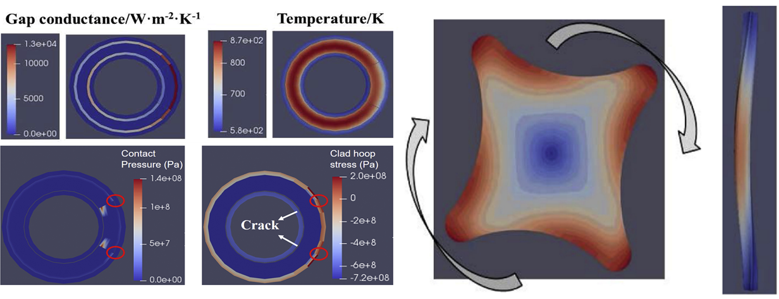
FIG. 1. Left: IXAF fuel performance at the presence of straight through radial crack that could lead to stronger local PCMI and stress concentration. Right: De-twist deformation (left, unsymmetrical strain magnitude) and bowing deformation (middle, 10 times enlarged) of HCF [Figures from [13]].

LEU+ and HALEU Implications
As noted, the power uprate and/or long fuel cycles or change of fuel to HCF/IXAF/Thoria will result in need for LEU+/HALEU fuels. Currently, LEU+ fuel assembly is being irradiated in a U.S. reactor as lead test assembly (LTA). HALEU supply chain continues to be under development in the U.S. while there are no concrete plans internationally. Beyond higher degree criticality safety during handling required for HALEU fuels, the adequate long term reactivity control is also needed for these enrichments. Typical burnable absorbers such as gadolinium oxide penalize fuel performance by lowering the fuel melting point and its thermal conductivity. Thorium could be used as a weak burnable absorber if impact of burnable poison on fuel performance becomes limiting. Control rod strength needs to be adequate to provide sufficient shutdown margin for HALEU fuels. In some SMRs, like NuScale, the regulator has allowed to use rod banks on different systems without needing an independent means of shutdown or even long term subcriticality [18]. As such, the more relaxed SMR treatment could allow for more efficient control to meet shutdown margin at higher power densities that is possible for LWRs with LEU+ and HALEU fuels. The other aspect of importance is cost, which motivated the original exploration of power uprate to reduce the cost of electricity production. Otherwise, TRISO fuel would have been proposed for water-cooled SMRs as perhaps the most accident tolerant concept but its high fabrication cost is problematic. In addition, TRISO’s low fuel volume density can force the enrichment even above 20% when increasing the power density of water-cooled SMRs while meeting reasonable cycle lengths. Unless HALEU supply chain gears up to provide affordable fuel stream, the concept requiring HALEU will have questionable economic potential.

Conclusion
In summary, water-cooled SMRs lack economy of scale to enable their wide adoption in the electricity market. They also sometimes aim at very long fuel cycle lengths which challenges conventional fuel in terms of hydrothermal corrosion and fretting wear. One promising way to gain back economy-of-scale is increasing its power density. ATFs such as the coated cladding have promise to enable both higher power density and long fuel cycles through enhancement in post-CHF survivability, lower hydrothermal corrosion and potentially more wear resilience. However, some ATF concept will push the enrichment needed to meet high power density to HALEU levels which is still not widely available or affordable.
ACKNOWLEDGEMENTS
Funding for this work was provided by DOE NUPE grant DE-NE009273 on topic of role of ATF for SMRs.

References

[1] | “Neutron Bytes,” 17 May 2025. [Online]. Available: https://neutronbytes.com/2025/05/17/geh-bwrx-300-smr-approved-for-construction-at-opgs-darlingtion-site/. [Accessed 9 June 2025].
[2] | NuScale, “NuScale US460 Standard Design Approval Application Review,” U.S. NRC, 2025.
[3] | A. S. K. Halimi, “Scale effects on core design, fuel costs, and spent fuel volume of pressurized water reactors,” Annals of Nuclear Energy, vol. 209, p. 110847, 2024.
[4] | S. K. Halimi A., “Impact of core power density on economics of a small integral PWR,” Nuclear Engineering and Design, vol. 385, p. 111488, 2021.
[5] | P. H. A. S. K. Seurin, “Impact of including fuel performance as part of core reload optimization: Application to power uprates,” Nuclear Engineering and Design, vol. 433, p. 113844, 2025.
[6] | K. K. M. Shirvan, “BWR-HD: An Optimized Boiling Water Reactor with High Power Density,” Nuclear Technology, vol. 184, no. 3, pp. 261-273, 2013.
[7] | M. e. a. S. K. Sevecek, “Development of Cr cold spray–coated fuel cladding with enhanced accident tolerance,” Nuclear Engineering and Technology, vol. 50, no. 2, pp. 229-236, 2018.
[8] | e. a. Shirvan K., “Experimental Investigation of CrNb Coatings for PWRs and BWRs,” in TopFuel, Nashville, 2025.
[9] | Y. S. K. W. Y. G. S. He, “Preliminary prediction for survival time of fuel rod under critical heat flux,” Annals of Nuclear Energy, vol. 151, p. 107896, 2021.
[10] | Y. S. K. W. Y. S. G. Deng, “Probabilistic view of SiC/SiC composite cladding failure based on full core thermo-mechanical response,” Journal of Nuclear Materials, vol. 507, pp. 24-37, 2018.
[11] | K. Shirvan, “Numerical investigation of the boiling crisis for helical cruciform-shaped rods at high pressures,” International Journal of Multiphase Flow, vol. 83, pp. 51-61, 2016.
[12] | Y. S. K. Choi, “Safety and thermo-mechanical performance of metallic helical cruciform fuel in light-water cooled small modular reactors,” in Topfuel, Gernoble, 2024.
[13] | K. H. P. K. M. Shirvan, “The design of a compact integral medium size PWR,” Nuclear Engineering and Design, vol. 243, pp. 393-403, 2012.
[14] | K. e. a. Shirvan, “Thoria-Urania Fuel Opportunities and Technical Features For New Reactor Builds,” in Topfuel, Gernoble, 2024.
[15] | K. C. A. Shirvan, “Unlocking Economic Nuclear Capacity: The Role of Advanced Fuel Technologies in Power Uprates,” in Topfuel, Nashville, 2025.
[16] | K. C. A. Shirvan, “Achieving Sizable Power-Uprate for Existing Fleet Through LEU+ and ATF,” in Topfuel, Charlotte, 2022.
[17] | Y. S. K. W. Y. S. G. Deng, “Utilization of 3D fuel modeling capability of BISON to derive new insights in performance of advanced PWR fuel concepts,” Journal of Nuclear Materials, vol. 516, pp. 271-288, 2019.
[18] | U. NRC, “Advisory Committee on Reactor Safeguards,” 10 July 2020. [Online]. Available: https://www.nrc.gov/docs/ML2019/ML20197C834.pdf. [Accessed 30 July 2025].

