IAEA
IAEA Extended Abstract Template
Technical Meeting on Advanced Technology Fuels: Progress on their Design, Manufacturing, Experimentation, Irradiation, and Case Studies for their Industrialization, Safety Evaluation, and Future Prospects
IAEA NFE TEAM
Vienna, 2025

Finite element simulation of mandrel test with ATF cladding
H. Yousefi^{1,2}, R. Lo Frano¹, M. Király², Z. Hózer², L. Tatár², F. D’Auria¹, D. Antok², N. Forgione¹
¹ University of Pisa, Pisa, Italy
² HUN-REN Centre for Energy Research, Atomic Energy Research Institute, Budapest, Hungary

Corresponding author: R. Lo Frano, rosa.lo.frano@unipi.it

INTRODUCTION: Accident Tolerant Fuel (ATF) claddings are designed to overcome the limitations of conventional Zirconium (Zr) alloys from Normal Operation Conditions (NOC) to Beyond Design Basis Conditions (BDBC) by reducing the metal–water reaction and hydrogen generation. As a short-term solution, coating stability at T>1200 °C in high steam pressure (BDBC), compatibility with the coolant, and minimal impact on neutron economy (NOC) is required, making thin (<50 μm) Chromium (Cr) coatings the only option for Pressurized Water Reactors (PWRs). However, to meet its intended function at each mode of operation, the coating's structural integrity must be verified, especially for NOC, as any failure during this phase would leave the core unprotected in accident scenarios. Physical Vapour Deposition (PVD) is a promising technique, as it offers uniform thickness, reduced residual stress, and eliminates defects such as wrinkles commonly seen in cold spray. The dominance of deposition kinetics over thermodynamics tailors a temperature-dependent, textured microstructure with finer grains than the bulk, while impurities primarily influence the fracture behaviour. To date, R&D has mainly focused on the mechanical integrity of unirradiated Cr-based coatings under accident conditions, while their behaviour under NOC, despite being the most frequent mode, remains largely theoretical, as coating integrity during NOC directly affects cladding performance under BDBC. As the Cr-layer is thin and it introduces minimal additional effects, conventional PWR performance metrics and phenomenon remain applicable. Under NOC, Pellet Cladding Mechanical Interaction (PCMI) is an unavoidable phenomenon that can impair the protectiveness of Cr-based coatings due to the radial expansion of the cladding caused by the pellet expansion. Additionally, the urge for higher burnup levels, the adoption of load-following, along with pellet deformation (chipping-hourglassing), intensifies the PCMI. To investigate coating behavior under the postulated PCMI, the modified mandrel ductility test was conducted within the SNETP-OFFERR “SPCMI with ATF Cladding” project, jointly led by the Università di Pisa (user team) and the HUN-REN Centre for Energy Research (infrastructure team). The project was in two interconnected phases: mandrel ductility tests, including post-test analysis such as SEM, profilometry, etc, on over 25 unirradiated as fabricated cladding samples, including Optimized ZIRLO (Opt-ZIRLO) and Zr1%Nb coated with Cr, CrN, or multilayer Cr/CrN using various PVD-sputtering methods, provided by CTU and AEOI from the IAEA CRP ATF-TS, along with uncoated E110 reference samples. Simultaneously, numerical studies using a validated 3D Finite Element (FE) model of mandrel test with coated Zr1%Nb sample were performed, integrated with an innovative code-coupling procedure. Furthermore, fractography analysis of fractured surfaces, in conjunction with ATF-TS separate-effect tests, contributed to the identification of failure modes.

1. MANDREL DUCTILITY TEST
The current mandrel test is displacement controlled, it employs a rigid hexagonal pyramidal spike mounted on a tensile machine, engaging with six rigid tapered (γ=2°) segments (separated by small clearances), with filleted edges, in contact with tube over an active height close to a single fuel pellet (Fig. 1). The sample sits on the ledge of the segments, having an initial gap between the segment and the tube (≈250μm). The presence of two fillets on the active length of the segment generates localized strain zones, which makes the configuration analogous the PCMI. To clarify the coating behaviour, first the loading procedure, consisting of loading (monotonic or cyclic) and unloading shall be studied. At the initial stage (Contact Initialization), spike insertion at a speed of (u_{z}) establishes contact on the tapered side of the segment, creating driving pressure, inducing friction-controlled sliding over the greased base plate, while the machine records minimal forces. Immediately after the gap closure, as contact has already been established, the elastic radial expansion of the tube (Deformation Response) occurs as the measured force rises rapidly, then the forces plateau above the yield strength followed by plastic radial expansion. The assumption of a rigid mandrel significantly simplifies the analysis, allowing the radial expansion of the tube at the segment–cladding contact to be u_{r}=u_{z}×tg(γ). Though idealized, it illustrates, at the contact regions, the cladding follows the segment, resulting in a 3D strain state, whereas regions with clearance experience a near plane-strain condition. At higher deformation the wall thinning and subsequent necking occurs, while cracking initiates in the high-strain contact zones. In the mandrel test, friction serves as both a critical mechanical factor and a significant source of uncertainty, as it affects both force transmission and local cladding deformation, potentially causing uneven segment sliding or even leading to segments binding and moving in pairs. Two strategies are implemented, first to minimize friction, as lower values are preferred for the material characterization test – including mitigation through standardized lubrication applied before each test – and to control friction variability with blind tests conducted on the reference material. The testing parameters set in the project consisted of two crosshead displacement rates, 0.0833 and 0.833 mm/s, quasi-static loading up to an average of 5% strain (conservative) to ensure that cladding kept its density and circularity, and they were conducted at room temperature and 300 °C (enclosed within a two-part furnace), with the latter being closer to realistic conditions, while the former was conservative.
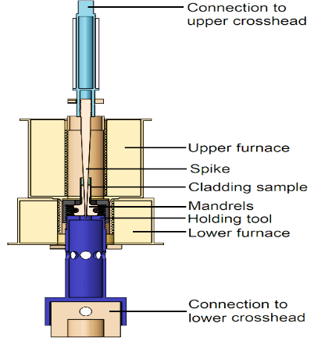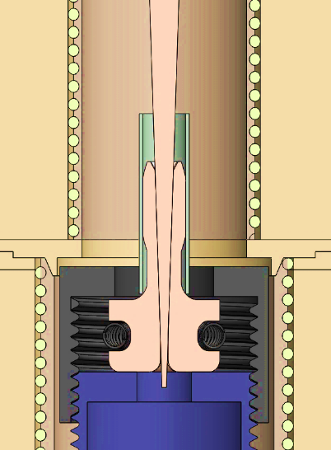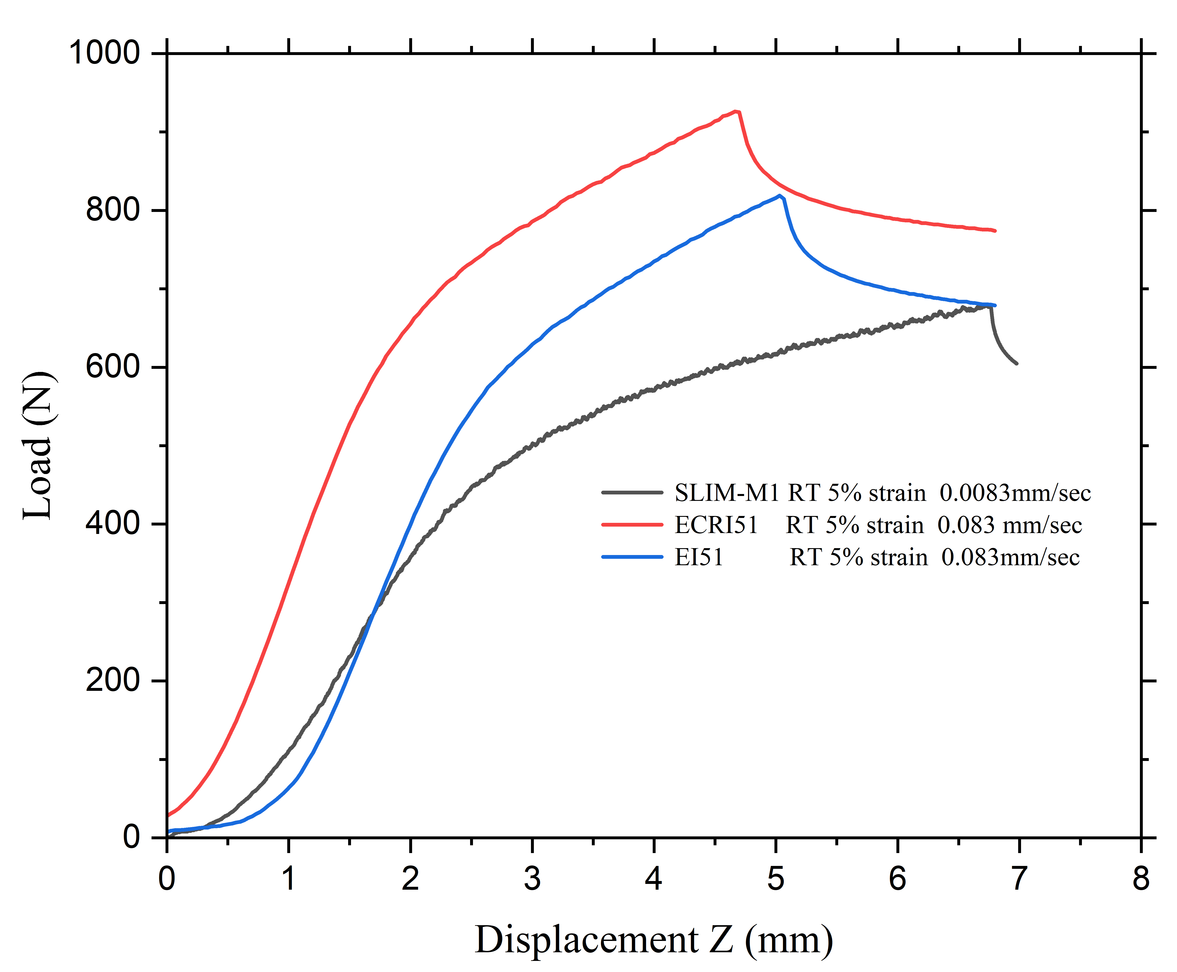
FIG. 1. Mandrel Test Setup FIG. 2. Force–Radial Displacement Curve

2. PROFILOMETRY
Profilometry is commonly used in post-test examinations to assess dimensional changes of the sample. In this study, Keyence VR-5200 machine (non-contact 3D surface profilometer) was used to measure surface topography. After setting a robust procedure to extract data, combined with mandrel test results, statistical analysis of axial and radial deformation revealed the influence of temperature, materials, and test uncertainties. As expected, the coated Zr-1%Nb samples exhibited lower force and higher plastic deformation and radial displacements compared to their Opt-ZIRLO counterparts at both temperatures. Moreover, results revealed an increase in the deformed area with respect to the active region of the segment, showing the creation of a tangent location. Additionally, profilometry identified additional, bending-induced radial deformation, which was previously unaccounted for as a potential source of experimental uncertainty. These results were then used to validate the 3D FE model, specifically developed to model the current mandrel test.

3. FINITE ELEMENT MODEL DESCRIPTION

Accurate fuel performance predictions rely on validated codes, appropriately scaled mechanical models, and realistic material properties. Given the complexity of the test and its inherent uncertainties, including complex geometry, large strains, material and geometric nonlinearity, and uncertain frictional effects, 3D FE analysis was chosen to simulate cladding behaviour. The 3D nonlinear analysis was performed using HEXAGON Marc/Mentat 2022.2, a FE code suited for advanced structural and multi-physics problems. Modelling began by generating deformable meshed bodies and rigid geometries, starting from a 2D CAD file of the actual test geometry, converted into a detailed 3D refined meshed 8-noded elements to meet both contact and meshing criteria. The selection of the glued mesh contact for addition of the Cr layer to the model was supported by experimental observations, as fractography of the coating interface revealed strong adhesion, as it was meshed with the exact axial and circumferential density as the cladding to ensure a homogenous response under loading (Fig. 4). The model also features realistic contact interactions (Fig. 5), boundary conditions, and loading cases, providing good alignment to the actual test. As with any simulation, validation and consistency checks were performed with reference samples to ensure the adequacy and accuracy of the procedure. A sensitivity study was also conducted on meshing, using axial mesh ratios of 1:1 and 2:1 between the mandrel. The elastic bending of previously omitted components was added to the model to better estimate the initial stages of the test (Fig. 5).

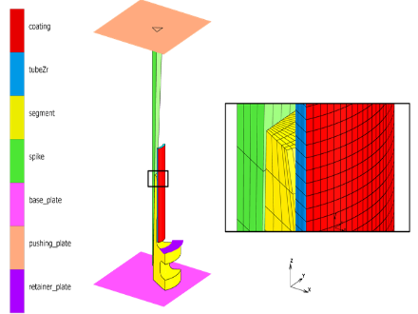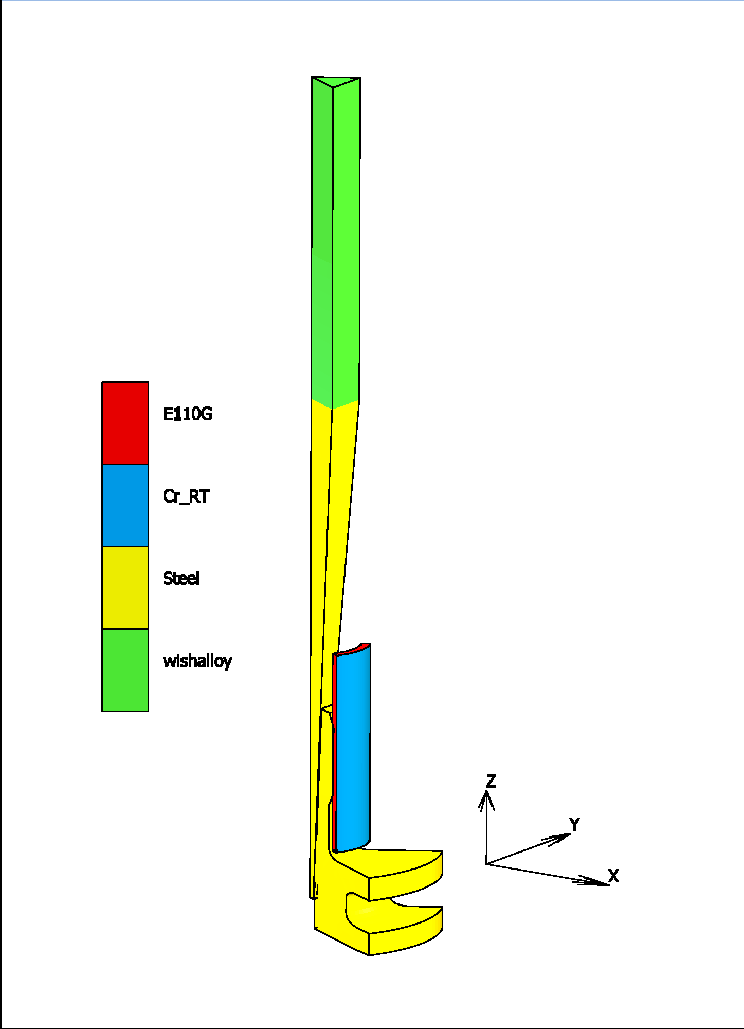
FIG. 4. Contact Description of FE Model FIG. 5. Material Description of the Modified FE Model

3.1 MECHANICAL ANALYSIS BASED ON FE MODEL OF MANDREL TEST

Once the model was validated, a mechanical analysis of the coated cladding was performed based on the material properties implemented. The first step was to verify the rigidity of the segments and the spike, as the assumption of a 5% average strain relies on their rigidity. After that a stress-strain analysis was conducted through the wall thickness. At the first phase of the test, the maximum stress occurs at the inner wall of the cladding due to initial hard contact, where the tangential stress component is highest, followed by a complex increase in stress through the thickness over time. While the Cr-layer shows an offset in stress relative to the Zr-alloy at the Cr-Zr interface, which propagates with contact, it suggests that coating failure likely occurred before Zr yielding, as both models displayed a consistent trend (Fig. 6), despite differences in specific details. Therefore, in contact problems like PCMI, plasticity along the thickness varies with contact propagation, with Cr layer affecting the mechanical response locally. The strain analysis on the other hand, confirmed that plasticity is also likely to occur at the inner side, yet more in between the segments, where the tangential strain is maximized (Fig. 7). A comprehensive fractographic analysis of the samples from the current project, coupled with mandrel tests performed during the ATF-TS separate effect test [2] revealed an intergranular-brittle failure mode instead of transgranular-brittle, indicating earlier failure than predicted by bulk material properties. This may hint at the importance of impurities, such as oxygen and carbon, which can impede the movement of dislocations, and it may vary for each coating technology and Zr-alloy.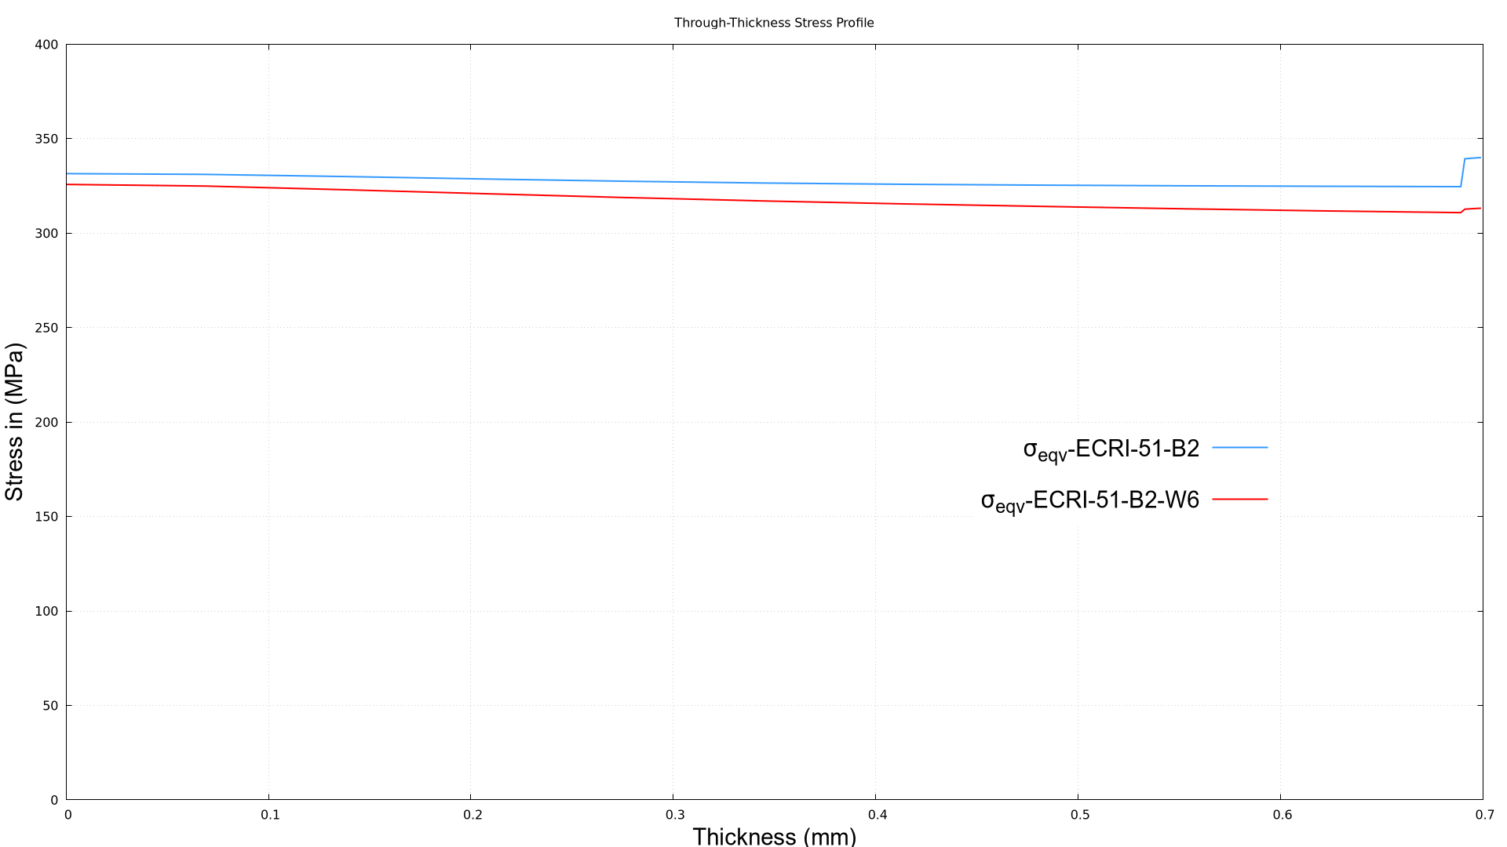 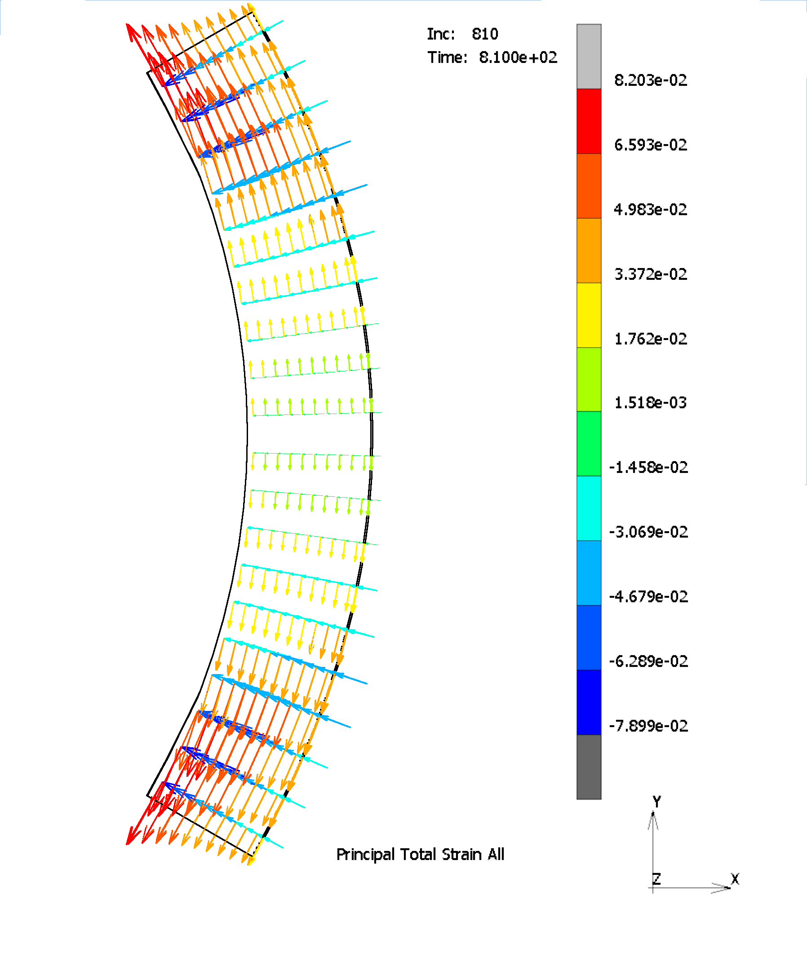
FIG. 6. Stress Profile Through Thickness FIG. 7. Strain Profile at the Mid-Surface of Deformed Zone

4.Code coupling

With ATF cladding advancing to TRL 7 and green taxonomy favouring advanced fuel technologies, there is a growing need for Fuel Performance Codes (FPCs) to simulate the ATF parent rod under NOC. However, since the FPCs are validated for uncoated claddings, their mechanical sub-models must be reassessed to ensure an accurate prediction of coating behaviour, particularly due to their limits in capturing complex contact-related phenomena, such as PCMI. On the other hand, 3D codes can accurately capture complex contact mechanisms. Therefore, to leverage the advantages of both approaches, an innovative code coupling strategy was developed. The coupling approach was based on the premise that cladding deformation observed in the mandrel test can be replicated using an equivalent gas, as the contact pressure during NOC-PCMI can be approximated by an increase in internal rod pressure. To support this approach, azimuthally averaged contact pressures were derived from the validated mandrel FE model (ECRI-51-B2) at specified locations (Fig.8), including the mid-height region under quasi-plane strain, and fillet zones with pronounced strain concentrations. During the coupling process, challenges such as interface inconsistencies, feedback instabilities, and uncertainties in friction modelling were addressed by the strategy implemented, maintaining clear boundaries between the 3D structural code and 1.5-D FPC TRANSURANUS, reducing uncertainties, and preserving model integrity. To verify the governing equations established in analogy between the mandrel test and the equivalent gas model, a separate FE model was realized. The results showed that, at maximum internal pressure, corresponding to peak loading condition, the coated cladding deformation aligned with the target average of 5%, confirming the accuracy of the model (Fig. 9).

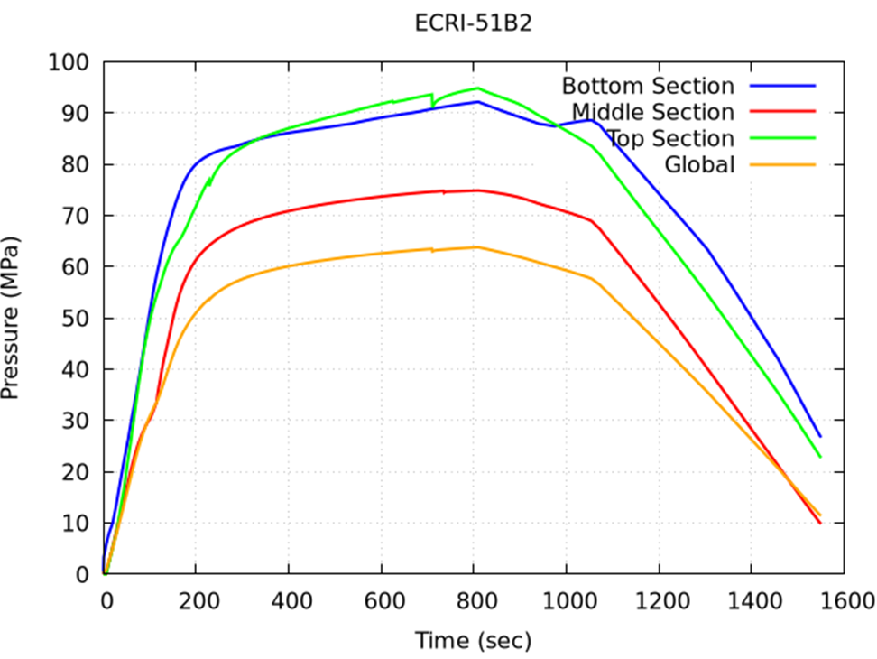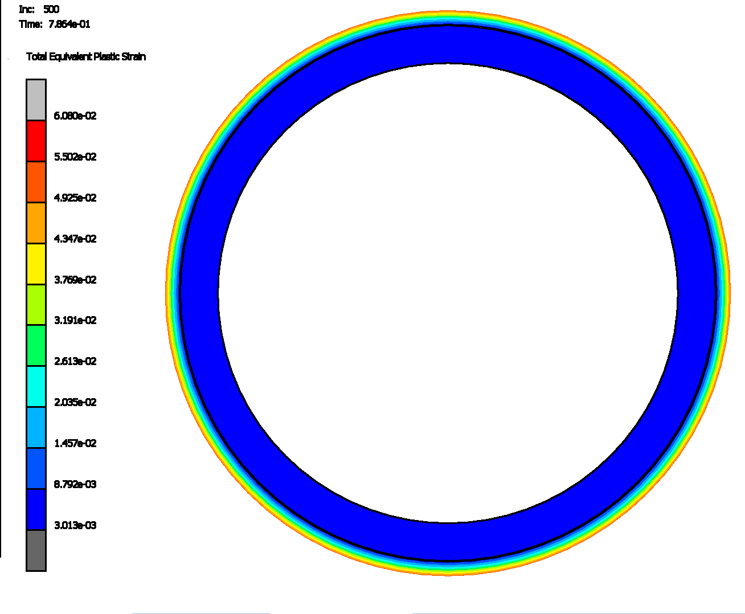
FIG. 8. Pressure History Obtained from Validated Mandrel FE Model
FIG. 9. Total Equivalent Plastic Deformation of Coated Sample at the Peak Pressure

ACKNOWLEDGEMENTS
The authors gratefully acknowledge the Czech Technical University and the Atomic Energy Organization of Iran for providing the materials used in the present testing.
REFERENCES
- Yousefi, H., Király, M., Hózer, Z., Vér, N., Novotny, T., Perez-Feró, E., Horváth, M., Tatár, L., Aragón, P., Schubert, A., & Van Uffelen, P. (2025, July). Mandrel ductility tests with ATF cladding. OFFERR Project report, HUN-REN Centre for Energy Research, Budapest.
- International Atomic Energy Agency. (2024, May 13). Experimental programme of accident tolerant and advanced technology fuel: Final report of a coordinated research program ATF-TS [Unpublished TECDOC report].

