IAEA
IAEA Extended Abstract
Technical Meeting on Advanced Technology Fuels: Progress on their Design, Manufacturing, Experimentation, Irradiation, and Case Studies for their Industrialization, Safety Evaluation, and Future Prospects
IAEA NFE TEAM
Vienna, 2025

Testing-Simulation of Pellet-Cladding Mechanical Interaction with ATF Claddings

H. YOUSEFI^{1,2}, M. KIRÁLY¹, Z. HÓZER¹, E. PEREZ-FERÓ¹, T. NOVOTNY¹, N.VÉR¹, A. PINTÉR-CSORDÁS¹

¹ HUN-REN Centre for Energy Research, Atomic Energy Research Institute, Budapest, Hungary
² University of Pisa, Pisa, Italy

Corresponding author: M. KIRÁLY kiraly.marton@ek.hun-ren.hu

INTRODUCTION: Chromium-based coated Accident Tolerant Fuel (ATF) cladding, currently the only feasible surface treatment for pressurized water reactors, mitigates the limitations of conventional Zirconium (Zr) claddings by enhancing performance, enabling higher burnup, and reducing exothermic metal-water reactions and cladding embrittlement from condition I to Beyond Design Basis Condition (BDBC), with the incorporation of a nitride layer specifically aimed to limit chromium diffusion, enhancing the overall stability of the coating. As coating performance depends on the integrity of the coating, its behaviour must be assessed through the whole plant operation spectrum. In this regard, to date, most studies have focused on BDBC, leaving the assessment of conditions I and II largely theoretical, potentially overlooking pre-accident failures. Pellet Cladding Mechanical Interaction (PCMI), driven by pellet swelling, is an unavoidable phenomenon in conditions I and II that generates radial contact pressure and cladding expansion, potentially leading to coating cracking. To evaluate coating response under such conditions, the mandrel ductility test was employed, as it simulates pellet expansion through radial displacement of a segmented tool. The SNETP-OFFERR project on the Simulation of PCMI with ATF claddings was a joint effort involving a user team, composed of several European nuclear research institutions, coordinated by the Università di Pisa, and the infrastructure team, the HUN-REN Centre for Energy Research. The technical focus of this collaboration was the development and application of redesigned segmented mandrel ductility tests, followed by post-test analysis of a range of unirradiated, coated and uncoated claddings. The primary objective of the project was to investigate the mechanical behaviour, deformation capability, and failure modes of the coating in samples subjected to radial displacement under postulated PCMI conditions, while in parallel, a novel Finite Element simulation was built and followed by an innovative code coupling to assess the mechanical sub-models of fuel performance codes to simulate coating behaviour. The mandrel test was followed by post-test analyses, including Scanning Electron Microscopy (SEM), Light Optical Microscopy (LOM), metallography, and high-temperature oxidation of coated samples. SEM and LOM were conducted after the mandrel test to investigate the potential presence of cracks, as their formation was uncertain. Subsequently, high-temperature oxidation tests were performed to assess the impact of possible pre-existing cracks on coating behaviour with oxidation parameters of 1000 °C for 1800 seconds in steam atmosphere, simulating extended LOss of Coolant Accident (LOCA) condition. Metallography aimed to evaluate microstructural changes at the cladding–coating interface, identify delamination or crack propagation, and assess diffusion behaviour, particularly in nitride-containing coatings, following mechanical strain and oxidation.
  - Mandrel Ductility Testing
To evaluate coating behaviour under postulated PCMI conditions, 25 unirradiated cladding samples were tested, including Cr, CrN, and Cr/CrN multilayer coatings applied with via various physical vapour deposition techniques on Zr1%Nb and Optimized ZIRLO (Opt-ZIRLO) alloys [1]. Uncoated Zr1%Nb and E110 served as references, with the Zr1%Nb and Opt-ZIRLO samples supplied by AEOI and CTU respectively in the IAEA CRP ATF-TS. The mandrel test setup involves a cladding sample that is radially expanded by the mandrel segments due to the vertical insertion of a central spike. This test simulates pellet expansion, a key contributor to fuel behaviour during power ramps and extended burnup. The current mandrel test has undergone significant modifications compared to earlier mandrel tests [2], more closely resembling PCMI conditions through the addition of a fillet and a modified contact surface. The test parameters included an average total radial strain of 5%, with quasi-static crosshead displacements of 0.0175/0.175 mm/min and temperatures of approximately 20 °C and 300 °C. Strain was conservatively exceeded the design limits of stress/strain/fatigue, while temperature conditions reflected realistic conditions. Additionally, a 3D animation was created to improve understanding of the testing process and aid code developers with clearer visuals (Fig. 1).
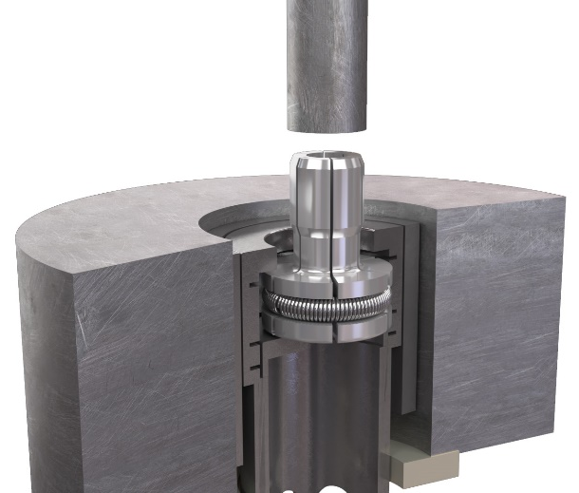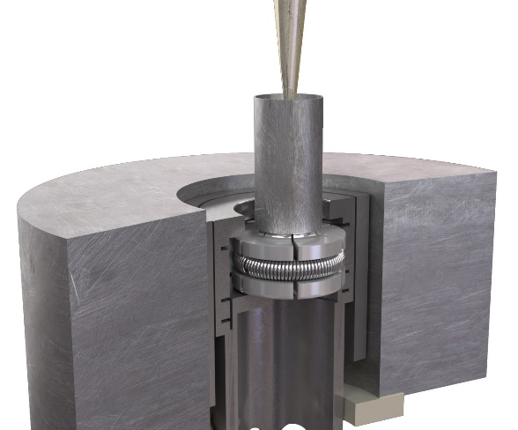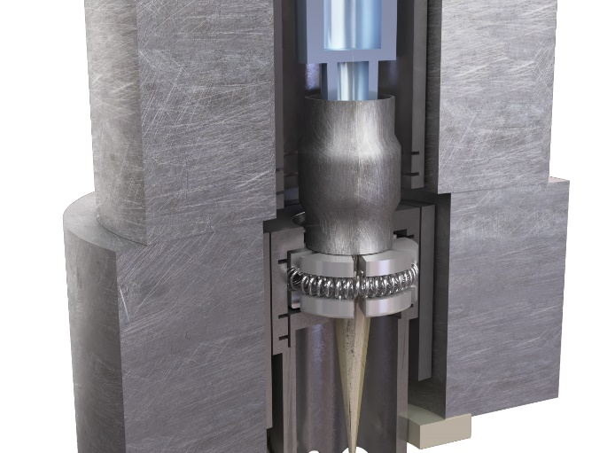
FIG. 1. 3D Animation of the Mandrel Ductility Test setup [1]
  - EXPERIMENTAL
The test included monotonic loading, reaching target deformation in 11 minutes after mandrel contact, and quasi-cyclic loading applied to a Cr-coated Opt-ZIRLO sample with 11 incremental steps to evaluate relaxation and fatigue, followed by unloading. Strict control of frictional conditions was essential, as even minor variations in friction coefficients significantly influenced load measurements and local cladding deformation, despite consistent strain outcomes, as confirmed through controlled blind tests. Preliminary results showed all samples reached 5% total average deformation without cracking of the Zr-alloy, confirming Zr cladding substrate ductility and load-bearing. Both coated and uncoated Opt-ZIRLO required higher force than Zr1%Nb at both temperatures, indicating greater strength of Opt-ZIRLO, though this difference was lower at higher temperature. The coatings were affected only by localized phenomena like surface cracking, with minimal impact on the mechanical behaviour of the claddings. Comparison between cyclic and monotonic loading highlights the effect of fuel conditioning on cladding behaviour once hard contact is established (Fig. 2).
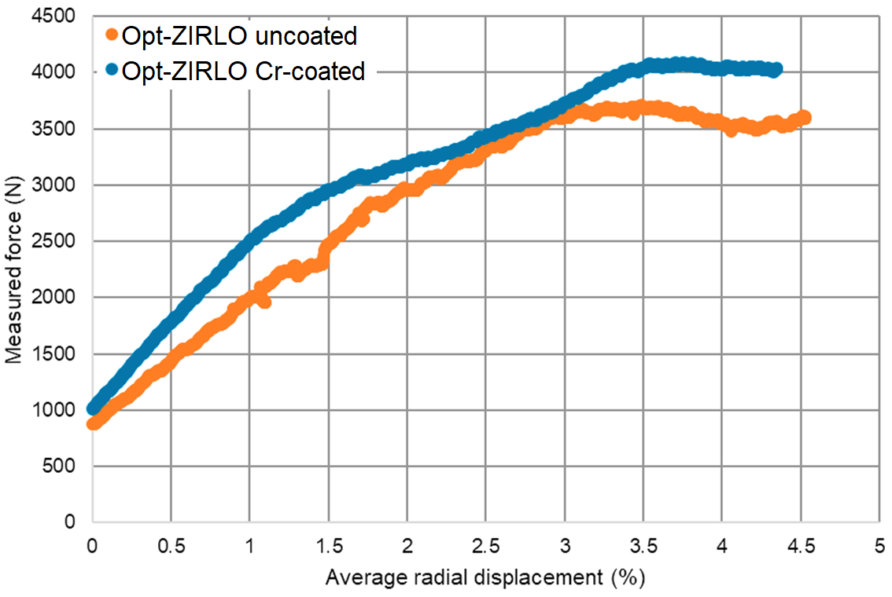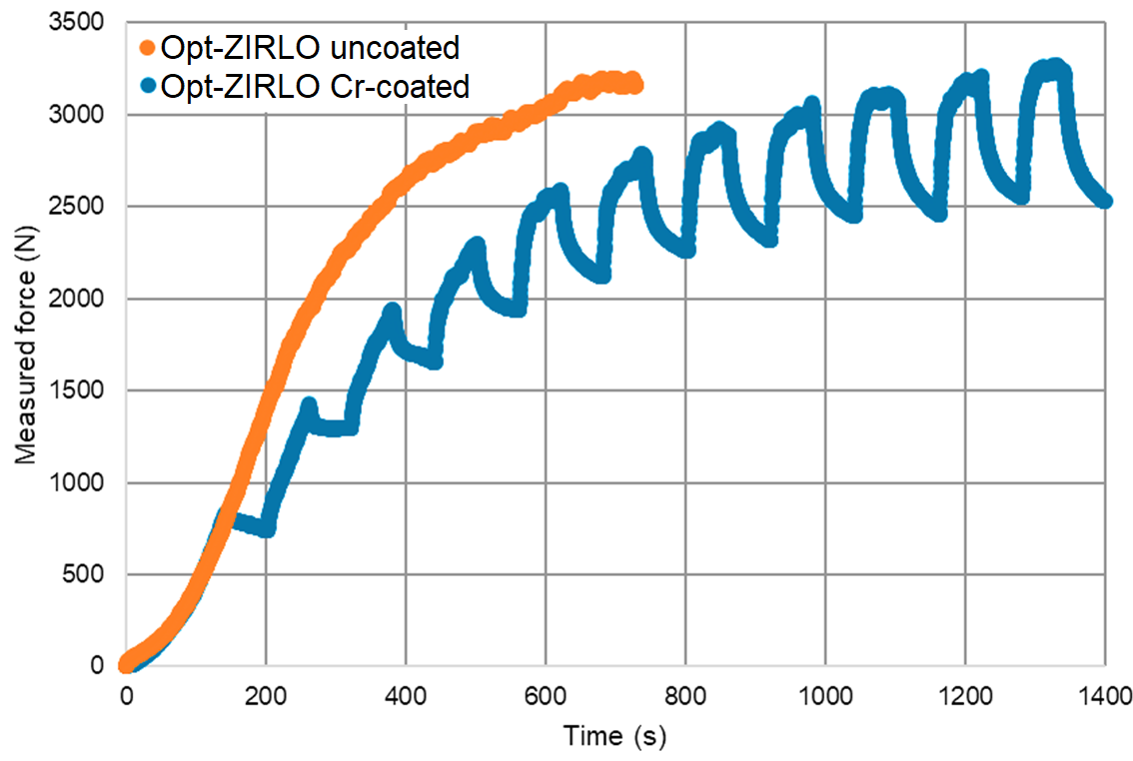
FIG. 2. Force–average displacement and force–time curves of Opt-ZIRLO samples tested at 300 °C [1]
  - Post-test SEM
The first phase of post-test characterization involved SEM to visualize the crack patterns and surface features induced during deformation (Fig. 3). The examination revealed consistent axial cracking across all coated samples, which was unrelated to the fabrication lines; however, the morphology and density of the cracks varied significantly with the Zr-alloy, temperature, and coating composition. For pure Cr-coated Opt-ZIRLO, at most strained locations, sparse ≈1 μm wide axial cracks were observed, while Zr1%Nb showed wider cracks (3–5 μm) spaced ≈150 μm apart. Crack width also increased with temperature mainly in Zr1%Nb, remaining nearly unchanged in Opt-ZIRLO, indicating greater resilience of Opt-ZIRLO and higher plasticity in Zr1%Nb, with both localized with sharp tips, indicative of the brittle fracture behaviour of the Cr layer in both alloys and temperatures. While in CrN and Cr/CrN multilayer coatings on Zr1%Nb, a different cracking pattern, with dense often V-shaped crack network (2-4 crack), with 1-5 μm width occurring every ≈100 μm was seen. These cracks followed distinctive lightning bolt-like paths, frequently branching and intersecting tangentially, with localized chipping at intersections, indicative of a pronounced brittle failure mechanism. Nevertheless, even with significant surface degradation, generalized delamination of the coatings was not observed, and the layers remained strongly adhered to the substrate.
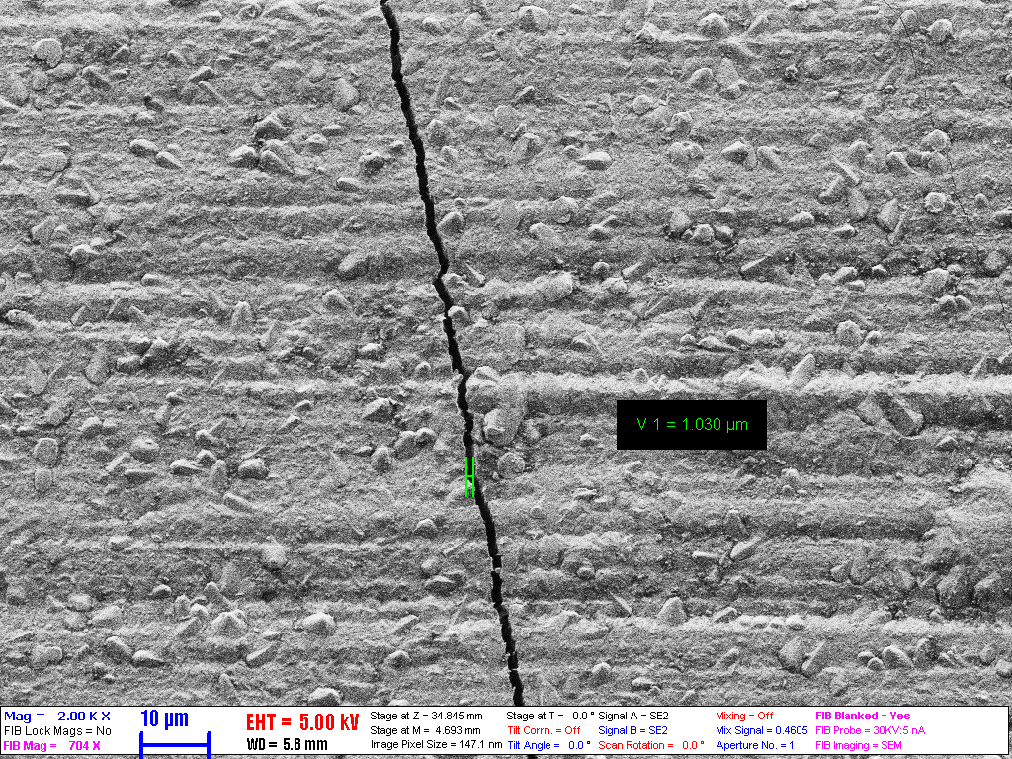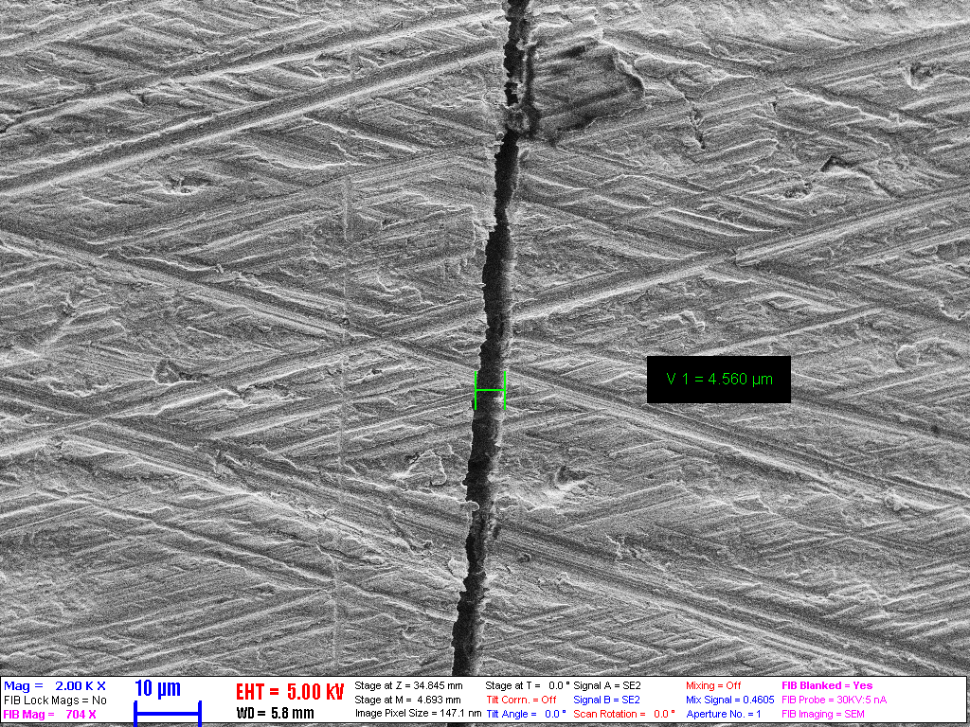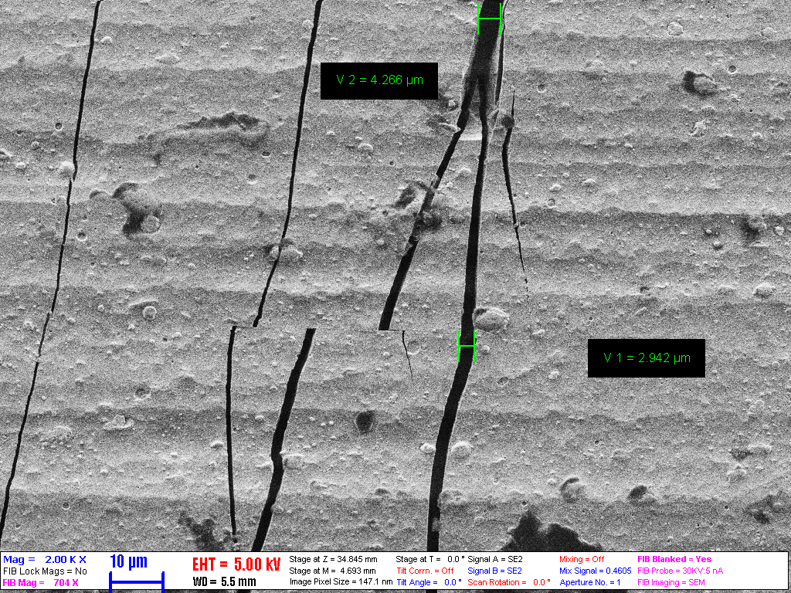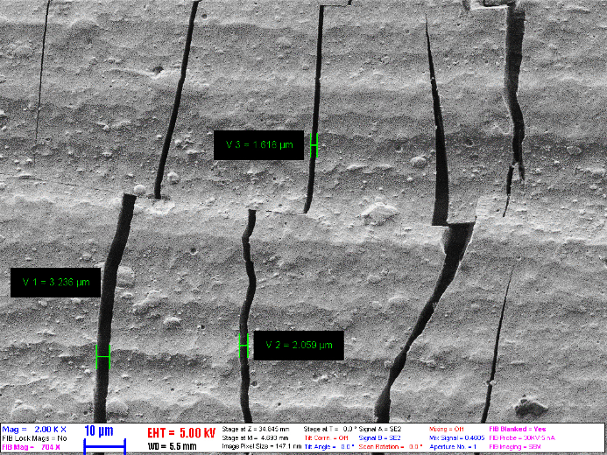
d)
a)
c)
b)
FIG. 3. Crack Width and Morphology of coating mandrel tested at 300 °C: a) Cr-coated Opt-ZIRLO b) Cr-coated Zr1%Nb c) CrN-coated Zr1%Nb d) Cr/CrN-coated Zr1%Nb [1]
  - Post-test oXIDATION and Metallography
To assess the effect of pre-existing cracks and reveal microcracking, six coated samples, Cr-coated Opt-ZIRLO and Cr/CrN-coated Zr1%Nb, were exposed to oxidation in steam at 1000 °C for 1800 seconds with Ar carrier gas, simulating extended LOCA after postulated-PCMI. Accurate assessment of coating oxidation behaviour requires prior consideration of mechanical behaviour. The specific mass gain normalized to surface data from oxidation tests revealed that Opt-ZIRLO-based samples showed higher mass gain than Zr1%Nb samples.
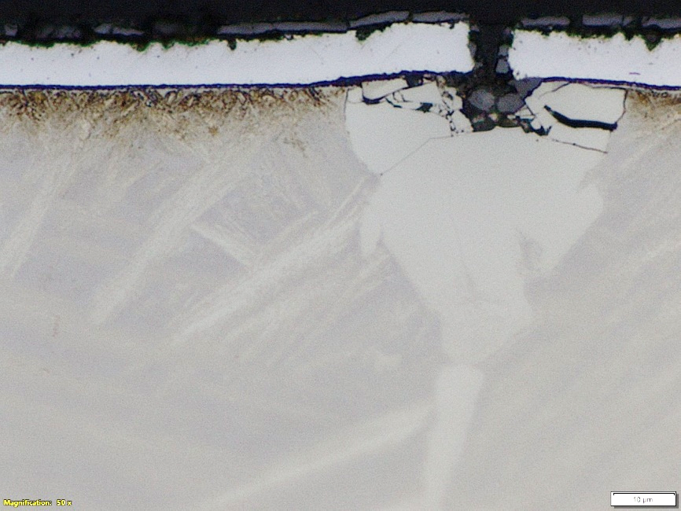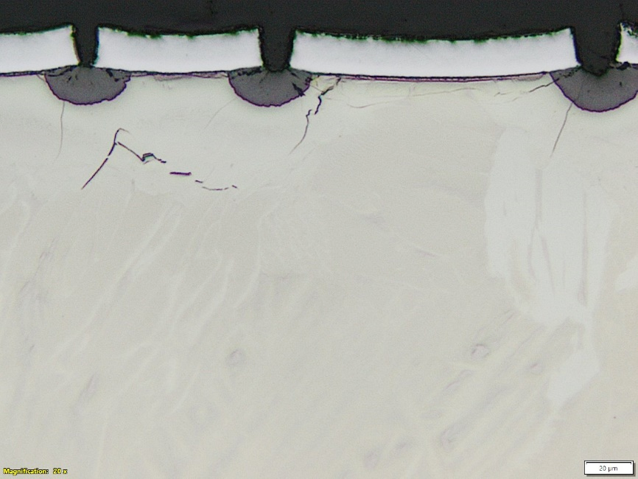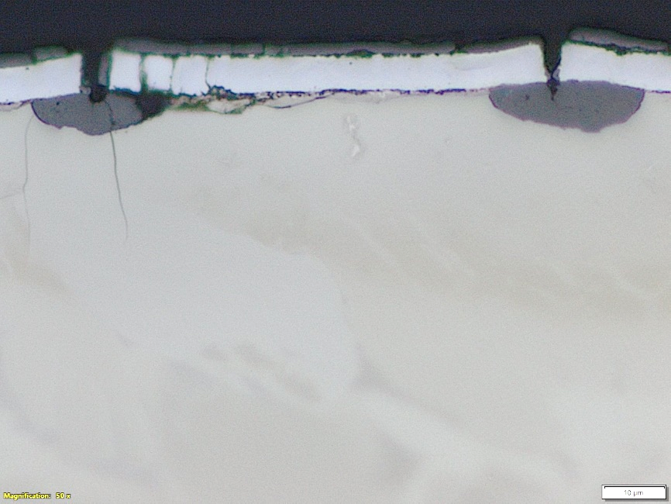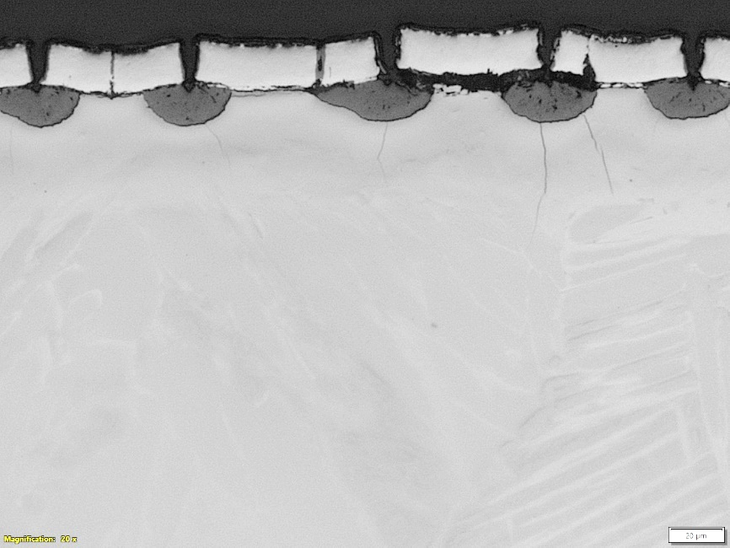
d)
c)
b)
a)
FIG. 4. Metallography after oxidation of a) Cr-coated Zr1%Nb and b) Cr-coated Opt-ZIRLO mandrel tested at 300 °C, and c) Cr-coated Zr1%Nb and d) Cr-coated Opt-ZIRLO mandrel tested at 20 °C [1]
The preliminary studies by LOM analysis reveals formation of green Cr₂O₃ layer on the coating surface and at cracked and exposed areas, which is not beneficial. Due to stability of Zirconia, the steam will preferentially oxidize the underlying Zr-alloy, while also leading to the formation of an oxygen-stabilized region, promoting embrittlement. Over time, the diffusion of Zr through Cr grain boundaries toward the outer surface causes reduction of Cr₂O₃, accelerating Zr oxidation, and potentially forming voids in the Cr layer. This effect will be accelerated when the volumetric expansion during oxidation induces tensile bending moment on the brittle interface, promoting further crack propagation beneath the coating with subsequent increase in oxidation. These results showed the behaviour of pre-cracked coating layers (Fig. 4) – which is largely unexplored in the literature compared to the extensive studies on intact coatings – showing that once the coating is cracked, its protective effectiveness may be significantly compromised under accidental conditions. To further investigate the oxidation effect on coating composition and morphology, samples were embedded in epoxy and prepared for metallographic analysis. LOM showed that coating cracks expose the Zr-alloy to localized oxidation, promoting crack growth in the oxygen-stabilized region, unlike uniform oxidation in conventional alloys, this may accelerate localized cracking and lower fracture toughness. The oxidation of the inner side reduces the thickness load-bearing prior beta phase. LOM analysis of CrN and Cr/CrN multilayer samples tested at different temperatures revealed that nitrogen interdiffusion in the coating and on the coating-substrate interface, leading to the formation of a brittle golden ZrN phase in the coating, at crack sites and interface regions (Fig. 5). Although ZrN may initially enhances corrosion resistance by reducing the intermixing of Cr and Zr, it then transform into porous ZrO₂ at high-temperature in steam atmosphere, accelerating oxidation. This effect was more evident in CrN-based coatings, highlighting a trade-off between short-term protection and long-term stability in nitrogen-containing coatings
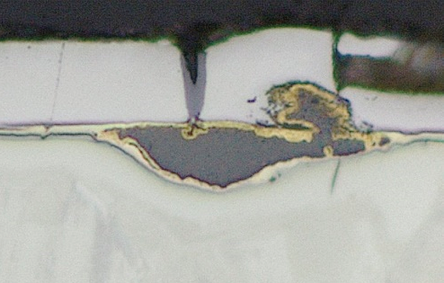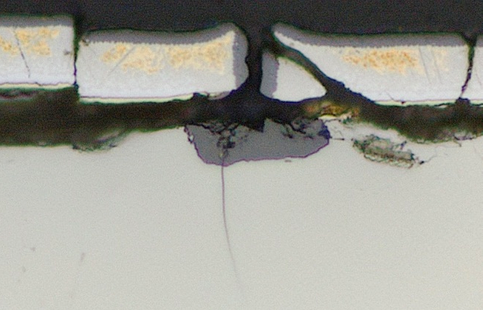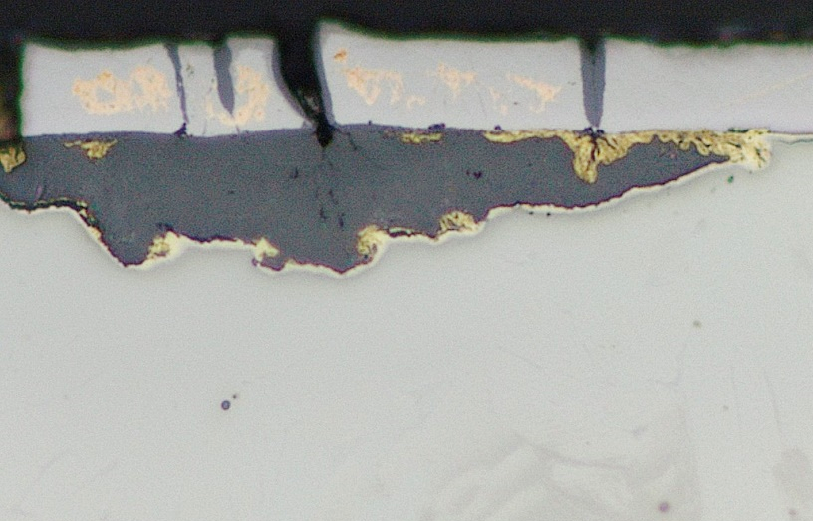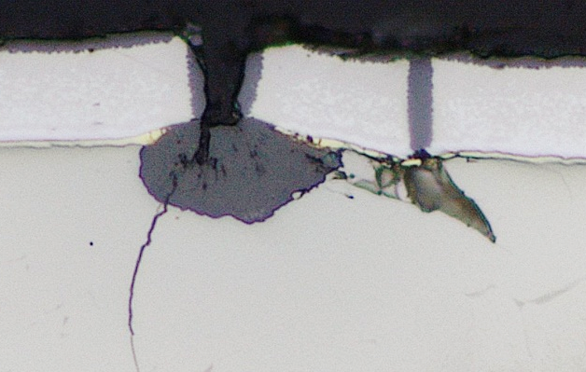
d)
c)
b)
a)
FIG. 5. Metallography after oxidation of CrN-coated Zr1%Nb mandrel tested a) at 20 °C and b) at 300 °C, and Cr/CrN-coated Zr1%Nb mandrel tested c) at 20 °C and d) at 300 °C [1]
  - Summary

The OFFERR ATF mandrel ductility testing project successfully assessed the mechanical behaviour of several ATF cladding candidates under representative postulated-PCMI conditions and established a novel database on coating crack formation. Cr-based coatings showed strong adhesion and good oxidation resistance, but remained prone to brittle cracking, which may hinder the cladding’s ability to fully meet ATF performance requirements. Post-test evaluations revealed the coating’s complex mechanical behaviour under varying conditions, underscoring the need for further experimental studies on its tensile mechanical properties. Selecting the best-performing coating composition and technology based on oxidation resistance and cracking is challenging, as each cladding type is designed for different reactor environments and conditions. However, the inherent brittleness of Cr and the interdiffusion of both Cr and nitrogen remain critical factors to consider in performance evaluation. Moreover, although all coating layers exhibited cracking, no spalling or large-scale delamination occurred. The coatings remained adherent even under extended LOCA oxidation conditions, indicating preserved mechanical integrity despite localized damage. However, the protective effectiveness of cracked coatings remains questionable and may diminish over time. These results highlight the importance of optimized design in terms of thickness, application techniques, and substrate compatibility. Improved microstructural control and impurity management, along with advanced predictive modelling through finite element methods and code coupling with fuel performance models, are essential next steps. Future efforts should incorporate irradiation effects such as neutron-induced hardening, creep, and fission gas behaviour to fully assess ATF cladding performance under in-reactor conditions, as current findings are based solely on unirradiated intact coatings.
ACKNOWLEDGEMENTS
The authors gratefully acknowledge the Czech Technical University and the Atomic Energy Organization of Iran for providing the materials used in the tests.
REFERENCES
- Yousefi, H., Király, M., Hózer, Z., Vér, N., Novotny, T., Perez-Feró, E., Horváth, M., Tatár, L., Aragón, P., Schubert, A., & Van Uffelen, P.. Mandrel ductility tests with ATF claddings. OFFERR Project Report, HUN-REN EK, Budapest. May 2025
- Márton Király, Márta Horváth, Richárd NAGY, NÓRA VÉR, ZOLTÁN HÓZER: Segmented mandrel tests of as-received and hydrogenated WWER fuel cladding tubes. Nuclear Engineering and Technology, Volume 53, Issue 9, Pages 2990-3002, 2021

