IAEA
IAEA Extended Abstract Template
Technical Meeting on Advanced Technology Fuels: Progress on their Design, Manufacturing, Experimentation, Irradiation, and Case Studies for their Industrialization, Safety Evaluation, and Future Prospects
IAEA NFE TEAM
Vienna, 2025

integral Irradiations and post-irradiation examinations of aTF concepts Performed at Idaho National Laboratory

R.S. HANSEN¹, A.W. COLLDEWEIH¹, P.G. PETERSEN¹, J.A. STOCKWELL¹, W.A. HANSON¹, F. CAPPIA¹, D.W. KAMERMAN¹

¹Idaho National Laboratory, Idaho Falls, United States of America

Corresponding author: R.S. HANSEN, robert.hansen@inl.gov

INTRODUCTION: In recent years, Idaho National Laboratory (INL) has performed both irradiation and post-irradiation examination (PIE) tests to support development and deployment of advanced technology fuel (ATF) concepts. The paper overviews test irradiations under pressurized water reactor (PWR) conditions at both commercial and test reactors. PIE was performed on rodlets fabricated by Framatome and irradiated in the ATF-2 water loop at INL’s advanced test reactor (ATR), as well as on lead test rods fabricated by Westinghouse and irradiated at the Byron generating station. Selected results from both are presented here.

OVERVIEW of irradiation activities
After the events at the Fukushima-Daichi nuclear power plants in 2011, the Department of Energy (DOE) Advanced Fuels Campaign (AFC) has focused significant efforts within the U.S. to develop fuel and cladding systems with enhanced accident tolerance for use in light water reactors. A primary thrust of this effort has taken the shape of cooperative research agreements between industry, national laboratories, and utilities, supported by DOE [1, 2]. Under this framework, concept development of ATF materials and subsequent fabrication has been led by industry. This has been followed closely by irradiation campaigns both in test reactors and commercial power plants, supported by the U.S. Department of Energy, industry vendors, and utilities operating those reactors. The near-term concepts, consisting of coated zirconium-based claddings, have progressed the furthest, achieving moderate burnups in prototypic conditions.
The national laboratory support for ATF has included the design and implementation of a fully prototypic irradiation testing environment, known as ATF-2, in ATR at INL [3]. This test location is within the pressurized water loop installed in the center flux trap (Loop 2A), allowing exposure of test rodlets to flowing water of typical PWR chemistry. The test train allows several tiers, each with a 2x3 array of rodlets of nominal 15 cm length, to be simultaneously irradiated, effectively testing different ATF concepts at the same time. The first irradiation phase, ATF-2B, spanned 7 steady-state cycles of ATR from 2018 to 2021. Rodlets from Framatome, General Electric and Westinghouse were irradiated, with linear heat generation rates ranging from 200 W/cm to over 400 W/cm [4], achieving burnups as high as 30GWd/mtU, and discharged pins have been sent to INL’s Hot Fuels Examination Facility (HFEF) for PIE [5]. After a 2-year outage at ATR due to allow a core internal changeout, the next irradiation phase began in 2023 [4]. This ATF-2C irradiation phase will extend burnup of some ATF-2B pins while also adding fresh unfuelled SiC-SiC cladding pins [5] as well as longer (60cm) fresh fuelled and instrumented rodlets from international collaborators (Mitsubishi Heavy Industries) [6, 7].
The AFC program has also been engaged with commercial irradiations of ATF concepts. An important piece has been developing the ability to receive, unload, and perform PIE on full length rods irradiated in commercial reactors. To this end, an initial shipment of lead test rods (LTRs) of both high burnup (up to 73 GWd/mtU) and first cycle ATF materials fabricated by Westinghouse (up to 31 GWD/mtU) irradiated in the Byron commercial reactor (a PWR) was made to Oak Ridge National Laboratory (ORNL) in 2021, and has undergone non-destructive PIE at least to the point of rodlet puncture for pressure and fission gas release analysis [8]. A second shipment from Byron, again with LTRs of both high burnup (up to 72GWd/mtU) and second cycle ATF materials (up to 55 GWd/mtU) was received by INL in 2024 to be used for both standard PIE, as well as refabrication of sections of some rods for transient testing in INL’s Transient Reactor Test Facility [9]. Select PIE results from these second cycle commercial irradiations of Westinghouse ATF concepts are presented below, as well as from ATF-2B irradiations of Framatome ATF concepts, to highlight recent efforts taking place at INL.

byron atf post-irradiation examination results
Of the twenty-five full-length rods shipped to INL from the Byron commercial reactor, ten are actively being worked as part of the AFC effort. Five are zirconium alloy rods which were discharged between 2003 and 2011, being investigated for high burnup behaviour. Of the remaining five, four are cold spray chrome-coated zirconium alloy rods from Westinghouse’s leading ATF design, discharged in either 2020 or 2022. The final rod is an uncoated zirconium alloy sister rod, also discharged in 2022. These latter five are the focus of the current ATF PIE efforts at INL.
Visual examinations, gamma spectroscopy, and profilometry have been completed for all five ATF rods, and gas puncture and rough sectioning have been completed for three of the five. Results from gamma spectroscopy and profilometry for one of the ATF rods are shown in FIG. 1. Axial gamma scans were performed using the HFEF precision gamma scanner, and the results for Cs-137 give a qualitative measure of the burnup profile. Larger dips can be seen at intervals of roughly 10” or 20”, corresponding to grid spacer locations, and smaller dips can be seen at the location of pellet-pellet interfaces. While both previously reported non-ATF Byron high burnup rods [9] and the ATF rods presented in this work showed similar dips in the gamma profile, the high burnup rods previously reported had much more defined dips at the same locations in the profilometry results compared to this ATF rod. Although there are many factors involved, the lack of pronounced dips in profilometry may indicate that oxidation of the ATF rod was less significant than the high burnup rods, as there is little change of measured diameter in spacer grid locations relative to the rest of the rod.
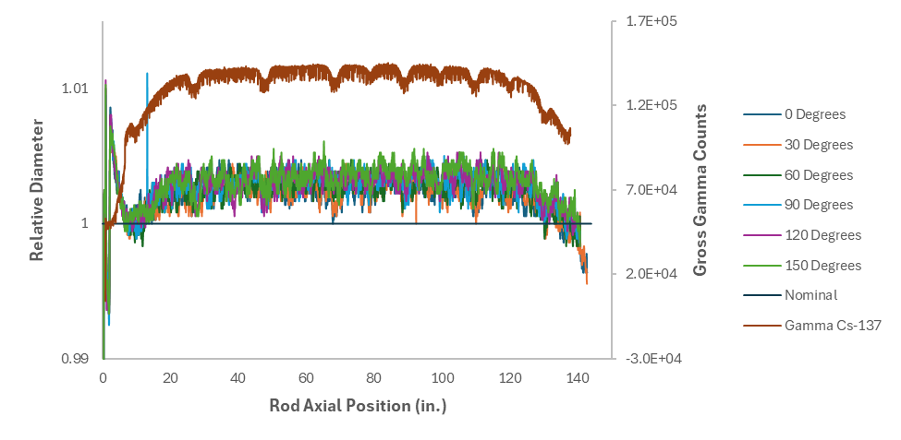
FIG. 1. Profilometry (left axis) and gamma scan (right axis) measurements from an ATF Byron LTR.
After rough sectioning of the full-length rod and further fine sectioning based on the non-destructive exams, a metallography/ceramography mount was prepared from one of the ATF rods. Optical light micrographs of this mount can be seen in FIG. 2. These preliminary results show excellent adherence of the Cr-coating to the cladding. There is also indication of very little hydride precipitation. Overall, initial results from the coated ATF rods are promising, with further PIE planned, including completion of gas puncture and sectioning, in-cell ring and axial mechanical testing using previously established methods [10, 11], and advanced characterization.
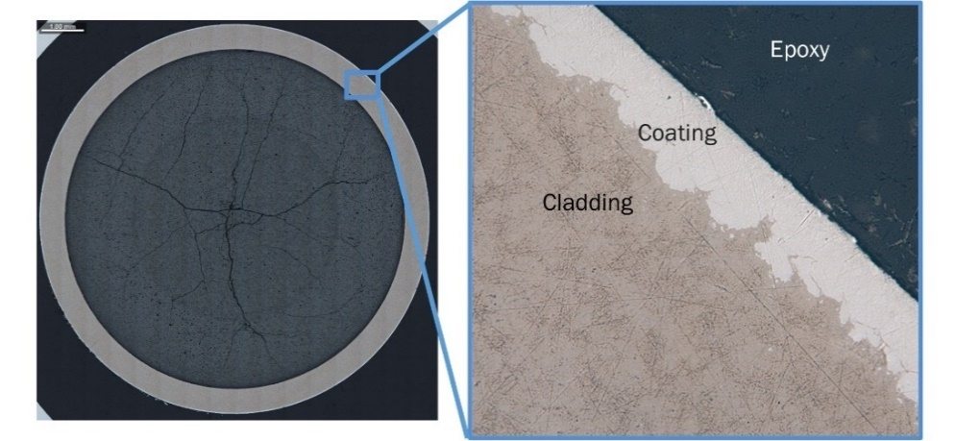
FIG. 2. Optical microscopy image of Cr-coated zirconium alloy cladding from an ATF Byron LTR.

ATF-2B Framatome post-irradiation examination results
PIE campaigns have also been conducted for low and moderate burnup rodlets irradiated in ATR as part of the ATF-2B irradiation tests, such as the Framatome near-term PROtect enhanced accident tolerant fuel concept. As with the commercial irradiations, these followed standard non-destructive examinations, as well as analyses of fuel burnup, hydrogen content, cladding metallography, coating thickness, and ring tension mechanical testing of cladding [12]. These have showed good coating adherence and appearance as previously reported. Coating behavior in ring test specimens has also been investigated through post-test fractography, which can be seen in FIG. 3. Even near the fracture surface where cracks induced by high hoop strains from the post-irradiation tests are present, cracks arrest at the coating-cladding interface. Signs of significant plastic deformation can be seen at these crack locations, indicating that a brittle fracture mode driven by crack propagation from the coating to the cladding is avoided.
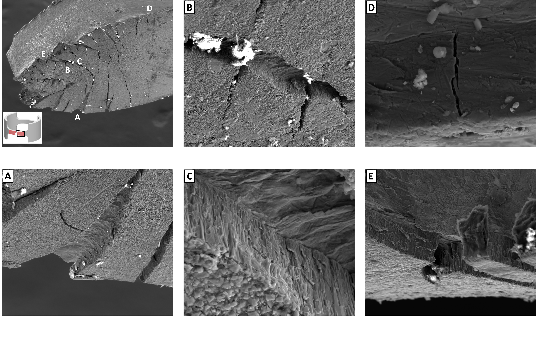
FIG. 3. Electron microscopy images of ring pull mechanical test samples from Framatome cladding tested at elevated temperature. Overview of failed gauge region in upper left image, with higher magnification micrograph locations labelled.

conclusions
The testing campaigns at INL presented above have shown generally positive behaviour for multiple near-term ATF Cr-coated cladding concepts, with good coating adherence being particularly noteworthy. This has paved the way for ongoing work, including the recent recent receipt of higher burnup tests from ATR at the HFEF hot cell, as well as a future shipment of higher burnup rods from Byron to INL in coming months. These efforts highlight the successes in irradiation testing and PIE within the AFC for near-term ATF concepts.
ACKNOWLEDGEMENTS
The authors gratefully acknowledge Framatome Inc. and Westinghouse Electric Co. for their cooperation in this work. This manuscript has been authored by Battelle Energy Alliance, LLC under Contract No. DE-AC07-05ID14517 with the U.S. Department of Energy. The United States Government retains and the publisher, by accepting the article for publication, acknowledges that the United States Government retains a nonexclusive, royalty-free, paid-up, irrevocable, world-wide license to publish or reproduce the published form of this manuscript, or allow others to do so, for United States Government purposes. This work was funded by the U.S. Department of Energy’s (DOE) Nuclear Fuel Cycle and Supply Chain (NFCSC) program. This report was prepared as an account of work sponsored by an agency of the United States Government. Reference herein to any specific commercial product, process, or service by trade name, trademark, manufacturer, or otherwise does not necessarily constitute or imply its endorsement, recommendation, or favouring by the United States Government or any agency thereof. The views and opinions of authors expressed herein do not necessarily state or reflect those of the United States Government or any agency thereof.
References
- S. M. Bragg-Sitton, M. Todosow, R. Montgomery, C. R. Stanek, R. Montgomery, and W. J. Carmack, "Metrics for the Technical Performance Evaluation of Light Water Reactor Accident-Tolerant Fuel," Nuclear Technology, vol. 195, no. 2, 2016-8-1, doi: 10.13182/NT15-149.
- P. Lyons and B. Crowell, "Development of light water reactor fuels with enhanced accident tolerance," in Report to Congress, United States Department of Energy, Washington, DC. https://energy. gov/sites/prod/files/2015/06/f23/Report% 20to% 20Congress, 2015.
- D. W. Kamerman, B. P. Durtschi, B. J. Curnutt, A. L. Carter, G. N. Hoggard, and F. Cappia, "Accident Tolerant Fuel Test 2B (ATF-2B) Irradiation Test Report," Idaho National Laboratory (INL), Idaho Falls, ID (United States), 2021.
- N. Capps et al., "The US Accident Tolerant Fuels Program: Recent Accomplishments Supporting Implementation," in TopFuel 2024, Grenoble, France, 2024.
- D. Kamerman et al., "An Integral Light Water Reactor Irradiation Experiment for Accident Tolerant Fuel Development," SSRN Electronic Journal, 2023, doi: 10.2139/ssrn.4341149.
- T. Labossiere-Hickman, A. Bascom, B. Durtschi, and D. Kamerman, "ATF-2C Physics Safety and Scoping Analysis," Transactions of the American Nuclear Society, vol. 127, no. 1, pp. 578-581, 2022.
- Y. Okada, "Development of Chromium Coated Cladding in Japan for the Commercial PWR," TopFuel2024, 2024.
- J. M. Harp et al., "Non-destructive Post Irradiation Examination of First Cycle Accident Tolerant and Advanced Zirconium Alloy High Burnup Fuel Rods," in TopFuel 2024, Grenoble, France, 2024.
- D. W. Kamerman et al., "Fuel Performance Studies at Idaho National Laboratory Making Use of the Byron Fuel Shipment," in TopFuel 2024, Grenoble, France, 2024.
- R. S. Hansen, D. W. Kamerman, P. G. Petersen, and F. Cappia, "Evaluation of the ring tension test (RTT) for robust determination of material strengths," International Journal of Solids and Structures, vol. 282, 2023/10/15, doi: 10.1016/j.ijsolstr.2023.112471.
- P. G. Petersen, R. S. Hansen, F. Cappia, D. Kamerman, K. Baird, and C. Christensen, "Design and Evaluation of a Ring Tension Test Grip for Remote Mechanical Testing of Irradiated Tubular Specimens," Journal of Testing and Evaluation, vol. 52, no. 6, 2024.
- R. S. Hansen et al., "Examinations of Cr-Coated M5Framatome Cladding Irradiated at the INL Advanced Test Reactor," in TopFuel 2024, Grenoble, France, 29 September-3 October 2024 2024, vol. Track 3: European Nuclear Society, pp. 168-177.

