IAEA
IAEA Extended Abstract
Technical Meeting on Advanced Technology Fuels: Progress on their Design, Manufacturing, Experimentation, Irradiation, and Case Studies for their Industrialization, Safety Evaluation, and Future Prospects
IAEA NFE TEAM
Vienna, 2025

Advancements in Hydrogen-Based
Transient Cladding Strain Limits
to Support Accident Tolerant Fuel

MICHAEL R. ORNER
Westinghouse Electric Company
Cranberry Township, Pennsylvania, United States
Email: ornermr@westinghouse.com

BRIAN L. MOUNT
Dominion Energy
Glen Allen, Virginia, United States
Email: brian.l.mount@dominionenergy.com

Corresponding author: MICHAEL R. ORNER, ornermr@westinghouse.com

INTRODUCTION: As the nuclear industry strives to support accident tolerant fuel (ATF), high burnup operation, extended cycle lengths, power uprates, and other major programs for pressurized water reactor (PWR) plants, an unintended consequence is a reduction in fuel performance margin, particularly for transient cladding strain (TCS). Historically, the U.S. Nuclear Regulatory Commission (NRC) has imposed a 1% uniform strain limit on zirconium-based cladding during overpower transients. However, this fixed limit does not account for material-specific behaviour, especially under varying hydrogen content and irradiation conditions. To address this, Westinghouse, in collaboration with the Pressurized Water Reactor Owners Group (PWROG), developed a hydrogen-based, performance-driven strain limit model for existing low recrystallized zirconium-based cladding. However, newer ATF cladding materials have been developed since the initial hydrogen-based strain limit was approved. Some of these materials, such as highly recrystallized zirconium-based cladding, behave differently from existing cladding alloys and cannot utilize the hydrogen strain limit in its current form. An improved limit, once again being developed by Westinghouse in collaboration with the PWROG, aims to recover margin for Westinghouse zirconium-based cladding, including ATF products. This advancement will enable the use of advanced fuel products and technologies for high energy fuel (HEF) applications and increased fuel duty.

Background
During steady-state operation, stress and strain on the cladding are due to the natural contact pressure between the fuel pellet and the zirconium-based cladding. Fuel rods are designed with an initial gap between the pellet and cladding to accommodate this contact pressure (FIG. 1).
FIG. 1. Fuel Rod Cross-Section Illustrating Initial Pellet-Cladding Gap
During steady-state operation, the pellet-cladding gap closes over time due to the solid swelling of the fuel pellets and the compressive pressure differential causing the cladding to creep down. This contact pressure between the pellet and cladding results in stress/strain, which is typically benign and insufficient to cause fuel failure. However, transient conditions such as overpower events can rapidly increase power, causing thermal expansion of the fuel pellet at a faster rate than the cladding material. This heightened pressure can lead to strain-induced deformation of the cladding, potentially causing fuel failure and releasing fission byproducts into the reactor coolant. The strain applied to the cladding during overpower accidents may be exacerbated by ATF and low enriched uranium plus (LEU+) products. As an example, increased fuel density provides a neutronics benefit because it allows for more ²³⁵U in the core; however, a denser pellet may also have increased swelling and subsequently higher cladding strain. Changes in the cladding alloy may improve resistance to corrosion at high burnup, but it can come at the expense of material strength. Development of advanced fuel products requires a balance between numerous, often competing, factors.
Historically, Westinghouse fuel has adhered to a constant 1% cladding strain limit during overpower transient events, as prescribed by the U.S. NRC Standard Review Plan (SRP) Section 4.2 [1]. This limit does not explicitly account for various factors impacting material strength, such as cladding properties, manufacturing processes, irradiation, temperature, and hydrogen uptake. Westinghouse, in collaboration with PWROG, has developed an alternative hydrogen-based strain limit [2]. A hydrogen-based strain limit derived from measured test data provides a more accurate representation of zirconium-based cladding behaviour and improves strain margin.

Hydrogen and Material Strength
Measurements and mechanical testing have shown that the yield strength (YS) and ultimate tensile strength (UTS) of zirconium-based cladding has a strong dependence on hydrogen content.
During reactor operation, zirconium cladding reacts with the coolant to produce zirconium oxide (ZrO₂) and free hydrogen (H₂). A fraction of the hydrogen is absorbed into the cladding, while the rest disperses into the coolant. Hydrogen pickup in the cladding is cumulative, and more is absorbed the longer the fuel rod remains in operation. If enough hydrogen is absorbed, it can exceed the terminal solid solubility (TSS) limit. Excess hydrogen above the TSS is precipitated as ZrH platelets. These zirconium hydrides accumulate near the outer cladding wall due to the temperature gradient across the cladding (FIG. 2). Hydrides form crack propagation pathways which cause ductility degradation in the cladding and a corresponding decrease in UTS.
FIG. 2. Hydride Distribution Accumulation Through the Cladding Wall

Hydrogen-Based Strain Limit
Westinghouse developed a uniform plastic elongation (UE_{Plastic}) strain limit for zirconium-based fuel cladding based on measured hydrogen and strain data [2]. In this context, UE_{Plastic} corresponds to the plastic strain component of the UTS. Unlike the uniform 1% limit, the UE_{Plastic} strain limit explicitly accounts for the effects of hydrogen embrittlement while continuing to ensure the integrity of the fuel during overpower transient events.
A comparison between the NRC SRP 1% strain limit [1] and the Westinghouse hydrogen-based UE_{Plastic} strain limit is shown in FIG. 3. Until the hydrogen reaches the saturation limit, the UE_{Plastic} strain limit is held steady at a value greater than 1%. After the saturation limit, when excess hydrogen is present in the cladding in the form of circumferential hydrides, the strain limit steadily decreases at an exponential decay.
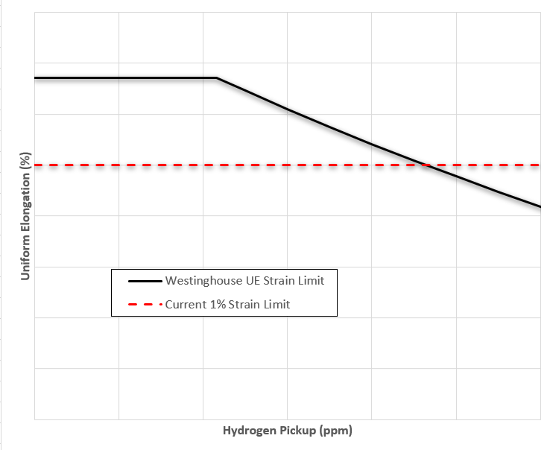
FIG. 3. Westinghouse Strain Limit as a Function of Hydrogen Pickup vs. Constant 1% Strain Limit
This hydrogen-based strain limit increases margin relative to the 1% limit as long as significant hydrogen is not absorbed into the fuel cladding during operation.

Discussion
The hydrogen strain limit from [2] was only developed and licensed using the cladding alloys available at the time. Since then, Westinghouse has developed new ATF products which are capable of operating for longer residency times and burnup up to 75 GWD/MTU due to their increased resistance to corrosion (both oxidation and hydrogen pickup). Improved corrosion resistance increases the benefit of a hydrogen-based limit by reducing the free hydrogen accumulated in the cladding during operation. However, advanced fuel products do not always exhibit the same behaviours as legacy cladding alloys.
For example, newer alloys with higher recrystallized annealing (RXA) are more ductile than older alloys with less RXA. Preliminary tests show that high RXA alloys have almost no UE_{Plastic} strain even though they have significantly higher total elongation relative to legacy fuel. Thus, a UE_{Plastic} strain limit like that developed in [2] is overly conservative for high RXA cladding.

Extension of a Hydrogen-Based Transient Cladding Strain Limit to ATF Products
Westinghouse and the PWROG are investigating use of the total (elastic plus plastic) uniform elongation (UE_{Total}) instead of UE_{Plastic} as a method for determining the strain limit for ATF products. As seen in FIG. 4, UE_{Total} increases the allowable strain relative to UE_{Plastic} which the cladding can undergo during an overpower accident without exceeding the UTS. This is a significant improvement in strain margin, particularly for high RXA cladding where the UE_{Plastic} is near zero. Allowing for both plastic and elastic strain, as opposed to just the plastic component, is consistent with the requirements of the NRC SRP [1]. UE_{Total} has also been presented as a more appropriate measure for calculating the cladding strain limit than UE_{Plastic} at a recent American Society for Testing and Materials (ASTM) symposium on zirconium.
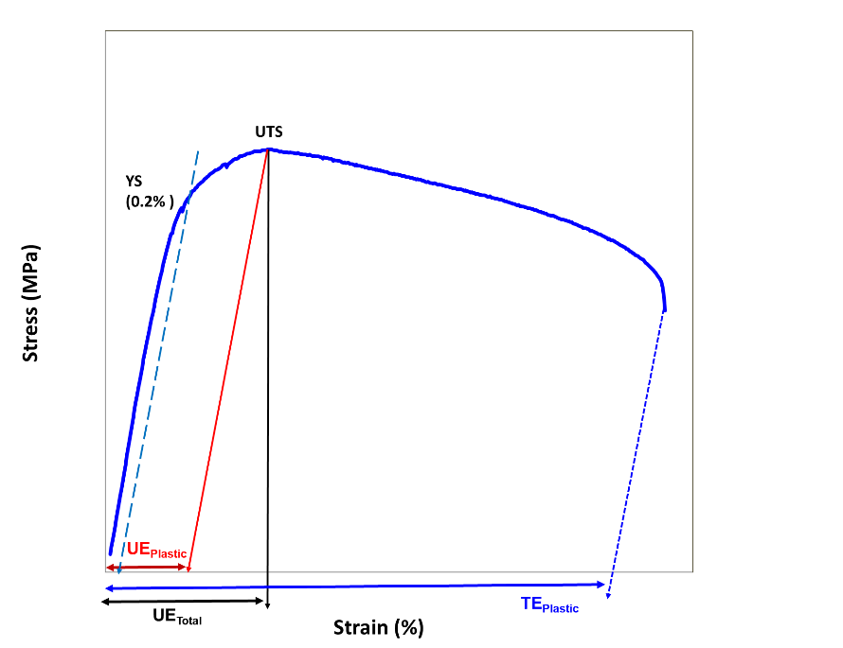
FIG. 4. Schematic of Stress-Strain Curve for Zirconium-Based Cladding
Westinghouse is currently partnering with Oak Ridge National Laboratory and the Studsvik testing facility in Nyköping, Sweden to perform additional testing, some first-of-a-kind, on ATF products. The tests are design to validate that UE_{Total} is a viable design limit for cladding strain during an overpower event and will serve as a supplement to the existing measured database. Once the new data is available, Westinghouse and the PWROG intend to submit a supplement to the original hydrogen-based strain topical report [2] which would extend use of a UE_{Total} strain limit for ATF products.

Conclusion
ATF features are critical to enabling longer residency times, burnup operation up to 75 GWD/MTU, LEU+ fuel, power uprates, and other major programs. Transient cladding strain is currently one of the most limiting fuel performance design criteria for PWR plants with ATF products because they cannot take advantage of the current hydrogen-based strain limit. Application of a new UE_{Total} limit, however, allows utilities to take advantage of ATF products without sacrificing design margin for transient cladding strain. Providing strain margin relief to ATF products is an important step in supporting the future operation of PWR plants.

Acknowledgements
The authors acknowledge the contributions of the PWROG, Westinghouse, Studsvik, and the ASTM Zirconium Symposium participants.
References
- U.S. NRC Standard Review Plan, NUREG-0800, Section 4.2, Rev. 3, “Fuel System Design,” March 2007.
- CREDE, T.M., PWROG Topical Report PWROG-21001-P-A, Rev. 0, “Hydrogen-Based Transient Cladding Strain Limit,” October 2023.

