Modelling of ATF micro-cell UO₂ fuel behavioUr under irradiation
Impact of thermal conductivity on expected thermal-mechanical behavior under irradiation
V. D’AMBROSI¹, R. MASSON¹, J. FAUQUE¹, L. PORTELETTE¹, G. LECLERE¹, J. LECHELLE¹, N. CHIKHI¹

¹CEA, Cadarache, France

Corresponding author: V. D’AMBROSI, veronica.dambrosi@cea.fr

INTRODUCTION: Microcell CERMET (CERamic METal) is an ATF (Accident Tolerant and Advanced Technology Fuels) where granules of UO₂ are enveloped in metallic channel resulting in a nuclear fuel characterized by enhanced thermal conductivity. This reduces the energy stored in the fuel thus increasing the grace period in case of an accident. Few experimental data are today available on this type of fuels. Modelling and simulation can therefore support the understanding of the expected performance under irradiation and help the optimization of this promising ATF. The actual scope of the work presented here is to develop a computational scheme dedicated to simulate the behaviour under irradiation of CERMET fuels, in nominal, incidental and accidental conditions. This paper presents the first step in the process: the effective thermal conductivity of a micro-cell CERMET is modelled by homogenization approach and then verified/validated against available experimental data and full-field calculations. It is then implemented in the ALCYONE code of the PLEIADES platform where the expected thermal-mechanical behaviour of the CERMET is studied in nominal conditions.

METHODS
Microcell CERMET fuel pellet is a composite material consisting of a metallic phase (generally Mo, Cr or W) distributed as to create a more-or-less continuous metallic channel enveloping ceramic granules (UO₂). This microstructure is obtained with a standard manufacturing process, co-sintering the UO₂ granules with the metal power [1]. The mixture is then pressed in a pellet shape, which leads to an anisotropic microstructure: the unit cells result elongated along the radial direction.
The general approach to model an effective thermal conductivity for this kind of heterogeneous materials is to apply homogenization approach. Table 1 presents three structural models used to predict the effective thermal conductivity as a function of the additive metal phase. Voigt and Reuss [2] are the upper and lower limits for the effective thermal conductivity, Maxwell model [3] is well suited for spherical particles uniformly distributed in the matrix. In the case of CERMET, because of the specific distribution of the two phases, the metal is considered the matrix ‘m’ having volume fraction ‘$c_{m}$’ and the UO₂ the inclusion ‘i’, having volume fraction ‘$c_{i}$’. In the following we consider Mo and Cr as metal phases. The thermal conductivity of UO₂ [4], Mo [5] and Cr [5] are considered established.
Because few experimental data are available on CERMET fuels, full-field modelling is used to verify/validate the homogenization approach. The MEROPE [6] software, developed by CEA, is devoted to the geometrical design and discretization of microstructures of random heterogeneous materials. It allows the generation of Representative Volume Elements (RVE) that are discretized in order to obtain their physical behaviour by means of FFT-based solver or finite elements. In this work, TMFFT is used [7]. Figure 1 shows transversal views of generated 1 mm x 1 mm CERMET-type microstructures (oxide in grey and metal in black) based on the available open literature available information [1], [8], [9]. These microstructures are obtained using different unit cell sizes and an aspect ratio equal to 3 (elongation along the radial direction divided by the elongation along the axial direction).
TABLE 1. Effective thermal conductivity models considered in this work for composite materials having two phases
Reference | Model | Phases distribution
Voigt (parallel model) [2] | $$k_{eff}=c_{m}k_{m}+c_{i}k_{i}$$ | 2-phases material having matrix ‘m’ and inclusions ‘i’, parallel distribution, upper limit
Reuss (series models) [2] | $$k_{eff}=\frac{1}{\frac{c_{m}}{k_{m}}+\frac{c_{i}}{k_{i}}}$$ | 2-phases material having matrix ‘m’ and inclusions ‘i’, series distribution, lower limit
Maxwell | $$k_{eff}=k_{m}(\frac{2k_{m}+k_{i}+2c_{i}(k_{i}-k_{m})}{2k_{m}+k_{i}-c_{i}(k_{i}-k_{m})})$$ | 2-phases material having matrix ‘m’ and inclusions ‘i’, spherical inclusions uniformly distributed (m=metal; i=UO₂)

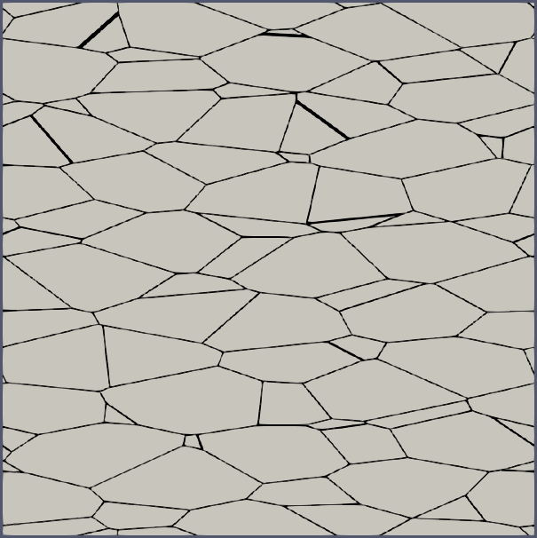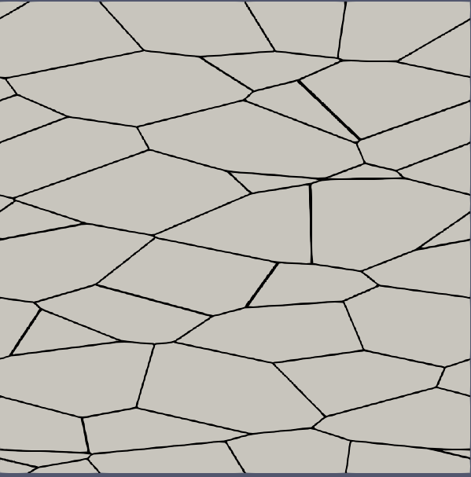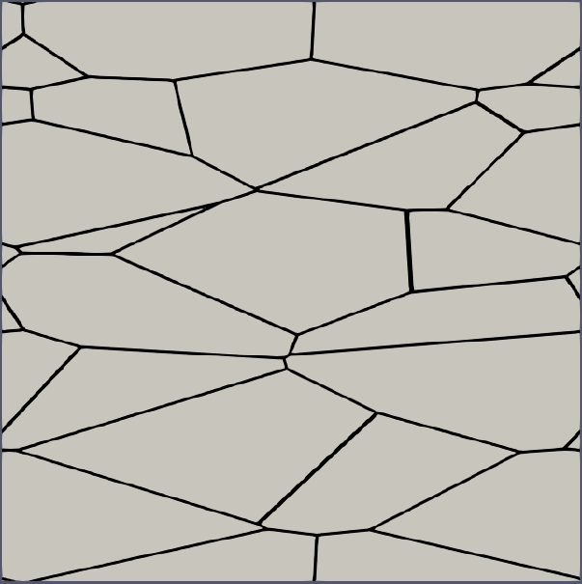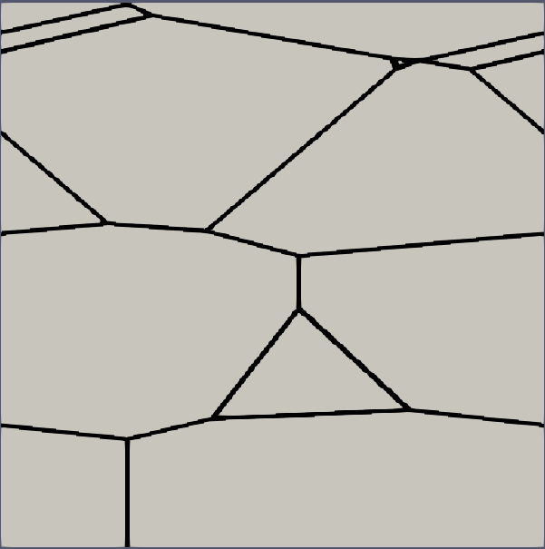
FIG 1: 2D RVE representation of a [1x1] mm of a CERMET having 5% metal (represented in black) enveloping UO₂ unit cells (in grey) and an aspect ratio of 3, developed for this study based on the information available in literature [3]. Different values of generative spheres (from left to right): 165, 265, 350, 530 µm.
Verification/validation phase leads to identify the most suited model to simulate the effective thermal conductivity of the CERMET fuel. This is then implemented in the ALCYONE fuel performance code of the PLEIADES platform [10] in order to analyse the effects on the thermal-mechanical behaviour under irradiation due to a pure increase of the thermal conductivity. The power histories of the xM3 rod [11], [12] are used as case scenarios to study the behaviour of the CERMET with respect to a standard UO₂.

RESULTS and discussion
Figure 2 shows the predictions of the models described in Table 1, compared to the results of the full-field model and to available experimental data. Voigt and Reuss models are the upper and lower bonds as expected. Maxwell model appears to be well adapted to model the thermal conductivity along the radial direction, even though the evaluation is slightly overestimated with respect to experimental data. This may be due to an overestimation of the aspect ratio. Also, modelled microstructures are ideals, the metal channel is perfectly continuous, which is not always the case when the volume fraction of the additive is 5% or less. Noteworthy is the fact that measurements on CERMET having different volume fraction of the additive show similar thermal conductivity, which supports the idea that the way in which Mo distributes strongly affects the effective behaviour. Uncertainty of measurements are not reported in the reference papers.
Maxwell model was thus implemented in the ALCYONE code. Fig. 3 (left) shows the effect of the additive on the fuel centreline temperature at the beginning of the irradiation. As expected, Mo leads to stronger reduction of temperatures with respect to Cr, because of its higher thermal conductivity. In the case of Cr, some measurements of centreline fuel temperature under irradiation are available [9] : a decrease of 220°C is measured for a linear power of 300 W/cm in a CERMET 3.3% Cr. ALCYONE calculated about 250°C lower in a CERMET 5%Cr with respect to a standard UO₂ fuel at about 250W/cm. Simulations are thus consistent with available experimental measurements.
Fig. 3 (left) also shows that in the case of CERMET fuels, the surface temperature of the fuel is higher. Fig.3 (right) shows the time evolution of the pellet-cladding gap. At the beginning of the irradiation the gap is larger because of the smaller thermal dilatation of the pellet, thus leading to a higher thermal resistance of the gap. The difference disappears once the gap is closed. Gap closure is delayed with respect to standard UO₂.
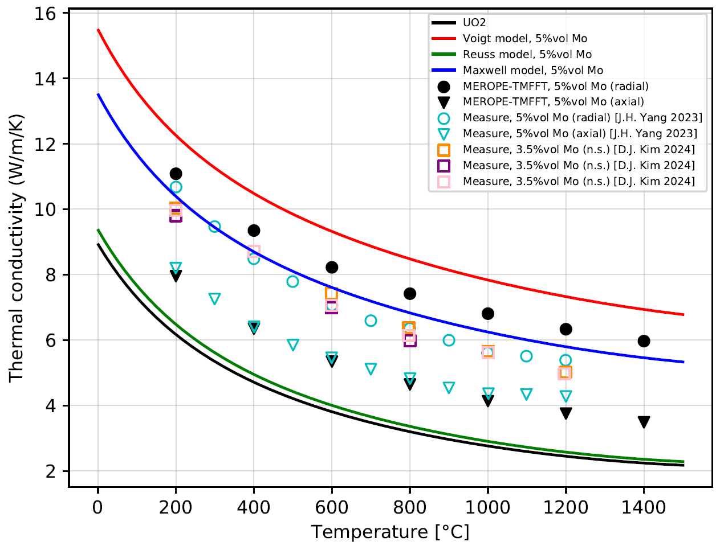
FIG.2: Effective thermal conductivity of UO₂-Mo obtained with models presented in Table 1 and comparison to results from the full-field approach and to available experimental data. The thermal conductivity of pure UO₂ is reported as well. In all simulations, UO₂ is considered at 95% D.T.
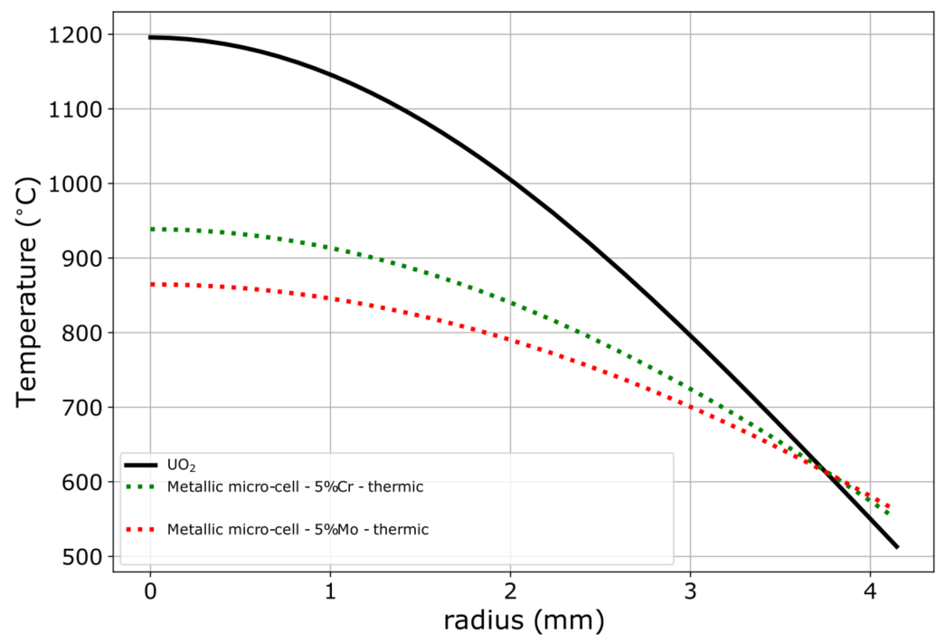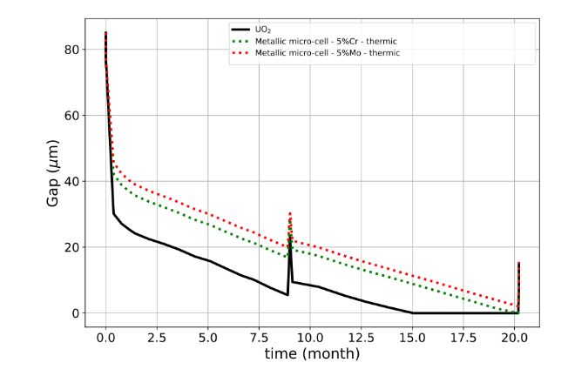
FIG. 3: Calculated radial profile of fuel temperature at Peak Pellet Node (PPN) at the beginning of the irradiation (left) and time evolution of the internal pressure, UO₂ in black, Cr in green and Mo in red.
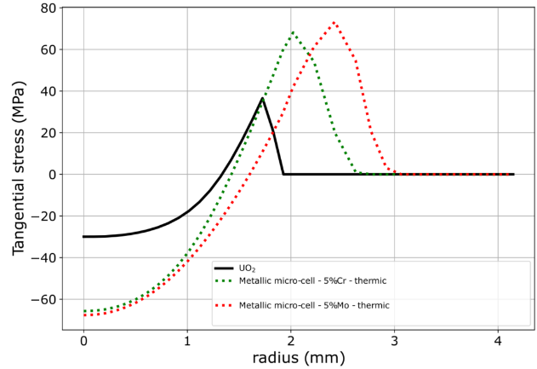
FIG. 4: Calculated radial profile at the beginning of the irradiation of tangential stresses in the fuel at PPN, UO₂ in black, Cr in green and Mo in red.
Fig. 4 shows the calculated radial distribution of tangential stress at the beginning of the irradiation: standard UO₂ cracks as expected (tangential stress is zero in the cracked zone). CERMET fuels crack as well but the radial extension is reduced because of the reduced thermal gradient: about 2 mm for UO₂, 2.8 mm for UO₂+5%Cr and 3 mm for UO₂+5%Mo. Because of the reduced tendency to crack, stiffness increases and stronger compressive stress appears at pellet centre. At this stage, the beneficial or negative effect on Pellet Clad Interaction cannot be really evaluated: better conductivity results in lower thermal dilatations but a stiffer pellet may lead to strong contact pressure at gap closure.
CONCLUSIONS
This paper presents the first step in the development of a resolution scheme dedicated to CERMET in ALCYONE. Maxwell model was found to be well adapted in modelling the effective radial thermal conductivity of CERMET fuel, even though anisotropy is neglected. The thermal-mechanical behaviour of the CERMET under irradiation was studied. It showed lower centreline temperatures and a lower tendency to crack. Gap closure is delayed. Future work will be dedicated to modelling the mechanical behaviour of the metal additive and of the resulting CERMET fuel under irradiation.
ACKNOWLEDGEMENTS
This study was founded by the French nuclear tripartite institute I3P CEA-EDF-FRAMATOME. The authors thank Marc Josien, Etienne Castelier and Antoine Boulore from CEA for their support and for the fruitful discussions. The authors also thank Sebastien Vimont for his contribution to this work.
References
[1] D.-J. Kim et al., “Fabrication of micro-cell UO2–Mo pellet with enhanced thermal conductivity,” Journal of Nuclear Materials, vol. 462, pp. 289–295, Jul. 2015, doi: 10.1016/j.jnucmat.2015.04.003.
[2] D. S. McLachlan, M. Blaszkiewicz, and R. E. Newnham, “Electrical Resistivity of Composites,” Journal of the American Ceramic Society, vol. 73, no. 8, pp. 2187–2203, 1990, doi: 10.1111/j.1151-2916.1990.tb07576.x.
[3] J. C. Maxwell, A treatise on electricity and magnetism, vol. 1. in Oxford University Press, no. 3rd Ed, vol. 1. 1904.
[4] J. H. Harding and D. G. Martin, “A recommendation for the thermal conductivity of UO2,” Journal of Nuclear Materials, vol. 166, no. 3, pp. 223–226, Aug. 1989, doi: 10.1016/0022-3115(89)90218-3.
[5] S. I. Abu-Eishah, “Correlations for the thermal conductivity of metals as a function of temperature,” International Journal of Thermophysics, vol. 22, no. 6, pp. 1855–1868, 2001, doi: 10.1023/A:1013155404019.
[6] M. Josien, “Mérope: A microstructure generator for simulation of heterogeneous materials,” Journal of Computational Science, vol. 81, p. 102359, Sep. 2024, doi: 10.1016/j.jocs.2024.102359.
[7] L. Moutin et al., “Conductivity of UO2 ceramics: Effect of a weakly to strongly branched pore network up to 500 ∘C (exp) and numerical simulations beyond,” Journal of Nuclear Materials, vol. 599, p. 155246, Oct. 2024, doi: 10.1016/j.jnucmat.2024.155246.
[8] J. H. Yang, H. S. Lee, D. S. Kim, D.-J. Kim, J.-H. Yoon, and Y.-H. Koo, “Mixed analytical model to estimate the anisotropic effective thermal conductivity and in-reactor performance of metallic microcell UO2,” Journal of Nuclear Materials, vol. 585, p. 154655, Nov. 2023, doi: 10.1016/j.jnucmat.2023.154655.
[9] D.-J. Kim et al., “Development status of microcell UO2 pellet for accident-tolerant fuel,” Nuclear Engineering and Technology, vol. 50, no. 2, pp. 253–258, Mar. 2018, doi: 10.1016/j.net.2017.12.008.
[10] C. Introïni and et al., “ALCYONE: the fuel performance code of the PLEIADES platform dedicated to PWR fuel rods behavior,” Annals of Nuclear Energy, vol. 207, p. 110711, Nov. 2024, doi: 10.1016/j.anucene.2024.110711.
[11] I. Arimescu and J. Karlsson, “Towards understanding beneficial effects of slow power ramps,” Journal of Nuclear Science and Technology, vol. 52, no. 10, pp. 1274–1280, Oct. 2015, doi: 10.1080/00223131.2015.1023382.
[12] V. D’Ambrosi et al., “Presentation of the xM3 Test Case of the P2M Simulation Exercise and Modeling with the Fuel Performance Code ALCYONE,” Nuclear Technology, vol. 210, no. 2, pp. 285–307, 2024, doi: 10.1080/00295450.2023.2253660.

