Improving RASIMS profile, success story from Sudan
Ammar M E HASSAN
ammarmehassan@gmail.com
Introduction: Legal Framework
Through Agency legislative assistance and staff training provided under previous TC projects, Sudan received support in drafting and promulgating a comprehensive Nuclear Act that covers radiation safety and nuclear security, safeguards of the facilities, nuclear materials, radiation sources, and all activities involving peaceful uses of nuclear energy and radiation technology in Sudan. The new Nuclear Act cited as “The Nuclear and Radiological Regulatory control Act, 2017” came into force on the date of signature by the President on 26/02/2017 and was published in the gazette issue No 1863 KH on 15 April 2017.

Radiation and Nuclear Safety Services
These services are provided by the Radiation and Nuclear Safety Institute (RNSI) of the Sudan Atomic Energy Commission (SAEC) to meet national regulatory requirements. The key achievements of the past IAEA TC projects comprise continuous capacity building support, establishment of personnel and workplace monitoring services, secondary standard dosimetry laboratory (SSDL), radioactive waste management facility, and foodstuff monitoring capabilities.
RASIMS profile
To facilitate the assessment of progress made in strengthening radiation safety infrastructure, country profiles for TSA 1, TSA 2, TSA 3 and TSA 7 in the IAEA’s RASIMS database are extensively being updated and almost complete awaiting review by the relevant IAEA Department. Regarding the status of the other thematic safety areas: TSA 4 profile is 80%, TSA 6 is 26% completed. TSA 5 is no longer part of RASIMS.
Objectives
The country aims at achieving high compliance with IAEA safety standards for all thematic areas by 2027.
Methodology
A committee has been established in 2016 by the D. G of SAEC to coordinate, edit, update and endorse the information uploaded to RASIMS.
This committee chaired by the Director General of SAEC and, co-chaired by the Secretary General of SNRRA, the RASIMS national coordinator as a reporter and the members include the director of RSNI-SAEC, AFRA NC, and 14 members; two for each thematic area, one from the Regulatory body (SNRRA) and the other from the service provider (RSNI-SAEC). The committee used to meet every two month to follow up the progress made by the designated CPs for each thematic area.
Results
As a result of the mechanism explained in the methodology section, the profile of Sudan has improved in general and in particular for thematic areas 1, 2 and 3 as shown in the following figure.

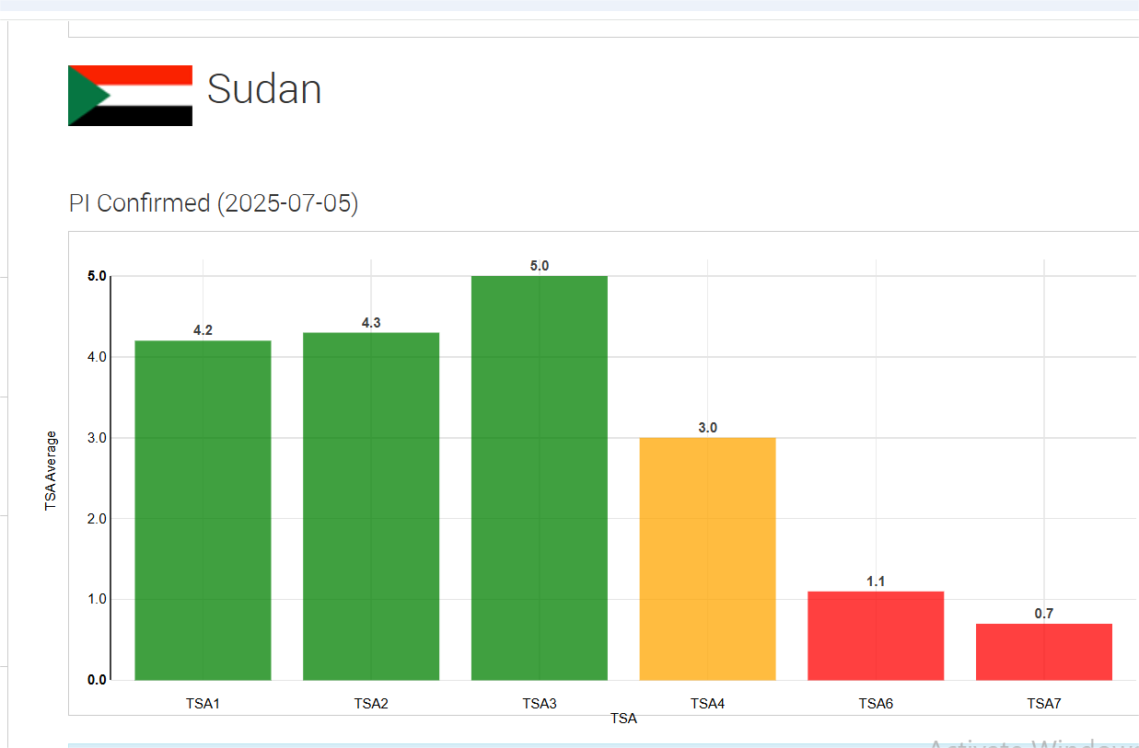

Disscussion
The mechanism of coordination between regulatory body and service provider was found to be very efficient and effective in improving the RASIMs profile of Sudan in few years and this mechanism is now adopted by AFRA project RAF9070 during the first coordination meeting in 2024, all participating member states assigned two CPs for each thematic area.
Conclusions The close coordination and strong partnership relation will change the shape of profiles to a better position and reflects the national commitment to ensure safety in all the peaceful applications of nuclear technology.
Recommendations
To national institutions in Sudan; to maintain this mechanism of coordination to achieve the stated objective in time.
To AFRA community; to adopt the mechanism effectively to ensure achieving the same results obtained in Sudan.
References
RASIMS platform
The Committee profile
Report of the First coordination meeting of RAF9070 Enhancing the Radiation Safety Infrastructure (AFRA)

