Development and Performance Evaluation of a Data Logger for Radiopharmaceutical Transport Safety

Yu-Mi Jung, Eun-Ha Cho

Radioisotope Research Division, Korea Atomic Energy Research Institute, Daejeon, Republic of Korea
Corresponding author: Yu-Mi Jung (e-mail: jym0731@kaeri.re.kr)

Ensuring real-time safety monitoring during the transport of radiopharmaceuticals has become increasingly important as global supply chains expand and shipment distances grow. Effective management of environmental conditions and radiation exposure throughout the logistics process is now recognized as a critical component of maintaining product integrity and patient safety. However, long-distance and cross-border shipments face multiple risks, including temperature fluctuations, radiation shielding failures, mechanical shocks, and unforeseen delays. These factors can directly compromise product quality and therapeutic effectiveness. At present, most transport systems lack advanced tools for continuous, real-time monitoring of critical safety parameters and for issuing timely alerts when abnormal conditions occur.

To address these challenges, we developed a data logger capable of continuously measuring and recording both temperature and radiation dose throughout the entire transport process. The device integrates high-precision temperature sensors and radiation detection modules within a compact, lightweight design that allows easy installation inside or outside transport containers without interfering with routine logistics operations. Importantly, the data logger operates reliably under extreme cryogenic conditions below –70 °C and offers a battery life exceeding 10 days, ensuring stable, long-term functionality even during extended transport durations or unexpected delays. This capability significantly improves resilience for both domestic and international shipment scenarios.

Extensive laboratory evaluations were conducted to verify measurement accuracy, data integrity, and system reliability under controlled environmental conditions. The device successfully collected precise temperature and radiation data over extended periods while maintaining uninterrupted operation. The integrated alert system functioned effectively, issuing real-time notifications whenever pre-set thresholds were breached, thereby enabling transport operators to respond rapidly to potential safety concerns before they escalated into critical incidents.

To assess real-world performance, domestic and international transport trials were performed across multiple routes and environmental conditions. Despite exposure to vibration, mechanical impact, and variable temperatures typically encountered during long-distance shipments, the data logger consistently maintained accurate data recording and reliable alert functionality. Figure 1 illustrates representative transport test result, showing continuous records of temperature and radiation dose measurements over time, thereby demonstrating the device’s capability to ensure both environmental monitoring and operational safety throughout the entire shipment process. These results confirmed that the system can serve as more than a passive data recorder, offering proactive risk detection and operational decision support for enhancing transport safety management frameworks.
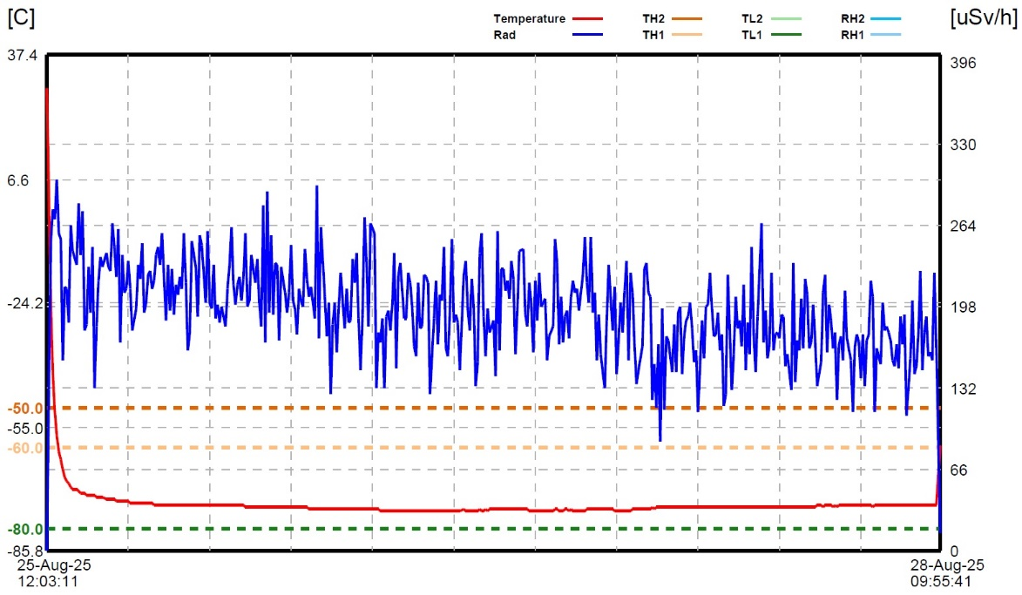
Figure 1. Continuous records of temperature and radiation dose measurements obtained during domestic transport test using the developed data logger.

Building on these successful outcomes, our team is now actively developing next-generation IoT-based data loggers that will incorporate additional sensing capabilities, including shock detection, illumination measurement, and real-time geolocation tracking. By integrating these devices with an IoT-enabled data management platform, we aim to provide simultaneous, real-time monitoring capabilities for consignors, carriers, consignees, regulators, and medical institutions. We expect this integrated system to significantly enhance transparency, ensure regulatory compliance, and optimize supply chain coordination across national and international transport networks.

In conclusion, the data logger presented in this study provides a practical, innovative, and regulation-ready solution for monitoring radiopharmaceutical transport safety. By combining continuous environmental monitoring, early warning capabilities, and compatibility with international transport standards, it establishes a solid foundation for modernizing safety management practices. Future collaboration with competent authorities, industry partners, and international organizations will focus on large-scale deployment, international standardization, and integration into global regulatory frameworks, ultimately contributing to safer, more efficient, and more resilient radiopharmaceutical transport systems worldwide.

