Development of an Advanced Cryogenic Transport Container for Radiopharmaceuticals

Eun-Ha Cho, Yu-Mi Jung

Radioisotope Research Division, Korea Atomic Energy Research Institute, Daejeon, Republic of Korea
Corresponding author: Eun-Ha Cho (e-mail: choeh36@kaeri.re.kr)

Safe and reliable transport of radiopharmaceuticals is a critical requirement for patient treatment and public health systems worldwide. Many therapeutic radiopharmaceuticals are highly sensitive to temperature changes and must be kept under strict cryogenic conditions to preserve their stability, quality, and therapeutic effectiveness. However, existing transport containers face significant limitations in maintaining ultra-low temperatures over long periods, providing adequate radiation shielding, and meeting increasingly strict international transport regulations. These constraints have created challenges for long-distance and cross-border shipments, increasing the risk of supply chain disruption and reduced product quality during transit.

To address these challenges, we have developed an advanced cryogenic transport container designed to maintain both the thermal and mechanical safety of radiopharmaceuticals throughout extended transport operations. From the initial design phase, the container was engineered to meet international requirements, including IAEA transport regulations, ensuring suitability for both air and ground shipment under diverse environmental and logistical conditions.

The newly developed container incorporates a multi-layer vacuum insulation system together with a high-efficiency coolant storage unit. This combination enables the container to maintain internal temperatures below –60 °C for more than 144 hours without interruption. During the engineering stage, extensive mechanical shock analyses and radiation shielding simulations were conducted to optimize structural integrity. These studies confirmed that the container can withstand vibration, mechanical impact, and potential contamination risks, while keeping radiation exposure levels strictly within IAEA regulatory limits to protect workers, the public, and the environment.

Comprehensive performance evaluations were carried out through both laboratory-based simulation testing and real-world transport trials. Thermal stability tests demonstrated that the container maintained internal temperatures below –60 °C continuously for six full days, even under simulated transport conditions involving frequent handling and environmental fluctuations. Mechanical stress testing further showed that the internal vials containing radiopharmaceuticals were neither overturned nor damaged under severe vibration and impact scenarios. Radiation shielding performance was also confirmed to remain well within internationally accepted safety thresholds across all testing stages, verifying the container’s reliability for practical applications.

The main engineering components of the container are illustrated in Figure 1, while Figure 2 provides a detailed view of the interior of the manufactured container, highlighting the reinforced structural design specifically developed to resist physical shocks during transportation. Together, these results clearly demonstrate that the container ensures both thermal stability and mechanical safety throughout the entire delivery process, addressing two of the most critical requirements for radiopharmaceutical transport.
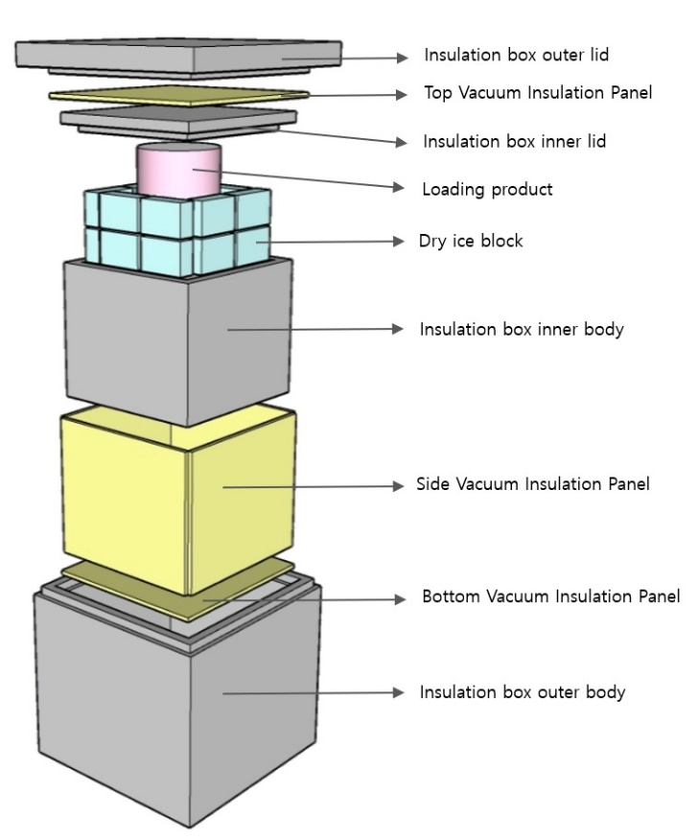
Figure 1. Schematic diagram of the cryogenic radiopharmaceutical transport container.
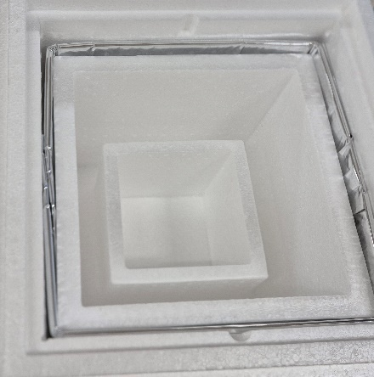
Figure 2. Interior view of the manufactured container showing the reinforced structure for enhanced shock resistance.

Overall, the advanced cryogenic transport container presented in this study offers a standardized, safe, and efficient solution for the international shipment of radiopharmaceuticals. By integrating engineering design, regulatory compliance, and empirical testing, the work establishes a foundation for improving transport safety, operational efficiency, and global supply chain security. Beyond technical achievements, this development also provides a model for how engineering innovations can align with public health objectives to ensure uninterrupted access to essential medical isotopes worldwide.

Future efforts will involve collaboration with regulatory agencies, medical institutions, and logistics providers to support international adoption, technology transfer, and eventual commercialization. The long-term goal is to establish this advanced transport container as a reference standard for the secure, efficient, and regulation-compliant delivery of radiopharmaceuticals across borders, contributing to improved patient care and treatment continuity on a global scale.

