Reimagining Nuclear Logistics: Sustainable Hybrid Airships for SMR Deployment

James Dexter
jdexter@straightlineaviation.com
1 2403191414
Straightline Aviation Hybrid Aircraft Operations

This synopsis proposes the emergent, safe and reliable hybrid Z1 airship technology as a logistics option for the transportation of Small Modular Reactors, (SMR), equipment, and personnel. The Z1 airship eliminates the need for conventional transportation on roads, rail, and waterways. This airship is designed by Lockheed Martin’s “Skunkworks,” and will maintain nuclear safety and security protocols and streamlines or eliminates the existing regulatory and logistics compliance issues of concern faced by the existing transportation industry.
This proven airship design technology utilizes electric hybrid propulsion, provides a payload capacity up to 100-tons, (METRIC) and provides point-to-point site landing capabilities on land or waterways. The Z1 will reduce project delivery timelines and eliminates dependence on ground or sea infrastructure. This hybrid Z1 airship provides an efficient delivery system and supports the promise and expansion of sustainable carbon-free energy to the world’s populated or most inaccessible regions.
The Z1 cargo airship is a product of Lockheed Martin “Skunkworks.” AT2 Aerospace www.at2aero.space , and former employees, will build the airship. Straightline Aviation www.straightlineaviation.com – is a United States FAA certified and approved operator and will operate the airships for Day/Night VFR/IFR operation. Straightline Aviation has successful experience operating various airship designs in 53-countries over 30-years.
Currently, Z1 will carry 21.3 metric tons in its cargo bay. The airship is scalable and a 100-ton version will soon follow the Z1 into production. An Air Cushion Landing System, similar to a hovercraft, is used to support the Z1 during landing and take-off. This system enables operation on a variety of surfaces, to include dirt, gravel, grass, snow or water. Operations are not dependent on conventional airport/runway environments, surface improvements are only necessary to support cargo movement on the ground.

Factor | Hybrid Airship | Traditional Logistics (Road/Sea/Rail)
Infrastructure Costs | Minimal – only basic landing zones  and maintenance hubs required. | High – roads, bridges, ports, and rail  networks may need upgrading or  construction to handle heavy loads.
Fuel and Emissions | Lower – electric hybrid propulsion cuts fuel costs and carbon penalties. | Higher – diesel, bunker fuel and aviation  grade fuels are costly and  carbon-intensive.
Handling and Transfers | Direct point-to-point reduces  handling and associated labor/equipment costs | Multiple transfers (port loading, rail yard handling, heavy trucks) increase costs  and risk of damage.
Delivery Time | Faster – reduces project delays  and associated financial penalties. | Slower – dependent on  scheduling and infrastructure readiness.
Regulatory Complexity | Single-mode nuclear cargo  Compliance: simplified documentation, oversight and monitoring. | Multi-modal regulatory oversight  (maritime, rail, road, customs) – more complex and costly.
Benefits of Airship Transport
- Lower operational costs – savings on fuel, infrastructure, and reduced delays.
- Faster ROI – quicker deployment means faster revenue generation
- Reduced environmental impact
Regulatory Compliance Roadmap for Aerial Nuclear Transport
Phase 1: Design & Certification
- Aircraft certification – compliance with ICAO and FAA/EASA hybrid aircraft regulations
- Cargo containment integrity certification
Phase 2: Nuclear Transport Authorization
- IAEA Guidelines – Adherence to IAEA Regulations for the Safe Transport of Radioactive Material.
- National Nuclear Regulatory Approval – Country-specific licenses for handling and moving SMRs
Phase 3: Operational Safety & Security
- Crew training – specialized training for nuclear cargo handling and contingencies.
- Flight path security – coordination with national airspace authorities and defence agencies.
- Emergency response protocols – pre-approved contingency plans for mid-flight emergencies or diversion.
Phase 4: Ongoing Compliance and Audits
- Annual safety audits – third-party inspections for airship integrity and nuclear containment systems.
- Incident reporting systems – real-time tracking, monitoring to regulators.
- Continuous improvement – updates to align with evolving IAEA, ICAO, and nuclear transport standards.

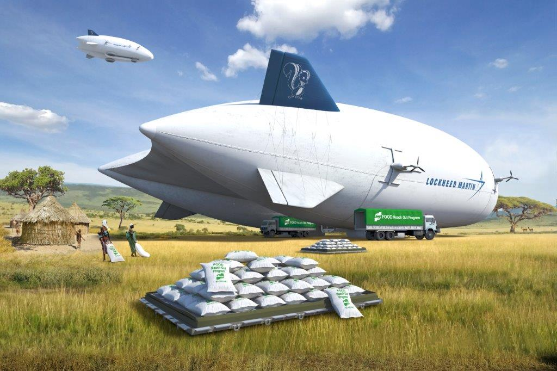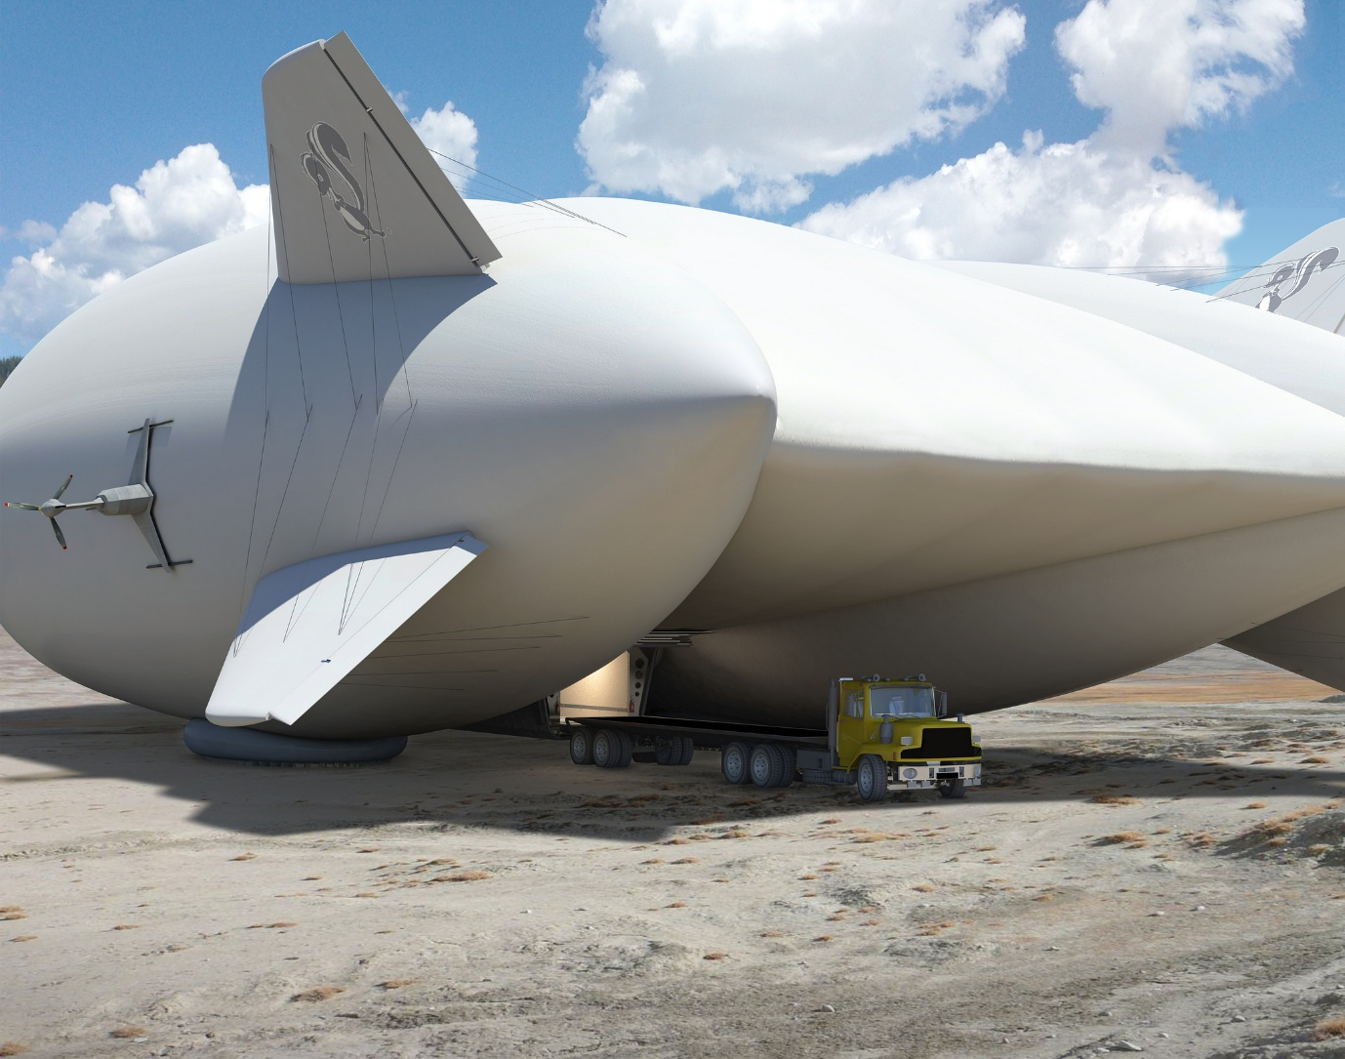

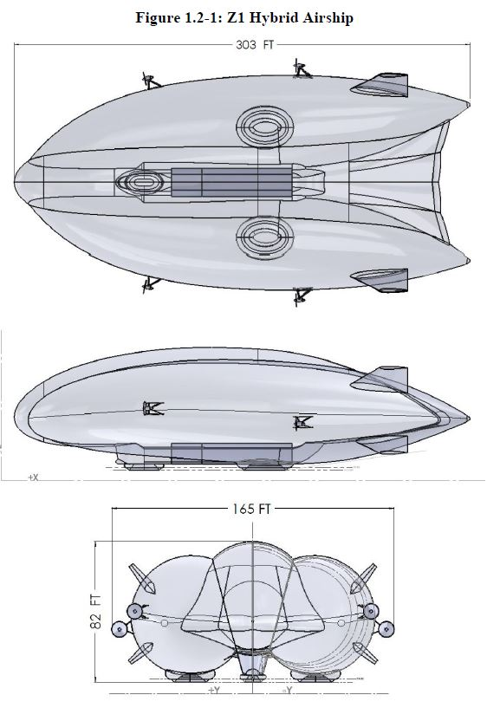

Z1 Hybrid Cargo Airship

