SAFE AND SECURE TRANSPORT OF SMALL MODULAR REACTORS FOR DEPLOYMENT IN NIGERIA
Nigeria is seriously considering the feasibility of deploying small modular reactors (SMRs) across its geopolitical zones in order to achieve the goal of energy sufficiency for the country. The rationale behind this decision is due to; the country’s low-capacity grid, cost considerations for the deployment of SMRs compare to the conventional nuclear power plants (NPPs) and other non-electrical power applications that Nigeria could benefit from the deployment of SMRs such as utilization of waste heat from nuclear reactors for industrial or district heating as well as water production.
Nigeria Atomic Energy Commission (NAEC) as the Nuclear Energy Programme Implementing Organization (NEPIO) saddled with the responsibility of coordinating Nigeria’s Nuclear Power Programme (NNPP) is currently developing Strategic Plan document for the development and deployment of SMRs in Nigeria.
Thus, the objective of the presentation is to address the safety and security requirements, robust regulatory framework and major challenges for safe and secure transport of SMRs development and deployment in Nigeria within the country’s national nuclear power roadmap framework.
It is expedient to note that the transportation of SMRs in a safe and secure manner in Nigeria will require careful planning, execution and compliance with international and national regulations as well as adherence to industry standards and guidelines for SMR security. Some of the key areas of focus to achieve safe and secure transport of SMRs for deployment in Nigeria are:
Safety Requirements
Perimeter Security: This can be achieved through the implementation of robust physical barriers and surveillance systems to prevent unauthorized access.
Insider Threats: To reduce insider threats, undertake extensive background checks and develop staff reliability programs.
Remote Monitoring: Enhancing security through the use of emerging technologies such as drones, AI-driven surveillance, and real-time monitoring systems.
Security Requirements
Transportation Security: Securing the transport of fuel, components, and reactor modules through advanced tracking and monitoring systems.
Cybersecurity: Strong firewalls, encryption, and intrusion detection systems are used to protect digital systems from cyber-attacks.
Safeguards by Design: This can be achieved by working with the reactor vendor by incorporating non-proliferation measures into reactor design, such as material accountancy and containment systems.
Major Challenges
Infrastructure: Ensuring the upgrade and expansion of the existing infrastructure to support the transportation and deployment of SMRs.
Regulatory Readiness: Developing a robust regulatory framework that can oversee the safe and secure deployment of SMRs.
Electric Grid Capacity: Nigeria's electric grid capacity is of low-capacity, hence the integration of SMRs into the existing grid infrastructure would be of immense benefit.
Financing and Funding: Securing funding for SMR projects is a significant challenge, and Nigeria may need to explore alternative financing options, such as public-private partnerships.
Coordination and Planning: SMR deployment needs coordinated planning at regional and national levels, which might be a little difficult due to Nigeria's decentralized system of government.
Public Acceptance: Addressing public concerns and educating communities about the benefits and risks of SMRs.
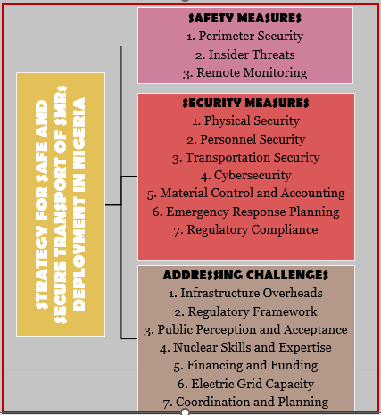
Figure 1: Strategy for Safe and Secure Transport of Small Modular Reactors in Nigeria
NAEC as the NEPIO can ensure safe and secure transport of SMRs deployment by addressing the major challenges and implementing robust safety and security measures in order for the country to harness the enormous potential of SMRs to meet its energy needs while ensuring the safety and security of its citizens.

