Effective Collaboration and Challenges among Key Stakeholders in the Safe and Secure Transportation of Radioactive Materials in Ghana
Gustav Gbeddy, Yaw Adjei-Kyereme, Eric T. Glover, Paul Essel, Evans Ameho, Emmanuel Aberikae
Ghana Atomic Energy Commission, Radiation Protection Institute, P.O.Box LG80, Legon, Ghana
Synopsis
The successful transportation of radioactive materials from the port of entry to the end users and vice versa is a highly regulated and technical process which involves key stakeholders to ensure safety and security. This paper is aimed at highlighting how the presence of effective collaboration among key stakeholders has aided the transportation of radioactive materials, the challenges encountered and the way forward. The key stakeholders include the Nuclear Regulatory Authority, Licensed Carriers, Consignees, the Radioactive Waste Management Centre (RWMC), the Police Service, Fire Service and other emergency service providers. These stakeholders have work collaboratively in ensuring the safe and secured transportation of all radioactive materials in Ghana. Two transport and logistics companies with varying carrying capacities have been licensed by the Regulator for inland transport of radioactive materials. The ends user applies to the Regulator for the relevant authorization and permit to import, export and use radioactive material and upon meeting the stringent regulatory requirements based on the category of the radioactive material involved the permit is then issued. The end user then contacts a licensed carrier and the RWMC depending on where the material will be stored. The RWMC plays an important role in the provision of radiation safety assessment, decommissioning, uninstallation of mounted radioactive devices, storage and permanent management of decommissioned radioactive materials or devices. A graded approach is used in the provision of security during and after the transport process. For category 1 and 2 radioactive materials, a police escort with all the necessary emergency protocols are deployed. A briefing session is normally held before commencement of operations and prior to the movement of the packaged material in the special purpose transport vehicle with relevant radiation protection protocols fully in place. The effective collaboration among key stakeholders has been demonstrated on a number of occasions as shown in the Figures below during the transport of category 1 and 2 sources.
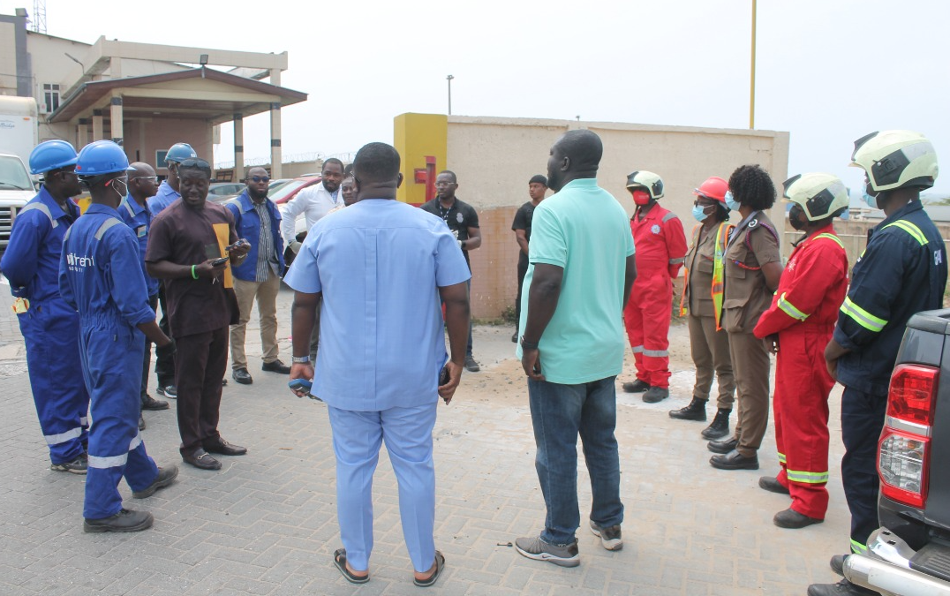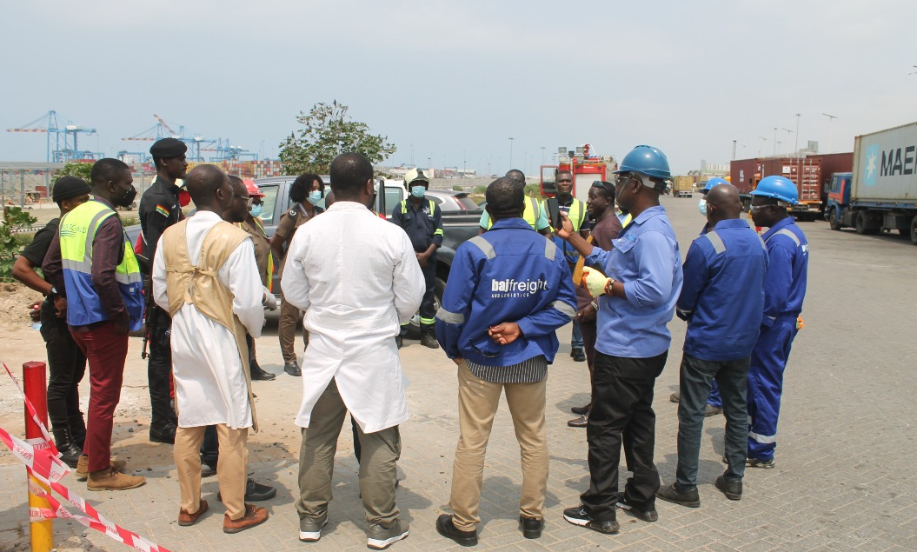
Fig. 1: Operational briefing session for all stakeholders during the retrieval and transportation of category 2 disused source from a Gamma Scanning Facility at Tema Harbour, Ghana

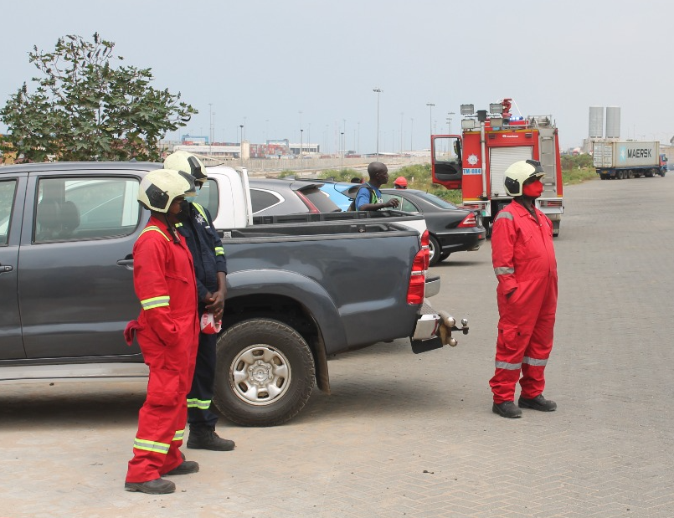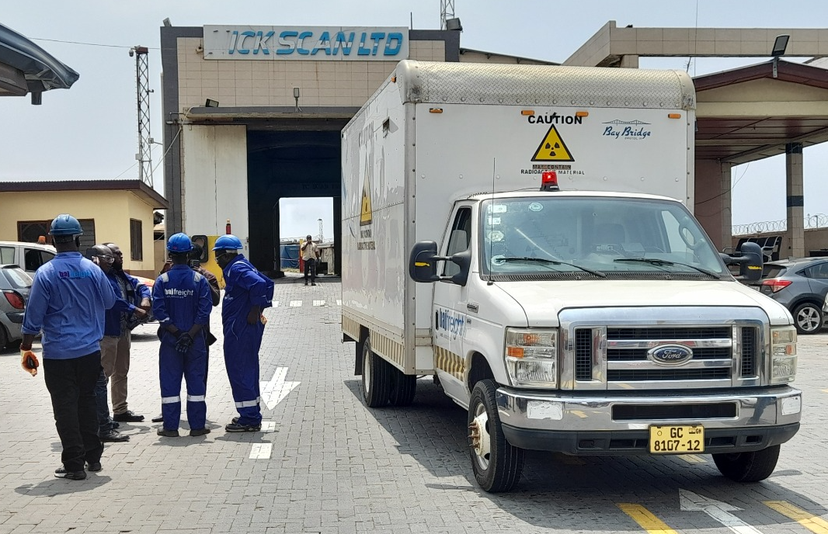
Fig. 2: Emergency Fire service on standby during the retrieval and transportation of category 2 disused source from a Gamma Scanning Facility at Tema Harbour, Ghana

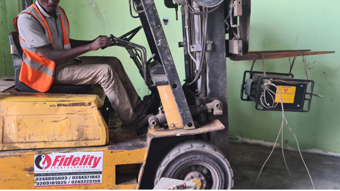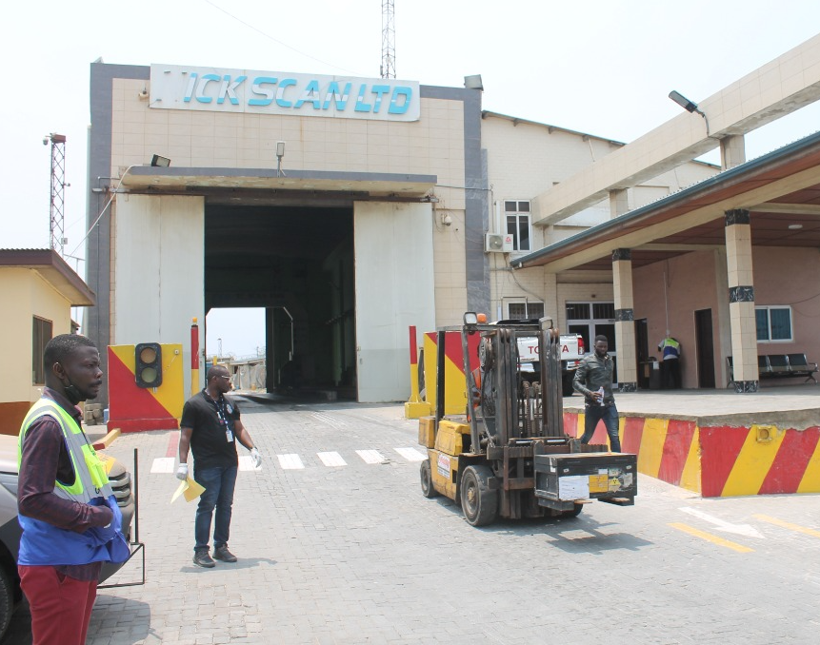
a
b
Fig. 3: Fork lifting of Co-60 device into transport packaging (a); transporting source in Type B(U) transport package (b)

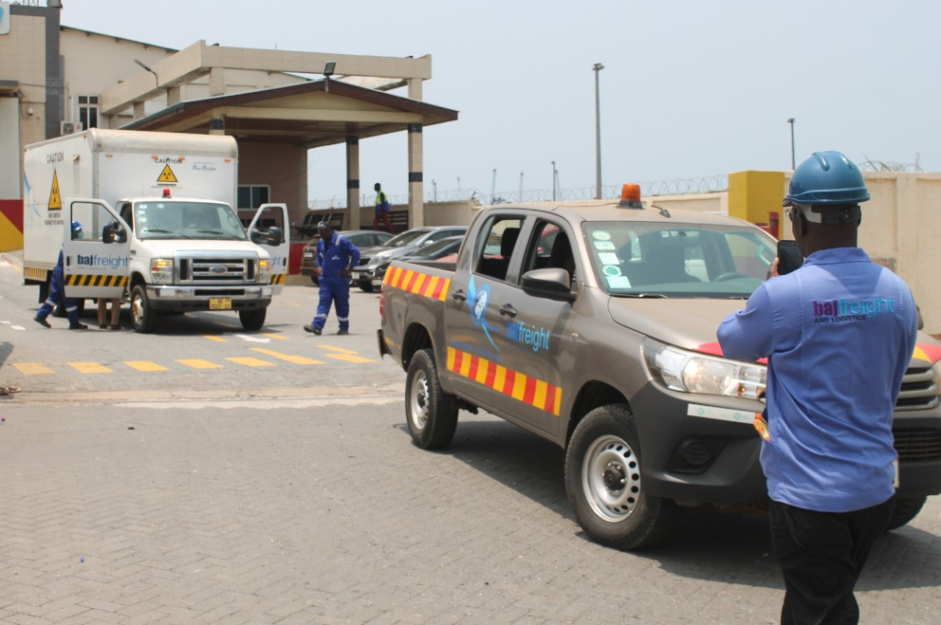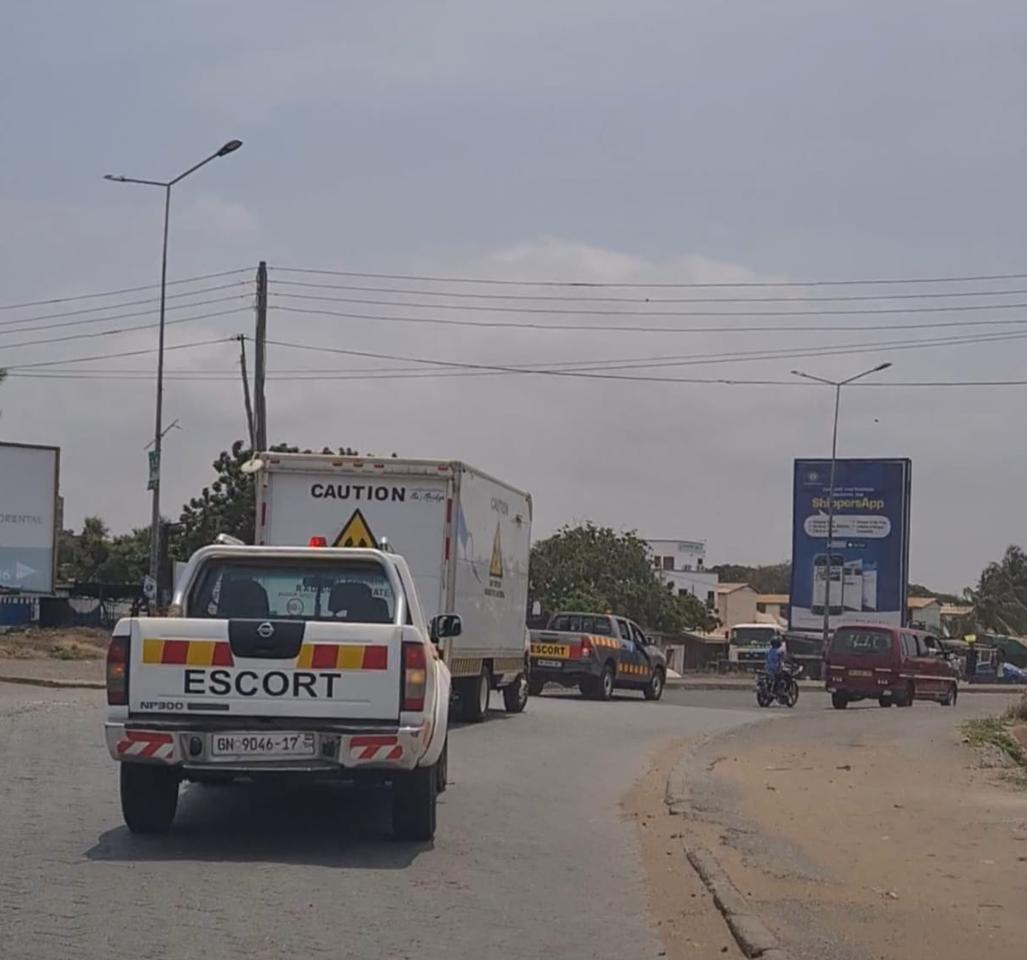
Fig. 4: Police escort transport of Category 2 disused Co-60 device from Tema Harbour to GAEC, Kwabenya
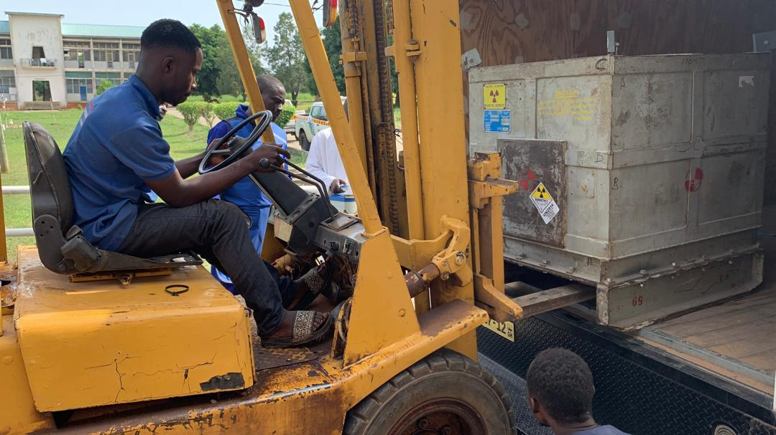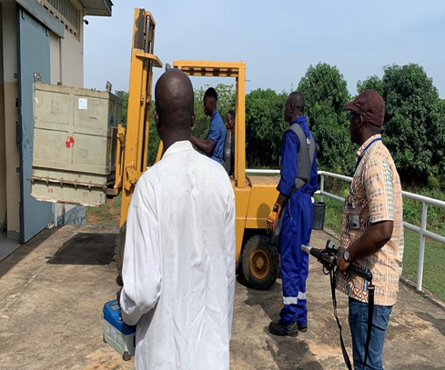
Fig. 5: Receipt and removal of disused Cat. 2 Co-60 teletherapy source package from the transport vehicle to the Radioactive Waste Management Facility at GAEC, Kwabenya for temporary storage

Although stakeholder collaboration in the transport of radioactive materials has been very effective in Ghana, a major challenge entails delays in contracting a flight carrier for the transport of disused radioactive materials for refilling for NDT applications. Secondly, the high fees and charges by the carriers, licensed transport and logistics companies to transport these class 7 hazardous materials imposes significant financial responsibility on the end user leading to delayed operations. The provision of a special purpose transport vehicle for radioactive material to RWMC via donor support will help reduce the cost of transportation drastically. Finally, the timeframe for obtaining the requisite authorization and permits from the competent authority can be frustrating especially if it affects the arrangement with the carriers particularly by flight. However, these challenges are been addressed to guarantee the provision of safe, secure and sustainable transport of radioactive materials in Ghana.

