A Numerical Framework for Calculating Fuel Damage Ratio in Horizontal Drop Accidents of SNF Transport Packages

Sanghoon Lee∗, and Seyeon Kim
Keimyung University, 1095 Dalgubeol-daero, Dalseo-gu, Daegu 42601, Republic of Korea
* Presenting and corresponding author, shlee1222@kmu.ac.kr

To assess the risks associated with spent nuclear fuel (SNF) transportation, it is essential to calculate the fuel damage ratio (FDR) of SNF rods loaded in transport casks. Owing to the geometric and material complexity of SNF, modeling the detailed behavior of every fuel rod and assembly within a single cask is impractical. This study therefore proposes a systematic methodology for calculating the FDR using simplified representations of nuclear fuel rods and assemblies optimized for failure analysis.
Three primary failure modes of SNF rods have been reported in the literature: (i) transverse tearing under bending (mode I), (ii) transverse tearing induced by bending and defects (mode II), and (iii) longitudinal tearing due to pinch loads and defects (model III). The present work develops a numerical methodology that addresses all three modes, incorporating reported or suggested failure criteria for each. Particular emphasis is placed on evaluating mode III failure under pinch loading.
First, a simplified fuel rod model was developed to reproduce failure behavior using through-thickness membrane plus bending stresses of the cladding as the failure criterion. The rod was modeled as a hollow beam of identical diameter to the actual fuel rod, with material properties and cross-sectional characteristics calibrated to reproduce the moment–deflection response of a detailed rod model. A stress correction factor was introduced to account for stress concentrations arising from pellet–clad interaction (PCI).
Second, a detailed model of a CE 16×16 fuel assembly was constructed using the simplified fuel rod model. This assembly was subsequently reduced to cuboid representations with identical external dimensions. The equivalent material properties of these cuboids, corresponding to fuel rod and spacer grid sections, were derived from compression, shear, and torsion analyses of the detailed model. The validity of the simplified assembly was confirmed by comparing key structural responses, such as impact accelerations, against those of the detailed model under drop conditions.
A post-processing script was then developed to extract maximum contact forces on individual fuel rods during impact events, thereby determining pinch loads. These loads were compared with a provisional pinch load failure criterion for FDR evaluation. Since the criterion for fuel rod failure under pinch loads remains under investigation, a new numerical approach is presented that derives this criterion from image-based finite element modeling with continuum damage mechanics. This approach enables explicit assessment of the influence of hydrides within SNF cladding on fracture resistance, and in particular, facilitates the evaluation of uncertainties arising from hydride morphology.
Fuel rod failure due to bending loads was evaluated based on calculated stress values from beam elements, which were compared against the membrane plus bending stress failure criterion to determine the FDR.
This methodology provides an efficient and reliable approach for assessing SNF rod failure in transportation scenarios, reducing computational complexity while maintaining accuracy in structural response predictions.

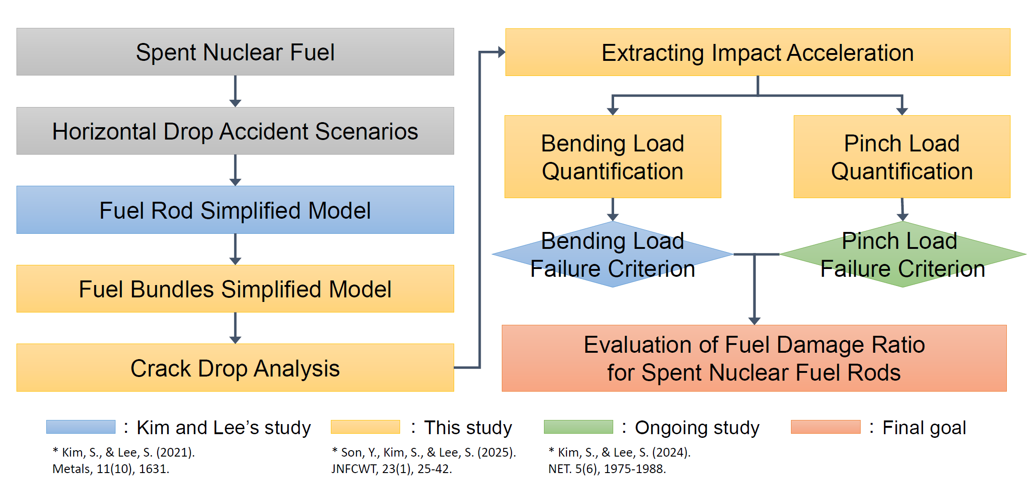
Figure 1. Proposed numerical framework for calculating the fuel damage ratio under horizontal impact

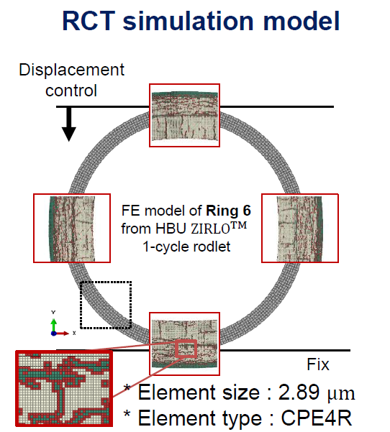 | 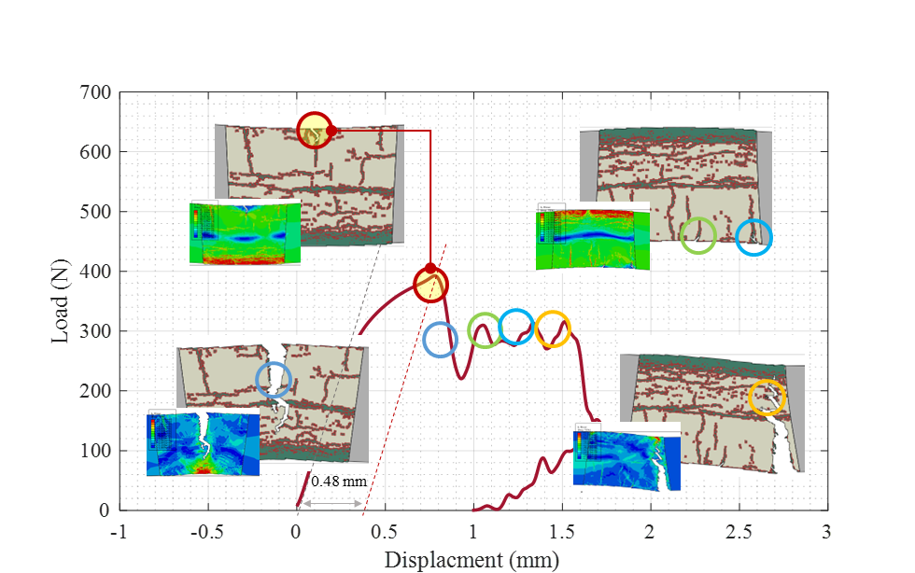
- Ring compression test (RCT) simulation model | - Simulation of Zirlo cladding failure under RCT with radially oriented hydrides
Figure 2. Developed image based finite element model for simulating the cladding behavior under RCT

References
[1] S. Kim and S. Lee, “Simplified Model of a High Burnup Spent Nuclear Fuel Rod under Lateral Impact Considering a Stress-Based Failure Criterion,” Metals (Basel), vol. 11, no. 10, p. 1631, 2021.
[2] Y. Son, S. Kim, and S. Lee, “A Framework for Fuel Damage Ratio Calculation in Spent Nuclear Fuel Transportation,” Journal of Nuclear Fuel Cycle and Waste Technology, vol. 23, no. 1, pp. 25–42, Mar. 2025, doi: 10.7733/JNFCWT.2025.004.
[3] S. Kim and S. Lee "Methodology for numerical evaluation of fracture resistance under pinch loading of spent nuclear fuel cladding containing reoriented hydrides" Nuclear Engineering and Technology 56.6 (2024): 1975-1988.

