Advancing Safety and Security by Design through the Development of RadSecure Mover for the Transport of Radioactive Material in Indonesia

Background
Indonesia’s nuclear energy programme is entering a decisive stage with the planned commissioning of its first nuclear power plant (NPP) by 2032. This milestone will inevitably increase the demand for the safe and secure transport of nuclear and radioactive materials, spanning medical isotopes, research reactor fuel, radioactive sources, and ultimately nuclear fuel cycle materials. Transport is widely recognized as one of the most sensitive links in the nuclear infrastructure chain: every shipment must guarantee both safety in preventing accidents, radiation exposure, and environmental contamination and security in protecting against theft, sabotage, or malicious acts.
At present, Indonesia lacks purpose-built transport vehicles for radioactive materials. Current practice relies on modified commercial trucks, which are only minimally adapted to international and national requirements. Such reliance introduces vulnerabilities: insufficient radiation shielding for high-activity sources, limited structural resilience, and the absence of integrated physical protection systems. These deficiencies stand in contrast with international benchmarks such as IAEA SSR-6 (Rev.1) for transport safety and the IAEA Nuclear Security Series No. 9-G (Rev.1) for transport security. Without dedicated transport infrastructure, Indonesia risks operational and regulatory gaps as it scales up nuclear activities in parallel with its energy transition.
The RadSecure Mover was developed to directly address this infrastructure gap. It represents Indonesia’s first industrial design intellectual property dedicated to radioactive material transport, combining nuclear safety and security functions in a unified vehicle platform. By embedding multilayer shielding, ergonomic access controls, integrated monitoring, and internationally compliant hazard communication into its exterior and functional design, the RadSecure Mover sets a precedent for safety–security by design, rather than relying on retrofitted commercial vehicles.
Design Strategies
The RadSecure Mover introduces a number of innovations that align with international and national requirements:
- Cabin as Command Centre: Aerodynamic yet protective design with reinforced structures, CCTV monitoring, and integrated communication systems, functioning as a mobile command and control unit in line with the principle of defence-in-depth.
- Shielded Cargo Space: Multilayer gamma and neutron shielding integrated into the vehicle’s structural body, with protective diagonal contours and chamfered rear roof for both structural resilience and aerodynamic efficiency.
- Controlled Access: Dual entry design (side access for inspection and top-loading for secure container handling) to improve operational flexibility while ensuring controlled access in compliance with regulations.
- Integrated Hydraulic Crane: Centrally positioned crane for balanced loading/unloading, hazard-coloured for visibility, and fully integrated with the body design to prevent external vulnerabilities.
- Safety–Security Visual Identity: Internationally compliant hazard colours (radiation yellow, trefoil symbols, hazard orange), reflective hazard lines, and clear “RadSecure Mover” branding, enhancing both hazard communication and rapid recognition by authorities.

Implementation and Validation
The RadSecure Mover has been formally submitted and accepted as an industrial design intellectual property in Indonesia, highlighting its novelty and technical uniqueness. To move from concept to validated system, the next stage emphasizes simulation-based modelling, ensuring that safety and security performance can be demonstrated before prototyping and certification. The modelling approach follows a stepwise logic, connecting radiation physics, accident scenarios, geographical context, and operational response into one integrated framework:
- Shielding validation with PHITS: Using the Particle and Heavy Ion Transport code System (PHITS), the design’s multilayer shielding will be assessed for both gamma and neutron emitters. This produces dose-rate envelopes under realistic loading conditions, demonstrating compliance with IAEA SSR-6 limits and national BAPETEN requirements.
- Accident release scenarios with ALOHA: Building on PHITS results, conservative accident or sabotage scenarios will be modelled using atmospheric dispersion tools - ALOHA. These provide what-if plume predictions, showing potential public exposure pathways if containment were compromised.
- Geospatial risk mapping with QGIS: Dispersion outputs and transport routes will then be overlaid on national maps using QGIS. By integrating population density, hospitals, police stations, and sensitive facilities, this step identifies high-risk zones, emergency response nodes, and standoff requirements along actual Indonesian transport corridors.
- Response performance with SimPy: Finally, discrete-event modelling will simulate the time-critical process from incident detection to resolution. Variables such as detection speed, responder distance, traffic congestion, and escort availability are tested to calculate time-to-safe-state and cumulative dose to responders and the public under different scenarios.
Through this integrated simulation chain, the RadSecure Mover moves beyond static design to become a validated safety–security system, linking physical shielding performance, accident consequences, geographical context, and human response capacity into one coherent framework

Relevance and Novelty
The RadSecure Mover is Indonesia’s first dedicated radioactive material transport vehicle, bridging a critical infrastructure gap ahead of NPP deployment. Its novelty lies in the integrated application of safety-by-design and security-by-design principles within a single transport system, rather than treating these as add-ons to commercial vehicles. By combining physical protection, radiation shielding, ergonomic handling, and visible hazard communication, it establishes a model for transport resilience that supports regulatory compliance and public confidence.
Beyond Indonesia, the RadSecure Mover offers a replicable model for newcomer countries facing similar readiness challenges. With further development through simulation validation and future prototyping, RadSecure Mover can become a benchmark for safety and security by design in radioactive material transport, directly supporting the IAEA’s goals of strengthening resilience, compliance, and innovation in transport systems.
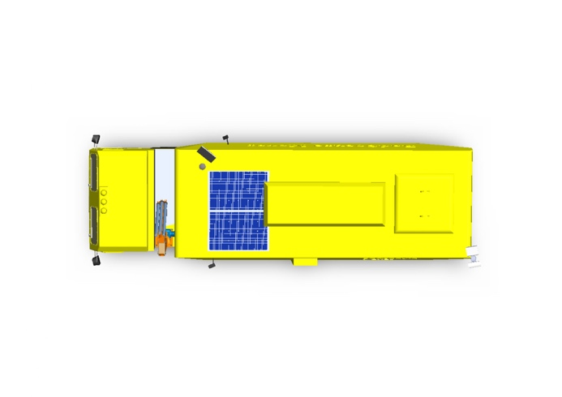 | 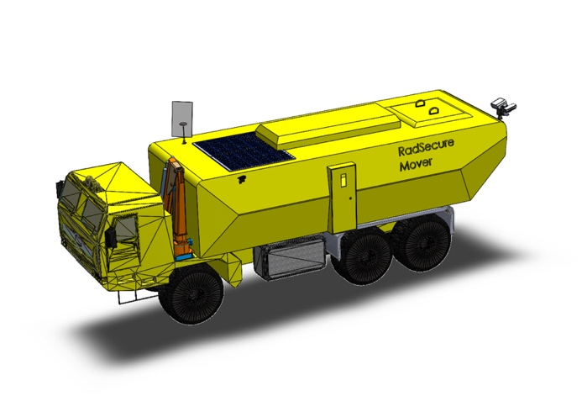
Figure 1. RadSecure Mover – Top View, illustrating the auxiliary solar panels, CCTV monitoring, and integrated communication systems, and top-loading access door designed for secure container handling and operational efficiency. | Figure 2. RadSecure Mover – Isometric View, integrating the cabin, shielded cargo space, and centrally positioned hydraulic crane to demonstrate safety- and security-by-design as a unified concept rather than retrofitted features.
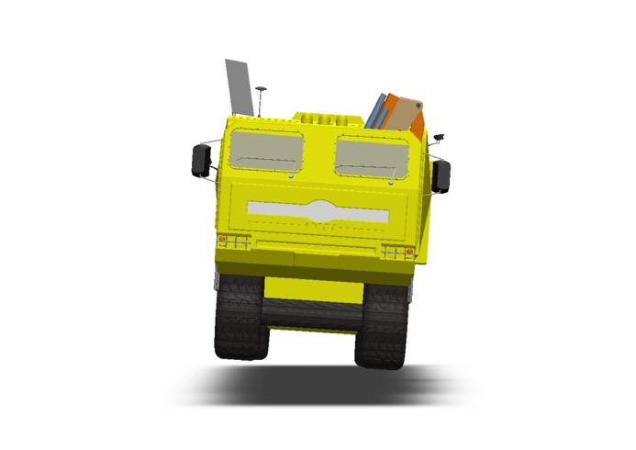 | 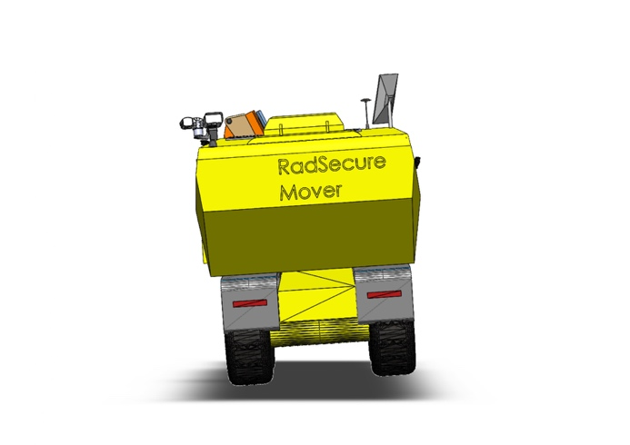
Figure 3. RadSecure Mover – Front View, showing an aerodynamic yet reinforced driver’s cabin designed as a mobile command-and-control unit with slanted windshield, reinforced pillars, and integrated monitoring systems. | Figure 4. RadSecure Mover – Rear View, featuring a chamfered roof contour for structural strength and aerodynamics.
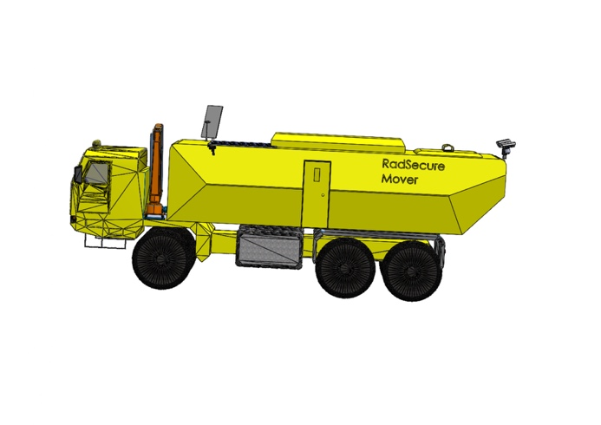 | 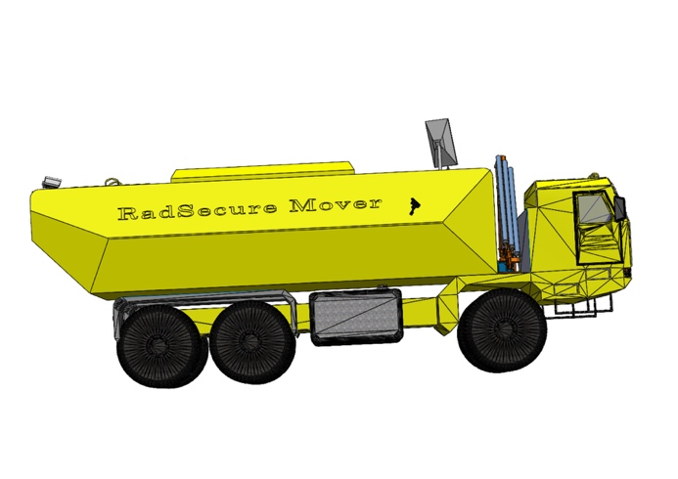
Figure 5. RadSecure Mover – Right Side View, highlighting the protective diagonal contour and side access door for inspection and controlled partial unloading in compliance with transport regulations. | Figure 6. RadSecure Mover – Left Side View, displaying hazard-colored protective lines, reflective strips for nighttime visibility, and strategically placed radiation trefoil symbols for hazard communication.

