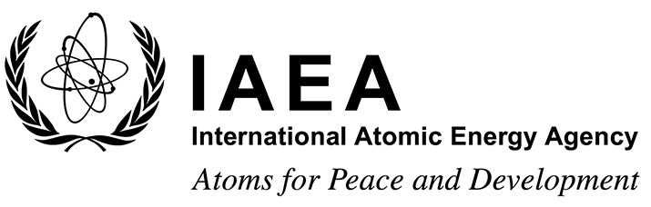 |  |  | Form C  EVT2304553
Grant Application Form

Technical Meeting on Tritium Breeding Blankets and Associated Neutronics
IAEA Headquarters, Vienna, Austria
01 April – 04 April 2025
To be completed by the participant and sent to the competent national authority (e.g. Ministry of Foreign Affairs, Permanent Mission to the IAEA, or National Atomic Energy Authority) of his/her country for subsequent transmission to the International Atomic Energy Agency (IAEA) either by email to: Official.Mail@iaea.org or by fax to: +43 1 26007 (no hard copies needed). Please also send a copy by email to the Scientific Secretary, Mr Ryan Wagner, Division of Nuclear Power, Department of Nuclear Energy (Email: R.Wagner@iaea.org) and to the Administrative Secretary, Ms M. Nicole Cordova Jurak, (Email: M.N.Cordova-Jurak@iaea.org).
Deadline for receipt by IAEA through official channels 03 February 2025
Family name(s): (same as in passport) |  |  |  | First name(s): (same as in passport) |  |  | Mr/Ms:
Mailing address: |  |  |  |  | Tel.:
 |  |  |  |  | Fax:
 |  |  |  |  | Email:
Date of birth (yyyy/mm/dd): |  |  |  |  | Nationality:
I plan to attend virtually: |  |  |  |  | Yes No
- Education (post-secondary):

Name and place of institution |  | Field of study |  |  | Diploma or Degree | Years attended  from to
- Recent employment record (starting with your present post):

Name and place of employer/ organization |  | Title of your position |  |  | Type of work | Years attended  from to
- Description of work performed over the last three years:

- Institute’s/Member State’s programme in field of event:

Date: ___________________ | Signature of applicant: ___________________________
Date: ___________________ | Name, signature and stamp of Ministry of Foreign Affairs, Permanent Mission to the IAEA or National Atomic Energy Authority  _________________________________________

