# conference pre-print

# SAFETY REGULATION OF FUSION FACILITIES IN THE RUSSIAN FEDERATION

M. POLIANSKII, A. KURYNDIN, S. SINEGRIBOV, A. KIRKIN, A. SMIRNOV

Scientific and Engineering Centre for Nuclear and Radiation Safety (SEC NRS)

Moscow, Russian Federation

Email: polyanskiy@secnrs.ru

**Abstract**

The paper presents the latest developments in establishing a safety regulation framework for fusion facilities in the Russian Federation. This includes legislative amendments governing atomic energy use and the formulation of federal rules and regulations (FRRs) to ensure the safety of fusion facilities, as well as the protection of personnel, the public, and the environment from potential radiation hazards. These requirements will become legally binding during the design, safety justification, and operation of both future fusion facilities and existing installations classified as nuclear facilities. The document also outlines proposed terminology, definitions, and a graded regulatory approach to impose additional safety standards on fusion and hybrid systems with elevated hazard potential.

At present, the issues of ensuring the safety of new types of nuclear installations, fusion and hybrid systems are not sufficiently regulated in the regulatory legal framework of the Russian Federation. Under Federal Law No. 170-FZ [1], regulated entities include nuclear installations (systems containing nuclear materials e.g., structures with reactors, critical/subcritical test facilities, reprocessing installations) and radiation sources (systems containing radioactive substances or generating ionizing radiation, independent of nuclear installations).

Fusion reactors and facilities exhibit hazards analogous to conventional nuclear installations and radiation sources, such as ionizing radiation, radioactive waste generation, and atmospheric releases. Certain radiation characteristics of fusion facilities (FFs) may align with those of large-scale nuclear facilities. Unique risks associated with FFs include tritium accumulation in structural components, tritium/dust releases, electromagnet quench events (loss of superconductivity), cryogenic hazards, electromagnetic fields, and the use of toxic substances.

Analysis of the existing regulatory framework identified the optimal approach: integrating FFs into current nuclear facility classifications under Russian law and developing new FRRs tailored to fusion and hybrid systems. Legislative amendments are proposed to enable this integration.

The cornerstone of this effort is the federal law “On Amendments to Article 3 of the Federal Law ‘On the Use of Atomic Energy’” [2], which was adopted [3] on 31 July 2025 with enactment on 1 January 2027. The Law [3] provides for the possibility to enable the classification of fusion facilities as either “nuclear installations” or “radiation sources”. High-intensity FFs, hybrid systems incorporating nuclear materials (e.g., blankets with fissile substances), as well as D-T FFs will qualify as “nuclear installations”. Experimental plasma devices with low neutron intensity or a small amount of radioactive inventory will qualify as “radiation sources”.

In accordance with the Law [3], the criteria for categorizing facilities and basic safety requirements should be established in the FRR. Proposals for four foundational FRRs are under development, including the “General Safety Provisions for Fusion Facilities” (GSP FF), which will establish the main most significant safety requirements. The requirements included in the draft of the first version of the GSP FF are rather technology neutral and have been developed on the basis of the requirements for other nuclear facilities:

* nuclear power plants [4];
* nuclear research reactors [5];
* radiation sources [6].

GSP FF establish requirements in terms of:

* basic safety criteria and principles realized in the design of the FF and its systems;
* compliance with the established limits of radiation doses to personnel and the public, norms of releases and discharges of radioactive substances during normal operation and abnormal operation, including design basis accidents;
* limitation of radiation impact on personnel, population and environment in case of beyond design basis accidents;
* ensuring the required quality of systems (elements) and work performed;
* conducting safety analyses;
* the scope of justification and operational documentation;
* measures to protect personnel and the public, and instructions in case of accidents;
* commissioning and decommissioning of FF;
* management of technological processes.

As outlined in the draft GSP FF, the core design principle is the application of defense in depth (DiD). This approach establishes DiD levels, sets requirements for physical barriers to prevent the release of radioactive substances and ionizing radiation, and specifies necessary technical and organizational measures to ensure these barriers remain effective.

The GSP FF introduces a graded approach to regulating FF safety, based on hazard factors and risk levels associated with FF characteristics, as well as the use of different technologies, materials, and substances. Additional safety requirements will be specified in FF safety data sheets for facilities where the following activities are planned:

* use of nuclear materials (e.g., in hybrid FF blankets) – due to the risk of criticality events;
* operation of high-intensity fusion devices – leading to continuous neutron irradiation of structural materials, significant activated dust generation, and accelerated degradation of systems and components due to damaging factors (ionizing radiation, high heat fluxes, flooding, electromagnetic radiation, etc.);
* use of tritium and/or other special non-nuclear materials for tritium production – requiring strict inventory control and accounting, given tritium’s high permeability and the potential formation of tritiated water and organic tritium compounds.

For implementation of the graded approach to regulating FF safety it is planned to use the classification, which can be seen below Fig. 1 and 2. Regulation of the safety of FFs that do not meet the criteria set out in the GSP FF is carried out in accordance with the provisions of Federal Law No. 99-FZ [7].

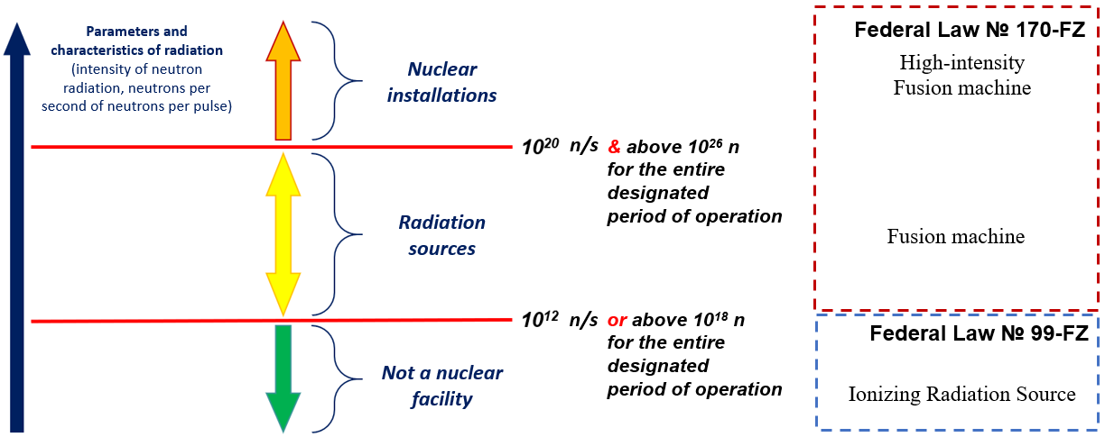

*FIG. 1. Criteria on Neutron Intensity.*

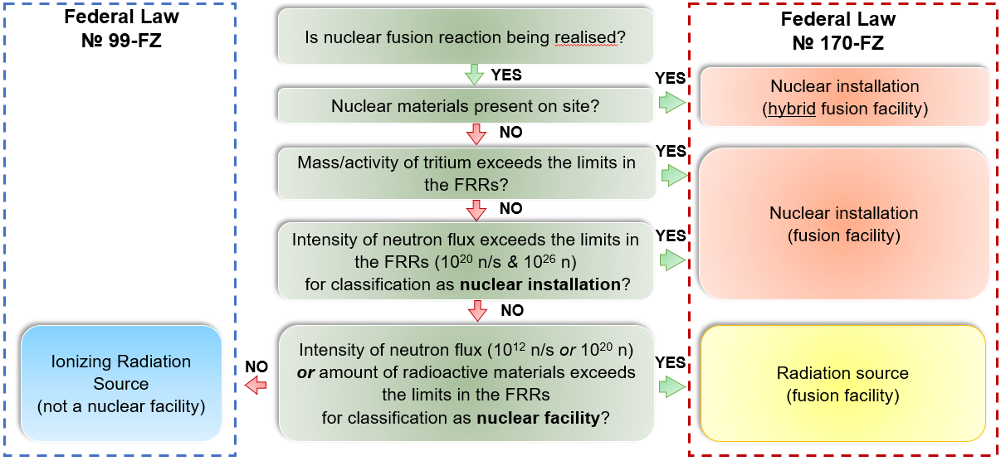

*FIG. 2. Classification scheme of Fusion Facilities.*

Additional safety requirements will be set for Fusion Facilities based on hazard factors and risk levels associated with facility characteristics, as well as the use of different technologies, materials, and substances, see Table 1.

TABLE 1. ADDITIONAL REQUIREMENTS FOR FUSION FACILITIES CLASSIFIED AS A NUCLEAR INSTALLATION

|  |  |
| --- | --- |
| **Criteria for classification  as a nuclear installation** | **Additional requirements** |
| Tritium usage | * for tritium-containing systems and components in the rooms where they are located * to control of discharges of radioactive substances * to minimize the accumulation of tritium in materials * to limit the release of radioactive substances, including in case of accidents * for accounting and control of Special Non-Nuclear Materials (including 3H, 6Li)  in the State System for Accounting and Control |
| Nuclear materials (NMs) usage  (238U, 232Th, etc.) | * for systems and components, including for the containment of NMs within established boundaries * for the means of exclusion of criticality * for heat removal systems (from blankets with NMs) * to control of neutron flux density in the blankets * for accounting and control of NMs * for handling systems and storages of NMs |
| High-intensity Fusion machine | * to control of the fusion reaction * for protection safety systems * to the probabilistic safety analysis, reliability analysis * for chemistry regimes of the media in the FFs systems and components * to develop of action plans for protection of the personnel and the public in case of accidents * for accident management * to the personnel training |

The GSP FF further introduces a classification of FF system elements based on their purpose, influence on safety, and the nature of the safety functions they perform. For systems fulfilling fundamental safety functions (such as protection, control, containment, and support) the GSP FF outlines core design and operational principles. Additionally, it standardizes key terms and definitions for FF safety regulation, drawing from the published Glossary [8].

Currently, alongside advancements in fusion technology, significant efforts are underway to expand the atomic energy safety regulatory framework, integrating FF into Russian legislation. The primary objectives for FF safety regulation in the Russian Federation include legislative updates and development of FRRs defining safety requirements for fusion and hybrid systems.

These initiatives are being actively advanced through collaboration among regulatory bodies, nuclear industry stakeholders, and organizations contributing to the federal project "Thermonuclear Energy Technologies".

Development of Federal rules and regulations in the field of atomic energy use for fusion facilities is important step for providing high level of safety. Development of approaches to safety regulation in the Russian Federation is based on international approaches as well as accumulated experience in regulating safety of NPPs, research reactors and radioactive sources. Close interaction with design and operation organizations of fusion facilities is also one of the key elements of the effective regulatory framework development.

References

1. Federal Law of the Russian Federation of November 21, 1995 No. 170-FZ “On the Use of Atomic Energy”  
   (<http://www.kremlin.ru/acts/bank/8503>).
2. Draft Federal Law No. 835243-8 “On Amending Article 3 of the Federal Law ‘On the Use of Atomic Energy’”   
   (in terms of regulating the safety of fusion reactors and facilities) (<https://sozd.duma.gov.ru/bill/835243-8>).
3. Federal Law of the Russian Federation of July 31, 2025 No. 342-FZ “On Amending Article 3 of the Federal Law   
   ‘On the Use of Atomic Energy’” (<http://www.kremlin.ru/acts/bank/52293>).
4. Federal rules and regulations in the area of nuclear energy use “General provisions for nuclear power plant safety assurance" NP-001-15 ([https://docs.secnrs.ru/catalog/FNP/NP_001_15/#](https://docs.secnrs.ru/catalog/FNP/NP_001_15/)).
5. Federal rules and regulations in the area of nuclear energy use "General safety provisions of nuclear research installations" NP-033-11 ([https://docs.secnrs.ru/catalog/FNP/NP_033_11/#](https://docs.secnrs.ru/catalog/FNP/NP_033_11/)).
6. Federal rules and regulations in the field of atomic energy use "General provisions of safety assurance for radioactive sources" NP-038-16 ([https://docs.secnrs.ru/catalog/FNP/NP_038_16/#](https://docs.secnrs.ru/catalog/FNP/NP_038_16/)).
7. Federal Law of the Russian Federation of May 4, 2011 No. 99-FZ “On Licensing of Certain Types of Activity” (<http://www.kremlin.ru/acts/bank/33139>).
8. Fusion facilities. Glossary. First edition

(<https://docs.secnrs.ru/catalog/works/Ustanovki_upravlyaemogo_termoyadernogo_sinteza_Glossariy_pervaya_redaktsiya/>).