# conference pre-print

# Gyrokinetic analysis for Fast Ion Effects on electron scale turbulence in kstar fire mode discharge

D. Kim1, S.J. Park2, N.T. Howard3, B.J. Kang4, G.J. Choi1, Y.W. Cho5, J. Kang6, H. Han7, J. Candy8, E.A. Belli8, T.S. Hahm2, Y.-S. Na2, C. Sung1*

1Korea Advanced Institute of Science and Technology, Daejeon, Republic of Korea

2Seoul National University, Seoul, Republic of Korea

3Massachusetts Institute of Technology, Cambridge, USA

4National Institute for Fusion Science, Nagoya, Japan

5Nanyang Technological University, Singapore, Singapore

6Tokamak Energy, Oxfordshire, UK

7Korea Institute of Fusion Energy, Daejeon, Republic of Korea

8General Atomics, San Diego, CA, USA

*Email: choongkisung@kaist.ac.kr

**Abstract**

The gyrokinetic analysis was performed to investigate the fast ion effects on electron scale turbulence in the KSTAR FIRE mode internal transport barrier (ITB) region. The gyrokinetic simulations focused on $k_{y}ρ_{s}≤60$ and minimum $k_{y}ρ_{s}=3$, where $k_{y}$ and $ρ_{s}$ are poloidal wave number and ion gyro radius, respectively. The gyrokinetic simulation predicted a significant energy flux reduction when fast ions were included. The impacts of several turbulence suppression mechanisms were investigated, including increased pressure gradient and dilution effects. It was found that electron scale turbulence was mainly suppressed by the effect of increased pressure gradient. In addition, the multi scale simulation with $k_{y}ρ_{s}≤12.8$ showed an energy flux reduction for whole simulated $k_{y}ρ_{s}$ range when fast ions were included, consistent with turbulence suppression observed in the single scale simulations.

# INTRODUCTION

Fast ion species such as fusion-born α particles is a key issue in the future magnetically confined fusion plasma. These fast ions will not only contribute to a significant fraction of plasma heating but also play an active role in turbulence dynamics as they interact with background micro-instabilities[1,2] by increasing pressure gradient[3], dilution[4], changing the shearing rate[5], and destabilizing the fast ion driven instability[6]. Therefore, understanding the impact of fast ions on turbulence is essential for optimizing the performance of future fusion plasmas**.**

Internal transport barrier (ITB) operation[7] is an alternative improved confinement regime compared to conventional H-mode, but without edge localized modes, which can cause periodic particle and energy bursts at the plasma edge and lead to severe damage to the wall[8]. However, detailed physical mechanisms responsible for ITB formation are still open questions. Recently, it has been reported that turbulence suppression by fast ions can play an important role in the formation of ITB[9–12], suggesting a broader impact of fast ion physics on advanced confinement regimes.

In KSTAR, the fast ion regulated enhancement (FIRE) mode[10,11,13] has been observed, where the high fast ion fractions were correlated well with ITB location. The gyrokinetic simulations show a significant energy flux reduction when fast ions were included. Previous studies have reported that ion scale turbulence was significantly suppressed due to dilution effects by the addition of fast ions[14].

Most studies investigating fast ion effects on turbulence have focused on ion scale turbulence[3,4,6,14]. Although electron scale turbulence has received much less attention, it is known that electron scale turbulence can degrade confinement by increasing electron transport[15] and coupling with ion scale turbulence[16]. A comprehensive understanding of turbulence regulation thus requires clarifying whether and how fast ions can affect electron scale turbulence. While ion scale turbulence suppression has been governed mainly by dilution effects[14] in KSTAR FIRE mode, it remains an open question whether the same holds true for the electron scale turbulence.

Therefore, in this study, we investigate the impact of fast ions on electron scale turbulence in KSTAR FIRE mode plasmas through the gyrokinetic simulations. In Section 2, gyrokinetic simulation setup and fast ion effects on electron scale turbulence through the various mechanisms, including increased pressure gradient and dilution, will be reported. Additionally, further investigation through the multi scale simulations will be discussed in Section 3. Finally, Section 4 will summarize the results and discuss the future work.

# Investigation of the electron scale turbulence suppression mechanism

## **Simulation Setup**

The gyrokinetic analysis was performed to investigate the fast ion effects on electron scale turbulence in KSTAR FIRE mode discharge (shot 22663, 5.35s) with experimental input parameters. By the local flux tube gyrokinetic simulation code, CGYRO[17], inside the ITB region ($ρ=0.4$) was focused, where $ρ$ is the square root of the normalized toroidal magnetic flux. The simulations focused on electron scale turbulence with $k_{y}ρ_{s}≤60$ and minimum $k_{y}ρ_{s}=3$ where $k_{y}$ and $ρ_{s}$ are poloidal wave number and ion gyro radius, respectively. Electromagnetic simulations including both perturbed electrostatic potential $δ\tilde{ϕ}$ and vector potential $δ{\tilde{A}}_{∥}$. The Miller equilibrium model[18] was used to consider the effects of experimental geometric parameters. Electrons were considered following the gyrokinetic equations. The collisions were treated with Sugama collision operators[19]. In addition, rotation, parallel rotation shearing, and $E×B$ shearing were included. Furthermore, a finite Debye length, which can affect electron scale turbulence, was considered. A flat effective charge $Z_{eff}(=Σ_{j}Z_{j}n_{j}^{2}/n_{e})$ profile was assumed with a single impurity species, carbon, where $Z_{j}$ is the charge of species $j$. Fast ions were treated as an additional ion species with a Maxwellian distribution[20], where fast ions were generated from neutral beam injection. In this study, the case with fast ions is based on experimental input profiles, while the case without fast ions assumes that the corresponding fast ion fraction is replaced by main ions.

## **Electron Scale Turbulence Suppression by Fast Ions**

The previous study reported that the addition of fast ions can affect the linear growth rate on $k_{y}ρ_{s}≤60$ [16]. In this section, the nonlinear gyrokinetic simulations were performed with focusing electron scale turbulence in $k_{y}ρ_{s}≤60$. Figure 1 shows the time series of gyroBohm normalized electron energy flux predicted by nonlinear gyrokinetic simulation, focusing on electron scale turbulence for the cases without fast ions and with fast ions. The energy flux was obtained by averaging the saturated phase. Here, $Q_{GB}$ is gyroBohm energy flux defined as $n_{e}T_{e}c_{s}{\left(ρ_{s}/a\right)}^{2}$ where $c_{s}$ and $a$ are ion sound speed and minor radius, respectively. The gyrokinetic simulation results show a significant electron energy flux reduction when fast ions were included.

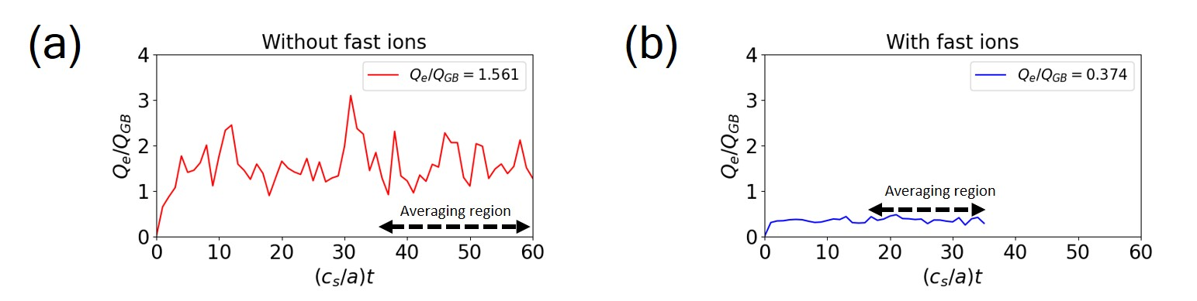

Figure 1. The time series of gyroBohm normalized electron energy flux predicted by nonlinear gyrokinetic simulation focusing on electron scale turbulence for (a) without fast ions and (b) with fast ions. The energy flux was obtained by averaging the saturated phase. Here, $Q_{GB}$ is gyroBohm energy flux defined as $n_{e}T_{e}c_{s}{\left(ρ_{s}/a\right)}^{2}$ where $c_{s}$ and $a$ are ion sound speed and minor radius, respectively.

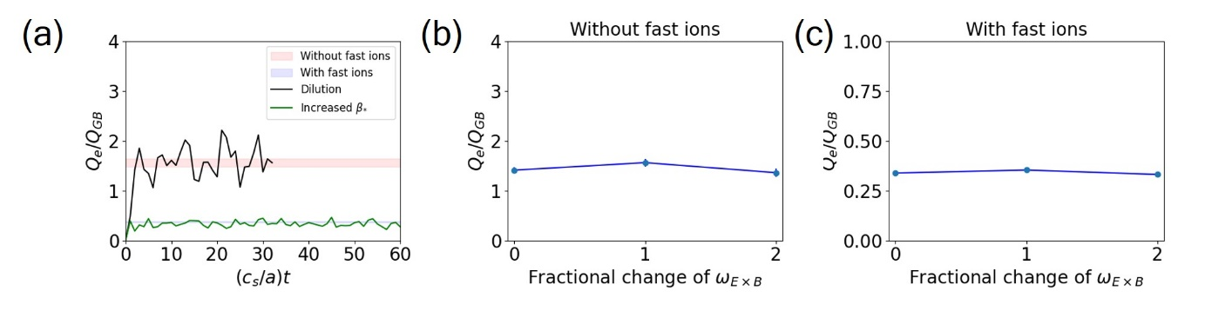

Figure 2. (a) Time series of gyroBohm normalized electron energy flux considering increased $β_{*}$ effect (green) and dilution effects (black). The shaded regions denote the uncertainty range for without fast ions (red) and with fast ions (blue). Electron energy flux with fractional change of $ω_{E×B}$, mean $E×B$ flow shearing rate, for cases (b) without fast ions and (c) with fast ions.

To investigate the detailed suppression mechanisms of electron scale turbulence by fast ions, each effect, including increased $β_{*}(∝∇p)$, dilution, and changes in shearing rate, was separately investigated. Figure 2(a) shows the time series of gyroBohm normalized electron energy flux considering increased $β_{*}$ and dilution effects, with shaded regions showing the uncertainty range of electron energy flux in each case shown in Figure 1. When $β_{*}$ increased, electron energy flux decreased to a close level to the case with fast ions, while including the dilution effects had a negligible effect on electron energy flux. In addition, electron energy flux does not change significantly when the shearing rate changes. These results supported that the impact of increased $β_{*}$ are dominant electron scale turbulence suppression mechanism by fast ions in electron scale simulations. In addition, the electron energy flux predicted by the electron scale simulation ($Q_{e}/Q_{GB}\sim 0.374$) are higher than that for ion scale simulations $(Q_{e}/Q_{GB}\sim 0.067)$. Therefore, electron scale turbulence may not be negligible, suggesting the requirement of multi scale simulations. The estimation of multi scale interaction will be discussed in Section 3.

# Preliminary gyrokinetic analysis of multi scale turbulence

## **Simulation Setup**

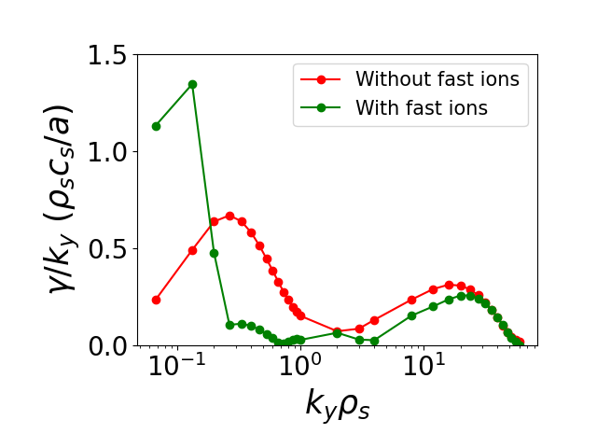

Figure 3. The ratio between linear growth rate $γ$ and poloidal wave number $k_{y}$, $γ/k_{y}$ as a function of $k_{y}ρ_{s}$ for cases without fast ions (red) and with fast ions (green)

As reported by the previous study[21], comparison between peaks in the ion scale range and the electron scale range of $γ/k_{y}$ can approximately provide whether electron scale turbulence is likely to be suppressed by ion scale turbulence or remain dominantly with affecting ion scale turbulence, where $γ$ is the linear growth rate. To estimate the importance of multi scale interaction between ion scale turbulence and electron scale turbulence, the $k_{y}ρ_{s}$ spectrum of $γ/k_{y}$ was investigated as shown in Figure 3. When fast ions were not included, $γ/k_{y}$ spectrum shows that the peak in ion scale range is larger than the peak in electron scale range, implying that electron scale turbulence can be suppressed by ion scale turbulence in the case without fast ions. In the case with fast ions, the peak in ion scale is smaller than the peak in electron scale range, while the peak of fast ion driven KBM[22], which is destabilized as fast ions were included in the $k_{y}ρ_{s}<0.27$ range, is dominant, indicating that fast ion driven KBM may contribute to the suppression of the electron scale turbulence. The details of the impact of this mode on electron scale turbulence will be left as future work.

## **Initial Multi Scale Simulation Results**

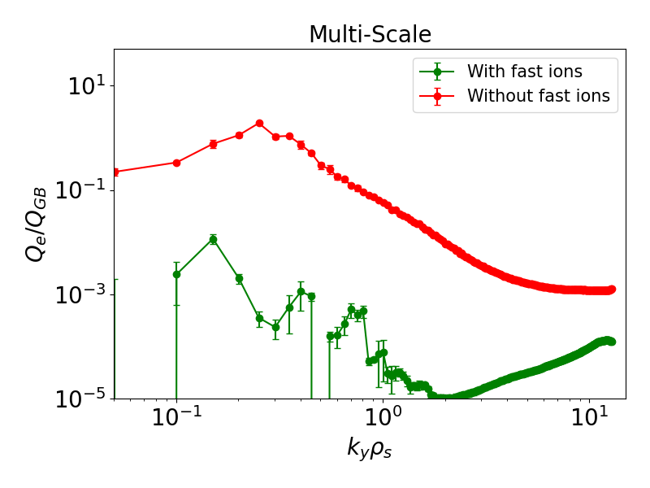

Figure 3. The $k_{y}ρ_{s}$ spectrum of electron energy flux predicted multi scale nonlinear simulations for the cases without fast ions (red) and with fast ions (green).

The impact of multi scale interaction was analyzed by nonlinear simulations including both ion and electron scale turbulence. Multi scale simulations cover the range up to $k_{y}ρ_{s}≤12.8$ due to the computing source limit. It should be noted that multi scale simulations do not include the higher $k_{y}ρ_{s}$ region where the peak of linear growth rate of electron scale turbulence appears, therefore, the present multi scale results provide only a limited view of multi scale dynamics. Nevertheless, Figure 5 showed that electron energy flux were reduced for whole simulated $k_{y}ρ_{s}$ range when fast ions were included, consistent with the previous study[14] and Section 2.

# Summary

1. A previous study[14] showed that ion scale turbulence was suppressed dominantly by dilution effects due to the addition of fast ions in the ITB region in KSTAR FIRE mode discharge. In this study, the fast ion effects on electron scale turbulence were investigated through the gyrokinetic simulations, focusing on electron scale where $k_{y}ρ_{s}≤60$ with minimum $k_{y}ρ_{s}=3$. The gyrokinetic simulation results showed a significant electron energy flux reduction when fast ions were included. The increased pressure gradient was mainly responsible for this reduction, while dilution effects and changes in shearing rate had a negligible effect on electron energy flux. In addition, the electron energy flux predicted by electron scale turbulence was higher than the electron energy flux from ion scale turbulence, indicating electron scale turbulence may not be negligible. To estimate the impact of multi scale interaction, linear stability analysis of the $γ/k_{y}$ spectra was performed. The linear simulation results approximately indicate the suppression of electron scale turbulence for both cases without and with fast ions. Preliminary multi scale simulation also predicted the turbulence suppression by fast ions in the whole simulated $k_{y}ρ_{s}$ range, consistent with single scale simulation results.

ACKNOWLEDGEMENTS

This study was supported by the R&D Program of the Korea Institute of Fusion Energy (KFE) (2025-EN2501) and the National Research Foundation of Korea (NRF) funded by the Korean government (Ministry of Science and ICT) (RS 2022-00155956). Computing resources were provided on the KFE computer KAIROS, funded by the Ministry of Science and ICT of the Republic of Korea (No. KFE-EN2541), and the National Supercomputing Center with supercomputing resources including technical support (KSC-2025-CRE-0204).

References

[1] Citrin J and Mantica P 2023 *Plasma Phys. Control. Fusion* **65** 033001

[2] Na Y-S et al 2025 *Nat Rev Phys* **7** 190–202

[3] Citrin J et al 2015 *Plasma Phys. Control. Fusion* **57** 014032

[4] Wilkie G J et al 2018 *Nucl. Fusion* **58** 082024

[5] Hahm T S et al 2023 *Physics of Plasmas* **30** 072501

[6] Mazzi S et al 2022 *Nat. Phys.* **18** 776–82

[7] Chung J et al 2021 *Nucl. Fusion* **61** 126051

[8] Zohm H 1996 *Plasma Phys. Control. Fusion* **38** 105–28

[9] Di Siena A et al 2021 *Phys. Rev. Lett.* **127** 025002

[10] Han H et al 2022 *Nature* **609** 269–75

[11] Han H et al 2024 *Physics of Plasmas* **31** 032506

[12] Brochard G et al 2024 *Phys. Rev. Lett.* **132** 075101

[13] Na Y-S et al 2025 (*Nucl. Fusion submitted)*

[14] Kim D et al 2023 *Nucl. Fusion* **63** 124001

[15] Mantica P et al 2021 *Nucl. Fusion* **61** 096014

[16] Howard N T et al 2016 *Phys. Plasmas* **23** 056109

[17] Candy J et al 2016 *Journal of Computational Physics* **324** 73–93

[18] Arbon R, Candy J and Belli E A 2021 *Plasma Phys. Control. Fusion* **63** 012001

[19] Sugama H, Watanabe T-H and Nunami M 2009 *Physics of Plasmas* **16** 112503

[20] Estrada-Mila C, Candy J and Waltz R E 2006 *Physics of Plasmas* **13** 112303

[21] Howard N T et al 2021 *Nucl. Fusion* **61** 106002

[22] Kim D et al 2025 (*Plasma Phys. Control. Fusion* submitted)