# conference pre-print

# Alpha particle generation and confinement in D-3He scenarios in JT-60SA

1. R. COELHO
2. Instituto de Plasmas e Fusão Nuclear, Instituto Superior Técnico, Universidade de Lisboa
3. Lisboa, Portugal
4. Email: rcoelho@ipfn.tecnico.ulisboa.pt
5. Ye. O. Kazakov
6. Laboratory for Plasma Physics, LPP-ERM/KMS
7. Brussels, Belgium
8. R. Novara, M. Nocente
9. Dipartimento di Fisica, Università di Milano-Bicocca
10. Milan, Italy
11. K. Särkimäki, A. Snicker
12. VTT Technical Research Centre of Finland
13. Espoo, Finland
14. S. Sipilä
15. Department of Applied Physics, Aalto University
16. Espoo, Finland
17. J. Garcia
18. CEA, IRFM
19. Saint-Paul-lez-Durance, France
20. **Abstract**
21. Future fusion reactors will rely on a significant fraction of self-heating by fusion born alpha particles coming from the DT plasma fuel mix. Understanding alpha particle generation and confinement is therefore critical and, in anticipation of ITER, should be subject to thorough research. Experimentally, however, no current large device can operate with DT fuel and therefore alternative schemes for alpha particle generation come into play. Since DT operation is not foreseen in the scientific exploitation of JT-60SA, a fusion scheme relying on He3 seeding and highly energetic 500keV beam is proposed similarly to what has been used in other devices such as JET although in there the original ~100keV scale beam ions were further accelerated using RF waves. In this work we investigate the generation and confinement of alpha particles stemming from this He3+NBI scheme, taking the forthcoming OP2 and future hybrid scenarios as reference plasmas. We will show that owing to the high-energy N-NBI system on JT-60SA, significantly higher values of alpha/neutron production rates can be achieved when considering similarly scoped experiments on JET while using significantly less He3 concentrations. Loss power and particle rates will also be discussed and optimised alpha birth rates shown for specific variants performed on the hybrid scenario where plasma density, position and temperature were varied at constant plasma current and magnetic field.
    1. INTRODUCTION

JT-60SA is a fully superconducting tokamak collaboratively designed and constructed by Japan and Europe. Its role is to serve as a supporting device for the ITER experimental program while advancing progress toward the future DEMO fusion reactor [1,2]. Building on the experience gained from JET and on superconducting tokamaks like WEST, EAST, and KSTAR, JT-60SA seeks to push the boundaries of superconducting tokamak technology and operational regimes by providing essential insights for creating steady-state, high performance operational scenarios [3,4]. In particular, JT-60SA aims to achieve and control high-β, high-bootstrap current fraction (fBS) and high normalized density (to Greenwald density), a critical step towards economically viable steady-state DEMO reactors [5]. Pivotal to achieve such goals, JT-60SA offers a range of versatile possibilities for controlling heating, current, and momentum inputs. Its capabilities encompass tangential off-axis negative ion source based neutral beam (N-NBI) injection of 10MW at a maximum energy of 500keV, positive ion source based neutral beams (P-NBI) at 85keV with 2 units of co-tangential beams (4MW), 2 units of counter-tangential beams (4MW) and 8 units of near perpendicular beams (16MW). With additionally 7MW of electron cyclotron resonance heating (ECRH), JT-60SA is poised to address the development of full non-inductive steady-state operation scenarios and to sustain weak/negative magnetic shear plasmas in high-beta advanced tokamak (AT) configurations.

Although JT-60SA is not foreseen to operate with DT fuel mix and thus not aiming explicitly at alpha physics studies, the beam-thermal fusion cross-section of the reaction Dbeam+3He 🡪 4He (3.6MeV) + p (14.7 MeV) has its maximum close to 500keV for fast deuterium (still one order of magnitude smaller than peak thermal DT fusion cross section). It is thus an excellent option for downscaled alpha particle studies of, e.g., the effect on core turbulence, MHD and electron dominated heating regimes. This approach avoids tritium manipulation and machine activation and has already been used in existing tokamaks. At JET, for instance [6,7], this technique was quite successful in enabling alpha particle studies in plasmas with experimental conditions matching $B_{0}=3.7T$, $I_{p}=2.5MA$, $n_{e}≈6×{10}^{19}m^{-3}$, $T_{e}(0)≈7keV$, 7MW of NBI and up to 6MW of ICRF power. The 3-ion ICRH scheme [8] D-DNBI-3He was used and 3He concentrations were of the order 20–25%. Since at JET the NBI beam ions energies are at most ~100keV, the RF power was key to further accelerate some of the D-NBI ions to MeV range energies at the ion-ion hybrid layer in the plasma core. Clear evidence of alpha particle generation from the 3He+D fusion reaction was made at an estimated rate $r_{alpha}≈2×{10}^{16}s^{-1}$, assisted by gamma-ray spectra measurements [9]. This alpha-production rate in D-3He plasmas (although much smaller than in D-T plasmas) was sufficient to observe several fast-ion effects associated with alpha particles and furthermore prepare alpha-particle diagnostics for their future use in D-T experiments [10].

In this work we investigate the birth and confinement properties of fusion born alpha particles from Dbeam+3He fusion reactions in two JT-60SA scenarios using the ASCOT5 code suite [11]. First, a future hybrid operational scenario (scenario 4) is addressed and a series of variants of the scenario are explored in an attempt to find maximal net alpha particle throughput accounting both for birth and confinement. Such variants involve different settings for plasma density, position, and temperature. Secondly, the forthcoming OP2 deuterium scenario will be addressed and variants in density and temperature will be also investigated. Key performance indicators addressing beam shinethrough, alpha birth and loss rates as well as alpha birth, absorbed and lost powers will be provided on all cases investigated.

* 1. PLASMA SCENARIOS AND MODELLING WORKFLOW

The two plasma scenarios considered in this study address different stages of operation of the device. The first scenario to be investigated, simulated by the CRONOS integrated modelling framework [12], is the foreseen high performance hybrid scenario (scenario 4) of operation of JT-60SA [5], a βN=3, ne/nGW=0.67 deuterium plasma at 3.5MA/2.28T plasma current and toroidal magnetic field and total external heating of 37MW (30MW of NBI + 7MW of ECRH). The second scenario, simulated by the METIS integrated modelling framework [13] and anticipated for the forthcoming OP2 campaign of JT-60SA, is a peaked density βN=1.64, ne/nGW=0.43 deuterium plasma at a higher plasma current of 4.6MA for the same toroidal magnetic field. Contrary to the hybrid scenario, it assumes a sawtoothing plasma and total external heating of ~17.5MW (16MW of NBI + 1.5MW of ECRH). The equilibrium flux surfaces for both scenarios overlaid with the beamlets’ centerline for the N-NBI system used throughout this work are shown in Fig. 1 (left). The density, temperature and safety factor (q) profiles are shown in Fig. 1 (right).



*FIG. 1 – Flux surfaces and N-NBI beamlines (left), electron and ion densities (top right) and electron and ion temperatures and safety factor (q) profiles (bottom right). Blue and red color/symbol represent, respectively, the Scenario4 and OP2 scenarios.*

In both scenarios the N-NBI system was used at full 10MW power at the maximum energy of 500keV. However, the two scenarios bear some differences which can have notable effects on the fusion alpha yield from beam-target reactions using deuterium and 3He. Firstly, the OP2 scenario features a lower plasma density with a marginal difference in electron temperature. This translates to a higher slowing down time for the 500keV beam ions and thus potentially higher albeit more peaked fast deuterium density. In addition, the lower plasma density also entails a higher beam shinethrough in OP2. This was confirmed in the simulation workflow with OP2 yielding ~0.35MW/m2 (total power ~0.4MW) whereas for Scenario4 one gets ~0.15MW/m2 (total power ~0.15MW). The simulation workflow is a 4-stage process. First, BBNBI calculates the beam deposition/ionization as well as shinethrough, and then markers representing ionised deuterium source are traced in ASCOT until they exit the plasma or cool below 1.5 times the thermal temperature. AFSI then calculates the alpha fusion source distribution (or neutron source distribution in case of Dfast-Dthermal reaction) and markers representing fusion-born alpha particles sampled from AFSI are once again traced in ASCOT, allowing for the calculation of absorbed and lost alpha power as well as lost particle rates. In all cases markers were traced using the guiding-center approximation and the simulations included Coulomb collisions. In this preliminary study, it is assumed that the markers exiting the plasma are lost to partially compensate for not considering magnetic field ripple (fully consistent equilibria not available up to the wall). This allows for a rough estimate of the lost particle and power flux to the wall had ripple been accounted for. In Fig.2 the sequence of distributions functions (RZ dependence, integrated over all other phase space coordinates) is shown for the 4 stages where a 10% 3He concentration is assumed.

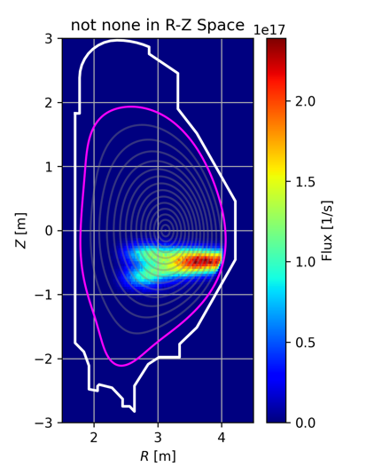

*FIG. 2 – Fast ion distribution vs RZ for a typical sequence of ASCOT5 suite codes used in this study. Ionised deuterium atoms from BBNBI (far left), slowed down fast deuterium from NBI with ASCOT (second from left), alpha birth distribution source from AFSI (third from left) and slowed down alpha distribution with ASCOT (far right). The hybrid scenario is considered.*

* 1. ALPHA PARTICLE GENERATION AND CONFINEMENT

In order to get a first estimate of the birth rates of alphas and neutrons expected in JT-60SA scenarios to 3He seeding, a scan over the 3He concentration was made, taking as example the hybrid scenario. While the concentration varied from 5 to 15%, the electron density remained constant and the ion density (single ion species, no impurity assumed) was varied accordingly to ensure quasi-neutrality. For these 3He concentrations, the deuterium fuel dilution does not significantly affect the fast deuterium birth rates from the neutral beam and the ensuing fast deuterium slowing down population, a pivotal control knob over alpha birth rates.

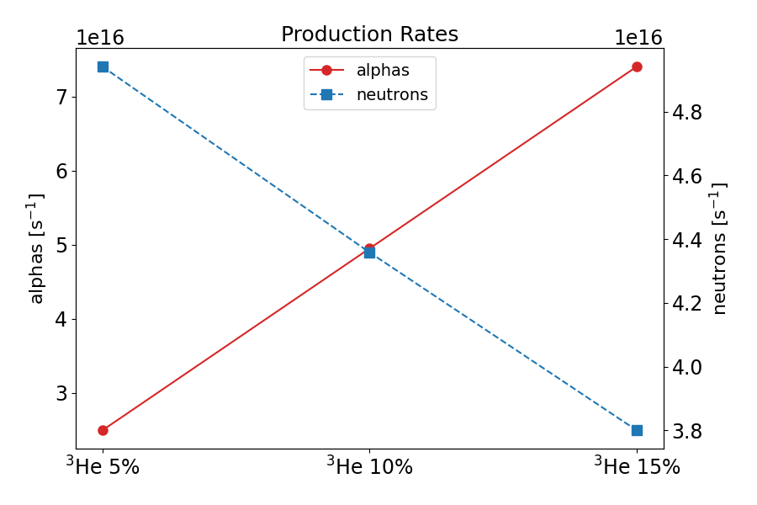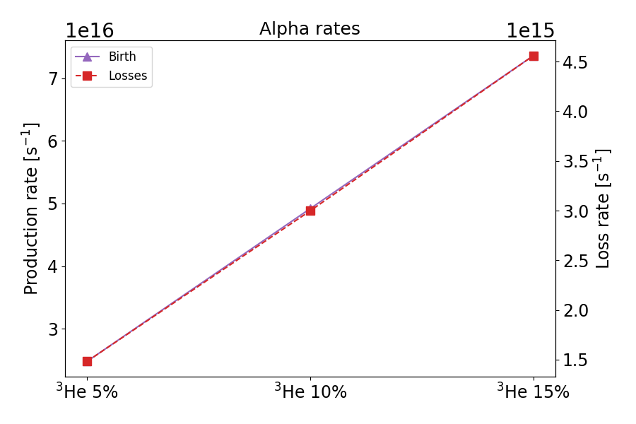

*FIG. 3 – Alpha birth and neutron rates (left) and alpha birth and loss rates (right) for the 3He concentration scan over the hybrid scenario.*

Unsurprisingly, the birth and loss rates of alphas are proportional to the 3He concentration as observed in Fig. 3 for Scenario 4. For the OP2 scenario, only estimates at 10% were made (discussed in *section 3.4*).

### Scan over plasma density

In the plasma density scans, the bulk plasma pressure was assumed to remain constant by varying the plasma temperature accordingly. A similar scaling factor was applied to the ion density (to ensure quasi-neutrality) and to the ion temperature. There are several elements at play on the alpha particle generation when scanning over plasma density (and temperature). Although reducing plasma density translates into less He3 fusion target ions, since plasma temperature is also higher, it ultimately means that the slowing down time for the energetic beam ions is larger and thus a larger fast deuterium population is anticipated. Over the density scan range (+20% down to -20%) the slowing down time spans 0.286-0.577s, i.e. it almost doubles. This clearly offsets the lower He3 population for the lower density cases. The alpha and neutron (from Dbeam-D fusion reactions) birth rates as well as the loss rates (including both prompt and collisionally diffused contributions) are shown in Fig. 4. Beam shinethrough, which is strongly dependent on plasma density, decreases from 0.4 MW (at peak power load of 0.4 MWm⁻²) at the lowest density to 0.05 MW (peak 0.05 MWm⁻²) at the highest density.

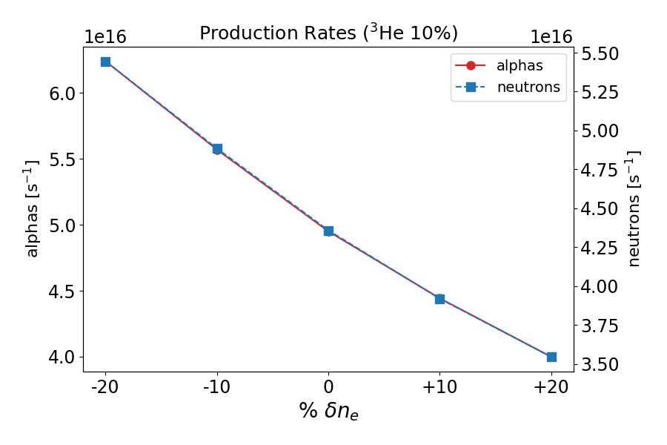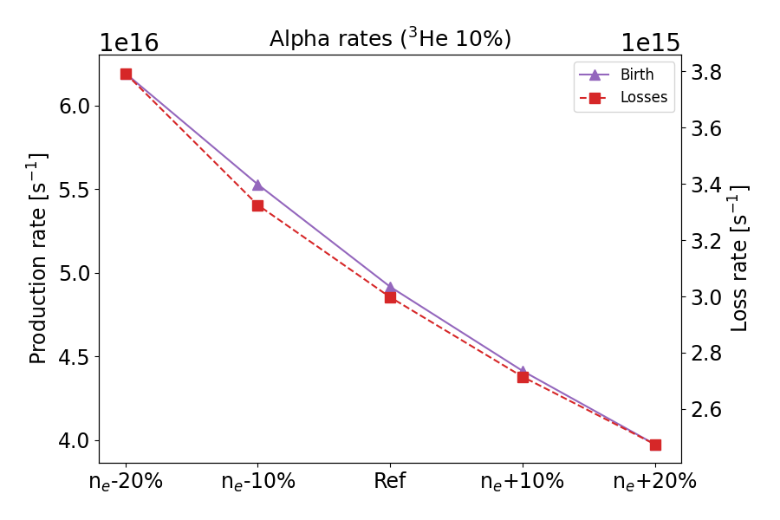

*FIG. 4 – Alpha birth and neutron rates (left) and alpha birth and loss rates (right) for the density scan over the hybrid scenario. A 3He concentration of 10% is considered.*

At 20% reduction in density, like that used in the JET pulse, one obtains an increase of 26% on the alpha birth rate, already a good improvement. Even in the worst-case scenario of increased density (and decreased temperature), the alpha birth rate fares at twice that observed in the JET pulse albeit at half the 3He concentration. The alpha loss rate follows the same trendline as the birth rate and, although increasing when density decreases, the corresponding power losses through the separatrix remain small varying between 1.45kW (highest density) and 2.14kW (lowest density). Such small powers should be of no concern even if they were to eventually reach the first wall.

### Scan over plasma position

The next logical step to increase the alpha birth rate further is to optimise the plasma position. This stems from the fact that the N-NBI beams are directed both off-axis and with beamlines below the plane crossing the magnetic axis. This means the beam doesn’t probe as high plasma density and temperature and 3He density as it would do if passed closer to the magnetic axis. Higher average 3He density and plasma temperature is a proxy for higher alpha birth rates. As easily verified in Fig. 5, when the plasma is rigidly shifted 10cm down, there is a clear increase in the fast deuterium density and it is located closer to the magnetic axis. In Fig. 5 the radial coordinate (S) is the square root of the normalised poloidal magnetic flux. Another obvious advantage of reducing the gap between the beamlines and the magnetic axis position is the longer beam path and higher average plasma density along the beam path, reducing beam shinethrough. This was confirmed in the simulations with the +10cm plasma upshift yielding 0.179MW (at peak power load of 0.175 MWm⁻²) whereas the -10cm case yielded 0.124 MW (peak 0.111 MWm⁻²). With the plasma shifted down 10cm, the higher fast deuterium population will thus undergo fusion reactions with on average higher 3He density and, consequently, the alpha birth rate increases as shown in the simulations results of Fig. 6. The alpha loss rate here shows an opposite trend to the birth rate which is explained by a more external birth position of the alphas as the plasma moves further from the beamlines.

*FIG. 5 – Radial profile of slowing down distributions of fast deuterium from the beam (left) and of fusion alphas from fast deuterium and 3He (right) for the vertical position scan over the hybrid scenario. A 3He concentration of 10% is considered.*

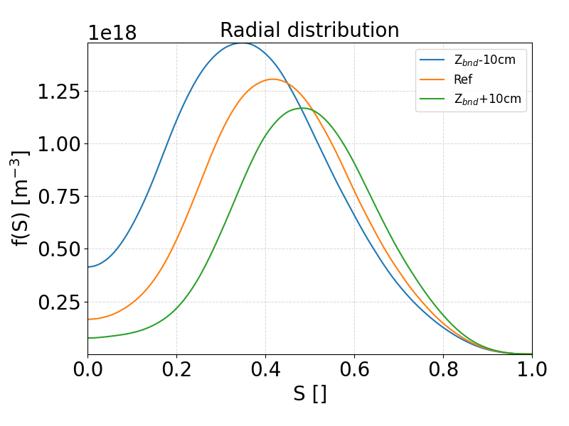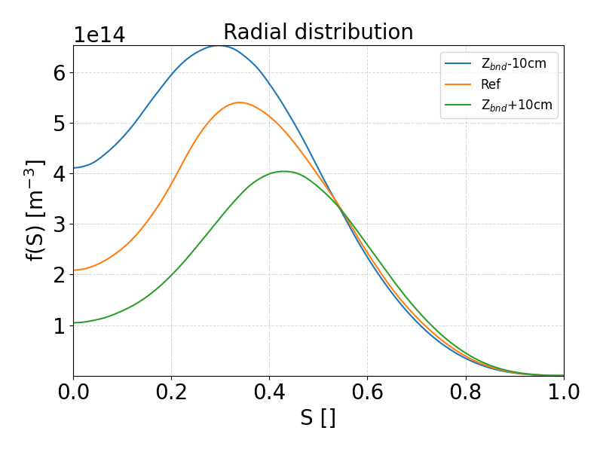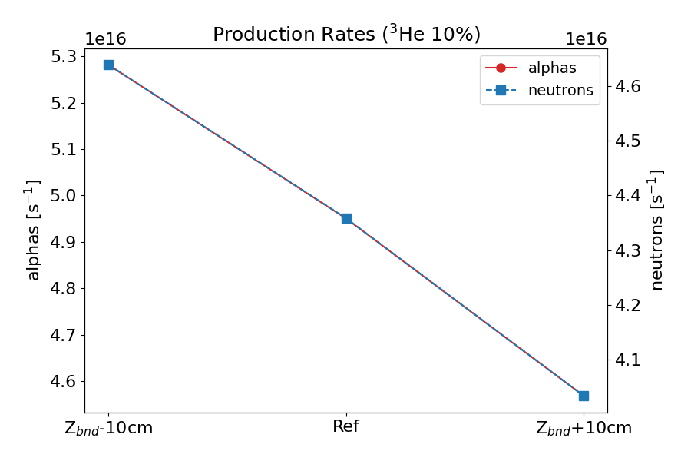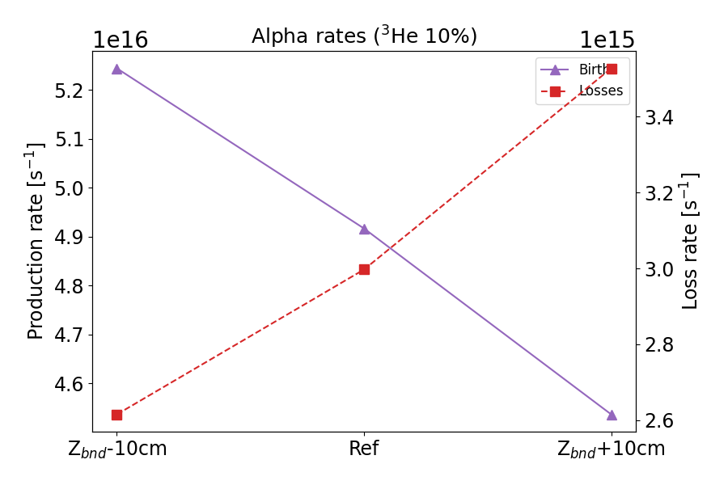

*FIG. 6 – Alpha birth and neutron rates (left) and alpha birth and loss rates (right) for the vertical position scan over the hybrid scenario. A 3He concentration of 10% is considered.*

### Scan over plasma temperature

As a last variant of the hybrid scenario, we consider the case where additional ECRH power would be available, raising the electron temperature further by 10% and 20%. Admittedly, a new plasma equilibrium should be derived to account for the slight increase in the plasma pressure and eventual changes in the current density profile. However, in this preliminary study we just want to get a rough estimate of the expected increase in alpha birth and loss rates resulting from the temperature increase. The 10% and 20% temperature increase variants are considered to pile up on the already optimised 20% density decrease (at constant pressure) and 10cm down shift of the plasma. This allows an easier insight on the gain in alphas generated and confined in the plasma as we progress in the scenario modification. As shown in Fig. 7, when tweaking the scenario the increasing trend in fast deuterium and alphas is clear and encouraging.

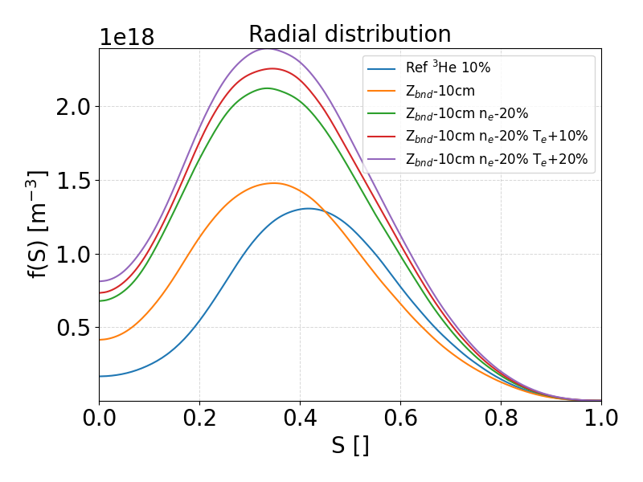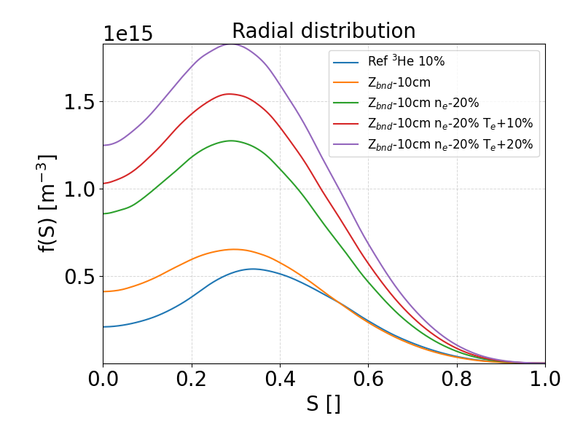

*FIG. 7 – Radial profile of slowing down distributions of fast deuterium from the beam (left) and of fusion alphas from fast deuterium and 3He (right) for the stepwise scenario variant including a temperature scan over the hybrid scenario. A 3He concentration of 10% is considered.*

In terms of alpha and neutron production rates, clear gains are observed as successive modifications are introduced into the scenario, with the increase in plasma density (and corresponding decrease in temperature) being the most significant, as anticipated (see Fig. 8). At 10% of 3He concentration, an optimal birth rate of alphas four times higher than the results obtained at JET (albeit with only 7MW of NBI contrary to 10MW in this hybrid scenario of JT-60SA) using 20-25% of 3He is observed, showcasing the potential of this hybrid scenario and of the JT-60SA device and actuators.

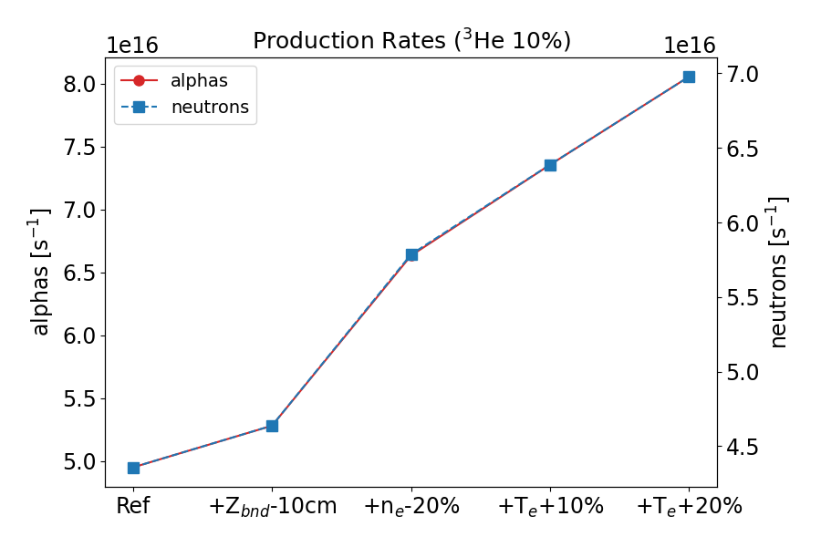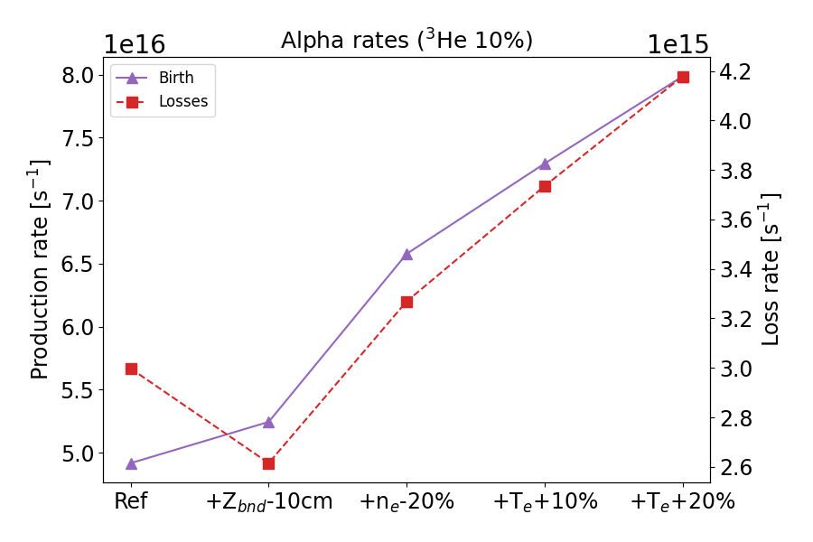

*FIG. 8 – Alpha birth and neutron rates (left) and alpha birth and loss rates (right) for the stepwise scenario variant including a temperature scan over the hybrid scenario. A 3He concentration of 10% is considered.*

Regarding alpha losses (on average 5-6% for the several variants considered), the simulations show that, as anticipated, the majority of losses are prompt losses although some collision-induced losses are also observed coming from counter-passing fusion born alphas. Delayed losses account for roughly 12% of the total alpha power loss. Alphas crossing the plasma boundary are predominantly lost on the outboard side, below the magnetic equilibrium equatorial midplane, and typically as trapped orbits. The alpha loss rate histograms over energy-pitch space and over the radial-like coordinate S are shown in Fig. 9. The histograms are built with the lost marker birth coordinates over phase space. While most of the lost alphas are born with negative velocity pitch (either counter-passing or trapped), all alphas are lost as trapped orbits and at positive pitch (outer below-midplane portion of the banana orbit). As expected, the dominant losses originate from alphas born from mid-radius outwards.

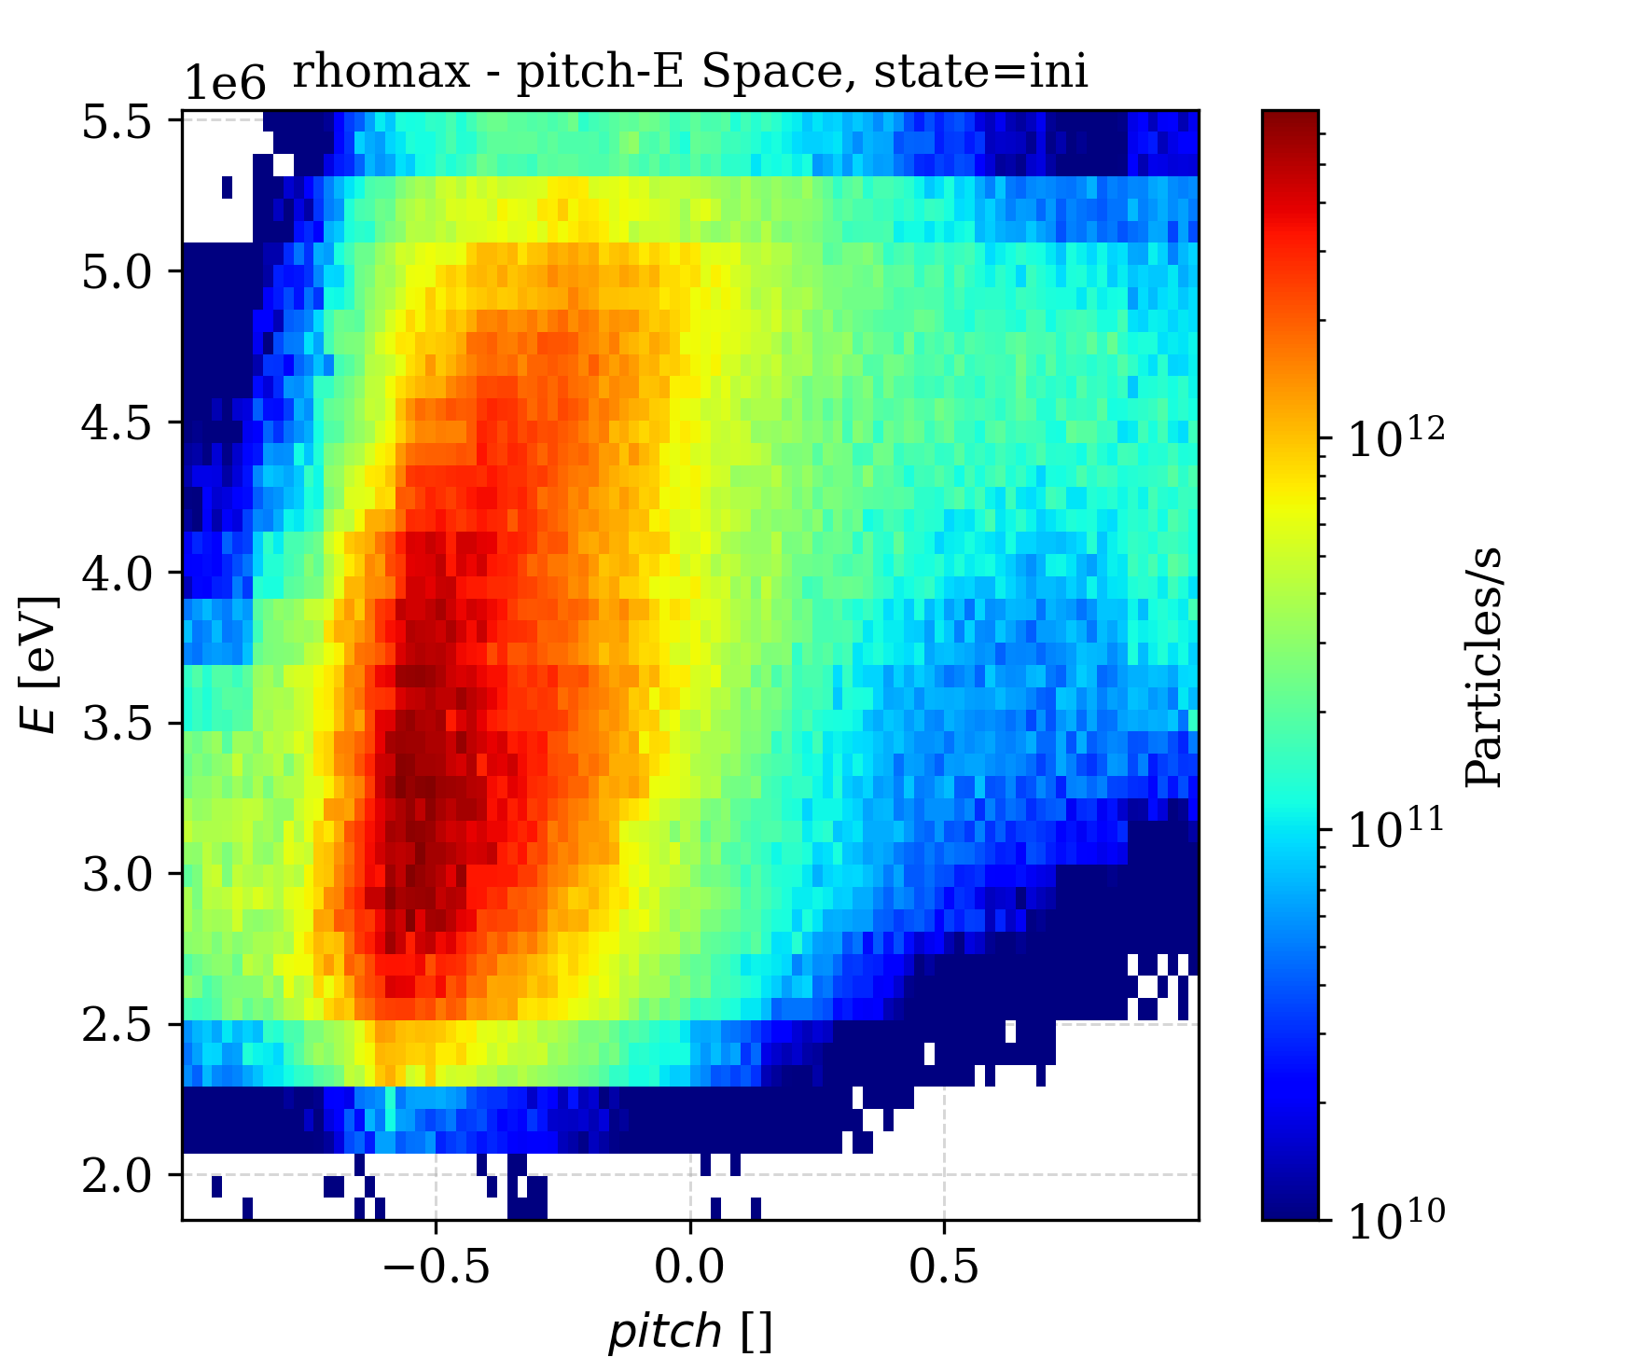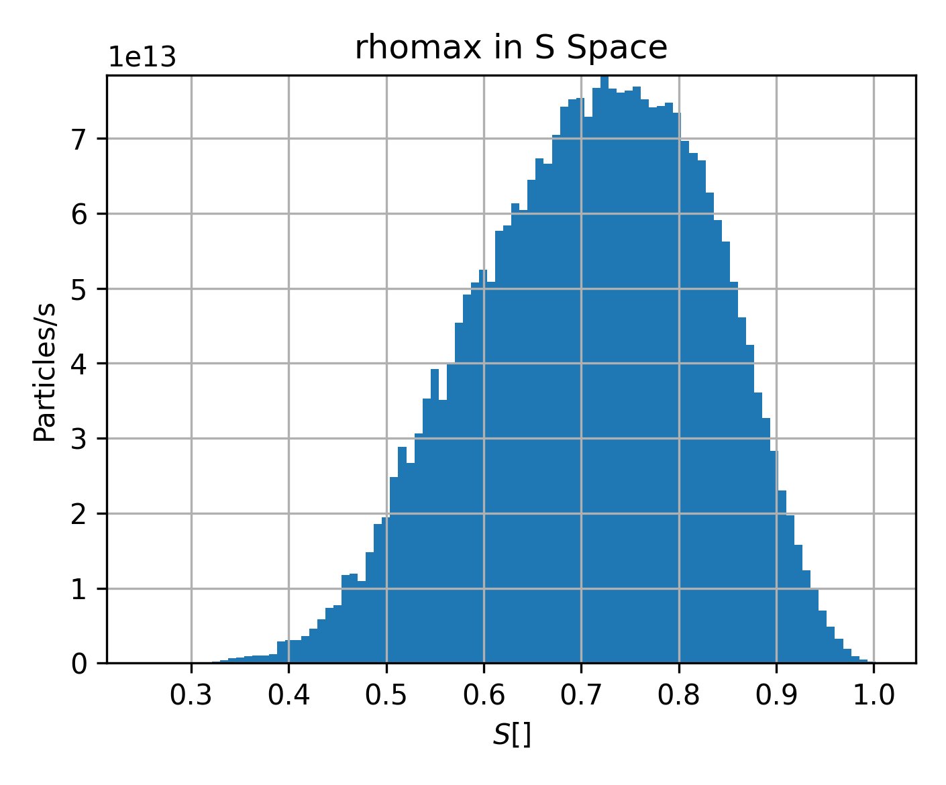

*FIG. 9 – Alpha markes histograms over energy-pitch (left) and radial (right) space on the reference hybrid scenario. The marker coordinates and histograms are taken at the birth time. A 3He concentration of 10% is considered.*

### Optimal scan applied to OP2 scenario

As a last scenario we now focus on the foreseen operational baseline scenario for OP2 experimental campaign already detailed in Section 2. Contrary to the stepwise approach in the alpha birth rate optimization followed for the hybrid scenario, in this OP2 scenario there is no real margin to change the vertical position of the plasma since the plasma boundary shows much smaller gaps to the first wall. Therefore, the optimization of the alpha birth rate is constrained only to adjustments in plasma density and temperature. As observed in Fig. 10, the improvement from reducing plasma density is marginal when compared to the hybrid scenario. This is easily explained by the already low plasma density in the reference case. A reduction in density increases the beam shinethrough significantly (see Fig. 11) thus undermining the potential benefits in terms of the increase in slowing down time. The alpha loss rate is around 3% for all scenario variants, roughly half of the loss rate obtained in the hybrid scenario and its variants.

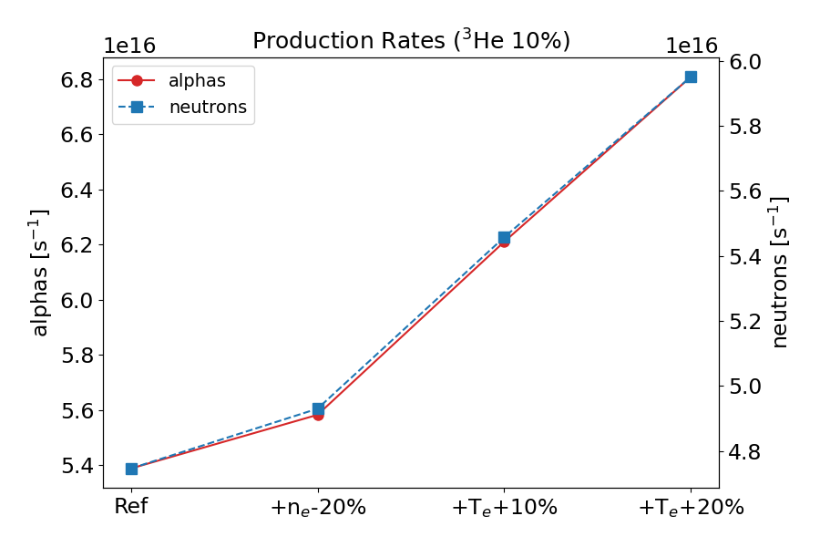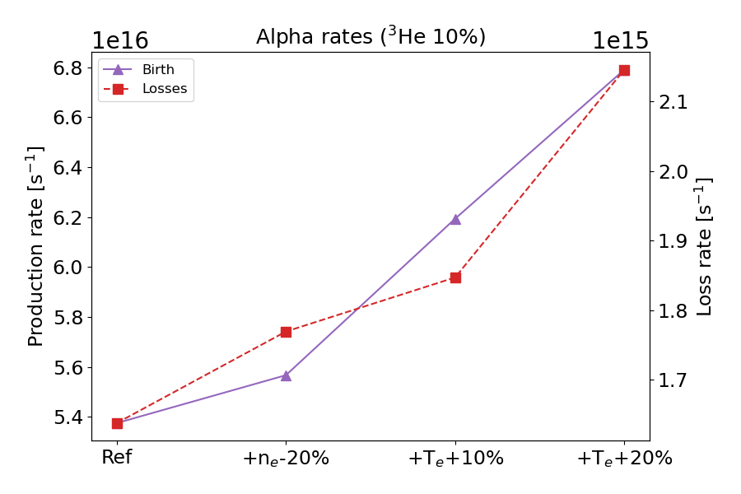

*FIG. 10 – Alpha birth and neutron rates (left) and alpha birth and loss rates (right) for the stepwise scenario variant including a temperature scan over the OP2 scenario. A 3He concentration of 10% is considered.*

*FIG. 11 – Beam shine-through power (left) and peak power load on the wall (right) for the stepwise scenario variant including a temperature scan over the OP2 scenario. A 3He concentration of 10% is considered.*

* 1. CONCLUSIONS

In this work, two possible plasma operation scenarios for the JT-60SA tokamak were analyzed as a potential testbed for generating fusion-born alpha particles through Dbeam+3He reactions. A hybrid-like scenario at 37MW with ITB in the ion energy channel modelled by CRONOS code suite and a lower power (17.5MW) baseline scenario modelled by METIS code suite were considered. A synergistic approach was adopted while investigating which scenario variants to apply on each scenario in order to maximize the alpha particle steady state population. Since the two most important control knobs are ultimately the N-NBI fast deuterium and the 3He densities, excluding the obvious 3He concentration, increasing the slowing down time for the energetic deuterium population proved instrumental.

Through a suitable combination of decrease in plasma density, increase in plasma temperature and rigid plasma shift to allow for the N-NBI beam path to cross the plasma closer to the magnetic axis, a 60% increase in the alpha birth rate over the reference hybrid scenario is achieved. The alpha confinement properties in all scenario variants remain very similar resulting in a relative alpha loss rate of 5-6%. The predicted alpha-production rate on JT-60SA exceeds the corresponding alpha rate in D-3He experiments on JET ($r_{alpha}≈2×{10}^{16}s^{-1}$). Given that and accounting for additional actuators not available on JET such as ECRF, we might expect the observation of new alpha-particle effects in future experiments. Furthermore, the developed fast-ion scenario will contribute to the advancement of novel measurement techniques for alpha particles in support of ITER"

Regarding the OP2 scenario, considering its tight boundary gaps to the first wall, only the density and temperature variants were explored. Since the reference plasma density is closer to the lower operational limit for acceptable beam shinethrough at 500 keV beam energy, further density reduction strongly increases shinethrough losses. As a result, the benefit in terms of additional slowing-down fast ions—and consequently in alpha birth rate—is marginal compared with the hybrid scenario.

ACKNOWLEDGEMENTS

IPFN activities were supported by FCT - Fundação para a Ciência e Tecnologia, I.P. by project reference UID/50010/2023, UID/PRR/50010/2025 and by project reference LA/P/0061/2020.

References

1. Kamada Y *et al.*, Completion of JT-60SA construction and contribution to ITER, Nucl. Fusion **62**, (2022) 042002
2. GIRUZZI G *et al.*, Physics and operation oriented activities in preparation of the JT-60SA tokamak exploitation, Nucl. Fusion **57**, (2017) 085001
3. Yoshida M *et al.*, Plasma physics and control studies planned in JT-60SA for ITER and DEMO operations and risk mitigation, Plasma Phys. Control Fusion **64** (2022) 054004
4. Yoshida M *et al*., Overview of plasma operation and control studies in the first plasma campaign of JT-60SA, Plasma Phys. Control Fusion **67** (2025) 065010
5. JT-60SA Research Plan Research Objectives and Strategy v4.0 JT-60SA (2018)
6. KAZAKOV YE. O. *et al.*, Physics and applications of three-ion ICRF scenarios for fusion research,Phys. Plasmas **28** (2021) 020501
7. NOCENTE M *et al.*, Generation and observation of fast deuterium ions and fusion-born alpha particles in JET D-He3 plasmas with the 3-ion radio-frequency heating scenario,Nucl. Fusion **60** (2021) 124006
8. KAZAKOV YE. O. *et al.*, Efficient generation of energetic ions in multi-ion plasmas by radio-frequency heating,Nat. Phys. **13** (2017) 973
9. MAILLOUX J *et al.*, Overview of JET results for optimising ITER operation, Nucl. Fusion **62**, (2022) 042026
10. KIPTILY V *et al.,* Excitation of Alfvén eigenmodes by fusion-born alpha-particles in D-3He plasmas on JET, PlasmaPhys. Control. Fusion **64** (2022) 064001
11. VARJE J *et al.,* High-performance orbit-following code ASCOT5 for Monte Carlo simulations in fusion plasmas. *arXiv preprint arXiv:1908.02482*, 2019
12. GARCIA J *et al.*, Physics comparison and modelling of the JET and JT-60U core and edge: towards JT-60SA predictions, Nucl. Fusion **54** (2014) 093010
13. ARTAUD J *et al.*, METIS: a fast integrated tokamak modelling tool for scenario design. Nuclear Fusion Journal of Plasma Physics and Thermonuclear Fusion **58** (2018) 105001