Surface damage and deuterium retention in tungsten under high-flux detached recombining linear plasmas

Jipeng Zhu1, Wei Jin1,\*, Weizhi Yao1, Xiaoqiu Ye1, Xuxu Liu1, Changan Chen1,\*

1 Institute of Materials, China Academy of Engineering and Physics, Mianyang City, Sichuan Province, P.R. China

In the future deuterium-tritium fusion phase, it is essential to achieve partial detachment of divertor plasmas in order to maintain an acceptable level of particle and heat loads. There should be a clear, evidence-based prediction of D/T retention within plasma-facing materials (PFMs) throughout their operational lifespan, utilizing existing experimental or numerical methodologies. A compact linear plasma device has been developed based on cascaded arc which can provide stable detached deuterium plasmas with flux up to 1024 m-2s-1, heat load up to 15 MWm-2. The spectroscopic measurements shown high-n transitions from electron-impact recombination process and flux decrease with increasing impurity injection from ion current measurements, which are the typical characteristics of plasma detachment. The ion species and concentration has also been investigated in partially detached plasmas, and it is shown that: the ions are not solely D+ or D2+, but instead a substantial amount of D/D3+ at elevated pressures; when impurities like nitrogen are introduced, compound ions like ND4+/N2D+ can form. The surface damage is inhomogeneous in space under partially detached plasmas. The blister preferred to exist in medium region other than the center where has the maximum flux density. The nucleation and growth of μm-blisters are deeper and saturated due to micro-cracking of blister dome. The sputtering and formation of nano-blistering morphology above the μm-blisters have been found and they are both grain orientation dependent. The deuterium retention and blister distribution vary nonlinearly with bias voltage, showing an inflection point at -40V. The TDS and microstructure revealed that the retention was dominated by blister-induced defects. The simulation based on rate equations of diffusion-trapping has been applied to explain the experimental observations. It changed from trapping mode to diffusion mode at elevated temperature. The divertor detachment is beneficial to managing tritium inventory, ensuring that deuterium does not diffuse too deeply into the material or accumulate in deeper traps. This study has revealed for the first time the nonlinear behaviors of tungsten irradiation damage and deuterium retention under the partially detached divertor conditions, providing critical references for controlling the detachment degree in fusion reactors.

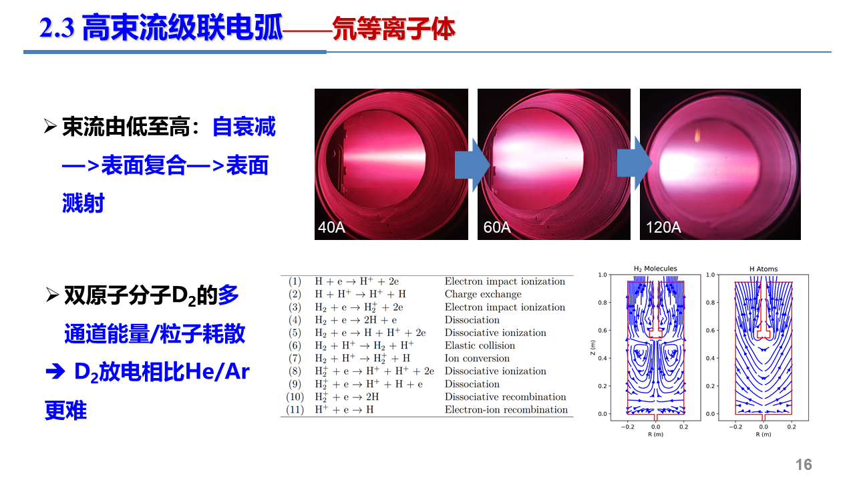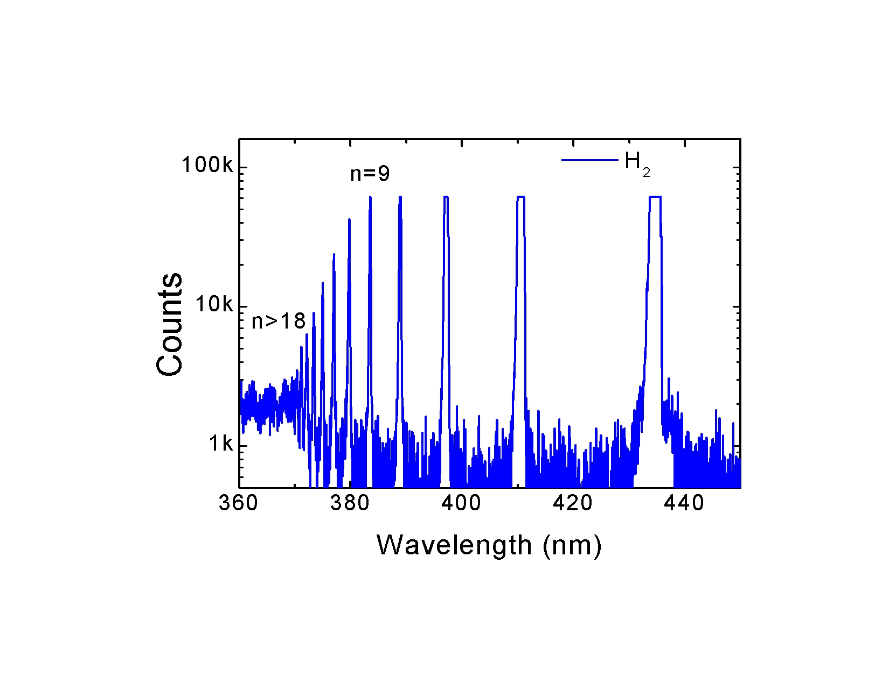

Fig.1. Detached plasmas generated in linear magnetic device and its typical spectrum.

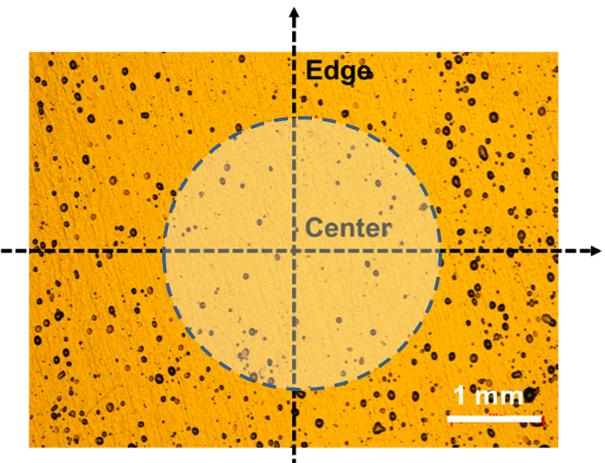H:\NSFC面上\等离子体辐照\SEM 2023\610.tif H:\NSFC面上\等离子体辐照\SEM 2023\622.tif

Fig. 2. The blister is inhomogeneous with fewer amount in the centre of plasma.

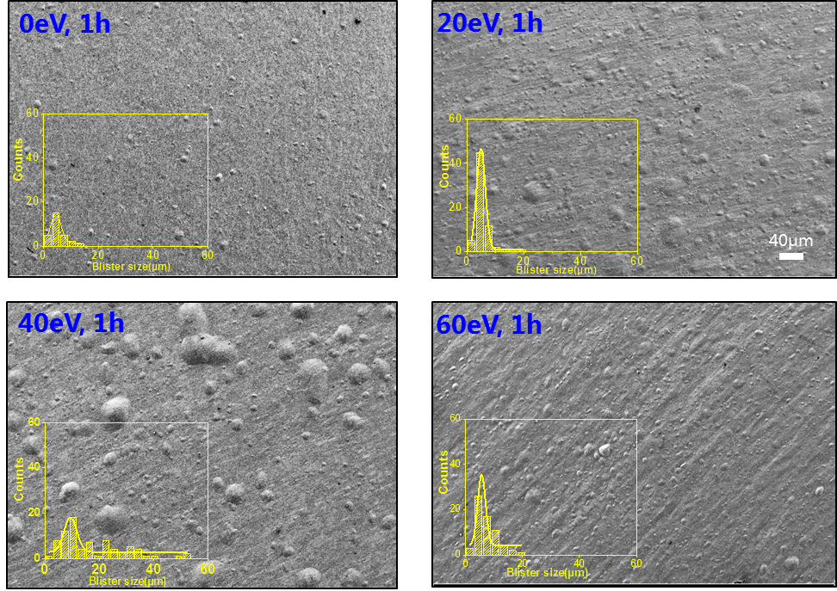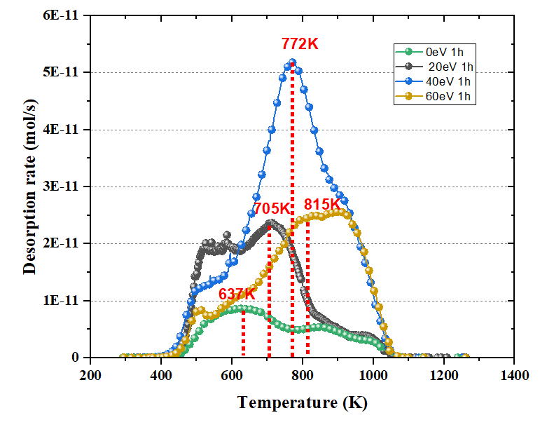

Fig. 3. Surface blister distribution and deuterium retention in pure tungsten after plasmas irradition.